Ames Iowa Housing price prediction
  - SMU MSDS Statistical Foundations Project

Jose Hernandez, Derek Rogers, Nicole Assenza
TAble of
Contents
Exploratory Data Analysis 1
Transformations 1
Relationships 1
Analysis 1 2
Findings 2
Conculsion 2
Analysis 2 3
Findings 3
Model Design 3
Forwards Selection 3
Backwards Selection 4
Stepwise Selection 4
Custom Model 4
Conclusion 5

Exploratory Data Analysis
Optional Introduction goes here

Transformations
Talk about transformations

Relationships
Talk about relationships

Analysis 1

Findings
Talk about findings

Conculsion
Talk about conclusions

Analysis 2

Findings

Model Design
Talk about what parameters we included for model selection

Forwards Selection
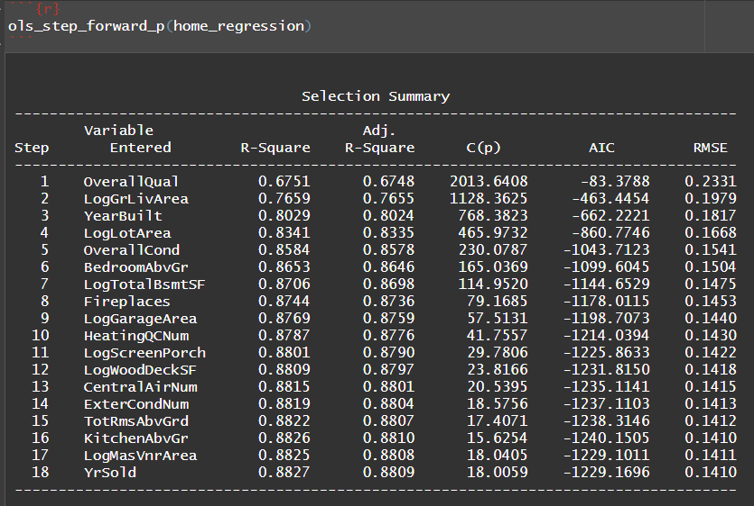

Backwards Selection
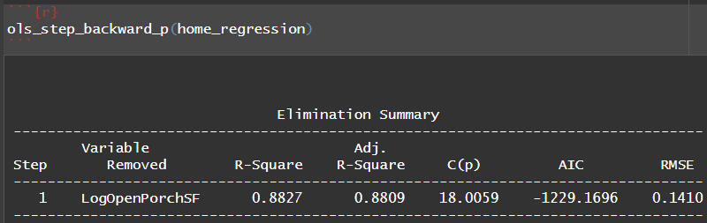

Stepwise Selection
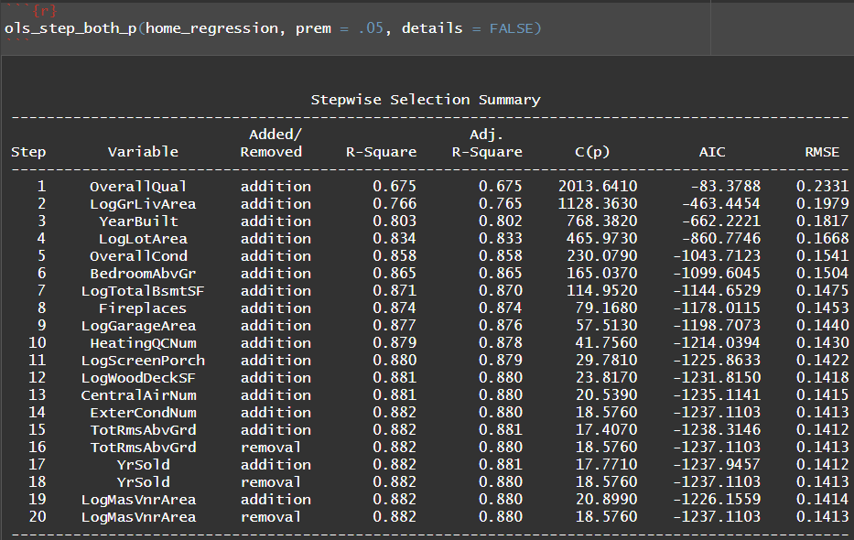

Custom Model
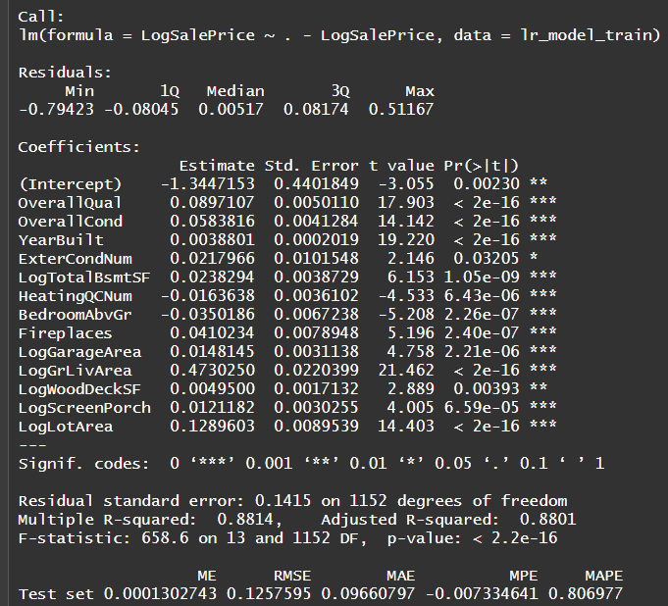

Conclusion
Conclusion for analysis 2 goes here

