A Testimonial for Margaret
Dear Margaret,

I just had to write and tell you how much my husband and I are loving the cactus painting we commissioned from you last month. It arrived beautifully packaged, and the colors are even more striking in person than they were in the preview photos. We hung it in our dining room and it has become the conversation piece of every dinner party.

My favorite detail is the way the light hits the blooms — it genuinely looks like late afternoon sun coming through a window. My friends have been asking who the artist is and I am happily sending them to artbyme.studio.

Thank you for creating something that brings us so much joy every day.

Warmly,
Jennifer Alvarez
Austin, TX
March 14, 2026
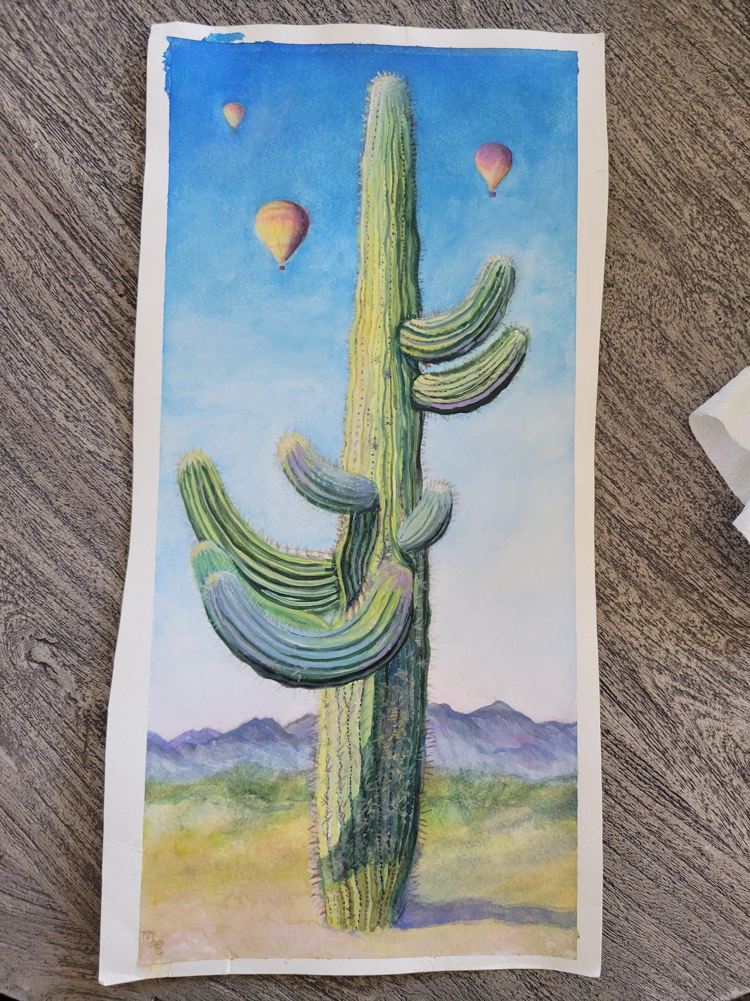
The "Hot Air II" commission in our dining room

