# Lab: Interfaces and Abstraction

Problems for exercises and homework for the <https://softuni.bg/courses/csharp-oop-advanced-high-quality-code>

You can check your solutions here: <https://judge.softuni.bg/Contests/Compete/Index/705#1>

## Shapes

Build hierarchy of interfaces and classes:

|  |
| --- |
| <<inteface>>  <<Drawable>> |
| **+Draw()** |

|  |
| --- |
| **Circle** |
| **-radius: Integer** |

|  |
| --- |
| Rectangle |
| **-width: Integer**  **-height: Integer** |

You should be able to use the class like this:

|  |
| --- |
| StartUp.cs |
| var radius = int.Parse(Console.ReadLine());  IDrawable circle = new Circle(radius);  var width = int.Parse(Console.ReadLine());  var height = int.Parse(Console.ReadLine());  IDrawable rect = new Rectangle(width, height);  circle.Draw();  rect.Draw(); |

### Examples

|  |  |
| --- | --- |
| **Input** | **Output** |
| 3  5  4 | *******  ** **  ** **  * *  ** **  ** **  *******  ****  * *  * *  * *  **** |

### Solution

For circle drawing you can use this algorithm:

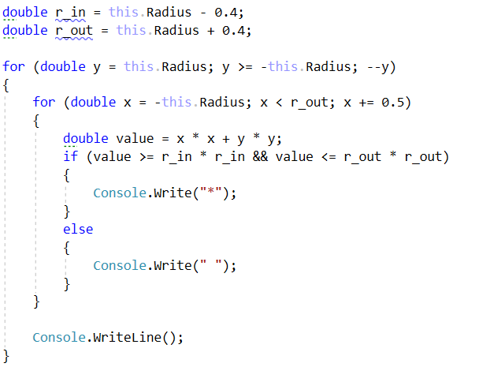

For rectangle drawing algorithm will be:

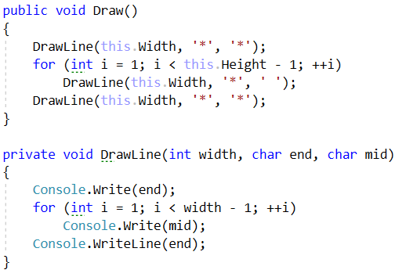

## Cars

Build hierarchy of interfaces and classes:

|  |
| --- |
| <<ICar>> |
| **+Model: string**  **+Color: string**  **+Start(): string**  **+Stop(): string** |

|  |
| --- |
| <<IElectricCar>> |
| **+Battery: int** |

|  |
| --- |
| Seat |
| **+ToString(): string** |

|  |
| --- |
| Tesla |
| **+ToString(): string** |

Your hierarchy have to be used with this code

|  |
| --- |
| Main.java |
| ICar seat = new Seat("Leon", "Grey");  ICar tesla = new Tesla("Model 3", "Red", 2);  Console.WriteLine(seat.ToString());  Console.WriteLine(tesla.ToString()); |

### Examples

|  |  |
| --- | --- |
| **Input** | **Output** |
|  | Grey Seat Leon  Engine start  Breaaak!  Red Tesla Model 3 with 2 Batteries Engine start  Breaaak! |