2024 Fall CIS515/451 – Lab 2

PyOpenGL and PyGame

Instructor: Dr. Jie Shen

Release date: Sept 18, 2024

Due date: Sept 29, 2024

Student Name:

You may find one or two partners to complete this lab. If you can’t find any partner, you may complete it alone. In the case of two or three team members, please submit only one copy with the names of all the team members.

Graduate students need to complete this lab independently.

OpenGL is one of the most popular graphics libraries. PyOpenGL is the Python binding of the OpenGL.

Python is one of the most popular languages and is widely applied in data science, artificial intelligence, and many other disciplines.

PyGame is a cross-platform set of Python modules designed for writing video games. It includes computer graphics and sound libraries designed to be used with the Python programming language.

# 

Use PyPI in Visual Studio to install the packages: PyOpenGL and PyGame.

You may also use pip install … on command line.

# **Question 1 Simple PyGame Window (10 points)**

Use PyOpenGL and PyGame to create a simple window output with the following features:

1. Window title: “Simple PyGame Window”
2. Window size: 680 x 480
3. Window color: Green

Show the output as a screenshot.

# **Question 2 Modification of Background Color (10 points)**

Modify the code in Question 1 such that the color of PyGame window is changed to:

1. Blue

Show the result as a different screenshot.

# **Question 3 Sierpinski Triangle (10 points)**

Use PyOpenGL and PyGame to draw the Sierpinski triangles with iterations = 1, 2, 3, 4.

Below is the result of iteration = 4:



# **Question 4 Koch Snowflake (10 points)**

Use PyOpenGL and PyGame to draw the Koch snowflakes based on a line segment with iterations = 1, 2, 3, 4.

Below is the result of iteration = 4:

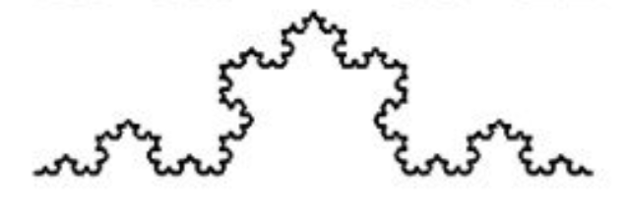

Submission of Lab 2

You should create screenshots for all the tasks in this lab.

You should submit your work through Canvas site as an MS word document or a pdf file for cis 515/451 lab. The filename of the word document should follow the convention: FirstName_LastName_Cis515-451-Lab2.doc.