在之前的基础上 绘制一个四边形
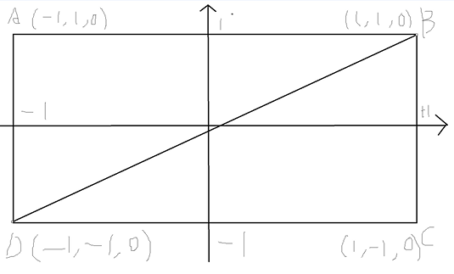
增加一组新的三角形顶点

#include <glad/glad.h>
#include <GLFW/glfw3.h>
#include "Shader.h"
#include <iostream>
using namespace std;
#define STRINGIZE(x) #x
#define SHADER(shader) "" STRINGIZE(shader)
int main()
{
glfwInit();
glfwWindowHint(GLFW_CONTEXT_VERSION_MAJOR, 3);
glfwWindowHint(GLFW_CONTEXT_VERSION_MINOR, 3);
glfwWindowHint(GLFW_OPENGL_PROFILE, GLFW_OPENGL_CORE_PROFILE);
GLFWwindow* window= glfwCreateWindow(800,600,"OpenGL",nullptr,nullptr);
//opengl 运行模式单线程 要调用opengl api是在单一线程内进行
//多个线程同时调用不被允许
//绑定这个window与当前main函数的线程
glfwMakeContextCurrent(window);
//初始化glad
gladLoadGLLoader((GLADloadproc)glfwGetProcAddress);
//顶点数据
float vertex[] =
{
-1.0f,1.0f,0.0f,
-1.0f,-1.0f,0.0f,
1.0f,1.0f,0.0f,
1.0f,1.0f,0.0f,
-1.0f,-1.0f,0.0f,
1.0f,-1.0f,0.0f
};
VAO *vao = new VAO();
vao->AddVertex3D(vertex, 6, 0);
//shader源码
const char * vertexShaderSource = SHADER(
#version 330\n
layout(location = 0) in vec3 pos; //输入
out vec3 outPos;
void main()
{
outPos = pos;
gl_Position = vec4(pos, 1.0); //输出
}
);
const char * fragmentShaderSource = SHADER(
#version 330\n
//输入来自顶点着色器 需要顶点着色器定义 out 变量
out vec4 color;
in vec3 outPos;
void main()
{
color = vec4(outPos, 1.0); //输出
}
);
Shader *vertexShader = new Shader(vertexShaderSource, ShaderType::VERTEX);
Shader *fragmentShader = new Shader(fragmentShaderSource, ShaderType::FRAGMENT);

Program * program = new Program(vertexShader->shaderId, fragmentShader->shaderId);
//绘制
while (!glfwWindowShouldClose(window)) //不关闭一直绘制
{
//
glClear(GL_COLOR_BUFFER_BIT);
program->UseProgram();
vao->BindVAO();
glDrawArrays(GL_TRIANGLES, 0, 6);
glfwSwapBuffers(window);
glfwPollEvents();
}
//释放
glfwTerminate();
delete vao;
delete vertexShader;
delete fragmentShader;
delete program;
return 0;
}

opengl 提供 ebo 优化重复顶点

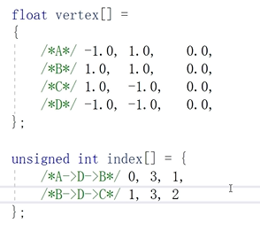
一个VAO 对应多个VBO 但是只共享一个EBO
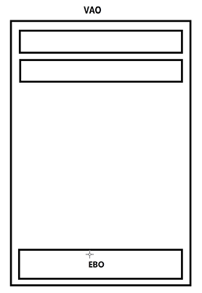

EBO函数调用

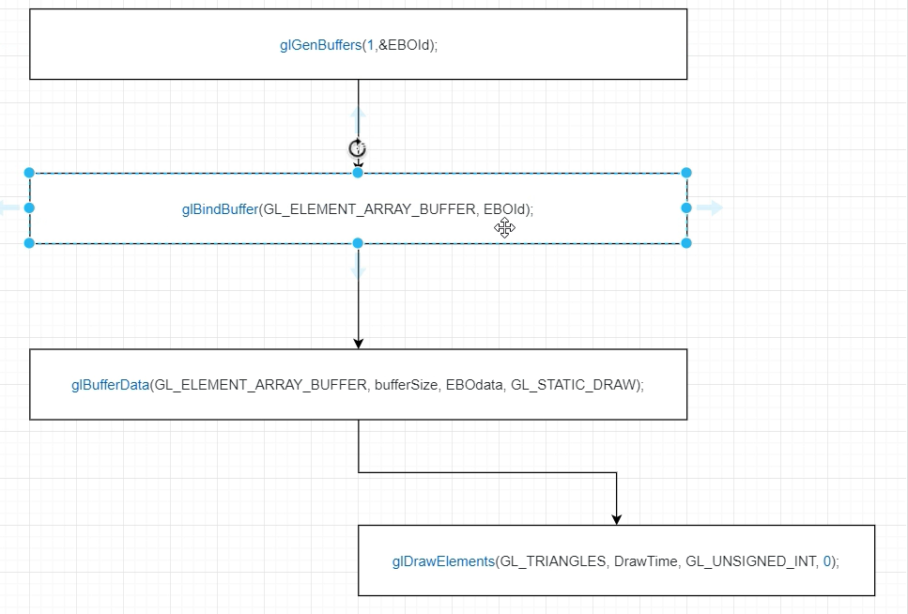

ebo 代码封装在 vao类中

class VAO
{
public:
VAO();
~VAO();
int AddVertex3D(float *data, int vertexCount, int layout);
int BindVAO();
int SetIndexData(unsigned int *indexData, int indexCount);
int Draw();
private:
GLuint vao=0;
GLuint ebo = 0;
int drawTime = 0;
std::vector<GLuint> vboList;
};

#include "Shader.h"
VAO::VAO()
{
glGenVertexArrays(1, &vao);
}
int VAO::AddVertex3D(float *data, int vertexCount, int layout)
{
glBindVertexArray(vao);
GLuint vbo = 0;
glGenBuffers(1, &vbo);
glBindBuffer(GL_ARRAY_BUFFER, vbo);
glBufferData(GL_ARRAY_BUFFER, vertexCount*3 * sizeof(float), data, GL_STATIC_DRAW);
//往layout传参数
glVertexAttribPointer(layout, 3, GL_FLOAT, GL_FALSE, 3 * sizeof(float), (GLvoid*)0);
glEnableVertexAttribArray(layout); //layout为0的单元打开
vboList.push_back(vbo);
glBindVertexArray(0);
return 0;
}
VAO::~VAO()
{
for (int i = 0;i < vboList.size();i++)
{
GLuint vbo = vboList[i];
glDeleteBuffers(1, &vbo);
}
vboList.clear();
if (ebo != NULL)
{
glDeleteVertexArrays(1, &ebo);
ebo = NULL;
}
if (vao != NULL)
{
glDeleteVertexArrays(1, &vao);
vao = NULL;
}
}
int VAO::BindVAO()
{
glBindVertexArray(vao);
return 0;
}
int VAO::SetIndexData(unsigned int *indexData, int indexCount)
{
glBindVertexArray(vao);
glGenBuffers(1, &ebo);
glBindBuffer(GL_ELEMENT_ARRAY_BUFFER, ebo);
glBufferData(GL_ELEMENT_ARRAY_BUFFER, indexCount*sizeof(unsigned int), indexData, GL_STATIC_DRAW);
drawTime = indexCount;
glBindVertexArray(0);
return 0;
}
int VAO::Draw()
{
BindVAO();
glDrawElements(GL_TRIANGLES, drawTime, GL_UNSIGNED_INT, 0);
return 0;
}

#include <glad/glad.h>
#include <GLFW/glfw3.h>
#include "Shader.h"
#include <iostream>
using namespace std;
#define STRINGIZE(x) #x
#define SHADER(shader) "" STRINGIZE(shader)
int main()
{
glfwInit();
glfwWindowHint(GLFW_CONTEXT_VERSION_MAJOR, 3);
glfwWindowHint(GLFW_CONTEXT_VERSION_MINOR, 3);
glfwWindowHint(GLFW_OPENGL_PROFILE, GLFW_OPENGL_CORE_PROFILE);
GLFWwindow* window= glfwCreateWindow(800,600,"OpenGL",nullptr,nullptr);
//opengl 运行模式单线程 要调用opengl api是在单一线程内进行
//多个线程同时调用不被允许
//绑定这个window与当前main函数的线程
glfwMakeContextCurrent(window);
//初始化glad
gladLoadGLLoader((GLADloadproc)glfwGetProcAddress);
//顶点数据
float vertex[] =
{
-1.0f,1.0f,0.0f,
1.0f,1.0f,0.0f,

1.0f,-1.0f,0.0f,
-1.0f,-1.0f,0.0f
};
unsigned int index[] = {
0,3,1,
1,3,2
};
VAO *vao = new VAO();
vao->AddVertex3D(vertex, 6, 0);
vao->SetIndexData(index, 6);
//shader源码
const char * vertexShaderSource = SHADER(
#version 330\n
layout(location = 0) in vec3 pos; //输入
out vec3 outPos;
void main()
{
outPos = pos;
gl_Position = vec4(pos, 1.0); //输出
}
);
const char * fragmentShaderSource = SHADER(
#version 330\n
//输入来自顶点着色器 需要顶点着色器定义 out 变量
out vec4 color;
in vec3 outPos;
void main()
{
color = vec4(outPos, 1.0); //输出
}
);
Shader *vertexShader = new Shader(vertexShaderSource, ShaderType::VERTEX);
Shader *fragmentShader = new Shader(fragmentShaderSource, ShaderType::FRAGMENT);

Program * program = new Program(vertexShader->shaderId, fragmentShader->shaderId);
//绘制
while (!glfwWindowShouldClose(window)) //不关闭一直绘制
{
//
glClear(GL_COLOR_BUFFER_BIT);
program->UseProgram();
vao->Draw();
glDrawArrays(GL_TRIANGLES, 0, 6);
glfwSwapBuffers(window);
glfwPollEvents();
}
//释放
glfwTerminate();
delete vao;
delete vertexShader;
delete fragmentShader;
delete program;
return 0;
}

