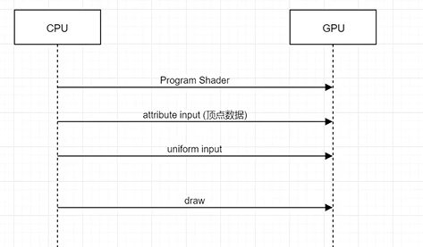

opengl是 cpu gpu之间的桥梁

shader是运行在GPU上的一段程序

shader输入两种 顶点数据 uniform 输出到帧缓冲

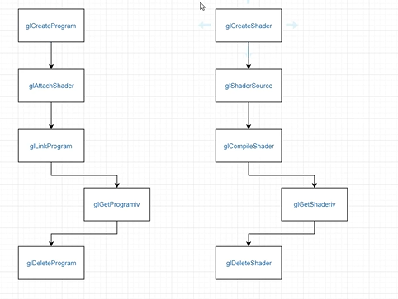

glGetShaderiv 获取错误使用

多个shader 垒在一起就是program 一般需要两个shader组成program

shader program封装

#pragma once
#include <glad/glad.h>
#include <GLFW/glfw3.h>
enum ShaderType
{
VERTEX = 1,
FRAGMENT = 2
};
class Shader
{
public:
Shader(char *shaderSource, ShaderType st);
~Shader();
GLint shaderId;

};
class Program
{
public:
Program(GLint vertexShader, GLint fragmentShader);
~Program();
private:
GLint programId = 0;
};

#include "Shader.h"
#include <iostream>
using namespace std;
Shader::Shader(char *shaderSource, ShaderType st)
{
//创建shader句柄
if (st == ShaderType::VERTEX)
{
shaderId = glCreateShader(GL_VERTEX_SHADER);
}
else if(st == ShaderType::FRAGMENT)
{
shaderId = glCreateShader(GL_FRAGMENT_SHADER);
}
else
{
shaderId = glCreateShader(GL_VERTEX_SHADER);
}
//绑定源码
glShaderSource(shaderId, 1, &shaderSource, NULL);
//编译源码
glCompileShader(shaderId);
//获取错误状态
GLint status;
glGetShaderiv(shaderId, GL_COMPILE_STATUS, &status);
//获取错误日志
GLint logLen = 0;
glGetShaderiv(shaderId, GL_INFO_LOG_LENGTH, &logLen);
if (logLen > 0)
{
char * log = new char[logLen];
glGetShaderInfoLog(shaderId, logLen, NULL, log);
cout << log << endl;
delete[] log;
}
}
Shader::~Shader()
{
if (shaderId != 0)
{
glDeleteShader(shaderId);
shaderId = 0;
}
}

#include "Shader.h"
#include <iostream>
using namespace std;
Program::Program(GLint vertexShader,GLint fragmentShader)
{
programId = glCreateProgram();
glAttachShader(programId, vertexShader);
glAttachShader(programId, fragmentShader);
glLinkProgram(programId);
//获取错误日志
GLint logLen = 0;
glGetProgramiv(programId, GL_INFO_LOG_LENGTH, &logLen);
if (logLen > 0)
{
char * log = new char[logLen];
glGetProgramInfoLog(programId, logLen, NULL, log);
cout << log << endl;
delete[] log;
}
}
Program::~Program()
{
if (programId != 0)
{
glDeleteProgram(programId);
programId = 0;
}
}

测试
#include <glad/glad.h>
#include <GLFW/glfw3.h>
#include "Shader.h"
#include <iostream>
using namespace std;
int main()
{
glfwInit();
glfwWindowHint(GLFW_CONTEXT_VERSION_MAJOR, 3);
glfwWindowHint(GLFW_CONTEXT_VERSION_MINOR, 3);
glfwWindowHint(GLFW_OPENGL_PROFILE, GLFW_OPENGL_CORE_PROFILE);
GLFWwindow* window= glfwCreateWindow(800,600,"OpenGL",nullptr,nullptr);
//opengl 运行模式单线程 要调用opengl api是在单一线程内进行
//多个线程同时调用不被允许
//绑定这个window与当前main函数的线程
glfwMakeContextCurrent(window);
//初始化glad
gladLoadGLLoader((GLADloadproc)glfwGetProcAddress);
//shader源码
char * vertexShaderSource = (char *)"int main(){}";
Shader *vertexShader = new Shader(vertexShaderSource, ShaderType::VERTEX);
Shader *fragmentShader = new Shader(vertexShaderSource, ShaderType::FRAGMENT);

Program * program = new Program(vertexShader->shaderId, fragmentShader->shaderId);
//绘制
while (!glfwWindowShouldClose(window)) //不关闭一直绘制
{
glfwSwapBuffers(window);
glfwPollEvents();
}
//释放
glfwTerminate();
delete vertexShader;
delete fragmentShader;
delete program;
return 0;
}

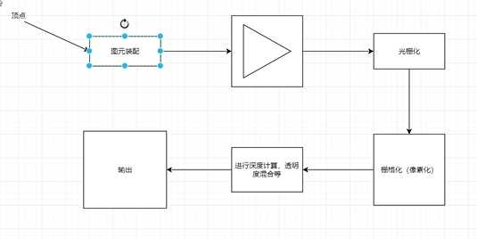

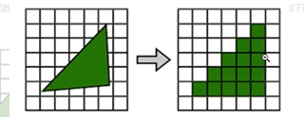

开始写shader

#include <glad/glad.h>
#include <GLFW/glfw3.h>
#include "Shader.h"
#include <iostream>
using namespace std;
#define STRINGIZE(x) #x
#define SHADER(shader) "" STRINGIZE(shader)
int main()
{
glfwInit();
glfwWindowHint(GLFW_CONTEXT_VERSION_MAJOR, 3);
glfwWindowHint(GLFW_CONTEXT_VERSION_MINOR, 3);
glfwWindowHint(GLFW_OPENGL_PROFILE, GLFW_OPENGL_CORE_PROFILE);
GLFWwindow* window= glfwCreateWindow(800,600,"OpenGL",nullptr,nullptr);
//opengl 运行模式单线程 要调用opengl api是在单一线程内进行
//多个线程同时调用不被允许
//绑定这个window与当前main函数的线程
glfwMakeContextCurrent(window);
//初始化glad
gladLoadGLLoader((GLADloadproc)glfwGetProcAddress);
//shader源码
const char * vertexShaderSource = SHADER(
#version 330\n
layout(location = 0) in vec3 pos; //输入
void main()
{
gl_Position = vec4(pos, 1.0); //输出
}
);
const char * fragmentShaderSource = SHADER(
#version 330\n
//输入来自顶点着色器 需要顶点着色器定义 out 变量
out vec4 color;
void main()
{
color = vec4(1.0, 0.0, 0.0, 1.0); //输出
}
);
Shader *vertexShader = new Shader(vertexShaderSource, ShaderType::VERTEX);
Shader *fragmentShader = new Shader(fragmentShaderSource, ShaderType::FRAGMENT);

Program * program = new Program(vertexShader->shaderId, fragmentShader->shaderId);
//绘制
while (!glfwWindowShouldClose(window)) //不关闭一直绘制
{
glfwSwapBuffers(window);
glfwPollEvents();
}
//释放
glfwTerminate();
delete vertexShader;
delete fragmentShader;
delete program;
return 0;
}

增加shader之后的代码 因为没有顶点输入 所以不会有效果。

