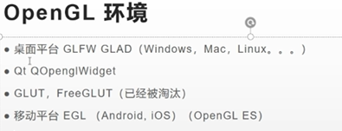

编译glfw源码 下载源码 源码目录新建bulid文件夹

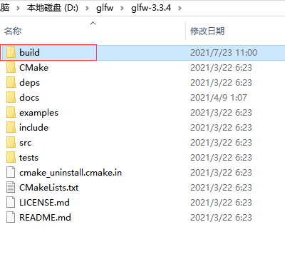
 修改这里为cmd 进入控制台

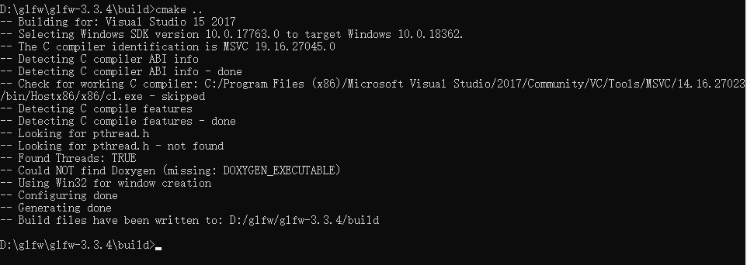

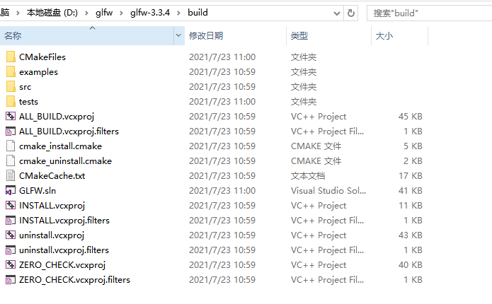
打开glad网页 在线生成相关代码

工程引用上面头文件 以及链接库 增加测试代码
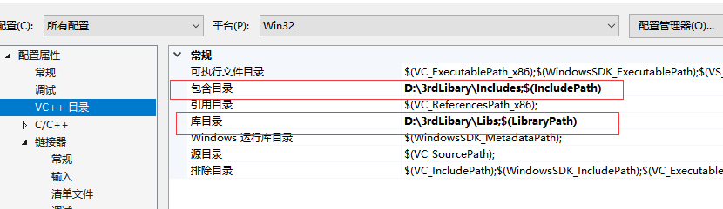

库文件目录

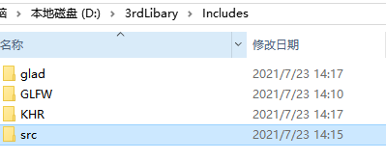



#include <glad/glad.h>
#include <GLFW/glfw3.h>
#include <iostream>
void framebuffer_size_callback(GLFWwindow* window, int width, int height);
void processInput(GLFWwindow *window);
// settings
const unsigned int SCR_WIDTH = 800;
const unsigned int SCR_HEIGHT = 600;
int main()
{
// glfw: initialize and configure
// ------------------------------
glfwInit();
glfwWindowHint(GLFW_CONTEXT_VERSION_MAJOR, 3);
glfwWindowHint(GLFW_CONTEXT_VERSION_MINOR, 3);
glfwWindowHint(GLFW_OPENGL_PROFILE, GLFW_OPENGL_CORE_PROFILE);
#ifdef __APPLE__
glfwWindowHint(GLFW_OPENGL_FORWARD_COMPAT, GL_TRUE); // uncomment this statement to fix compilation on OS X
#endif
// glfw window creation
// --------------------
GLFWwindow* window = glfwCreateWindow(SCR_WIDTH, SCR_HEIGHT, "LearnOpenGL", NULL, NULL);
if (window == NULL)
{
std::cout << "Failed to create GLFW window" << std::endl;
glfwTerminate();
return -1;
}
glfwMakeContextCurrent(window);
glfwSetFramebufferSizeCallback(window, framebuffer_size_callback);
// glad: load all OpenGL function pointers
// ---------------------------------------
if (!gladLoadGLLoader((GLADloadproc)glfwGetProcAddress))
{
std::cout << "Failed to initialize GLAD" << std::endl;
return -1;
}
// render loop
// -----------
while (!glfwWindowShouldClose(window))
{
// input
// -----
processInput(window);
// render
// ------
glClearColor(0.2f, 0.3f, 0.3f, 1.0f);
glClear(GL_COLOR_BUFFER_BIT);
// glfw: swap buffers and poll IO events (keys pressed/released, mouse moved etc.)
// -------------------------------------------------------------------------------
glfwSwapBuffers(window);
glfwPollEvents();
}
// glfw: terminate, clearing all previously allocated GLFW resources.
// ------------------------------------------------------------------
glfwTerminate();
return 0;
}
// process all input: query GLFW whether relevant keys are pressed/released this frame and react accordingly
// ---------------------------------------------------------------------------------------------------------
void processInput(GLFWwindow *window)
{
if (glfwGetKey(window, GLFW_KEY_ESCAPE) == GLFW_PRESS)
glfwSetWindowShouldClose(window, true);
}
// glfw: whenever the window size changed (by OS or user resize) this callback function executes
// ---------------------------------------------------------------------------------------------
void framebuffer_size_callback(GLFWwindow* window, int width, int height)
{
// make sure the viewport matches the new window dimensions; note that width and
// height will be significantly larger than specified on retina displays.
glViewport(0, 0, width, height);
}

