Texture函数调用

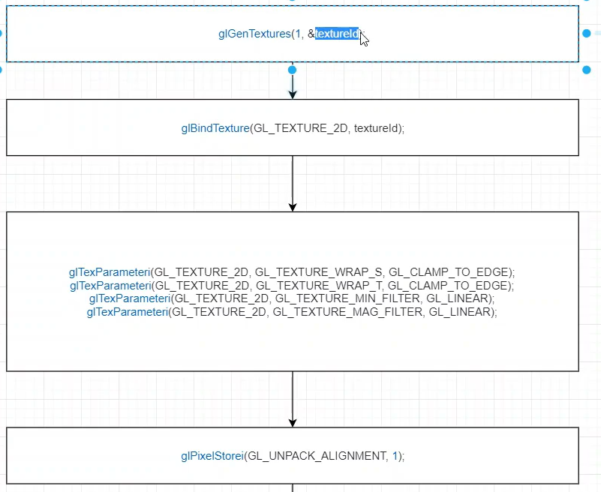


代码实现

int imgWidth = 2;
int imgHeight = 2;
unsigned char imgData[]=
{
255,0,0, 0,255,0,
0,0,255, 127,127,127
};
GLuint texId = 0;
glGenTextures(1, &texId);
glBindTexture(GL_TEXTURE_2D, texId);
glTexParameteri(GL_TEXTURE_2D, GL_TEXTURE_WRAP_S, GL_CLAMP_TO_EDGE);
glTexParameteri(GL_TEXTURE_2D, GL_TEXTURE_WRAP_T, GL_CLAMP_TO_EDGE);
glTexParameteri(GL_TEXTURE_2D, GL_TEXTURE_MIN_FILTER, GL_LINEAR);
glTexParameteri(GL_TEXTURE_2D, GL_TEXTURE_MAG_FILTER, GL_LINEAR);
glPixelStorei(GL_UNPACK_ALIGNMENT, 1);//1字节对齐
glTexImage2D(GL_TEXTURE_2D, 0, GL_RGB, imgWidth, imgHeight, 0, GL_RGB, GL_UNSIGNED_BYTE, imgData);

传入shader

//tex传给shader 使用glUniform1i
//纹理单元 0-31 编号
//传入纹理单元号0
GLuint texLoc = glGetUniformLocation(program->programId, "tex");
//激活0号位单元
glActiveTexture(GL_TEXTURE0)
glBindTexture(GL_TEXTURE_2D, texId);
glUniform1i(texLoc, 0);

纹理坐标

增加顶点着色器 layout
从应用程序 增加uv坐标
const char * vertexShaderSource = SHADER(
#version 330\n
layout(location = 0) in vec3 pos; //输入
layout(location = 1) in vec3 uvPos; //输入
out vec3 outPos;
out vec3 outUVPos;
uniform float a;
void main()
{
outPos = pos;
outUVPos = uvPos;
float _a = sin(a);
gl_Position = vec4(pos*_a, 1.0); //输出
}
);

float vertexUV[]=
{
0.0f,1.0f,0.0f,
1.0f,1.0f,0.0f,
1.0f,0.0f,0.0f,
0.0f,0.0f,0.0f
};
VAO *vao = new VAO();
vao->AddVertex3D(vertex, 6, 0);
vao->AddVertex3D(vertexUV, 4, 1);
vao->SetIndexData(index, 6);

const char * fragmentShaderSource = SHADER(
#version 330\n
//输入来自顶点着色器 需要顶点着色器定义 out 变量
out vec4 outColor;
in vec3 outPos;
in vec3 outUVPos;
uniform sampler2D tex;
void main()
{
vec2 uv = vec2(outUVPos.x, outUVPos.y);
vec4 color = texture(tex, uv);
outColor = color; //输出
}
);

测试代码

#include <glad/glad.h>
#include <GLFW/glfw3.h>
#include "Shader.h"
#include <iostream>
using namespace std;
#define STRINGIZE(x) #x
#define SHADER(shader) "" STRINGIZE(shader)
int main()
{
glfwInit();
glfwWindowHint(GLFW_CONTEXT_VERSION_MAJOR, 3);
glfwWindowHint(GLFW_CONTEXT_VERSION_MINOR, 3);
glfwWindowHint(GLFW_OPENGL_PROFILE, GLFW_OPENGL_CORE_PROFILE);
GLFWwindow* window= glfwCreateWindow(800,600,"OpenGL",nullptr,nullptr);
//opengl 运行模式单线程 要调用opengl api是在单一线程内进行
//多个线程同时调用不被允许
//绑定这个window与当前main函数的线程
glfwMakeContextCurrent(window);
//初始化glad
gladLoadGLLoader((GLADloadproc)glfwGetProcAddress);
//顶点数据
float vertex[] =
{
-1.0f,1.0f,0.0f,
1.0f,1.0f,0.0f,

1.0f,-1.0f,0.0f,
-1.0f,-1.0f,0.0f
};
unsigned int index[] = {
0,3,1,
1,3,2
};
float vertexUV[]=
{
0.0f,1.0f,0.0f,
1.0f,1.0f,0.0f,
1.0f,0.0f,0.0f,
0.0f,0.0f,0.0f
};
VAO *vao = new VAO();
vao->AddVertex3D(vertex, 6, 0);
vao->AddVertex3D(vertexUV, 4, 1);
vao->SetIndexData(index, 6);

float aa = 1;
//shader源码
const char * vertexShaderSource = SHADER(
#version 330\n
layout(location = 0) in vec3 pos; //输入
layout(location = 1) in vec3 uvPos; //输入
out vec3 outPos;
out vec3 outUVPos;
uniform float a;
void main()
{
outPos = pos;
outUVPos = uvPos;
float _a = sin(a);
gl_Position = vec4(pos*_a, 1.0); //输出
}
);
const char * fragmentShaderSource = SHADER(
#version 330\n
//输入来自顶点着色器 需要顶点着色器定义 out 变量
out vec4 outColor;
in vec3 outPos;
in vec3 outUVPos;
uniform sampler2D tex;
void main()
{
vec2 uv = vec2(outUVPos.x, outUVPos.y);
vec4 color = texture(tex, uv);
outColor = color; //输出
}
);
Shader *vertexShader = new Shader(vertexShaderSource, ShaderType::VERTEX);
Shader *fragmentShader = new Shader(fragmentShaderSource, ShaderType::FRAGMENT);

Program * program = new Program(vertexShader->shaderId, fragmentShader->shaderId);
int imgWidth = 2;
int imgHeight = 2;
unsigned char imgData[]=
{
255,0,0, 0,255,0,
0,0,255, 127,127,127
};
GLuint texId = 0;
glGenTextures(1, &texId);
glBindTexture(GL_TEXTURE_2D, texId);
glTexParameteri(GL_TEXTURE_2D, GL_TEXTURE_WRAP_S, GL_CLAMP_TO_EDGE);
glTexParameteri(GL_TEXTURE_2D, GL_TEXTURE_WRAP_T, GL_CLAMP_TO_EDGE);
glTexParameteri(GL_TEXTURE_2D, GL_TEXTURE_MIN_FILTER, GL_LINEAR);
glTexParameteri(GL_TEXTURE_2D, GL_TEXTURE_MAG_FILTER, GL_LINEAR);
glPixelStorei(GL_UNPACK_ALIGNMENT, 1);//1字节对齐
glTexImage2D(GL_TEXTURE_2D, 0, GL_RGB, imgWidth, imgHeight, 0, GL_RGB, GL_UNSIGNED_BYTE, imgData);
//绘制
while (!glfwWindowShouldClose(window)) //不关闭一直绘制
{
//
glClear(GL_COLOR_BUFFER_BIT);
program->UseProgram();
GLuint loc = glGetUniformLocation(program->programId, "a");
glUniform1f(loc, aa);
//tex传给shader 使用glUniform1i
//纹理单元 0-31 编号
//传入纹理单元号0
GLuint texLoc = glGetUniformLocation(program->programId, "tex");
//激活0号位单元
glActiveTexture(GL_TEXTURE0);
glBindTexture(GL_TEXTURE_2D, texId);
glUniform1i(texLoc, 0);
vao->Draw();
aa += 0.003;
glDrawArrays(GL_TRIANGLES, 0, 6);
glfwSwapBuffers(window);
glfwPollEvents();
}
//释放
glfwTerminate();
delete vao;
delete vertexShader;
delete fragmentShader;
delete program;
return 0;
}

