算法技术文档
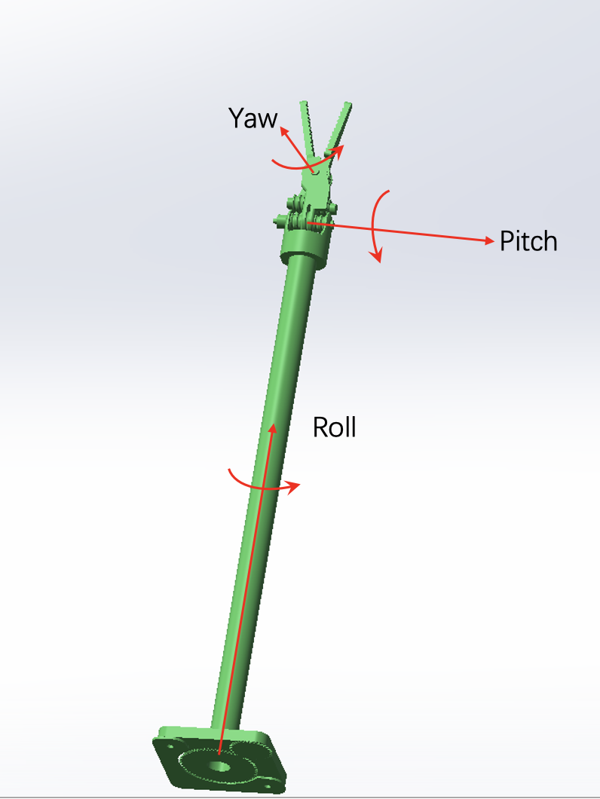
该项目为实现类似于达芬奇的手术机械臂夹爪的效果，夹爪硬件采用3个自由度的机械臂加一个夹爪开合的自由度设计，系统输入为手柄给定3个旋转关节的角度和一个夹爪开合的角度。系统机械臂的实际自由度只有3个，故不能实现绕任意给定的方向旋转，给定方向意味着3个自由度，而且稳定位置也是3个自由度，系统超定。达芬奇的实现是采用大臂带动小臂协同运动，实现6自由度的增稳控制。该项目的硬件约束故不考虑该情况的实现。现在介绍整体的解藕设计，首先定义坐标系如下：
采用欧拉角描述对应姿态，则输入姿态与输出姿态线型映射即可。具体实现代码见后文，环境采用Arduino，依赖库环境FTServo (舵机驱动库), FastLED (总线式LED驱动，可选)。舵机采用位置模式，最大力矩和最大加速度见每个舵机的配置，使用飞特的上位机即可查看。

1. 完整的坐标系建立与 D-H 参数 (Denavit-Hartenberg)
根据机械臂结构图，采用标准 D-H 方法建立坐标系:
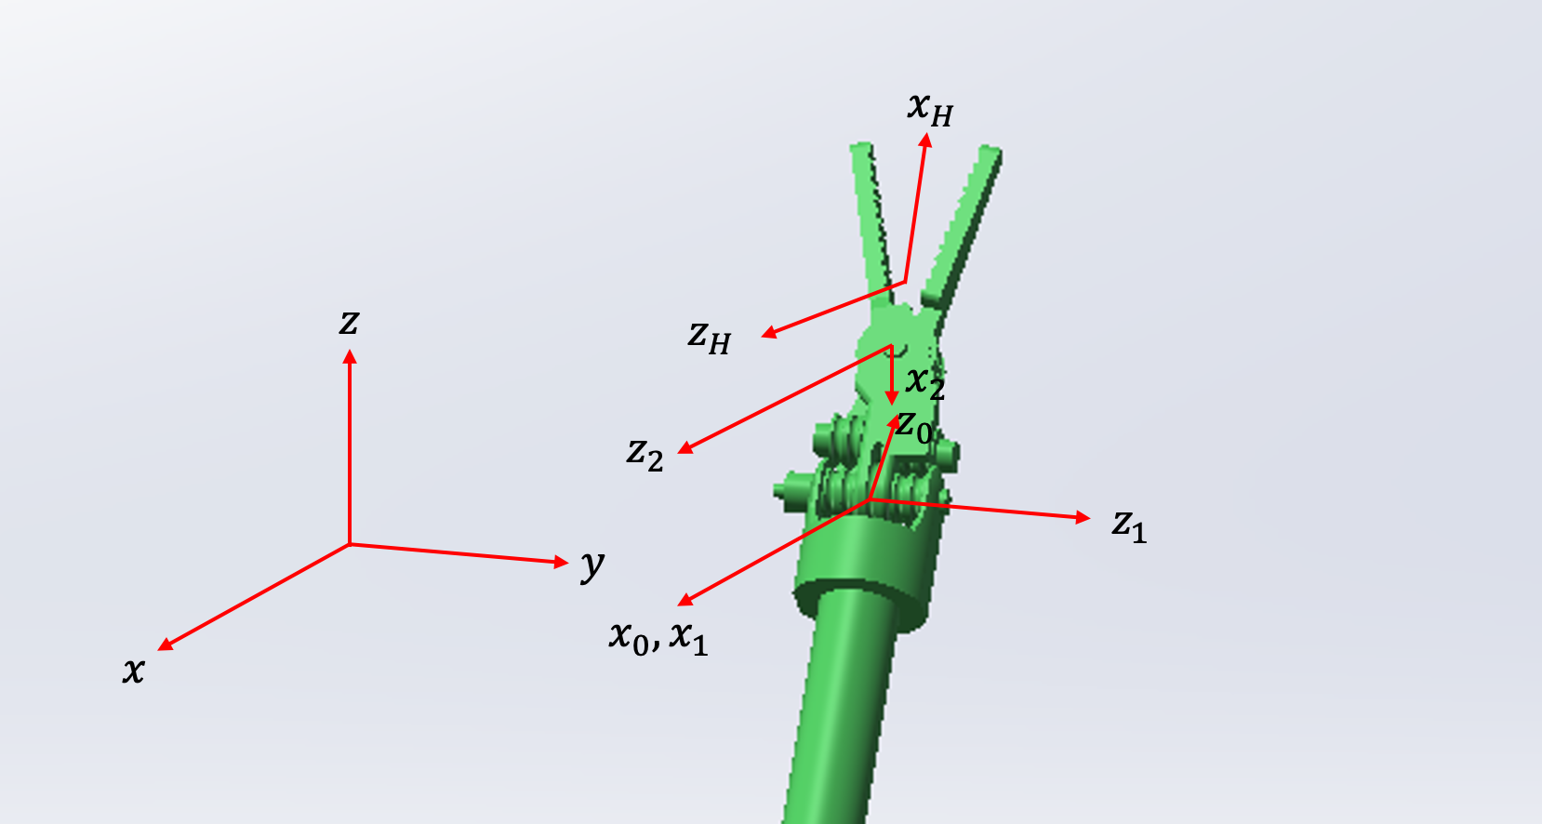
该机械臂由三个旋转关节组成，其核心设计参数如下表：
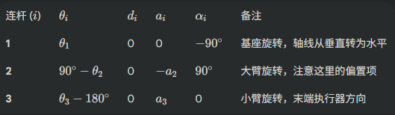
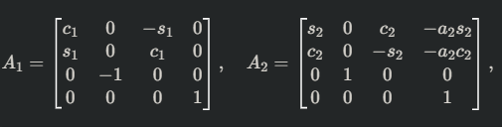
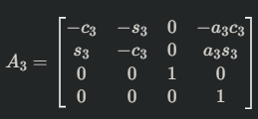
(1) 末端位置表达式 (Position)与旋转矩阵
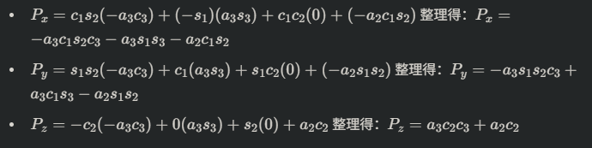
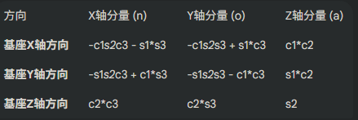
(2) 完整代码
// ESP32 Dev Module
#include <SCServo.h>
#include <HardwareSerial.h>
#include <FastLED.h>

HardwareSerial SerialServo(1); // UART1
SMS_STS sms_sts;

#define LED_PIN 23 // WS2812 pin
#define S_RXD 18
#define S_TXD 19
#define NUM_LEDS 12 // num of LED
// #define DEBUGINFO

CRGB leds[NUM_LEDS];

const int NUM_SERVO = 8;
int ID[NUM_SERVO] = {1, 2, 3, 4, 5, 6, 7, 8};
int Pos[NUM_SERVO];
int Speed[NUM_SERVO];
int Load[NUM_SERVO];
int Voltage[NUM_SERVO];
int Temper[NUM_SERVO];
int Move[NUM_SERVO];
int Current[NUM_SERVO];

byte ControlID[4] = {1,2,3,4};

bool lock_flag = false;
bool unload_flag = false;
const float gripper_open = 5.0;
#define LOCK

uint8_t cmd_buf[8];
int buildSMSWriteCmd(uint8_t id, uint8_t cmd, uint8_t* out_buf) {
// Serial Protocol: 0 -> unload; 1 -> enable; 128 -> 2048 calibration when in position mode
out_buf[0] = 0xFF; // head
out_buf[1] = 0xFF; // head
out_buf[2] = id; // Servo ID
out_buf[3] = 0x04; // Length
out_buf[4] = 0x03; // Instructuion
out_buf[5] = 0x28; // Reginster
out_buf[6] = cmd; // Cmd
uint8_t check = ~(id + 0x04 + 0x03 + 0x28 + cmd) & 0xFF;
out_buf[7] = check;
return 8;
}

void setAllLED(CRGB color) {
for (int i = 0; i < NUM_LEDS; ++i) leds[i] = color;
FastLED.show();
}

void setup()
{
SerialServo.begin(500000, SERIAL_8N1, S_RXD, S_TXD);
sms_sts.pSerial = &SerialServo;
Serial.begin(115200);

delay(1000);

FastLED.addLeds<WS2812, LED_PIN, GRB>(leds, NUM_LEDS);
FastLED.clear();
FastLED.show();

sms_sts.WritePosEx(ID[5-1], 2048, 0, 0);
sms_sts.WritePosEx(ID[6-1], 2048, 0, 0);
delay(2000);
}

void loop()
{
// Step 1: feedback of 8 servos
for (int i = 0; i < NUM_SERVO; ++i) {
sms_sts.FeedBack(ID[i]);
if(!sms_sts.getLastError()){
Pos[i] = sms_sts.ReadPos(-1);
Speed[i] = sms_sts.ReadSpeed(-1);
Load[i] = sms_sts.ReadLoad(-1);
Voltage[i] = sms_sts.ReadVoltage(-1);
Temper[i] = sms_sts.ReadTemper(-1);
Move[i] = sms_sts.ReadMove(-1);
Current[i] = sms_sts.ReadCurrent(-1);
if(i == 6)
{
Serial.print("ID:"); Serial.print(ID[i]);
Serial.print(" Pos:"); Serial.println(Pos[i]);
}
#ifdef DEBUGINFO
Serial.print("ID:"); Serial.print(ID[i]);
Serial.print(" Pos:"); Serial.print(Pos[i]);
Serial.print(" Speed:"); Serial.print(Speed[i]);
Serial.print(" Load:"); Serial.print(Load[i]);
Serial.print(" V:"); Serial.print(Voltage[i]);
Serial.print(" T:"); Serial.print(Temper[i]);
Serial.print(" Move:"); Serial.print(Move[i]);
Serial.print(" Current:"); Serial.println(Current[i]);
#endif
} else {
Serial.print("FeedBack error for ID: "); Serial.println(ID[i]);
Pos[i] = -1;
setAllLED(CRGB(255, 0, 0));
exit(-1);
}
}

// Step 2: hand cmd
int p5, p6, p7, p8, mid;
p5 = Pos[4];
p6 = Pos[5];
p7 = Pos[6];
p8 = Pos[7];
mid = 2048;
float roll_cmd, pitch_cmd, yaw_cmd, gripper_cmd; // map from hand
float roll_in, pitch_in, yaw_in; // trans hand cmd to servo inputs

roll_cmd = -(p8 - mid) / 4096.0 * 360.0;
pitch_cmd = (p6 - mid) / 4096.0 * 360.0 * 1.5;
yaw_cmd = -(p5 - mid) / 4096.0 * 360.0 * 6.0 ;

gripper_cmd = -(p7 - mid) / 4096.0 * 360.0 * 1.5;

// Step 3: RPY of the center of gripper
roll_in = 65 / 35.0 * roll_cmd;
pitch_in = 4.5 / 5.5 * pitch_cmd;
yaw_in = 5.15 / 5.5 * yaw_cmd + 3.25 / 5.5 * pitch_cmd;

// Step 4: calculate servo cmd
int s1_pitch, s2_roll, s3_yaw_right, s4_yaw_left;
const int s1_phase = -1, s2_phase = 1, s3_phase = -1, s4_phase = 1;
const float gripper_range = 30.0;
s1_pitch = int(s1_phase * pitch_in / 360.0 * 4096.0 + 2048.0);
s2_roll = int(s2_phase * roll_in / 360.0 * 4096.0 + 2048.0);
s3_yaw_right = int(s3_phase * (yaw_in - gripper_cmd + gripper_range) / 360.0 * 4096.0 + 2048.0);
s4_yaw_left = int(s4_phase * (yaw_in + gripper_cmd*1.2 - gripper_range) / 360.0 * 4096.0 + 2048.0);

// Step 5: Run servo
#ifdef LOCK
if(gripper_cmd > gripper_open)
{
if(!unload_flag)
{
buildSMSWriteCmd(ID[5-1], 0, cmd_buf);
SerialServo.write(cmd_buf, 8);
delay(1);
buildSMSWriteCmd(ID[6-1], 0, cmd_buf);
SerialServo.write(cmd_buf, 8);
delay(1);
unload_flag = true;
}
sms_sts.WritePosEx(ID[1-1], s1_pitch, 0, 0);
sms_sts.WritePosEx(ID[2-1], s2_roll, 0, 0);
sms_sts.WritePosEx(ID[3-1], s3_yaw_right, 0, 0);
sms_sts.WritePosEx(ID[4-1], s4_yaw_left, 0, 0);
lock_flag = false;
}
else
{
if(!lock_flag)
{
buildSMSWriteCmd(ID[5-1], 1, cmd_buf);
SerialServo.write(cmd_buf, 8);
delay(1);
buildSMSWriteCmd(ID[6-1], 1, cmd_buf);
SerialServo.write(cmd_buf, 8);
delay(1);
for(int i = 0; i < 6; i++)
sms_sts.WritePosEx(ID[i], Pos[i], 0, 0);
lock_flag = true;
}
unload_flag = false;

}

#else
sms_sts.WritePosEx(ID[1-1], s1_pitch, 0, 0);
sms_sts.WritePosEx(ID[2-1], s2_roll, 0, 0);
sms_sts.WritePosEx(ID[3-1], s3_yaw_right, 0, 0);
sms_sts.WritePosEx(ID[4-1], s4_yaw_left, 0, 0);
#endif

// rate control
delay(3);
}

// update library link
// https://raw.githubusercontent.com/espressif/arduino-esp32/gh-pages/package_esp32_index.json

