# 高校招生系统说明书

## 需求分析：系统开发背景分析

### 背景

高等院校的招生录取工作，是一个复杂工作。涉及到大量考生和院校的数据，人工进行录取工作量大、主观性强、容易滋生腐败行为。通过开发“招生录取系统”，实现录取过程的自动化等工作。大大节约录取时间、使录取更加公正、客观。

### 功能特性

（蓝色标出已实现特性）

FE1.高校招生计划录入

FE2.学生志愿录入

FE3.各学生信息一览

FE4.自动投档

FE5.高校招生列表查询

FE6.学生录取结果查询

FE7.各高校招生情况一览

FE8.一键清空招生信息

### 可选功能

AFE1.高校招生结果报表打印

AFE2.学生录取结果报表打印

AFE3.学生成绩修改跟踪

AFE4.学生录取结果修改跟踪

AFE5.高校调剂意向录入

AFE6.学生调剂意向录入

AFE7.自动调剂

AFE8.一键清空调剂结果

## 系统分析与设计：重点为数据库表结构设计，各表的描述等。

### 实体关系

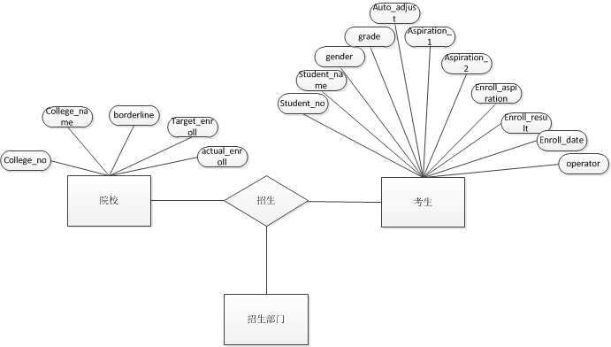

### 表结构设计

高校(高校代码,高校名称,录取分数线,预计录取数)

学生(准考证号,学生姓名,性别,高考成绩)

志愿(学生准考证号,志愿优先级,院校代码)

调剂意愿(学生准考证号,是否调剂)

-- 0未录取,-1调剂录取,1第一志愿录取,2第二志愿录取

录取结果(学生准考证号,录取结果)

-- -1退档,非-1院校代码

调剂结果(学生准考证号,调剂结果)

## 系统实现：主要包含数据库用户的创建、创建表的脚本、存储过程及触发器实现脚本等。

### 创建用户并授权

|  |
| --- |
| CREATE USER yjy_homework IDENTIFIED BY 111111 default tablespace MY_TABLESPACE; |
| GRANT CONNECT,RESOURCE TO yjy_homework;  GRANT CREATE TABLE,CREATE ANY INDEX,CREATE VIEW,CREATE SEQUENCE,CREATE SYNONYM TO yjy_homework; |
| GRANT UNLIMITED TABLESPACE TO yjy_homework; |

### 表、序列、索引

#### 表

|  |  |
| --- | --- |
| 高校表 | CREATE TABLE college (  college_number NUMBER(4) PRIMARY KEY,  college_name VARCHAR2(30) NOT NULL,  borderline NUMBER(3) CHECK (borderline BETWEEN 300 AND 700),  targetEnroll NUMBER(3) CHECK (targetEnroll <= 100),  actualEnroll NUMBER(3) DEFAULT 0  ) |
| 学生表 | CREATE TABLE STUDENT (  student_number NUMBER(5) PRIMARY KEY,  student_name VARCHAR2(15) NOT NULL,  gender NCHAR(1) CHECK (gender IN ('男', '女')),  grade NUMBER(3) CHECK (grade BETWEEN 0 AND 700)  ) |
| 学生志愿表 | CREATE TABLE student_will(  student_number NUMBER(5) REFERENCES STUDENT,  priority NUMBER(2),  aspiration NUMBER(4) REFERENCES COLLEGE,  PRIMARY KEY (student_number,priority) |
| 调剂意愿表 | CREATE TABLE auto_adjust_will (  student_number NUMBER(5) REFERENCES STUDENT,  auto_adjust NUMBER(1) DEFAULT 0  ) |
| 录取结果表 | CREATE TABLE student_enroll_result(  student_number NUMBER(5) PRIMARY KEY REFERENCES STUDENT,  enroll_result NUMBER(1) -- 0未录取,-1调剂录取,1第一志愿录取,2第二志愿录取  "ENROLL_OPERATOR" NVARCHAR2(15) DEFAULT NULL  ) |
| 调剂录取结果表 | CREATE TABLE auto_adjust_result(  student_number NUMBER(5) PRIMARY KEY REFERENCES STUDENT,  college_number NUMBER(5) REFERENCES COLLEGE  ) |

#### 序列

|  |  |
| --- | --- |
| 学生表id生成序列 | CREATE SEQUENCE student_sequence START WITH 1 |
| 高校表id生成序列 | CREATE SEQUENCE college_sequence START WITH 1 |

#### 索引

暂不需要。

### 视图

|  |  |
| --- | --- |
| 考生录取结果(考生编号，姓名，院校代码，院校名称)  （包括志愿录取、调剂录取和退档的所有考生） | CREATE OR REPLACE VIEW ENROLL_RESULT AS  SELECT  sno,  sname,  cno,  COLLEGE_NAME  FROM (  SELECT  STUDENT_NUMBER sno,  STUDENT_NAME sname,  FIND_ENROLL_COLLEGE(STUDENT_NUMBER) cno  FROM STUDENT  ) my_table, COLLEGE  WHERE my_table.cno = COLLEGE_NUMBER; |
| 录取情况(院校编号，院校名称，招生人数，缺额) | CREATE OR REPLACE VIEW COLLEGE_ENROLL_RESULT AS  (  SELECT  COLLEGE_NUMBER,  COLLEGE_NAME,  ACTUALENROLL,  TARGETENROLL - ACTUALENROLL Vacancies  FROM (SELECT  COLLEGE_NUMBER,  COLLEGE_NAME,  TARGETENROLL,  COUNT_ACTUAL_ENROLL(COLLEGE_NUMBER) ACTUALENROLL  FROM COLLEGE)  ) |
| 志愿视图(学生编号,志愿1,志愿1学校名称,志愿2,志愿2学校名称,是否调剂) | CREATE OR REPLACE VIEW ALL_WILL AS  SELECT  STUDENT_NUMBER,  ASPIRATION1,  FIND_COLLEGE_NAME(ASPIRATION1) CNAME1,  ASPIRATION2,  FIND_COLLEGE_NAME(ASPIRATION2) CNAME2,  AUTO_ADJUST  FROM (  SELECT  STUDENT_NUMBER,  GET_ASPIRATION(STUDENT_NUMBER, 1) ASPIRATION1,  GET_ASPIRATION(STUDENT_NUMBER, 2) ASPIRATION2,  AUTO_ADJUST  FROM AUTO_ADJUST_WILL  ) |

表、视图间关系如图：

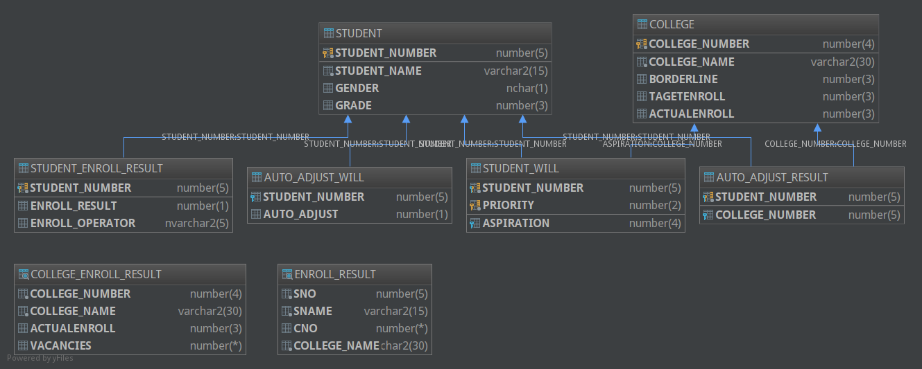

### 初始化数据

数据已导出为.sql文件，放置在src/main/doc/testdata目录下。

### 函数、存储过程、触发器、pl/sql

#### 函数

|  |  |
| --- | --- |
| 根据学生编号找出考入的高校编号，退档则为null | create FUNCTION find_Enroll_College(sno NUMBER) RETURN NUMBER  IS  college_number NUMBER(5);  v_enroll_result NUMBER(1);  BEGIN  SELECT ENROLL_RESULT INTO v_enroll_result FROM STUDENT_ENROLL_RESULT WHERE STUDENT_NUMBER=sno;  IF (v_enroll_result=0) THEN -- 退档  SELECT NULL INTO college_number FROM dual;  ELSIF (v_enroll_result=-1) THEN -- 调剂录取  SELECT COLLEGE_NUMBER INTO college_number FROM AUTO_ADJUST_RESULT WHERE AUTO_ADJUST_RESULT.STUDENT_NUMBER=sno;  ELSIF (v_enroll_result=1) THEN -- 第一志愿录取  SELECT ASPIRATION INTO college_number FROM STUDENT_WILL WHERE STUDENT_WILL.STUDENT_NUMBER=sno AND STUDENT_WILL.PRIORITY=1;  ELSIF (v_enroll_result=2) THEN -- 第二志愿录取  SELECT ASPIRATION INTO college_number FROM STUDENT_WILL WHERE STUDENT_WILL.STUDENT_NUMBER=sno AND STUDENT_WILL.PRIORITY=2;  ELSE -- 异常  SELECT NULL INTO college_number FROM dual;  END IF;  RETURN college_number;  END; |
| 计算高校的实际招生人数 | CREATE FUNCTION count_actual_enroll(p_college_number NUMBER)  RETURN NUMBER  IS  enroll_count NUMBER;  BEGIN  SELECT count(*)  INTO enroll_count  FROM ENROLL_RESULT  WHERE ENROLL_RESULT.CNO = p_college_number;  RETURN enroll_count;  END; |
| 根据学生编号和志愿号得出志愿高校代码 | CREATE OR REPLACE FUNCTION GET_ASPIRATION(sno IN NUMBER,ano IN NUMBER) RETURN NUMBER  AS  college NUMBER;  BEGIN  SELECT ASPIRATION INTO college FROM STUDENT_WILL WHERE STUDENT_NUMBER=sno AND PRIORITY=ano;  RETURN college;  END; |
| 根据高校编号选出高校名称 | CREATE OR REPLACE FUNCTION FIND_COLLEGE_NAME(cno IN NUMBER) RETURN NVARCHAR2  AS  cname NVARCHAR2;  BEGIN  SELECT COLLEGE_NAME INTO cname FROM COLLEGE WHERE COLLEGE_NUMBER=cno;  RETURN cname;  END; |
| 判断某个学生是否已被录取 | create OR REPLACE FUNCTION IS_STUDENT_ENROLLED(sno IN NUMBER)  RETURN NUMBER  AS  is_enrolled NUMBER(1);  BEGIN  SELECT count(*)  INTO is_enrolled  FROM STUDENT_ENROLL_RESULT  WHERE STUDENT_NUMBER = sno AND ENROLL_RESULT IS NOT NULL AND ENROLL_RESULT != 0;  RETURN is_enrolled;  END; |

#### 存储过程

|  |  |
| --- | --- |
| 清空录取结果 | create OR REPLACE PROCEDURE clear_status  AS  BEGIN  DELETE STUDENT_ENROLL_RESULT;  DELETE AUTO_ADJUST_RESULT;  COMMIT ;  END; |
| 投档(高校编号,志愿编号) | CREATE OR REPLACE PROCEDURE ENROLL_PROC(P_YXBH IN NUMBER, WILL_NUMBER IN NUMBER)  AS  V_ZSRS NUMBER(3); -- 招生人数  V_LQFSX NUMBER(3); -- 录取分数线  V_YXMC VARCHAR2(30); -- 院校名称  V_COUNT NUMBER(3);  BEGIN  SELECT  --取院校信息  TARGETENROLL,  BORDERLINE,  COLLEGE_NAME  INTO V_ZSRS, V_LQFSX, V_YXMC  FROM COLLEGE  WHERE COLLEGE_NUMBER = P_YXBH;  V_COUNT := 0;  -- 志愿为高校P_YXBH,且成绩高于分数线,且尚未被录取的学生  FOR STU_REC IN (SELECT STUDENT.STUDENT_NUMBER  FROM STUDENT, STUDENT_WILL  WHERE IS_STUDENT_ENROLLED(STUDENT.STUDENT_NUMBER)=0  AND PRIORITY = WILL_NUMBER  AND ASPIRATION = P_YXBH  AND STUDENT.STUDENT_NUMBER = STUDENT_WILL.STUDENT_NUMBER  AND GRADE >= V_LQFSX  ORDER BY GRADE DESC) LOOP  EXIT WHEN V_COUNT >= V_ZSRS;  -- 插入录取结果  INSERT INTO STUDENT_ENROLL_RESULT VALUES  (STU_REC.STUDENT_NUMBER, WILL_NUMBER, USER);  V_COUNT := V_COUNT + 1;  END LOOP;  COMMIT;  END; |
| 一键自动投档 | CREATE OR REPLACE PROCEDURE AUTO_PROC  AS  v_max_priority NUMBER(2);  v_min_priority NUMBER(2);  BEGIN  FOR COLLEGE_REC IN (SELECT COLLEGE_NUMBER  FROM COLLEGE) LOOP  SELECT  max(PRIORITY),  min(PRIORITY)  INTO v_max_priority, v_min_priority  FROM STUDENT_WILL;  -- 第n志愿录取  FOR n IN v_min_priority..v_max_priority LOOP  ENROLL_PROC(COLLEGE_REC.COLLEGE_NUMBER, n);  END LOOP;  END LOOP;  END; |
|  | -- 尚未被录取，且同意调剂的学生  CURSOR adjustable_student IS  SELECT STUDENT_NUMBER  FROM AUTO_ADJUST_WILL  GROUP BY STUDENT_NUMBER  HAVING IS_STUDENT_ENROLLED(STUDENT_NUMBER) = 0;  -- 调剂录取  FOR v_student IN adjustable_student LOOP  SELECT *  INTO v_college_number  FROM COLLEGE, COLLEGE_ENROLL_RESULT, STUDENT  WHERE VACANCIES > 0 AND COLLEGE.COLLEGE_NUMBER = COLLEGE_ENROLL_RESULT.COLLEGE_NUMBER AND  STUDENT_NUMBER = v_student.STUDENT_NUMBER AND GRADE > BORDERLINE;  END LOOP;  V_COUNT := V_COUNT + 1;  COMMIT; |

#### 触发器

|  |  |  |
| --- | --- | --- |
| 已删除，采用视图提取高校实际招生人数，而不直接将数据保存在基表。因为oracle没有计算列，触发器又因为读锁而无法计算。 | 变动志愿录取结果表时自动更新学校实际录取人数（也可以将学校实际录取人数做成计算列） | CREATE OR REPLACE TRIGGER UPDATE_COLLEGE_ENROLL  AFTER INSERT OR UPDATE OR DELETE  ON STUDENT_ENROLL_RESULT  BEGIN  UPDATE COLLEGE  SET ACTUALENROLL = COUNT_ACTUAL_ENROLL(COLLEGE_NUMBER);  END; |
| 变动调剂录取结果表时自动更新学校实际录取人数（也可以将学校实际录取人数做成计算列） | CREATE OR REPLACE TRIGGER UPDATE_COLLEGE_ENROLL_ADJUST  AFTER INSERT OR UPDATE OR DELETE  ON AUTO_ADJUST_RESULT  BEGIN  UPDATE COLLEGE  SET ACTUALENROLL = COUNT_ACTUAL_ENROLL(COLLEGE_NUMBER);  END; |

#### pl/sql

|  |  |
| --- | --- |
| 创建测试数据 | DECLARE  sno NUMBER(5);  gender NVARCHAR2(1);  BEGIN  sno := STUDENT_SEQUENCE.nextval;  IF (mod(sno,2) = 1)  THEN  gender := '男';  ELSE  gender := '女';  END IF;  INSERT INTO STUDENT VALUES (sno, '学生' || sno, gender, 500 + sno);  Commit；  END; |

### 权限与安全

暂无。

### 性能分析

|  |  |
| --- | --- |
| 查询 | 视图的定义、以及所有的查询语句，其中用到的查询连接都是基于主键的连接。按照当前的表结构设计，即使不建索引查询速度也不会慢多少。 |
| 并发 | 学生和高校信息录入功能暂不开放，因此不考虑这两者相关的并发情况；一键录取功能是基于ENROLL_PROC存储过程实现的，经过测试，该存储过程能完全保障数据一致性。 |

## 备份方案

暂无。

## 心得体会

①dml触发器中不能调用读该表的函数，因为此时表发生了变化, 触发器/函数不能读它。

②数据库设计时不要考虑过多扩展性，这会导致编码难度大大增加（增删改都要专门编写一个存储过程）。按照ORM的思路建表最合适，最终结果大概符合2NF或3NF，但是存取数据的sql可以很简单地编写，也和ORM框架有很好的契合。