程序设计作业2023217480_刘奕博_信安2班_第二章

2-16
#include <iostream>
using namespace std;
int main ()
{
double a=1;
cout <<"输入数字"<<endl;
cin >>a;
cout <<"输出数字"<<endl;
cout <<a<<endl;
return 0;

}
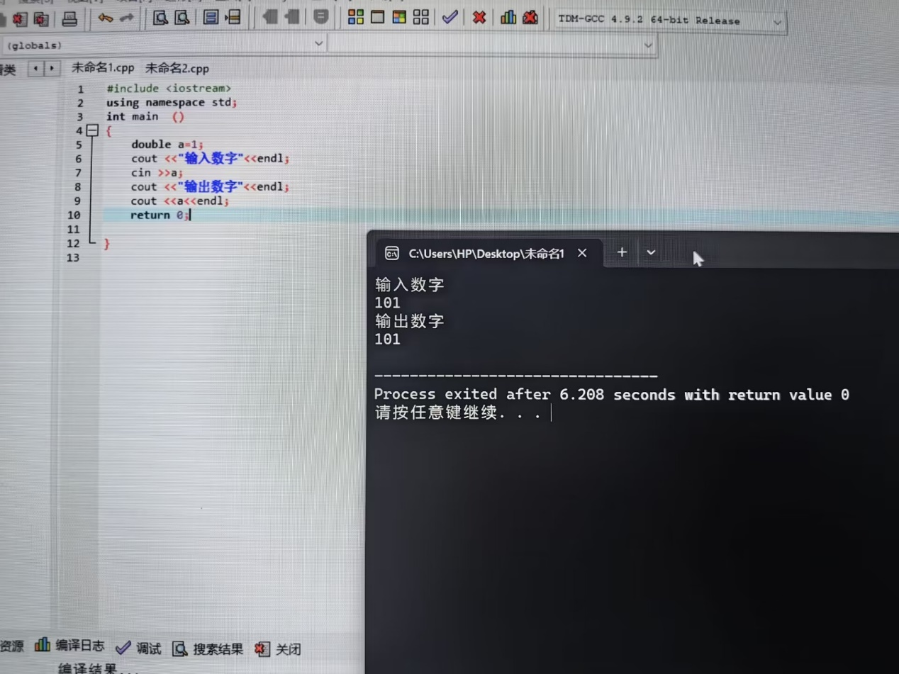

2-19
#include<iostream>
using namespace std;
int main()
{
unsigned int x;
unsigned int y=100;
unsigned int z=50;
x=y-z;
cout<<"Difference is:"<<x<<endl;
x=z-y;
cout<<"\nNow difference is:"<<x<<endl;
return 0;
}
运算结果如下
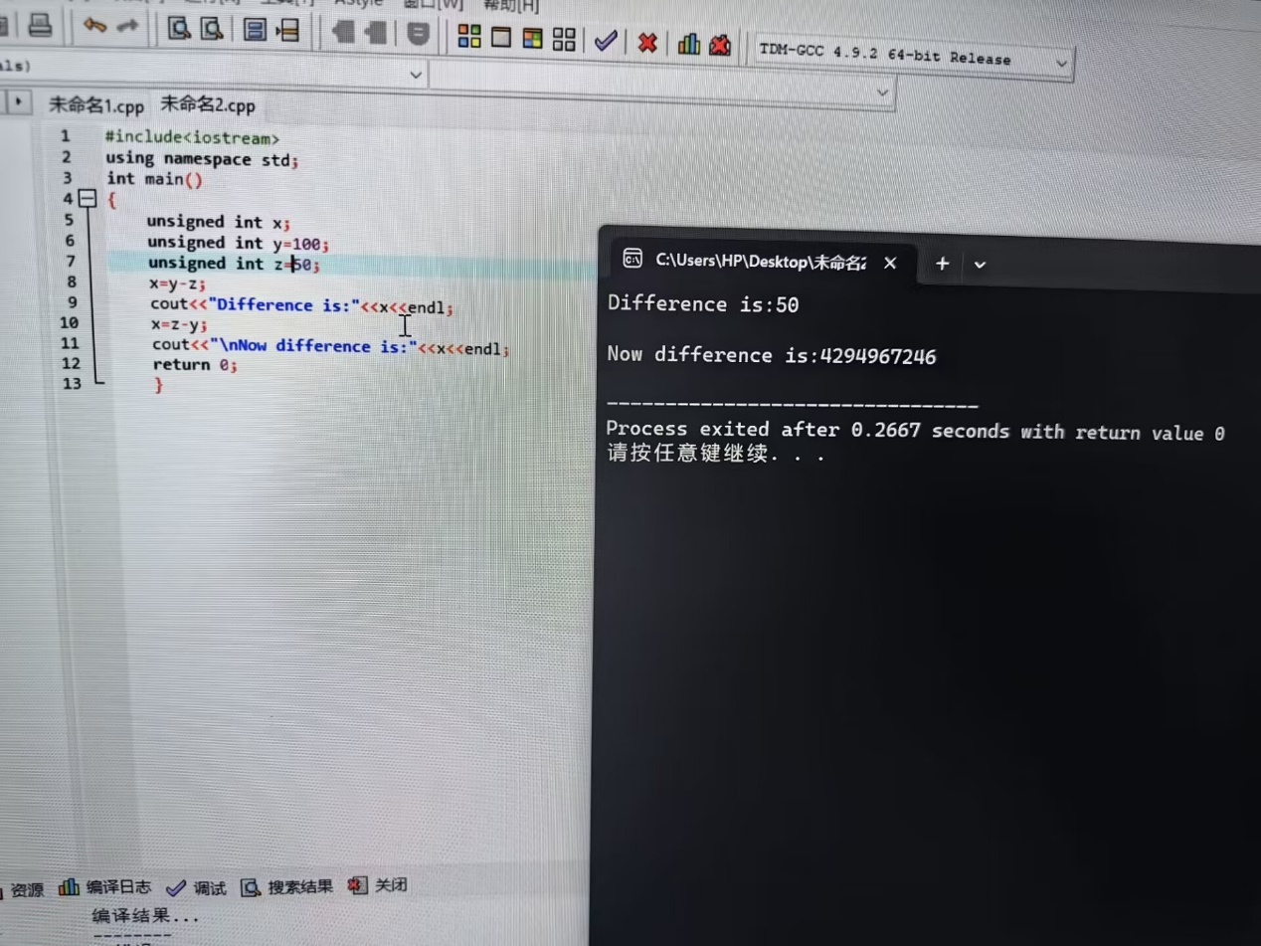
查了一下，unsigned int的范围在0-4294967295
z-y为负，发生了数据溢出

2-20
#include <iostream>
using namespace std;
int main()
{
int myAge=39;
int yourAge=39;
cout<<"I am:"<<myAge<<"years old."<<endl;
cout<<"You are:"<<yourAge<<"years old."<<endl;
myAge++;
++yourAge;
cout<<"One year passes..."<<endl;
cout<<"I am:"<<myAge<<"years old."<<endl;
cout<<"You are:"<<yourAge<<"years old."<<endl;
cout<<"Another year passes。"<<endl;
cout<<"I am:"<<myAge++<<"years old."<<endl;
cout<<"You are:"<<++yourAge<<"years old."<<endl;
cout<<"Let^s print it anain."<<endl;
cout<<"I am:"<<myAge<<"years old."<<endl;
cout<<"You are:"<<yourAge<<"years old."<<endl;
return 0;
}
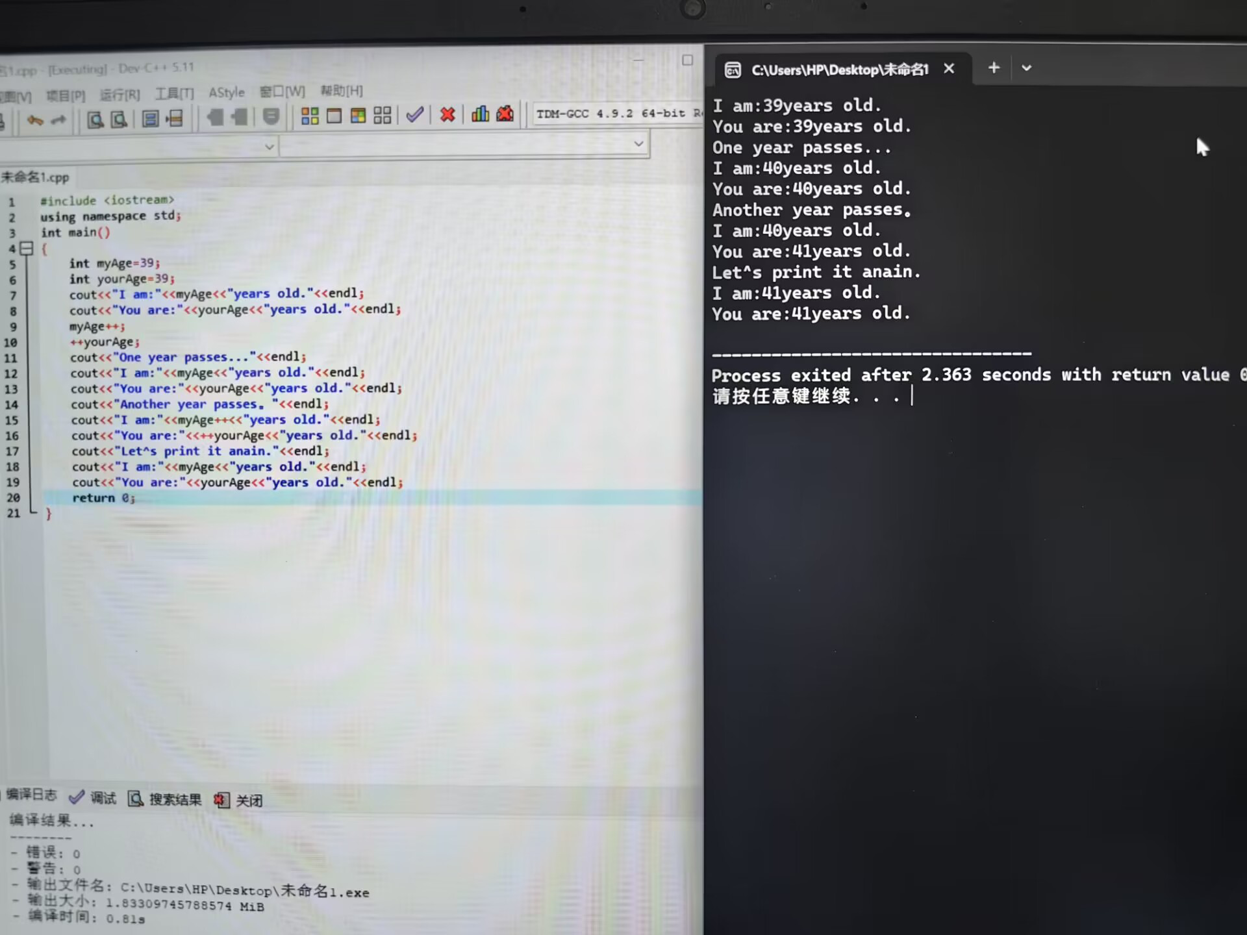
I: 39—运算后（无运算）自增—40—运算输出—40—自增后再输出—41；
You：39—自增后运算（无运算）--40—自增后输出—41—运算再输出—41

2-26

#include<iostream>
#include<stdlib.h>
using namespace std;
int main()
{
char rain;
while(1)
{
cout << "现在正在下雨吗" << endl;
cout << "若下雨，请输入Y" << endl;
cout<<"若不下雨，请输入N"<<endl;
cin>>rain;
if(toupper(rain)==&apos;Y&apos;)
{
cout<<"现在正在下雨。"<<endl;
break;
}
if(toupper(rain)==&apos;N&apos;)
{
cout<<"现在没有下雨。"<<endl;
break;
}
}
return 0;
}

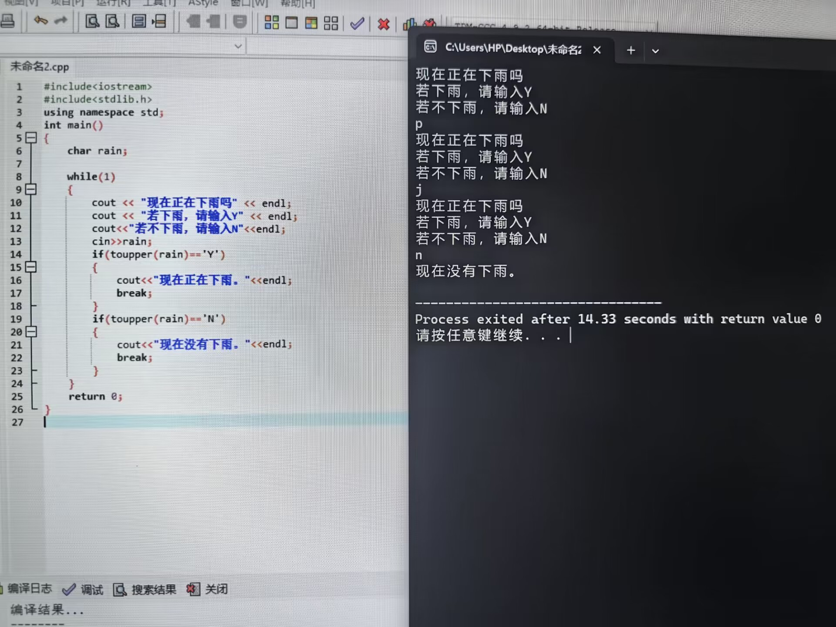
在while（1）中只有满足rain为Y或N时才能跳出循环，否则继续提问
（while后接条件，条件成立就循环，1本身是真，故若无跳出，就无限循环）

