**Assignment 2: The IT World**

1. **Team profile:**

**Team name:**

**Personal information:**

* **Nguyen Huu Gia Thanh (s3932584):** Ho Chi Minh City is where I was born. My family has lived in Hanoi, Vietnam's capital, since I was in third grade since that is where my father's extended family lives and works. I graduated from Chu Van A high school, which is one of Vietnam's most famous and well-known high schools, particularly in Hanoi. Following that, I received a 27 on the national exam. My mother tongue is Vietnamese, and I can also communicate in English. There are several advantages to learning English, including the ability to converse with more international acquaintances. Furthermore, because so much orthodox information is written in English, it really assists me when I need to conduct research. Aside from that, I enjoy playing basketball**.** My mother took me to the basketball court when I was a youngster, and I watched people having fun with each other via how they played and worked as a team, and the enthusiasm for the orange ball came to mind. I seldom exercise at home, so after school, my bestie and I always go to the court near our houses to unwind and play basketball. Furthermore, I am a major fan of League of Legends, one of the world's most popular MOBA games. I used to play it a lot with my secondary school friends, but since I started high school, I have had to learn to manage my time more effectively, so I now play games once or twice a week since I have so many other things to worry about. I chose to pursue information technology for a variety of reasons. For starters, it permits me to pursue a variety of employment routes. To work as a game developer, a cybersecurity expert, or a web developer, for example. Now, I want to be a cybersecurity professional, but as my studies develop, I may get interested in other sectors that are more appropriate for me. Second, according to the fourth industrial revolution, any creative technology may fall behind the times at the speed of light, and I appreciate working in an atmosphere that always challenges me to keep learning. Finally, like everyone else in the world, I study and work to pursue my passion while still earning a living, and there is nothing better than doing what you enjoy while also earning money. I have been intrigued about my cousin's writing stuff on his computer since I was in seventh school. I was curious about the language he was using until he informed me, he was developing software for his homework. By displaying some of his works, he expanded my imagination. He went on to say that all colorful pages and games are the result of a logical mix of algorithms created by web and game creators. I was also amazed that he hacked the game by inserting some short code into the software, and I hoped that one day I might be able to do the same. After that moment, I began to like programming and began looking for basic programs that aided me a lot in high school.
* **Doan Duy Bach (s39326953)**: First and foremost, my name is Doan Duy Bach. s3926953 is my student number, and s3926953@rmit.edu.vn is my e-mail address. My hometown is in the Vietnamese province of Thai Nguyen. I am a devout atheist who believes in evolution. This year, I completed 12 years of study, during which time I acquired English. As a result, my primary languages of communication are Vietnamese and English. Reading and sports including football, badminton, and table tennis are two of my favorite pastimes. I currently own a goldfish as a pet. I do not have any IT experience right now because I am still new to the field, but I aim to obtain more in the future. Coding is my favorite IT-related pastime. I began coding when I was thirteen years old. At the time, I was enrolled in MindX, a well-known technological school, for an online Python coding course. I learnt a lot of code knowledge within a few weeks of studying, and I felt delighted anytime I completed a coding assignment, therefore coding became my passion associated with IT from that point forward.
* **Don Tuan Duong (s3927233):** I was born in Hanoi, Vietnam's capital city. During my 12 years of education, I acquired various languages, but the ones I use the most currently are Vietnamese, my home tongue, and English. I am presently a first-year Information Technology student at RMIT (Royal Melbourne Institute of Technology) University Hanoi. The world of computers has always captivated me, and I have always wondered how such a little person can do so much. I spend much of my leisure time with a friend playing video games, and I also participate in sports and exercise to stay in shape. I used to play a lot of games on my parents' computer when I was a kid. Since then, I have always been curious about how computer games, websites, and other apps are created. As a result, I realized that one of the disciplines I want to pursue after high school is Information Technology. As I progressed through high school, I saw documentaries on computer science pioneers such as Bill Gates, Steve Jobs, and others. In addition, I study about the computer's components, how they function, and how data is stored, among other things. RMIT is one of the greatest institutions in Vietnam for IT students, which is why I selected it as my first choice. I want to improve my English abilities and learn more about coding and computer systems at RMIT.
* **Thai Phuc Nguyen (s3926861):** I am only a first-year student at RMIT, having recently graduated from high school. Vietnamese and English are the languages I use, however I learned German in the past. I spend all my leisure time playing computer games and listening to music, although I do occasionally pass the time by writing "novels" about my own plot and characters, but I seldom share them with anyone. I prefer IT because it is practical; understanding IT can help me find a stable job with a respectable salary in the future. In addition, I have always been fascinated by computers and programming since I first used the internet. What began as a simple desire to play on a computer video game became a way of life for me, as I began to discover how the games I was playing were created, for example, utilizing popular game engines such as "unreal engine," and customizing computer games using code and design. Overall, my IT experience is little, since what I have learnt about the subject is only the beginning.

**Team profile:**

* **Nguyen Huu Gia Thanh(s3932584):**

**-The results of an online Myers-Briggs test:** <https://www.16personalities.com/entj-personality>

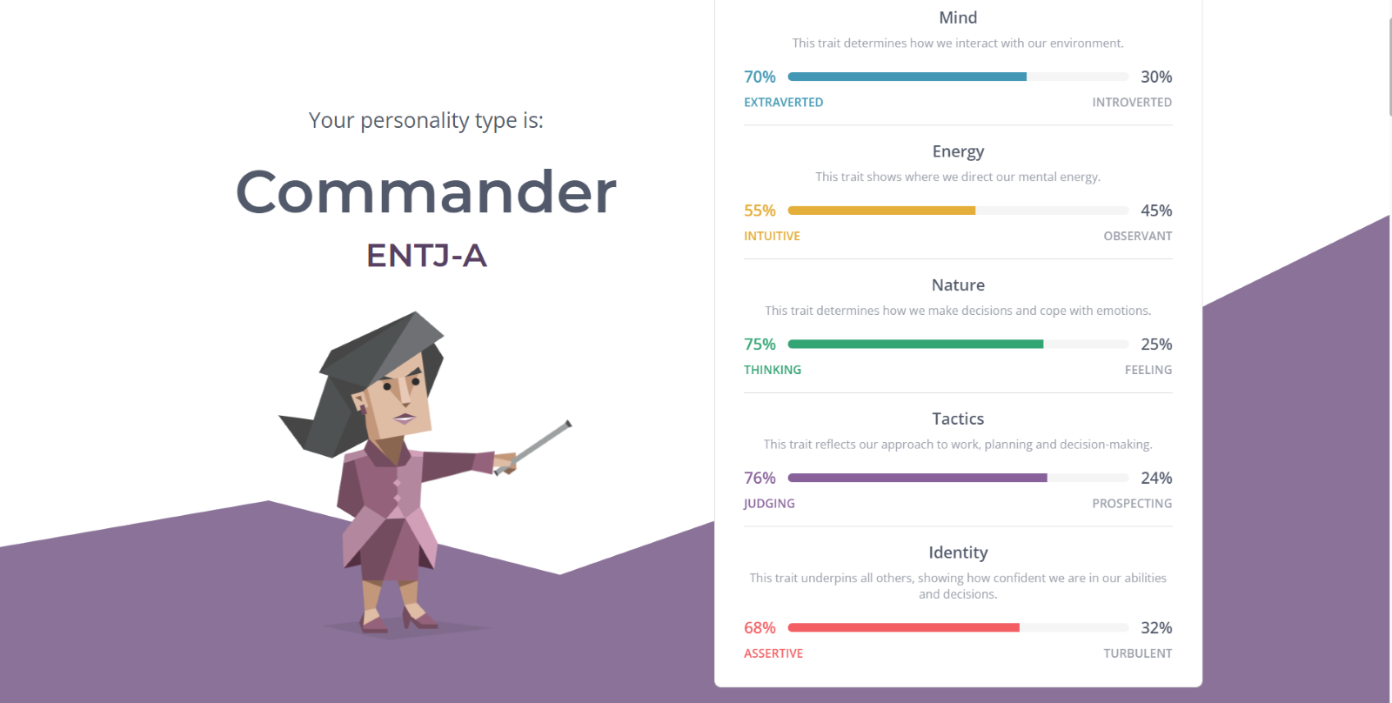

**- The results of an online learning style test:**

Link: <http://www.educationplanner.org/students/self-assessments/learning-styles-quiz.shtml?event=results&A=7&V=6&T=7>

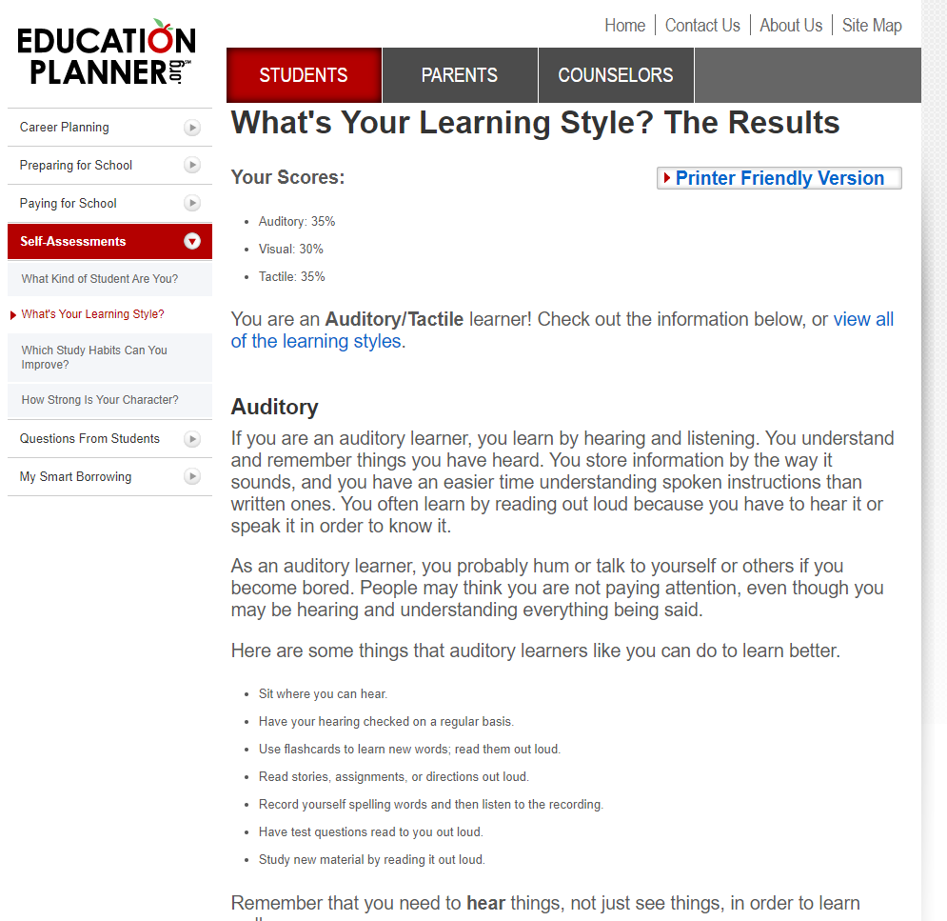

* **The results of Big Five Personality Test:**

Link: <https://www.truity.com/test-results/bigfive/17315/23329842>

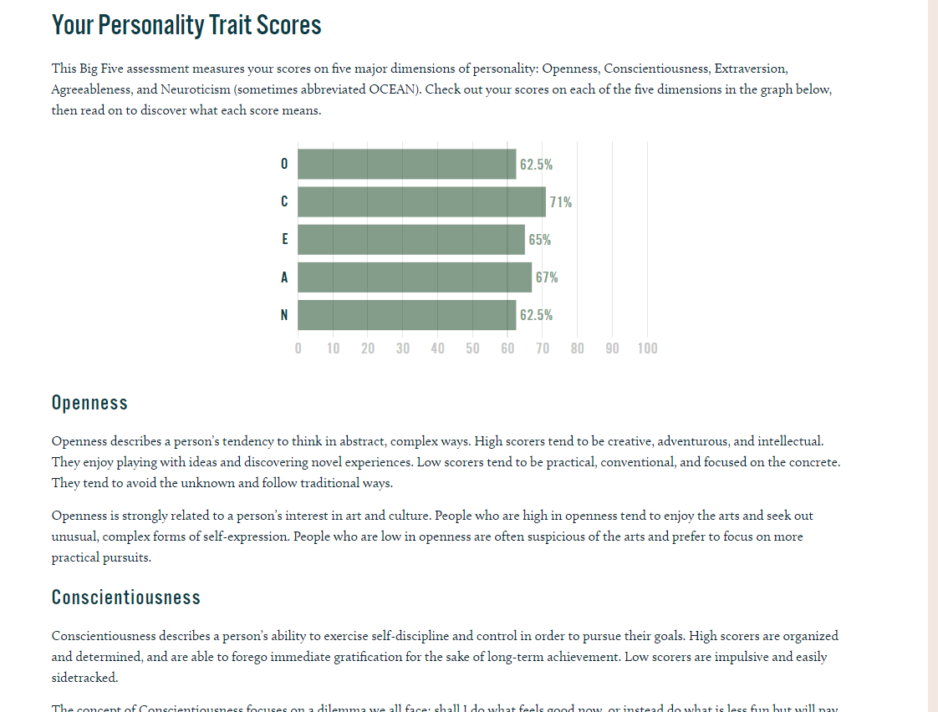

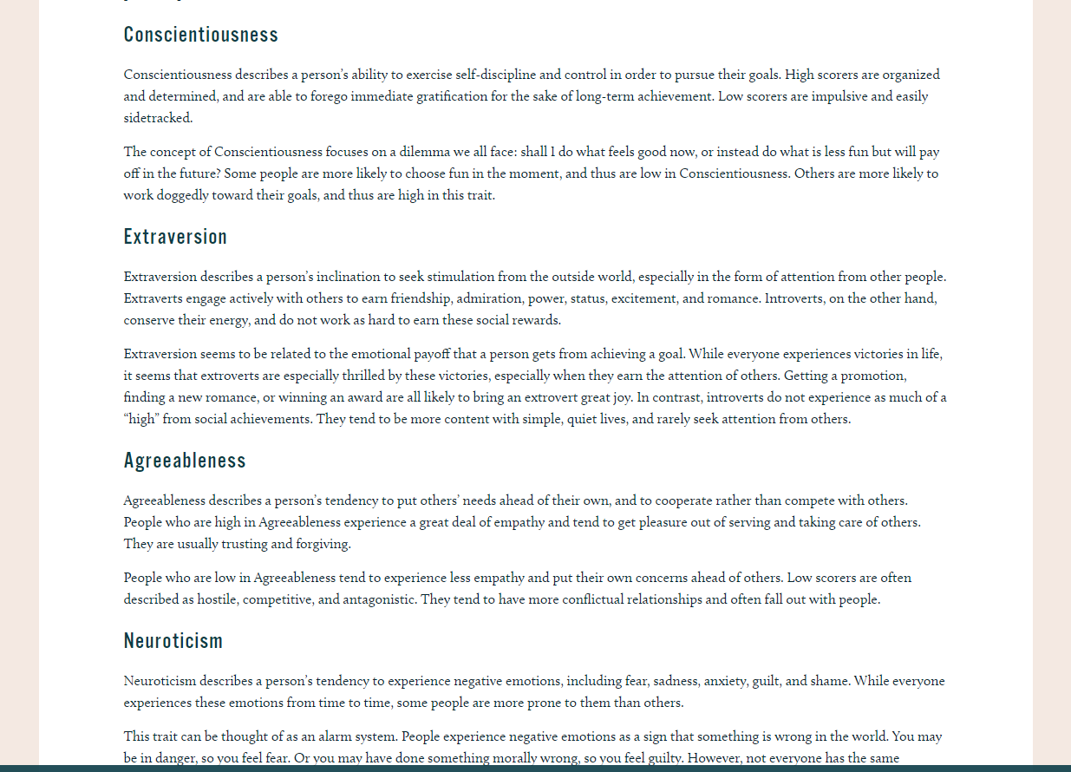

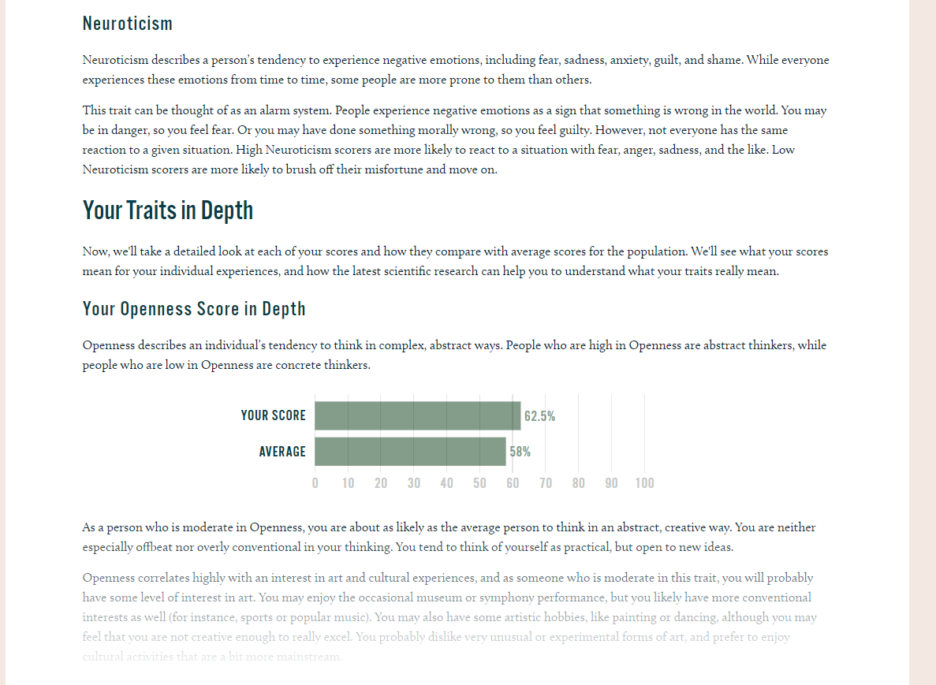

* **Doan Duy Bach (s3926953):**

**- The results of an online Myers-Briggs test:**

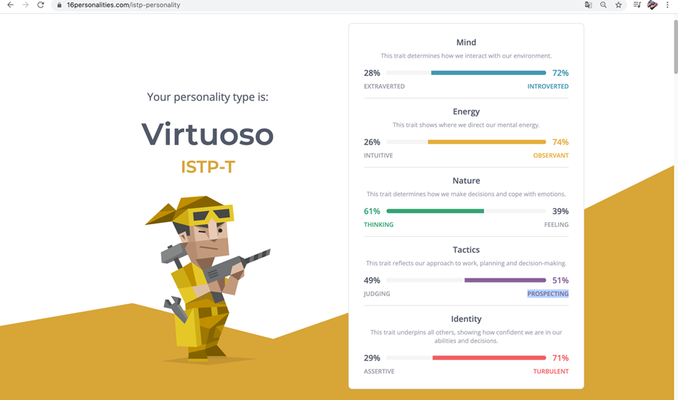

**- The results of an online learning style test:**

**Link:** [**http://www.educationplanner.org/students/self-assessments/learning-styles-quiz.shtml?event=results&A=6&V=9&T=5**](http://www.educationplanner.org/students/self-assessments/learning-styles-quiz.shtml?event=results&A=6&V=9&T=5)

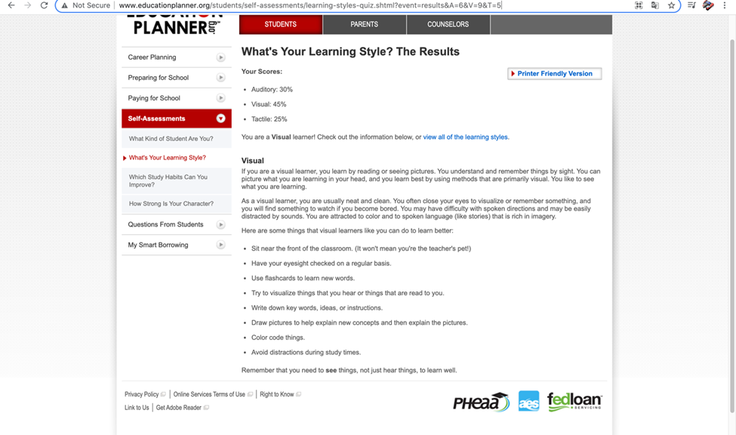

**- The results of one further online test: How create are you?**

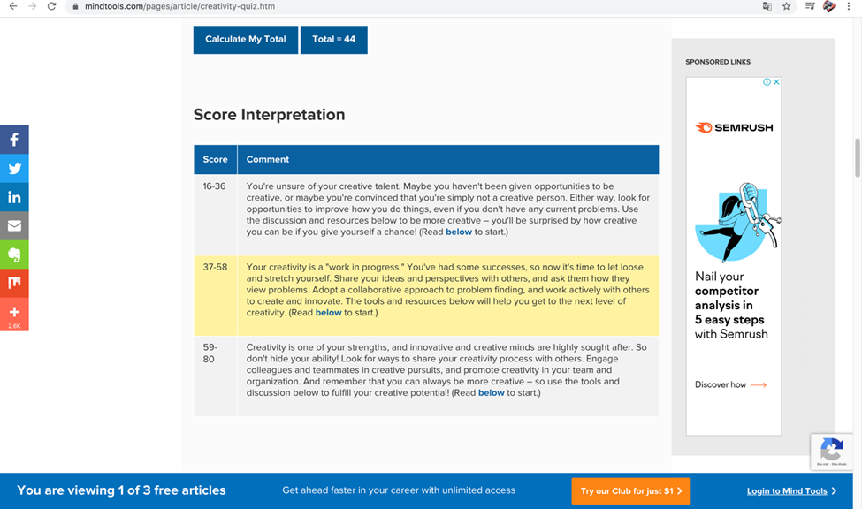

* **Don Tuan Duong (s3927233):**

**MBTI Test results:**

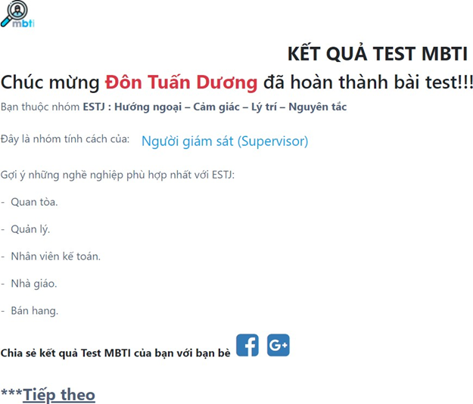

**Learning Style Test results:**

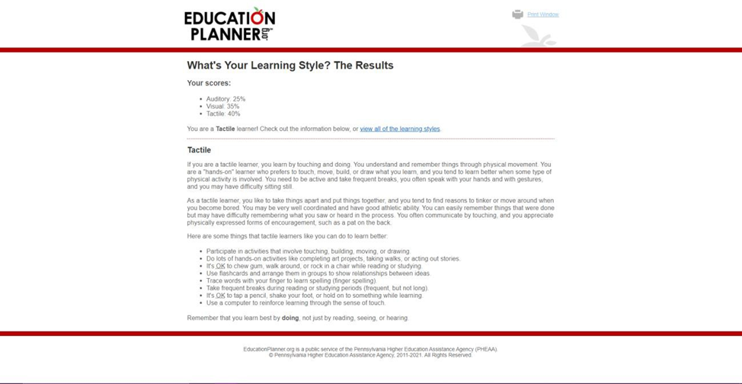

* **Thai Phuc Nguyen (s3926861):**
* The results of an online Myers-Briggs test: The results of an online learning style test: An IQ test as an additional test: To me

**Ideal Jobs:**