# Personal Information

MY PROFILE

* Name: Don Tuan Duong
* Student ID: s3927233
* Email address: [s3927233@rmit.edu.vn](mailto:s3927233@rmit.edu.vn)
* Personal background: I was born in Hanoi, the capital city of Vietnam. I have learned many languages throughout 12 years of education, but the languages that I use the most now are Vietnamese, my mother tongue, and English. I am now a freshman at RMIT University Hanoi, and I am studying Information Technology. I have always been tempted by the world of computer, wondering how such a small can do almost anything. I spend most of my free time playing videogames with my friend and I sometimes play sports and do exercise to keep myself in shape.

# Interest in IT

* When a was a little boy, I play a lot of games on my parents’ computer. Since then, I’ve always wondered how they made the games, websites and other applications on the computer. Therefore, I determined that the majors I want to learn after I graduated high school must be Information Technology. As I was progressing through high school, I have seen documentary films about pioneers in Computer Science like Bill Gates, Steve

Jobs, … In addition to that, I also learn about the computer’s components, what makes the computer’s work, what stores the data and so on. The reason why I chose RMIT as a go-to university is because it is one of the best universities for IT students in Vietnam. At RMIT, I want to strengthen my English skills and also gain more knowledge about coding and computer systems.

***Strong point:*** one of my strong points is that I can easily absorb new knowledge that I came across. If you are trying to explain something to me, you will only have to explain it once. Thus I am an outgoing person, which contribute to my communication skills.

***Weak point:*** but at the same time, I still have a lot of things a have to improve. For instance, I can’t stay focus for too long and I can be distracted very easily

# Ideal job

Link: [https://itviec.com/it-jobs/software-developer-net-c-c-koh-young-technology-inc-](https://itviec.com/it-jobs/software-developer-net-c-c-koh-young-technology-inc-2101) [2101](https://itviec.com/it-jobs/software-developer-net-c-c-koh-young-technology-inc-2101)

## Job description:

* You will be developing a new Inspection equipment by modern & cutting-edge technologies.
* You will have the chance to contribute to the design and architecture of the company’s market leading product at an early stage, as well as building a high-performance infrastructure.
* You will have the opportunity to lead smart factory revolution with advanced technologies.
* Provided with comparative compensation packages including salary, insurance and paid leave

**Job requirement:**

* Bachelor’s degree of higher
* At least 1 year experience in developing windows application (MFC, .WPF, C++, C#)
* Intermediate or higher understanding of .Net Framework

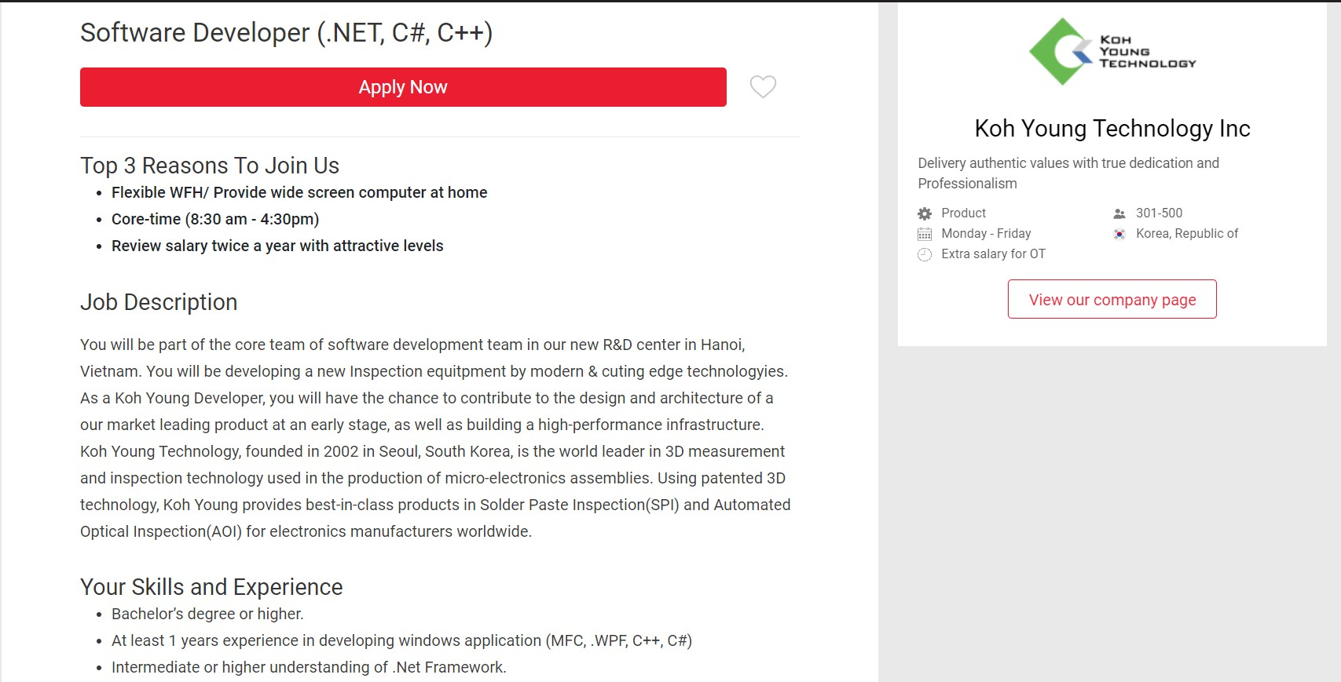

## Acquired skills:

* Quick learner
* Fast and precise working
* Basic understanding of C and Python

# Personal Profile

* MBTI Test results:

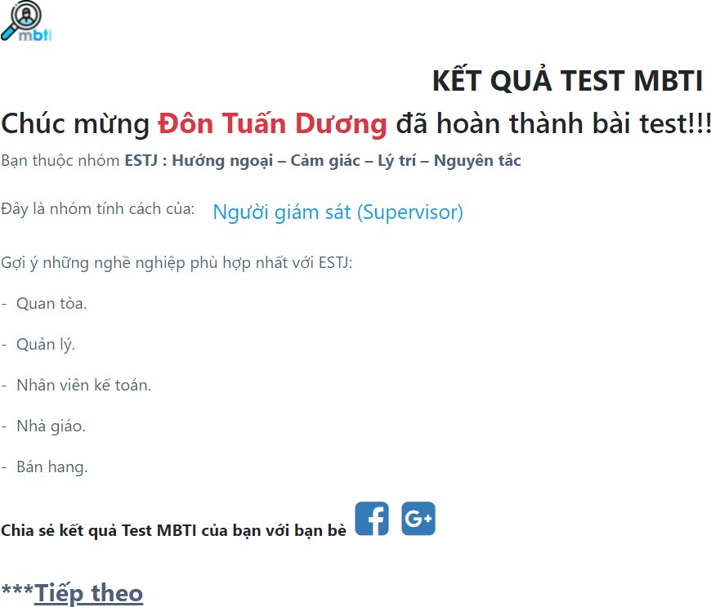

* 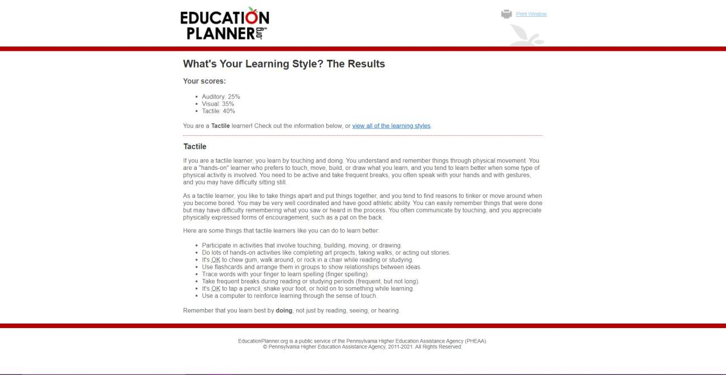Learning Style Test results:

# Project Idea

As the pandemic is getting more and more complicated, a total lockdown is an almost unavoidable outcome, all big company, small company, markets and other service will surely close, schools are no exception. But education is an important aspect in life, which shouldn’t be stop even during lockdown. So, my project idea will be a new e- learning platform.

E-learning is a form of educating based on the connection of the internet. Both the teachers and the student can easily access an e-learning simply with a computer, a tablet or a smart phone and internet connection. Through e-learning, teachers can impart knowledge, send homework and exercise very easy, and student can access the lessons’ records in case they don’t pay attention or missing the lessons. During COVID- 19, e-learning has proven to be the fastest, cheapest and most reliable solution to a great number of problems rising with the lockdown. It is so popular that even after the pandemic has cooled down, there are still a lot of online extra class courses.

This idea is not a new and innovative idea since there are already plenty of application that support e-learning like Zoom, Microsoft Teams, Google Meet, etc. But there’s a problem with them, one that is easy to recognize. Most of the apps that we use today has their server placed in foreign country. Their server has one big advantage is that it can handle so many people at a time without stuttering. But recently, Vietnam has had a hard time connecting to a foreign server due to constant issue with the fiber-optic cable, which makes studying online become very difficult and irritating. I want to make an e- learning platform that has a server placed in our country so that students and teachers will encounter less connection issues during class.

This E-learning platform will be called STOC, which is short for Students and Teachers Online Classes, a platform that enable teachers to conduct lessons, give out assignment and due date, answer students’ questions and track whether the student is on the platform or not. It will also help students to make their own study group, get reminders of assignments’ due date. Furthermore, every lesson conducted will be automatically

recorded and available for download if a student can’t join the class or not fully understand it, and you can make your own timetable on the app to know what lessons is coming up. Because Vietnam had been using traditional face-to-face teaching method, and some of the teachers are old, which make it very hard for them to adapt to the new teaching method, which require a computer, a piece of technology that most of the

traditional teacher aren’t familiar with. That is why I want STOC to be user-friendly and extremely easy to use. First of all, the apps default language must be Vietnamese so that those who don’t know English can still figure out how to use the app. Second of all, when you first turn on the app, it will ask if you want to learn the basic use of the app.

STOC, like many other e-learning platform, can have access to your device’s camera and mic for you to communicate with the class, a fully customizable background for your camera

To use STOC, you need a computer or a laptop with working camera and mic, 4GB of RAM or more and a good internet connection to avoid stuttering, or you can use your tablet or smart phone to use STOC. You can either download the app to use, or use it directly on your web browsers

In order to make this project idea came true, one has to know how to use WebRTC and JavaScript, which are the two most important thing to make a fully functional web video call. Furthermore, a visual artist is a must have to make STOC’s user’s interface simple and appealing to the consumers. The last and most important thing is to have a big enough server to handle many classes occur all at once.

If this project is successful, STOC can be the mainstream platform for schools to use in case of a lockdown

