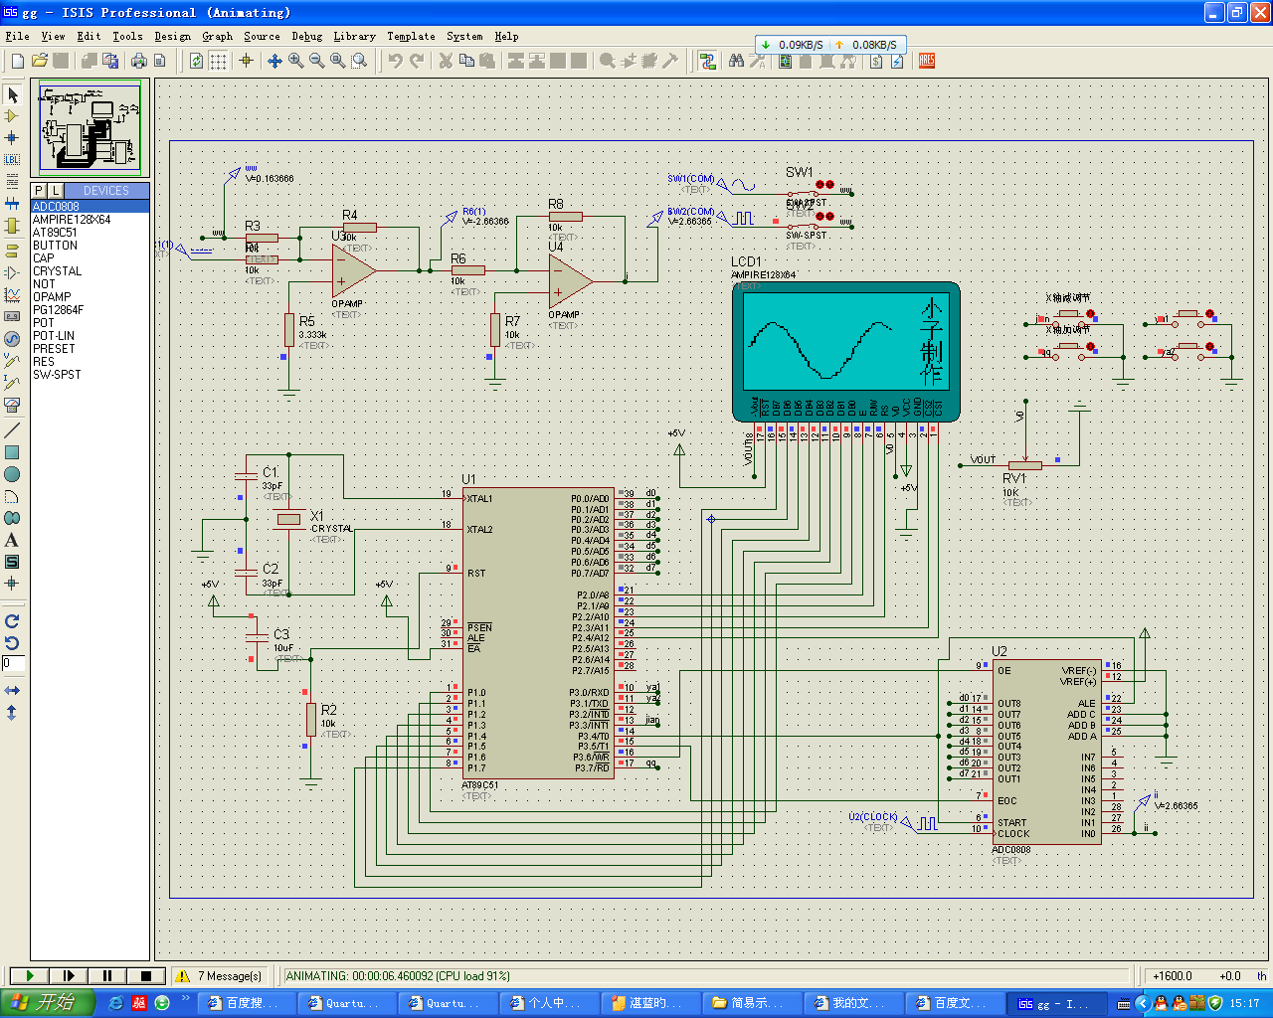

#include <reg51.h>
#include <intrins.h>
#include <ADC0808.c>
sbit DI=P2^2; // 数据\指令 选择
sbit RW=P2^1; // 读\写 选择
sbit E=P2^0; // 读\写使能
sbit CS1=P2^4; // 片选1
sbit CS2=P2^3; // 片选2
sbit busy=P1^7;
sbit jia=P3^7;
sbit jian=P3^3;
sbit jia1=P3^0;
sbit jian1=P3^1;
unsigned int i;
unsigned char ye,lei,shu;
unsigned char a[94];
char code t[]={

0x00,0x00,0x08,0x00,0x04,0x00,0x02,0x00,0x01,0x80,0x40,0x60,0x80,0x00,0x7F,0xFF, //小
0x00,0x00,0x00,0x20,0x00,0x40,0x00,0x80,0x01,0x00,0x06,0x00,0x00,0x00,0x00,0x00,

0x00,0x80,0x00,0x80,0x00,0x82,0x00,0x82,0x00,0x82,0x40,0x82,0x80,0x82,0x7F,0xE2, //子
0x00,0xA2,0x00,0x92,0x00,0x8A,0x00,0x86,0x00,0x80,0x00,0xC0,0x00,0x80,0x00,0x00,

0x00,0x40,0x00,0x60,0x3F,0x5E,0x01,0x48,0x01,0x48,0xFF,0xFF,0x11,0x48,0x21,0x4C, //制
0x1F,0x68,0x00,0x40,0x07,0xF8,0x40,0x00,0x80,0x00,0x7F,0xFF,0x00,0x00,0x00,0x00,

0x00,0x80,0x00,0x40,0x00,0x20,0xFF,0xF8,0x00,0x87,0x00,0x40,0x00,0x30,0x00,0x0F, //作
0xFF,0xF8,0x08,0x88,0x08,0x88,0x08,0xC8,0x0C,0x88,0x08,0x0C,0x00,0x08,0x00,0x00,
};

void checkstate()
{
//bit dat;
DI=0;
RW=1;
//P1=0x00;
do
{
E=1;
E=0;
//仅当第7位为0时才可操作(判别busy信号)
}while(busy==1);
}
void writecommand(unsigned char command) //写命令
{
checkstate();
DI=0;
RW=0;
P1=command;
E=1;
E=0;
}
void writedate(unsigned char date) //写数据
{
checkstate();
DI=1;
RW=0;
P1=date;
E=1;
E=0;
}

void pianxuan(unsigned int i)
{
if(i==1)
CS1=0,CS2=1;
if(i==2)
CS1=1,CS2=0;
if(i==3)
CS1=0,CS2=0;
}
void cleanscreen() //清屏
{
unsigned char page,i;
for(page=0xb8;page<0xc0;page++)
{
writecommand(page);
writecommand(0x40);
for(i=0;i<64;i++)
writedate(0x00);
}

}
void init(void) //开显示，起始行0行
{
writecommand(0xc0);
writecommand(0x3f);
}
void delay_50us(uint t)
{
uchar j;
for(;t>0;t--)
for(j=19;j>0;j--)
;
}
void shuju()
{
pianxuan(i);
writecommand(ye);
writecommand(lei);
writedate(shu);
}
void qing()
{
uchar i;
for(i=0xb8;i<=0xbf;i++)
{
ye=i;
shu=0x00;
shuju();
}
}
void main()
{

uint r,j,g=0,q,dianya=1,k,p;
uchar U,m,l;
pianxuan(3);
cleanscreen();
init();
pianxuan(2);

l=0xb8;
for(k=0;k<4;k++,l=l+0x02)
{
ye=l;
lei=0x70;
for(r=0;r<16;r++)
{
shu=t[2*r+1+32*k];
shuju();
lei++;
}
ye=l+0x01;
lei=0x70;
for(r=0;r<16;r++)
{
shu=t[2*r+32*k];
shuju();
lei++;
}
}

while(1)
{
uchar d1,d2,d3,d4,d5;
aaa:do
{
adc();
}while((AD!=128)&&(AD!=129)&&(AD!=130));
U=AD;
adc();
if(U>AD)
goto aaa;
while(jia==0)
{
while(jia==0);
g=g+1;
}
while(jian==0)
{
while(jian==0);
if(g!=0) g=g-1;
}
while(jia1==0)
{
while(jia1==0);
dianya=dianya+1;
}
while(jian1==0)
{
while(jian1==0);
if(dianya!=1) dianya=dianya-1;
}
for(j=0;j<94;j++) //AD采样
{
adc();
a[j]=AD;
delay_50us(g);
}
lei=0x40;
for(r=0,j=0;r<94;r++,j++)
{
if(j<64) i=1;
if(j==64) lei=0x40;
if(j>=64)i=2;
qing(); //清掉之前的内容
AD=a[j]*0.196/dianya; //计算在12864的电压值
if(AD<=7) ye=0xbf,shu=(0x80>>AD);
else if(AD<=15) ye=0xbe,shu=0x80>>(AD-8);
else if(AD<=23) ye=0xbd,shu=0x80>>(AD-16);
else if(AD<=31) ye=0xbc,shu=0x80>>(AD-24);
else if(AD<=39) ye=0xbb,shu=0x80>>(AD-32);
else if(AD<=47) ye=0xba,shu=0x80>>(AD-40);
else if(AD<=55) ye=0xb9,shu=0x80>>(AD-48);
else if(AD<=63) ye=0xb8,shu=0x80>>(AD-56);
if(r==0)
{
d1=shu;
d2=ye;
}
if(r!=0)
{
d3=shu;
d4=ye;
if(ye==d2)
{
if(shu>d1)
{
d5=shu;
d5=d5>>1;
while(d5!=d1)
{d5=d5>>1;
shu=shu|(shu>>1);}
}
if(shu<d1)
{
d5=shu;
d5=d5<<1;
while(d5!=d1)
{d5=d5<<1;shu=shu|(shu<<1);}
}
}

if(ye<d2)
{
for(q=0;q<7;q++)
{
shu=shu|(shu<<1);
}
shuju();
ye++;
while(ye<d2) {shu=0xff,shuju(),ye++;}
if(ye==d2){
shu=0x01;
if(shu<d1)
{
d5=shu;
d5=d5<<1;
while(d5!=d1)
{d5=d5<<1;shu=shu|(shu<<1);}
}
}
}
if(ye>d2)
{
for(q=0;q<7;q++)
{
shu=shu|(shu>>1);
}
shuju();
ye--;
while(ye>d2) {shu=0xff,shuju(),ye--;}
if(ye==d2){
shu=0x80;
if(shu>d1)
{
d5=shu;
d5=d5>>1;
while(d5!=d1)
{d5=d5>>1;shu=shu|(shu>>1);}
}
}
}
}
if(r!=0)
{
d1=d3;
d2=d4;
}
shuju();
if(lei!=0x7f) lei++;
}
}
}

