**Valeo Innovation Challenge 2017**

The contest’s purpose is to recognize an innovative automotive

Technology solution for cars of 2030.

Students can propose projects in two categories:

Technological Innovation

New ways to use cars

**You have just downloaded the pre-selection file: it’s the first step for you to have a chance to win the challenge!**

In this file, you are invited to specify some information on your team and detail your project in **5 pages maximum.**

Hereafter 6 tips to put all your chances on your side:

1. Be concise and pertinent: avoid information overload at this step of the challenge.
2. Beware of the spelling and the layout.
3. Respect the plan as it is defined in the rules Article 4.
4. Respect the dates defined in the rules Article 6.
5. If you wish, you can add images, videos or any elements that could help the jury to understand your concept quickly as stipulated in the rules article 7.
6. Rename the file with the name of your team and indicate it on the first page.

Best of luck, and see you on the podium!

**Valeo Innovation Challenge 2017**

**Phase 1**

To be uploaded as a .pdf document to the Valeo Innovation Challenge website

before the submission deadline

**Deadline: January 31, 2017; 12:00 pm CET**

|  |
| --- |
| *Please carefully read the* ***Valeo Innovation Challenge Rules and the FAQ*** *before starting the description of your proposal. Bear in mind that the proposal will be evaluated according to the selection criteria set out in the rules Article 7.*  *The project description* ***must use the******headings*** *on page 2. The structure of this document and the font must not be changed. The* ***minimum font size*** *allowed is* ***11*** *points and the font type is* ***Arial****. The maximum number of* ***5 pages*** *should be respected. You can insert texts, images or drawings.* |

**Team name**: People’s Champion

**Project title**: Automatic braking and Accident location system

**Abstract (15 lines max)**:

The accident prevention and accident location system is used to address the issue of vehicle safety and post accident measures that are currently being deployed. Keeping in mind the immeasurable value of a human life we are proposing a simple and effective method to achieve two primary goals namely,

1. Preventing vehicle collisions by using an automatic brake assist system.
2. In the case of an accident, bringing medical aid to the people in need as soon as possible using the accident location system.

The first primary objective can be achieved by a simple distance sensor and electronic brake trigger. The Front sensor measures the distance every few milliseconds, when the distance is reduced drastically the brake is triggered automatically. The second task is achieved with the help of a heartbeat sensor and a GPS location transmitter. In most cases deaths due to accidents do not happen on the spot but mostly gradually due to blood losses etc. Hence the medical response time is vital in saving a person’s life and this system can reduce the medical response time drastically. There is a heartbeat sensor which monitors the person’s condition and once an accident is detected, his vitals along with his location are immediately sent to the nearest hospital, hence an ambulance can be dispatched immediately. This can go a long way in determining whether a person lives or not. Hence both these systems serve the purpose of preventing the loss of human life.

1. **What is the problem? Or what is the situation to improve? (half page a page)**

Vehicles have become an integral part of all our lives, primarily we need vehicles for travel and

transport. In countries, where vehicle population is very high, road rules and external safety

measures are not strictly enforced accidents have become inevitable. Road accidents have

undoubtedly become the most frequent modes of damage to both human lives and goods. This is

when we realize that the roads are not safe anymore and thus a need arises for us to come up

with methods of prevention and damage control. The first and foremost priority of any structured

establishment is human safety, everyday new methods come up to ensure this unspoken rule and

the roads are no exception. Addressing this issue of vehicle safety and post-accident measures are

now the primary concern of our project. While major automobile companies are coming up with

new inventions, there is a need for simple, implementable and innovative features in the vehicle

itself rather than manipulating external influences to achieve safety. To give a more specific

picture about the situation to be improved, let’s take the example of how accidents take place in

the highways of India. The Indian roads are already known to the world as some of the worst

places to get stuck in, where traffic congestion is at its peak with a high level of impatience and

little adherence to the rules. Accidents on the Indian roads happen mainly due to

miscommunication between vehicles and in extension the driving in India were rules don't

exactly restrict or limit the vehicles, this is quite evident. Collision between vehicles has become

unrestricted and after the accident has happened there is no effective way of intimating the

concerned authorities for an immediate response. This issue of collision between vehicles is

controllable especially with the improvements in technologies. A first line response system

should be effected in the vehicles in case of emergencies.

1. **What is/are the current solution(s), if any? (1 page)**

There is a similar solution with respect to ours to the current scenario “Collision Avoidance System” is an automobile safety system designed to reduce the severity of a collision. It is also known as a **precrash system**, **forward collision warning system**, or **collision mitigating system**. It uses radar (all-weather) and sometimes laser (LIDAR) and camera (employing image recognition) to detect an imminent crash. GPS sensors can detect fixed dangers such as approaching the stop signs through a location database.

**What is your solution? (3 pages)**

The means of transport had developed and more equipped in the current world. Even though the technology improves, the occurrence of accidents increases day by day, there by leading to deaths and serious injuries. The Census briefs that about 1.4 lakh people died in India in 2015 and about 1.3 million had died worldwide due to accidents. This may increase in the upcoming years. The death rate can be reduced to a great extent by improving the technology and implementing it practically. This system will be more useful in the highways, where accidents occur at large numbers. Most of the accidents take place due to the driving of the vehicles at high speed and at night time in the highways. The below mentioned graphs show us the accident occurrence rate.

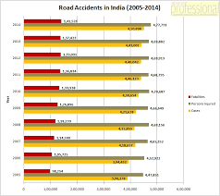 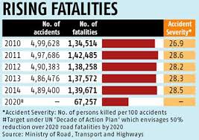

Here we had come up with the solution of implementing accident prevention and accident location tracking system in the automobiles.

These systems are clearly defined below:

1. The accident prevention method is based on the concept of brake assistance system. The brake assistance system is functioned by two ways:

* By sensing the rate of heart beat by means of pulse monitoring sensor.
* By sensing the distance between the vehicles by means of distance measurement sensor.

Once the detection is done, these systems either provide a warning to the driver when there is an imminent collision or take action autonomously without any driver input (by braking or steering or both). Collision avoidance by braking is appropriate at low vehicle speeds (e.g. below 50 km/h), while collision avoidance by steering is appropriate at higher vehicle speeds. Cars with collision avoidance may also be equipped with adaptive cruise control, and use the same forward-looking sensors. Various luxury car manufacturers such as Audi, Mercedes, Volvo, Lincoln, etc. have recently developed this system but it has its own flaws which we try to overcome through our work. The reason for proposing our solution is that this system is only available in luxury segment cars which make it unavailable for common man while design can be made at low-cost to ensure that even the lowest segment car can be installed with our system (Believing that all cars have electronic braking in 2030). Another disadvantage is that some cars have “Automatic Braking System” while some have “Accident locating system” but there is no such car that has both because it may increase the cost of the vehicle also no such proper system is created and existing systems are under development and can only be implemented completed by 2022. This is when our system lends a helping hand by combining both these systems (Advanced to existing) into a single module which is low-cost & compact.

We claim that our system is advanced because we propose to use pulse rate sensor in order to increase the accuracy as well as the efficiency of the system. Coming to the “Accident Location system” no such system is existing till date. It is only claimed to be as a theoretical idea and no one has ever claimed to be their idea. This makes our system unique. If our system is implemented if would create an advancement in technology and also reduce civilians deaths.

Primarily the brake assistance is done by monitoring the heartbeat of the driver. Here the pulse monitoring sensor senses the heart beat rate of the driver during driving of the car. The sensor is placed in the seat belt of the driver. When the car is about to collide at high speeds or at unavoidable situations, the heart beat goes high thus increasing the blood pressure and unusual tensions. In order to avoid it, the sensors are being implemented. The sensor is pre – programmed, such that when the heart beat crosses the given limit, it senses and it slows down the vehicle by means of applying the brake automatically. This can avoid accidents and prevent casualties.

Secondly the task is achieved by sensing the distance between the vehicles by distance sensor. The sensor is placed at the front of the vehicle. It measures the distance every few milliseconds. The logic followed here is that when the distance measured reduces drastically, the critical braking distance is calculated by the sensor which is pre-programmed and once the distance is reached the brake is triggered automatically.

**In the 2016 Berlin terror attack a truck was driven into the Berlin Christmas market and was brought to a stop by its automatic braking system.**

The system is sub classified into two modes:

1. Highway mode

2) Urban mode

1. In highway mode, the sensors are programmed such that the distance of contact between the opposite vehicle must be greater due to high velocity of the vehicle.
2. In urban mode the sensors are programmed such that the distance of contact between the opposite vehicle or two vehicles must be low comparatively.

**Accident location tracking system:**

The accident location tracking system is another idea that had been mentioned above. In case of failure of the electronic brake assistance system or at unavoidable situations the accident may occur. This system functions as soon as the accident takes place. The prime motive of the system is to track the vehicle which has met with an accident and to save the life of the concerned members by providing possible treatment at the earliest. The system functions on GPS, pulse rate monitoring and pressure sensor.

The system involves in the usage of pressure sensor, which senses the pressure that occurred during the accident and it opens up the airbag to provide safety for the passengers inside the vehicle. The sensor is programmed such that when it crosses the certain limit, it opens up the airbag. The pressure sensor is connected to the microcontroller where the GPS functions. The GPS initiates its function as soon as the pressure sensor functions. GPS is assisted with RF Transmitter and RF receiver. The system sends the information automatically to the nearest hospital, control room and friend’s contact that had been registered already at the time of booking of the car. The heartbeat monitoring sensor sends the physical details of the driver to the nearest hospital.

This will be useful at the highways, where there will be few ambulances for the rescue operation. Another added advantage of our system is that during night travel the coverage of head lamps will be low, but in the proposal system since sensor are used the car can brake automatically from longer distances than manual braking distance.

Future Scope of our system:

* Use of cameras to spot brake light indication to achieve much faster braking and accuracy.
* Rear collision avoidance system
* Accurate location recognition by using camera to send images of the accident area and sending to hospital.

**4) What type of mock up are you considering and how do you plan to build it? (Half a page)**

Initial step in the developing process is creating of a prototype—which is, simply defined, is a three- dimensional version of one’s vision. Creating a prototype can also be one of the most fun and rewarding steps one will take. That's because developing a prototype gives oneself the opportunity to really tap into creativity, using those skills that inspired one‘s invention idea in the first place, and that is an idea transformed into something tangible and real. Similar way our project is made into a prototype for the better understanding of the jury. This prototype is compact and cost effective which can indeed accommodate the expenses within the reimbursement amount and also if necessary can be fitted in an automobile to be certain that this idea is a success in real time application.

There are a total of 4 sensors that are to be connected in an automobile, the sensors are of high quality and long ranging, because in an automobile “Safety and Quality go hand in hand” so 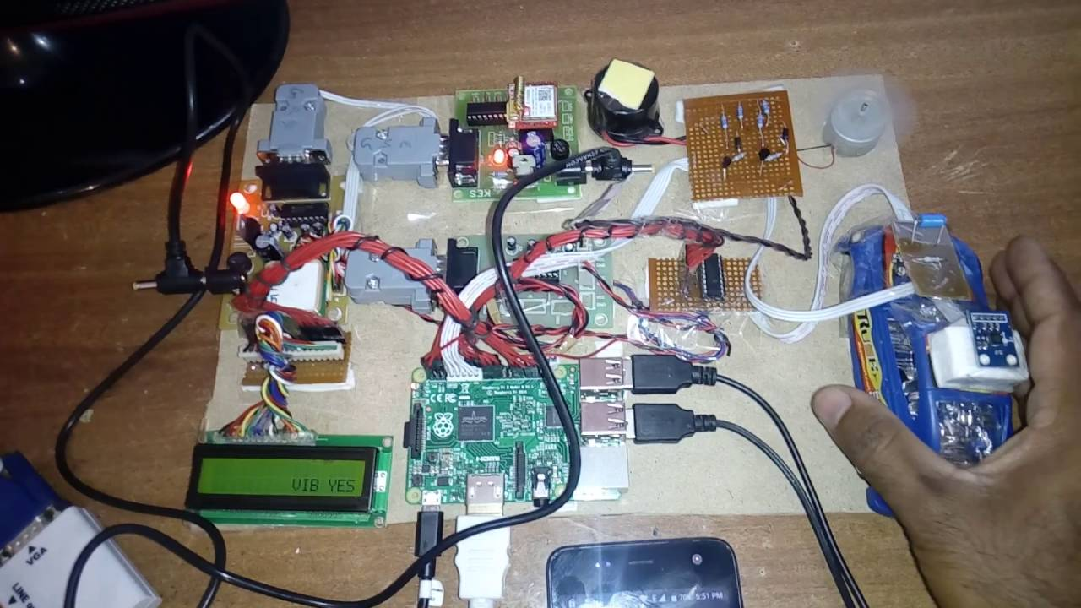 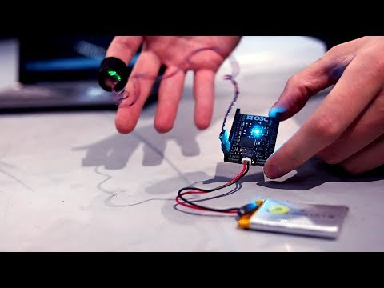

compromising on quality eventually leads to failure of the entire system. To test the working of our system LEDs can be used to show the output is activated, in case of, real-time application LEDs can be removed and the wiring can be connected to individual components of the automobile. The prototype or the system is so compact that is can be fitted right above the ECU due to space restrictions. The duration given for Phase-2 is more than enough to thoroughly make a prototype and also to conduct various tests to come out with a fool proof system. This system can reduce the accidents as well as drastically reduce the number of deaths if implemented on a global scale.