苏州大学实验报告
院、系 | 计算机学院 |  | 年级专业 |  | 计科 |  | 姓名 | 徐双奇 | 学号 | 1427405087
课程名称 |  | 嵌入式技术基础与实践 |  |  |  |  |  |  | 成绩
指导教师 |  |  |  | 同组实验者 |  | 无 |  | 实验日期

实 验 名 称 | 实验六 综合设计实验

一、实验要求
要求尽可能融合GPIO、UART、TIMER（含PWM）、Flash、AD、USB等模块构件，体系本课程所学知识要素。

二、实验目标
实现开发板作为从机实现USB功能

三、实验内容

main.c流程图
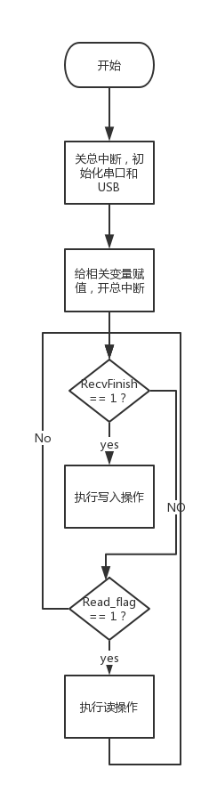

isr.c流程图
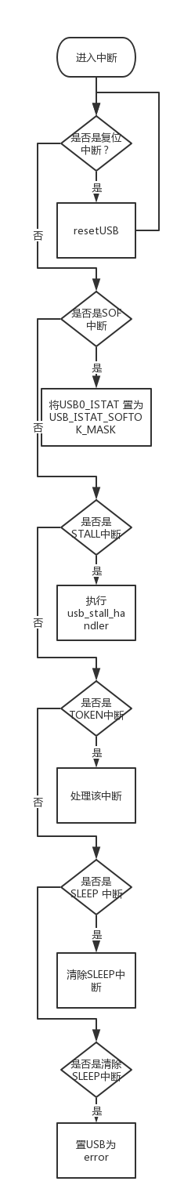

C#界面
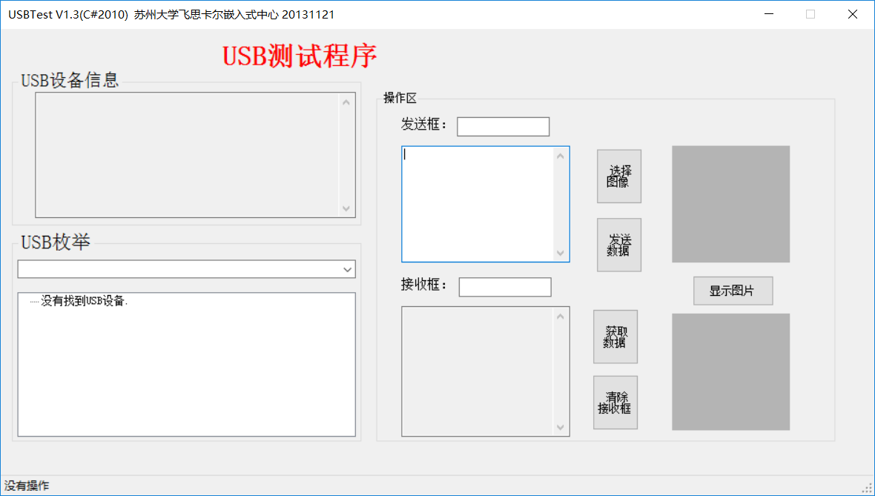
main.c

#include "includes.h"
#define NULL (( void * )( 0 ))

int main(void)
{
//1. 声明主函数使用的变量
uint_32 mRuncount; //主循环计数器

//2. 关总中断
DISABLE_INTERRUPTS;
//3. 初始化外设模块
light_init(RUN_LIGHT_BLUE,LIGHT_OFF); //初始化蓝色RUN灯
uart_init(UART_0,MCGIRCLK, 9600);//串口0初始化,串口0时钟源MCGIRCLK(4000Khz),波特率9600
uart_init(UART_1,BUSCLK, 9600); //串口1初始化, 总线时钟24000Khz,波特率9600
uart_init(UART_2,BUSCLK, 9600); //串口2初始化, 总线时钟24000Khz,波特率9600
uart_send_string(UART_1, "This is USBDevice Test!\r\n");
usb_init();
//4. 给有关变量赋初值
PackCount=0; //接收的包的数目
RecvCount=0; //待接收的数据包的数据
Read_flag=0; //USB读标志
SendDataBuff=NULL;
SendDataLength = 0;
SendImageOk=1;
//5. 使能模块中断
//6. 开总中断
ENABLE_INTERRUPTS;

//进入主循环
//主循环开始=============================================================
for(;;)
{
mRuncount++;
if (mRuncount > RUN_COUNTER_MAX)
{
mRuncount = 0;
light_change(RUN_LIGHT_BLUE); //蓝色运行指示灯（RUN_LIGHT_BLUE）状态变化
}

if(RecvFinish == 1) //数据包的已经接收完
{
disable_irq(USB_INTERRUPT_IRQ); //禁止USB中断
//擦除两个扇区待用,共2KB
flash_erase(122);
flash_erase(123);
//开始写
if(RecDataLength>1024)
{
if( (flash_write(122,0,1024,RecDataBuff)==0) &&
(flash_write(123,0,RecDataLength-1024,&RecDataBuff[1024]))==0)
{
uart_send_string(UART_1,"Write Flash OK\n");
//uart_sendN(UART_1,RecDataLength,RecDataBuff);
}
else
{
uart_send_string(UART_1,"Write Flash Error\n");
}
}
else
{
if((flash_write(122,0,RecDataLength,RecDataBuff))==0)
{
uart_send_string(UART_1,"Write Flash OK\n");
//uart_sendN(UART_1,RecDataLength,RecDataBuff);
}
else
{
uart_send_string(UART_1,"Write Flash Error\n");
}

}
enable_irq(USB_INTERRUPT_IRQ); //使能USB中断
RecvFinish=0; //接收完成标志清0
}

if(Read_flag == 1)
{
if(RecDataLength>1024)
{
flash_read(122,0,1024,RecDataBuff);
flash_read(123,0,RecDataLength-1024,&RecDataBuff[1024]);
uart_send_string(UART_1,"Read Flash OK\n\n");
//uart_sendN(UART_1,RecDataLength,RecDataBuff);
Read_flag=0;
}
else
{
flash_read(122,0,RecDataLength,RecDataBuff);
uart_send_string(UART_1,"Read Flash OK\n\n");
uart_sendN(UART_1,RecDataLength,RecDataBuff);
Read_flag=0;
}
disable_irq(USB_INTERRUPT_IRQ); //禁止USB中断
SendDataLength=RecDataLength;
SendDataBuff=RecDataBuff;
enable_irq(USB_INTERRUPT_IRQ); //使能USB中断
}

//以下加入用户程序--------------------------------------------------------
}//主循环end_for
//主循环结束==================================================================
return 0;
}

isr,c
//===========================================================================
//文件名称：isr.c
//功能概要： 中断底层驱动构件源文件
//版权所有：苏州大学飞思卡尔嵌入式中心(sumcu.suda.edu.cn)
//更新记录：2012-11-12 V1.0
//===========================================================================
#include "includes.h"
//========================中断函数服务例程===============================
//USB中断服务例程
void isr_usb(void)
{
// 复位中断
if(FLAG_CHK(USB_ISTAT_USBRST_SHIFT,USB0_ISTAT))
{

usb_reset_handler();
return;
}

//SOF中断
if(FLAG_CHK(USB_ISTAT_SOFTOK_SHIFT,USB0_ISTAT))
{
USB0_ISTAT = USB_ISTAT_SOFTOK_MASK;
}

// STALL中断
if(FLAG_CHK(USB_ISTAT_STALL_SHIFT,USB0_ISTAT))
{
usb_stall_handler();
}

//TOKEN中断
if(FLAG_CHK(USB_ISTAT_TOKDNE_SHIFT,USB0_ISTAT))
{
FLAG_SET(USB_CTL_ODDRST_SHIFT,USB0_CTL);
// USB 处理函数
usb_handler();
// 清除令牌完成中断
FLAG_SET(USB_ISTAT_TOKDNE_SHIFT,USB0_ISTAT);
}

// SLEEP 中断
if(FLAG_CHK(USB_ISTAT_SLEEP_SHIFT,USB0_ISTAT))
{
// 清除SLEEP中断
FLAG_SET(USB_ISTAT_SLEEP_SHIFT,USB0_ISTAT);
}

//错误中断
if(FLAG_CHK(USB_ISTAT_ERROR_SHIFT,USB0_ISTAT))
{
FLAG_SET(USB_ISTAT_ERROR_SHIFT,USB0_ISTAT);
}
}

C#程序
namespace USBTest
{
public partial class USBTest : Form
{

private void USBTest_Load(object sender, EventArgs e)
{
refreshDeviceList();

}

#region 跨线程调用和数据传递
public delegate void setText(Control frm, string sTemp);
void showText(Control obj, string text)
{
if (obj.InvokeRequired)
{
setText st = new setText(showText);
this.Invoke(st, new object[] { obj, text });
}
else
{
obj.Text = text;
}
}
#endregion

#region USB参数设置
int myPID = 0x2016; //产品ID
int myVID = 0x4031; //供应商ID
#endregion

USB usbTest;
public USBTest()
{
InitializeComponent();
usbTest = new USB(myVID, myPID);
usbTest.UsbDeviceNotifier.OnDeviceNotify += OnDeviceNotifyEvent;
usbTest.USBDataReceived += OnRxEndPointData;
}

//声明委托：用于跨越线程设置文本框的内容
public delegate void SetTextControlCallBack(string text, int type, bool
appendOrSet, Control control);

///-----------------------------------------------------------------*
/// <summary>
/// 设置控件内容
/// </summary>
/// <param name="text">字符串</param>
/// <param name="type">文本框的类型0--Control，1--TextBox</param>
/// <param name="appendOrSet">是追加还是赋值 true-表示追加
/// false-表示赋值</param>
/// <param name="control">控件</param>
///-----------------------------------------------------------------*
private void SetTextControl(string text,
int type, bool appendOrSet, Control control)
{
//如果调用方位于创建该控件线程以外的线程时，需要获取是否要调用Invoke方法
if (this.InvokeRequired)//control
{
SetTextControlCallBack setTextCallBack = new SetTextControlCallBack
(SetTextControl);
this.Invoke(setTextCallBack,
new object[] { text, type, appendOrSet, control });
}
else //如果不是线程外的调用时：设置文本框的值
{
if (appendOrSet == true)
{
control.Text += text;
}
else
{
control.Text = text;
}
if (type == 0)
{
control.Text = "";
control.Text = text;
}
else if (type == 1)
{
control.Text += "\r\n";
//设置滚动位置
((TextBox)control).SelectionStart =
((TextBox)control).TextLength;
((TextBox)control).ScrollToCaret();//滚动到当前光标位置
((TextBox)control).SelectionLength = 0;

}
//control.Text += "\r\n";
control.Refresh();
}
}
///-----------------------------------------------------------------
/// <summary>
/// 对 象:button1
/// 事 件:Click
/// 功 能:发送数据
/// 函数调用:(1)sendData，发送数据，返回Bool
/// </summary>
/// <param name="sender"></param>
/// <param name="e"></param>
///-----------------------------------------------------------------
private void button1_Click(object sender, EventArgs e)
{

bool flag;
this.TSSLState.Text = "过程提示: 执行发送数据...";
int length,DataPackagecount;
byte[] firstPack=new byte[5];
byte[] tosend = Encoding.Default.GetBytes(sendData.Text);
//int i, j;
// byte[] temp = new byte[32];

length = tosend.Length;
DataPackagecount = (length-1) / 32 + 1;
firstPack[0] = (byte)'A';
firstPack[1] = (byte)'B';
firstPack[2] = (byte)'C';
firstPack[3] = (byte)'D';
firstPack[4] = (byte)(DataPackagecount);
flag = usbTest.sendData(firstPack,5);

Thread.Sleep(500);

//for (i = 0; i < DataPackagecount-1;i++ )
//{
// for (j = 0; j < 32;j++ )
// {
// temp[i] = tosend[32*i+j];
// }
// flag = usbTest.sendData(temp,32);
// if (flag == true)
// this.TSSLState.Text = "第"+(int)(i+1)+"包数据发送成功!";
// else
// this.TSSLState.Text = "第"+(int)(i+1)+"包数据发送失败!";
//}
//for (j = 0; j < length%32; j++)
//{
// temp[i] = tosend[32 * i + j];
//}
//flag = usbTest.sendData(temp, length%32);
//if (flag == true)
// this.TSSLState.Text = "第" + (int)(i + 1) + "包数据发送成功!";
//else
// this.TSSLState.Text = "第" + (int)(i + 1) + "包数据发送失败!";
//发送数据
flag = usbTest.sendData(sendData.Text);
//判断是否发送成功
if (flag == true)
this.TSSLState.Text += "数据发送成功!";
else
this.TSSLState.Text += "数据发送失败!";
}
///-----------------------------------------------------------------
/// <summary>
/// 对 象:button2
/// 事 件:Click
/// 功 能:接受框清空
/// 函数调用:无
/// </summary>
/// <param name="sender"></param>
/// <param name="e"></param>
///-----------------------------------------------------------------
private void button2_Click(object sender, EventArgs e)
{
recData.Text = usbTest.recData();//清空接收框数据
recCount.Text = string.Empty; //清空图像框
picRecv.Image = null; //清空图像框
}
///-----------------------------------------------------------------
/// <summary>
/// 函数名:OnDeviceNotifyEvent
/// 参 数:(1)sender,Object类型
/// (2)e,DeviceNotifyEventArgs类型
/// 功 能:接收缓冲区数据
/// 返 回:无
/// </summary>
/// <param name="textbox"></param>
/// <param name="str"></param>
///-----------------------------------------------------------------
private void OnRxEndPointData(object sender, EndpointDataEventArgs e)
{

int recDataBuffCount = e.Count;//获取数据长度
byte[] recDataBuff = new byte[recDataBuffCount];//重定义数组

if (recDataBuffCount < 1)//当长度小于1直接返回
{
return;
}

for (int i = 0; i < recDataBuffCount; i++)
{
this.TSSLState.Text = "正在接收数据....";
recDataBuff[i] = e.Buffer[i];//接收数据到数组recDataBuff
}

showText(recData, Encoding.Default.GetString(recDataBuff));
this.TSSLState.Text += "接收数据成功!";

}
///-----------------------------------------------------------------
/// <summary>
/// 函数名:OnDeviceNotifyEvent
/// 参 数:(1)sender,Object类型
/// (2)e,DeviceNotifyEventArgs类型
/// 功 能:判断是否是指定设备
/// 返 回:无
/// </summary>
/// <param name="textbox"></param>
/// <param name="str"></param>
///-----------------------------------------------------------------
private void OnDeviceNotifyEvent(object sender, DeviceNotifyEventArgs e)
{
//判断是否插入设备
if (e.EventType == EventType.DeviceArrival)
{
//看看目前新连接的USB设备是不是目标设备
if (e.Device.IdProduct == myPID && e.Device.IdVendor == myVID)
{
//发现目标设备并打开该设备
if (!usbTest.connectionStatus)
{
this.TSSLState.Text = "USB设备打开失败";
throw new Exception("USB设备打开失败");
}
else
{
this.TSSLState.Text = "插入USB设备是目标设备";
refreshDeviceList();
this.cboDevices.SelectedIndex = 0;
string str = usbTest.MyUsbDevList.Count.ToString();
SetTextControl(e.Device.ToString(), 1, true, this.TbEnumerationMsg);
SetTextControl("已连接的设备:" + str, 1, true, this.TbEnumerationMsg);
}
}
else
{
this.TSSLState.Text = "插入USB设备不是目标设备";

}
}
else if (e.EventType == EventType.DeviceRemoveComplete)
{
//看看目前移除的USB设备是不是目标设备
if (e.Device.IdProduct == myPID && e.Device.IdVendor == myVID)
{
usbTest.CloseUSB();//关闭USB设备
this.TSSLState.Text = "移除的USB设备是目标设备";
refreshDeviceList();
this.cboDevices.Text = "";
this.TbEnumerationMsg.Text = "";

}
else
{
this.TSSLState.Text = "移除的USB设备不是目标设备";

}
}
}
///-----------------------------------------------------------------
/// <summary>
/// 对 象:USBTest
/// 事 件:FormClosed
/// 功 能:关闭USB接口
/// 函数调用:无
/// </summary>
/// <param name="sender"></param>
/// <param name="e"></param>
///-----------------------------------------------------------------
private void USBTest_FormClosed(object sender, FormClosedEventArgs e)
{
try
{
usbTest.CloseUSB();//关闭USB设备
}
catch { }
}
///-----------------------------------------------------------------
/// <summary>
/// 函数名:addDevice
/// 参 数:(1)deviceReg,UsbRegistry类型
/// 功 能: 添加描述符
/// 返 回:无
/// </summary>
/// <param name="textbox"></param>
/// <param name="str"></param>
///-----------------------------------------------------------------
private void addDevice(UsbRegistry deviceReg)
{
if (!deviceReg.Open(out usbTest.MyUsbDevice)) return;
usbTest.MyUsbRegistry = deviceReg;

TreeNode tvDevice = tvInfo.Nodes.Add("设备描述符");
string[] sDeviceAdd = usbTest.MyUsbDevice.Info.ToString().Split(new char[] { '\r', '\n' }, StringSplitOptions.RemoveEmptyEntries);
foreach (string s in sDeviceAdd)
tvDevice.Nodes.Add(s);

foreach (UsbConfigInfo cfgInfo in usbTest.MyUsbDevice.Configs)
{
TreeNode tvConfig = tvDevice.Nodes.Add("配置描述符 " + cfgInfo.Descriptor.ConfigID);
string[] sCfgAdd = cfgInfo.ToString().Split(new char[] { '\r', '\n' }, StringSplitOptions.RemoveEmptyEntries);
foreach (string s in sCfgAdd)
tvConfig.Nodes.Add(s);

TreeNode tvInterfaces = tvConfig; //.Nodes.Add("Interfaces");
foreach (UsbInterfaceInfo interfaceInfo in cfgInfo.InterfaceInfoList)
{
TreeNode tvInterface =
tvInterfaces.Nodes.Add("接口描述符[" + interfaceInfo.Descriptor.InterfaceID + "," + interfaceInfo.Descriptor.AlternateID + "]");
string[] sInterfaceAdd = interfaceInfo.ToString().Split(new char[] { '\r', '\n' }, StringSplitOptions.RemoveEmptyEntries);
foreach (string s in sInterfaceAdd)
tvInterface.Nodes.Add(s);

TreeNode tvEndpoints = tvInterface; //.Nodes.Add("Endpoints");
foreach (UsbEndpointInfo endpointInfo in interfaceInfo.EndpointInfoList)
{
TreeNode tvEndpoint = tvEndpoints.Nodes.Add("端口0x" + (endpointInfo.Descriptor.EndpointID).ToString("X2"));
string[] sEndpointAdd = endpointInfo.ToString().Split(new char[] { '\r', '\n' }, StringSplitOptions.RemoveEmptyEntries);
foreach (string s in sEndpointAdd)
tvEndpoint.Nodes.Add(s);
}
}
}
usbTest.MyUsbDevice.Close();
}
///-----------------------------------------------------------------
/// <summary>
/// 对 象:cboDevices
/// 事 件:SelectedIndexChanged
/// 功 能:当SelectedIndex值改变时调用此函数
/// 函数调用:无
/// </summary>
/// <param name="sender"></param>
/// <param name="e"></param>
///-----------------------------------------------------------------
private void cboDevices_SelectedIndexChanged(object sender, EventArgs e)
{
if (cboDevices.SelectedIndex >= 0)
{
tvInfo.Nodes.Clear();
addDevice(usbTest.MyUsbDevList[cboDevices.SelectedIndex]);
}
}
///-----------------------------------------------------------------
/// <summary>
/// 函数名:refreshDeviceList
/// 参 数:无
/// 功 能: 重置treeview和comboBox
/// 返 回:无
/// </summary>
/// <param name="textbox"></param>
/// <param name="str"></param>
///-----------------------------------------------------------------

private void refreshDeviceList()
{
cboDevices.SelectedIndexChanged -= cboDevices_SelectedIndexChanged;
usbTest.MyUsbDevList = UsbDevice.AllDevices;
cboDevices.Sorted = false;
cboDevices.Items.Clear();
foreach (UsbRegistry device in usbTest.MyUsbDevList)
{
string sAdd = string.Format("Vid:0x{0:X4} Pid:0x{1:X4} (rev:{2}) - {3}",
device.Vid,
device.Pid,
(ushort)device.Rev,
device[SPDRP.DeviceDesc]);

cboDevices.Items.Add(sAdd);
}
cboDevices.SelectedIndexChanged += cboDevices_SelectedIndexChanged;

if (usbTest.MyUsbDevList.Count == 0)
{
tvInfo.Nodes.Clear();
tvInfo.Nodes.Add("没有找到USB设备.");
}
}

private void button3_Click(object sender, EventArgs e)
{
OpenFileDialog openfile = new OpenFileDialog();
openfile.Title = " 请选择图片";
openfile.Filter = "图片 (*.jpg;*.bmp;*png)|*.jpeg;*.jpg;*.bmp;*.png|AllFiles(*.*)|*.*";
if (DialogResult.OK == openfile.ShowDialog())
{
try
{
// 读取图片，转换为字符数组
byte[] bytes = File.ReadAllBytes(openfile.FileName);
// 用Base64编码
string base64buffer = Convert.ToBase64String(bytes);
sendData.Text = base64buffer;

showText(sendCount, (sendData.Text.Length).ToString());
this.picSend.ImageLocation = openfile.FileName; //显示图片
this.picSend.SizeMode = PictureBoxSizeMode.Zoom;
}
catch
{
}
}
}

private void button4_Click(object sender, EventArgs e)
{
bool flag;
this.TSSLState.Text = "过程提示: 发送读数据命令...";
byte[] temp;

temp = new byte[4];
temp[0] = (byte)'R';
temp[1] = (byte)'E';
temp[2] = (byte)'A';
temp[3] = (byte)'D';
//发送数据
flag = usbTest.sendData(temp, 4);
//判断是否发送成功
if (flag == true)
this.TSSLState.Text += "读命令发送成功!";
else
this.TSSLState.Text += "读命令发送失败!";
}

private void ShowPictureClick_Click(object sender, EventArgs e)
{
string str = string.Empty;
str = this.recData.Text; //获取接收框数据
byte[] bytes = Convert.FromBase64String(str); //转化为字符数组

showText(recCount, (recData.Text.Length).ToString()); //显示接收到数据的长度
picRecv.Image = System.Drawing.Image.FromStream(new MemoryStream(bytes));
this.picRecv.SizeMode = PictureBoxSizeMode.Zoom; //在图像框里按原比例显示图像
}

}

}

四．实验总结
通过此次试验大致了解了将开发板作为USB的执行过程。

