Sesiunea de Comunicări Științifice Studențești 2026

MOBILE APPLICATION FOR FLOODING FORECASTING AND PREVENTION

GEORGESCU Gabriel¹, VOICU Delia-Andreea², VODĂ Flavia-Alexandra³, TOMESCU Vlad-Costin⁴, IVAN Andrei Mario
¹Faculty: IIR, Specialization: Industrial Informatics, Year: III, e-mail: gabriel.georgescu04@stud.fiir.upb.ro
²Faculty: IIR, Specialization: Industrial Informatics, Year: I
³Faculty: IIR, Specialization: Robotics (English), Year: II
⁴Faculty: IIR, Specialization: Robotics (Romanian), Year: II

ABSTRACT: FloodGuard predicts floods on industrial sites and tells the workers about it. Per site, it produces a rolling 48-hour risk forecast. If the risk climbs, the predicted inundation zone gets pushed straight to the phones of workers and safety managers. The data is free and all European: Copernicus Sentinel-1 SAR, EFAS, GloFAS through Open-Meteo, plus Open-Meteo’s own precipitation feed. Two parts make up the system, a Python FastAPI backend and a Flutter client. The paper covers our architecture, the data-fusion approach, the mobile UI, and end-to-end validation.
KEYWORDS: flood forecasting, industrial safety, Copernicus, EFAS, GloFAS, mobile application, FastAPI, Flutter.
1. Introduction
Floods cause the biggest economic losses out of any natural hazard in Europe, and industrial sites tend to take the worst of it. Plants get built next to rivers or on the coast because that is where shipping happens, so once the water arrives there is no quick way to clear them out. And the water is rarely the whole problem at a chemical plant or refinery. Spills follow it. Electrical fires. Contaminated runoff.
Free European flood data does exist. The trouble is granularity. National warnings cover whole river basins. Consumer weather apps target people on the couch, not someone in a hard hat on a factory floor. What FloodGuard does is take that public data, fuse it into a single per-site risk score, and push the result into a Flutter client that also handles evacuation routing and a man-down SOS. The remainder of the paper covers architecture, score construction, the mobile interface, and our testing approach.
2. State of the Art
EFAS forecasts ten days ahead on a 5 km European grid. GloFAS reaches thirty days, globally. Both are open in name. In practice you need Climate Data Store credentials and the cdsapi async job model, neither of which fits a backend that wants a fresh snapshot every thirty minutes. Sentinel-1 SAR sees water surfaces through any weather and at night, which is great, except for the six-day revisit interval. That kills it for live forecasting, so we treat it strictly as a confirmation source.
Open-Meteo wraps a handful of national weather models behind one hourly API. EU-hosted, no key. Their Flood API exposes GloFAS-derived discharge forecasts in the same shape, and that ended up being our base layer. The paid options (FloodFlash, Previsico, FM Global) all want a subscription and proprietary sensors. The open-source ones target hydrologists or post-event mapping. As far as we can find, none of them push public-data forecasts directly to a worker’s phone.
3. System Architecture
Two pieces: a Python FastAPI backend, and a Flutter mobile app. The backend stores configured sites with their thresholds, drives the forecast pipeline, persists each new snapshot, and broadcasts it out to whatever clients happen to be connected. The mobile app displays the latest forecast, lets a worker change their own status, walks them through evacuation, and fires the SOS. Communication goes over REST and a WebSocket stream.
Backend stack: Python 3.11, FastAPI, SQLite during development, PostgreSQL with PostGIS in production, plus httpx and Pydantic. Internally we kept the modules pretty boring: configuration, database schema, forecast aggregation, the sites REST API, a push-token registry, the scheduler, mobile worker endpoints, and thin wrappers over Sentinel Hub, EFAS, and the OpenStreetMap Overpass API. The Flutter side leans on flutter_map, web_socket_channel, and flutter_local_notifications. It holds no forecast state of its own. Every screen either pulls from the backend or reacts to a WebSocket event.
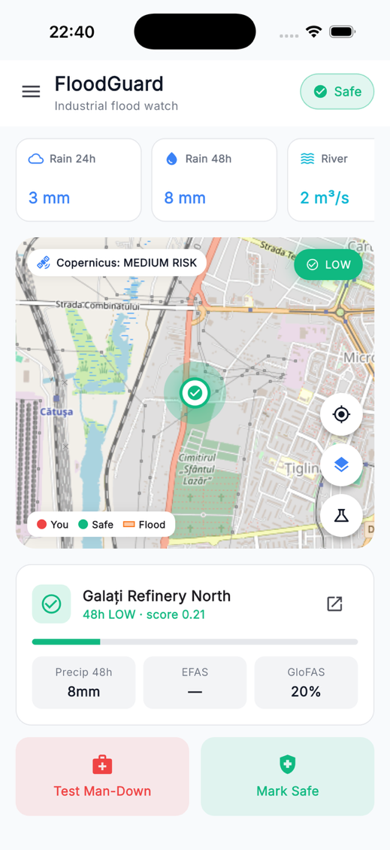
Fig. 1. FloodGuard high-level system architecture
4. Data Fusion and Risk Aggregation
Four free data sources feed FloodGuard. Open-Meteo gives us hourly precipitation forecasts, which we sum into 24- and 48-hour totals. The Open-Meteo Flood API hands over daily river discharge from GloFAS. We keep the maximum across the next two days, normalise it against a baseline (a rolling 30-day mean from the API, or a configured bankfull discharge if we have one), and turn the result into a 0-to-1 probability via a piecewise-linear ramp from 1.0× to 3.0× the baseline. EFAS publishes threshold-exceedance probabilities through a WMS; a feature-info query returns the value directly. Sentinel-1 SAR comes in through the Copernicus Data Space Sentinel Hub APIs. Only for confirmation. Never for live forecasting.
The aggregate risk score is a weighted sum across four normalised drivers: 24-hour precipitation against the site threshold, 48-hour precipitation against its threshold, EFAS probability, and the GloFAS-derived probability. Every driver gets clipped to [0, 1] before weighting. Default weights are 0.25 each, with per-site tuning if an operator wants it. The final score then drops into one of five risk classes (minimal, low, medium, high, extreme) using fixed bands at 0.20, 0.40, 0.65, and 0.85. Workers only see the class and a colour. Safety managers can drill into the raw numbers when they need to.
For the moment the inundation polygons are a simplified circular expansion around the site centroid that grows with the risk class. A visual cue, not a hydrological model. The plan is to swap them out for an EU-DEM lookup at some point.
5. Forecast Pipeline and Scheduling
The forecast scheduler is an asyncio task that lives inside the FastAPI process. Every 30 minutes (FORECAST_INTERVAL_SECONDS, configurable) it iterates through every configured site, skips any whose snapshot is still fresh, fans out the four data sources in parallel via asyncio.gather, computes the score, writes the snapshot, and emits a forecast:updated event on the WebSocket stream. Sites that land at high or extreme also fire an alert:new. A failure on any individual site is logged and the cycle moves on. POST /api/forecast/run runs the same cycle synchronously, which is useful for debugging or cron-style deployments.
One thing worth flagging: the scheduler is single-instance. Run more than one Uvicorn worker and each one will spin up its own copy, producing duplicate snapshots. The workaround for now is FORECAST_SCHEDULER_ENABLED=0 on the web workers, with the scheduler running as its own process. A Redis-backed lock, or APScheduler with cluster coordination, is on the roadmap.
6. Mobile Application Design
A single helper class, RiskStyle, owns the visual identity of each risk class: colour, Material icon, label, gradient. Minimal is grey, low is a safe green, medium is amber, high is orange, extreme is red. The palette is meant to read like normal safety signage. It also holds up for colourblind workers, since every colour ships with an icon and a label as well.
The dashboard puts a status pill at the top (Safe, Monitor, Need Help, or Emergency) and an alert banner that only shows up during emergencies. Most of the upper half is a hero map: OSM tiles, inundation polygons, the evacuation route, the worker’s own pulsing position marker, a static safe-point marker, and a small Copernicus risk badge in the corner. Under the map sits a forecast card with the active site, the risk class with a progress bar, and three mini-driver chips. Two action tiles at the bottom trigger Test Man-Down and Mark Safe.
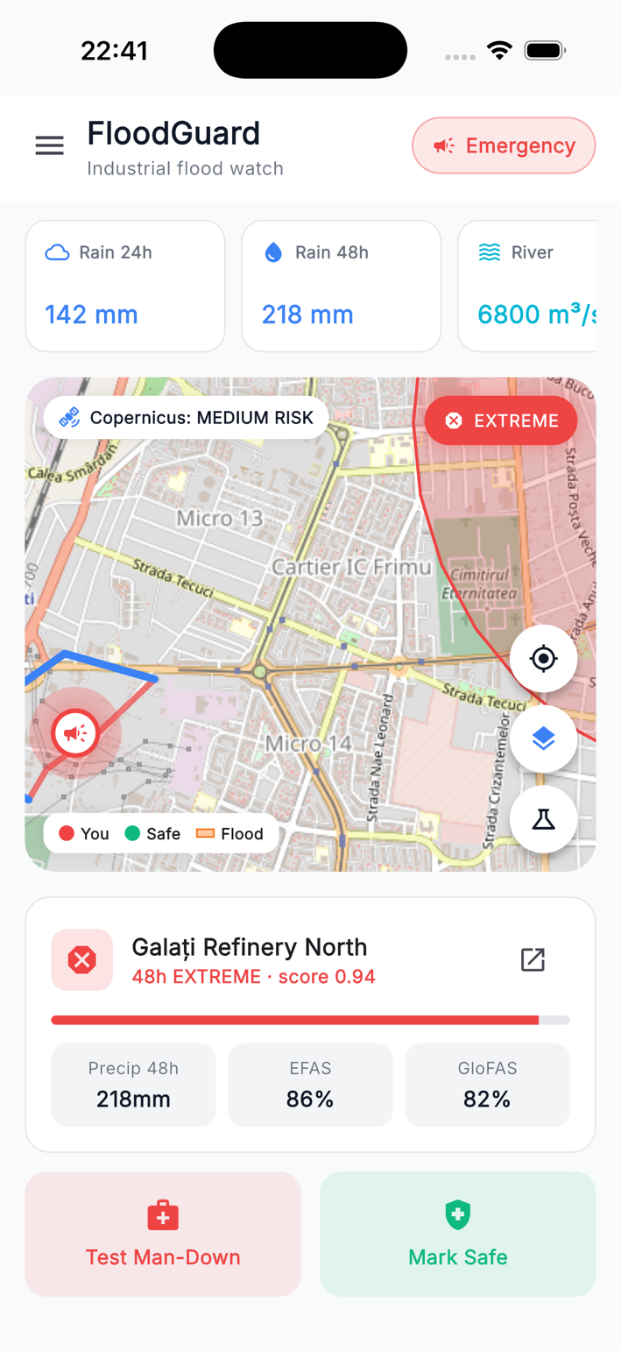
Fig. 2. Dashboard screen during an active high-risk alert
The site list screen carries a portfolio header at the top with Extreme, High, Medium, and Calm counters, followed by a list that refreshes itself on every forecast:updated event. Tap a site and the site forecast screen opens. Its hero card has a gradient background, a circular icon, the risk class spelled out in large bold letters, and a horizontal score bar. The icon pulses with a sine-wave animation when the class is high or extreme. Underneath, a six-tile grid shows the drivers behind the score: 24-hour and 48-hour precipitation, EFAS and GloFAS probabilities, the river-discharge maximum, and the baseline. A map card at the bottom shows the inundation polygon.
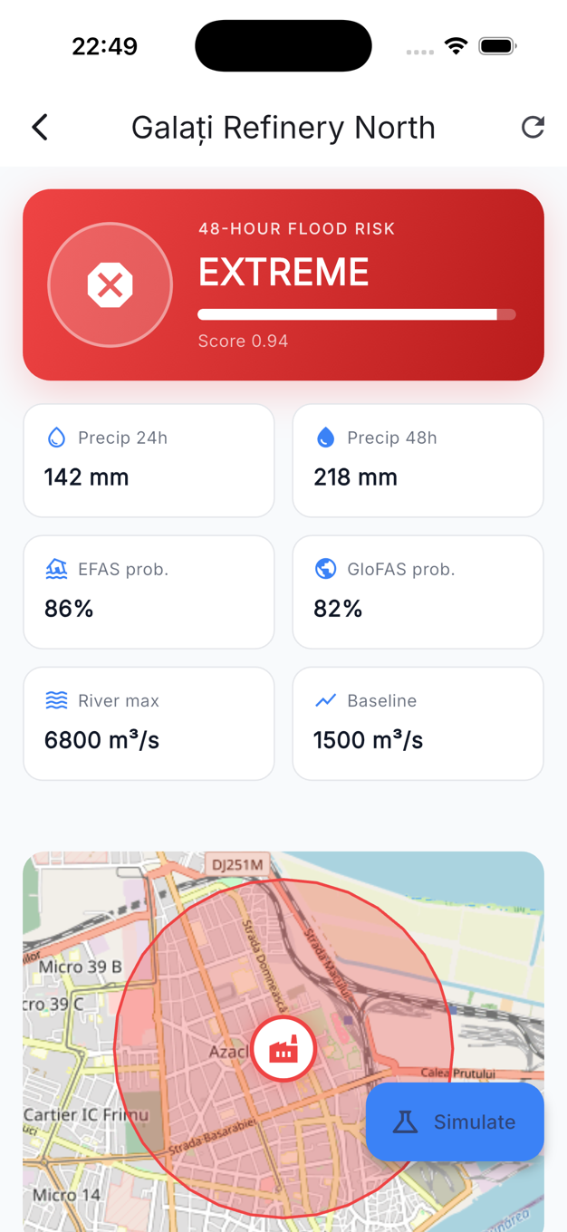
Fig. 3. Site forecast screen with extreme-risk hero card and predicted inundation
The man-down procedure runs entirely on the client. A movement watchdog tracks the GPS during an active evacuation and trips if no movement is detected for sixteen seconds. The screen turns red, a thirty-second countdown starts, and audio plays through flutter_tts. Tapping I’M FINE marks the alert as accidental. If the countdown lapses, the SOS is committed with the worker’s GPS coordinates and mobility profile, and broadcast as alert:mobile_emergency.
For push delivery we picked the WebSocket stream plus flutter_local_notifications instead of Firebase Cloud Messaging. When a forecast:updated or alert:new comes in, the client fires a system tray notification through the local plugin. The downside is obvious: nothing arrives if the OS has killed the app. For an industrial product where the app stays open across a worker’s whole shift, that trade-off was acceptable. ntfy.sh is on the shortlist for the killed-app case.
7. Demonstration and Validation
Real floods do not show up on demand. So we built a controlled simulation surface that drops synthetic forecast snapshots into the same database table the live ones use, and travels the exact same WebSocket broadcast path. POST /api/sites/{site_id}/simulate?level=... accepts low, medium, high, extreme, and reset. The first four each pick a preset combination of risk score, class, precipitation, and probabilities. The synthetic snapshot is committed and the same broadcasts go out as in real life. Reset clears the synthetic state and re-runs the live pipeline.
On the client this is exposed through a demo controls screen with a site dropdown, a five-tile risk grid, and Trigger Man-Down and Mark Safe buttons. Each tap goes through in a single network round trip, and system tray notifications fire for whichever risk classes are configured to alert. We deliberately did not gate the simulation behind a feature flag. Safety managers use it for worker training, administrators use it to verify push tokens are actually registered, and every simulation leaves auditable rows in the alerts and history tables.
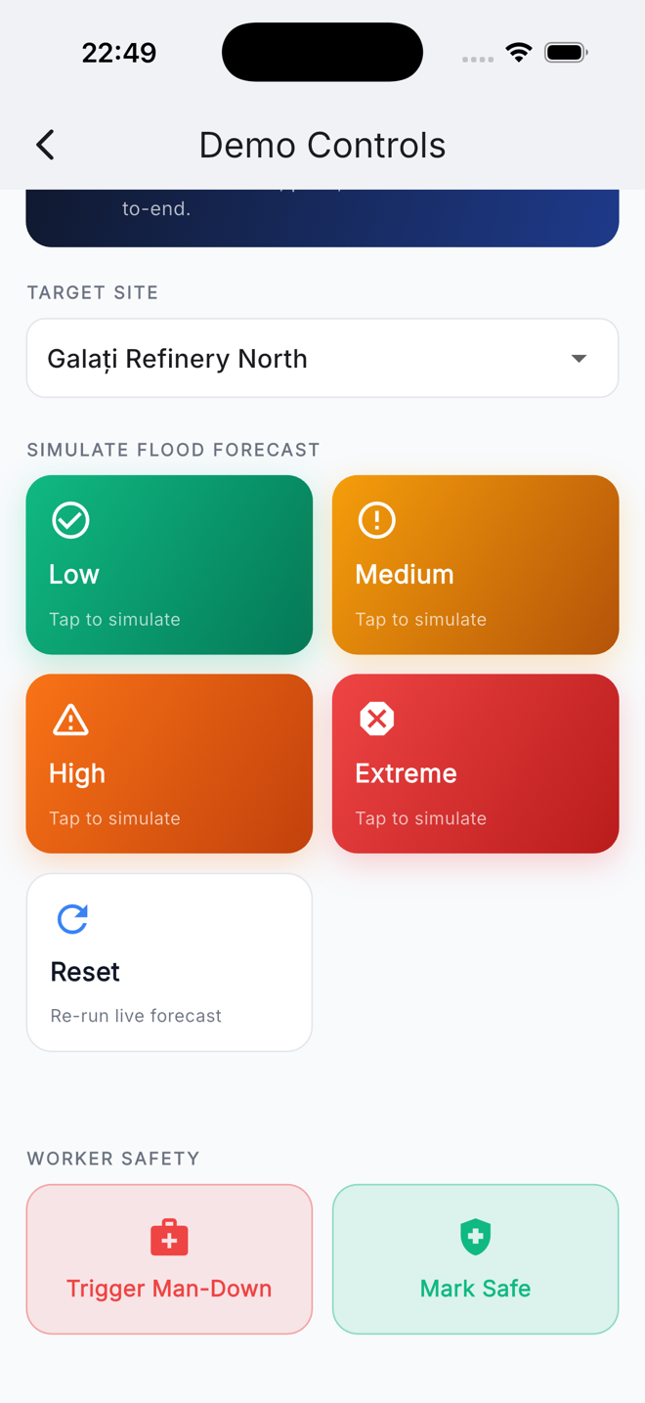
Fig. 4. Demo controls screen used for end-to-end validation
8. Conclusions
FloodGuard takes four free European data sources, mixes them into a per-site 48-hour flood risk forecast, and pushes the result to industrial workers through a Flutter client with a risk dashboard, predicted inundation polygons, and a man-down SOS. A few takeaways from building it. The fusion algorithm shows that precipitation, gridded flood probability, and river discharge can be combined into a tunable per-site score using only public data. Keeping the same risk-class palette across every screen of the Flutter interface made the UI noticeably easier to reason about during development. The man-down procedure sits on top of the forecast rather than next to it, and that is the part we are happiest with. The simulation surface lets us validate the system end to end and doubles as a training tool. And running notifications through the WebSocket plus local notifications saved us from dragging in Firebase.
Plenty is left to do. The inundation polygon generator should be replaced with a proper EU-DEM lookup. A killed-app push path through ntfy.sh would close the obvious gap in delivery. The scheduler needs a Redis-coordinated cluster setup before it ever sees more than one worker. And the Flutter client should be offline-first rather than assuming the WebSocket is always there. With those four pieces in place, FloodGuard has a credible path from a student project to something industrial safety teams could actually run, without paying anyone for a licence.
9. Bibliography
[1]. European Environment Agency (2024), Economic losses from weather- and climate-related extremes in Europe, EEA Briefing, Copenhagen, https://www.eea.europa.eu/.
[2]. Thielen, J., Bartholmes, J., Ramos, M.-H., de Roo, A. (2009), "The European Flood Alert System – Part 1: Concept and development", Hydrology and Earth System Sciences, 13 (2), 125–140, ISSN 1027-5606.
[3]. Alfieri, L., Burek, P., Dutra, E., Krzeminski, B., Muraro, D., Thielen, J., Pappenberger, F. (2013), "GloFAS – global ensemble streamflow forecasting and flood early warning", Hydrology and Earth System Sciences, 17 (3), 1161–1175, ISSN 1027-5606.
[4]. European Commission (2024), Copernicus Emergency Management Service – European Flood Awareness System, online documentation, https://www.efas.eu/.
[5]. Schumann, G. J.-P., Moller, D. K. (2015), "Microwave remote sensing of flood inundation", Physics and Chemistry of the Earth, 83-84, 84-95, ISSN 1474-7065.
[6]. Open-Meteo (2024), Free Weather and Flood Forecast API, developer documentation, https://open-meteo.com/.
[7]. ESA Copernicus (2024), Copernicus Data Space Ecosystem and Sentinel Hub APIs, online documentation, https://dataspace.copernicus.eu/.
[8]. Flutter (2024), Flutter SDK Documentation, Google LLC, https://docs.flutter.dev/.
10. Notations
Abbreviations used in this paper:
API = Application Programming Interface;
CEMS = Copernicus Emergency Management Service;
DEM = Digital Elevation Model;
EEA = European Environment Agency;
EFAS = European Flood Awareness System;
FCM = Firebase Cloud Messaging;
GloFAS = Global Flood Awareness System;
GPS = Global Positioning System;
REST = REpresentational State Transfer;
SAR = Synthetic Aperture Radar;
SOS = distress signal used by the man-down procedure;
VV = vertical-transmit, vertical-receive radar polarisation;
WMS = Web Map Service;
WebSocket = bidirectional real-time communication protocol.

