Salonga, Kyla Mae O.

2ECE-E

**DATA WRANGLING**

**PROBLEM 1:**

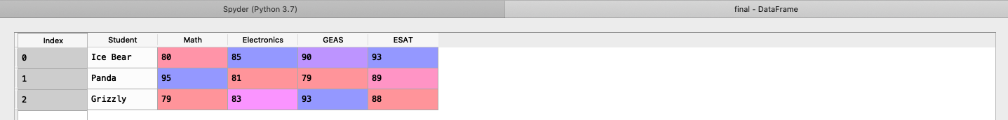

Long:

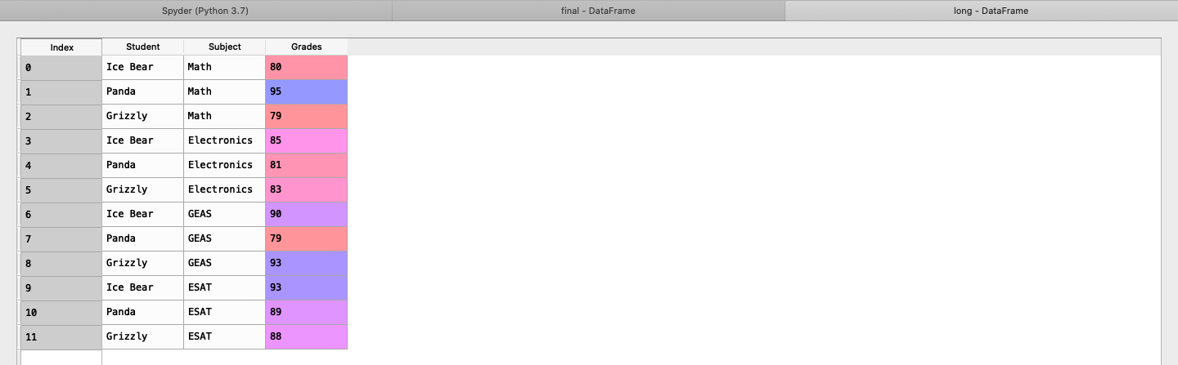

Long (tidy):

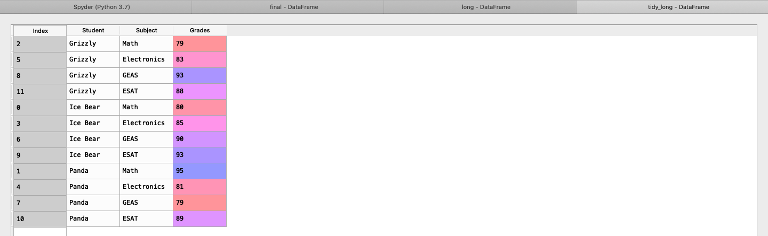

**PROBLEM 2:**

