**Salonga, Kyla Mae**

**2ECE-E**

**Python Code:**

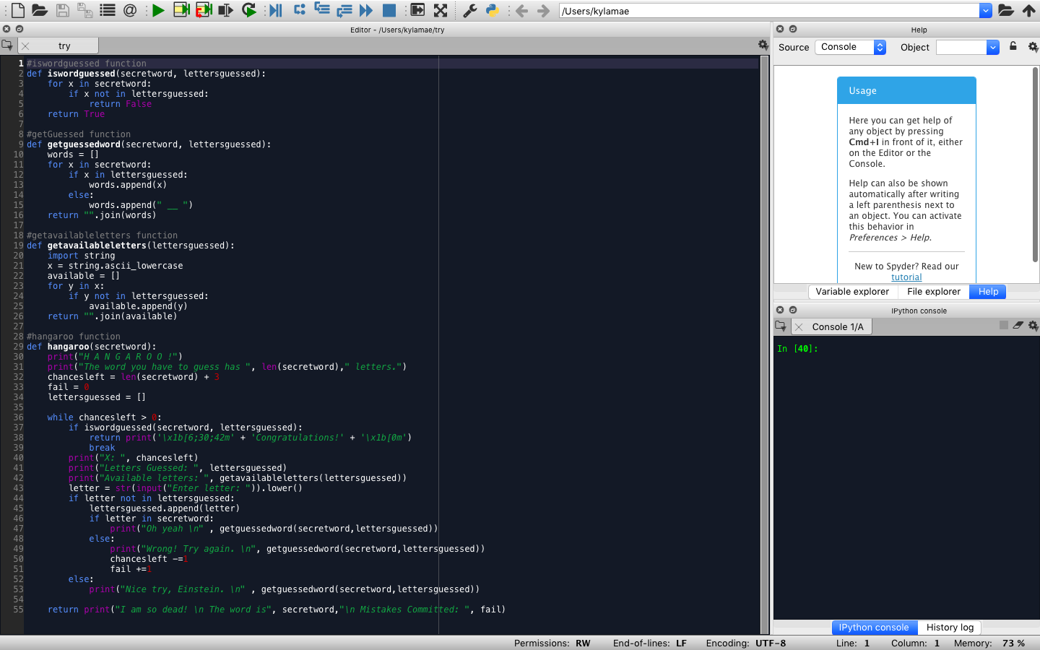

**Input word to be guessed and start the game:**

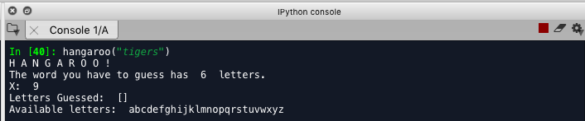

**Start guessing letters:**

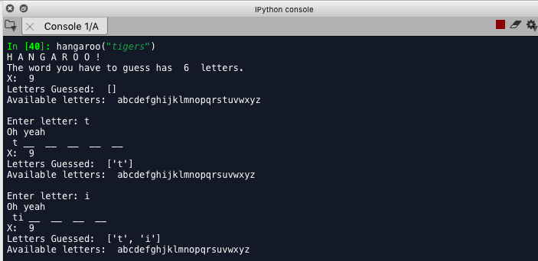

**When you input wrong answer:**

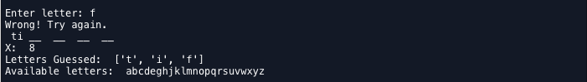

**When you finally got it right:**

