**SALONGA, KYLA MAE O.**

**2ECE-E**

**PROBLEM 1:**

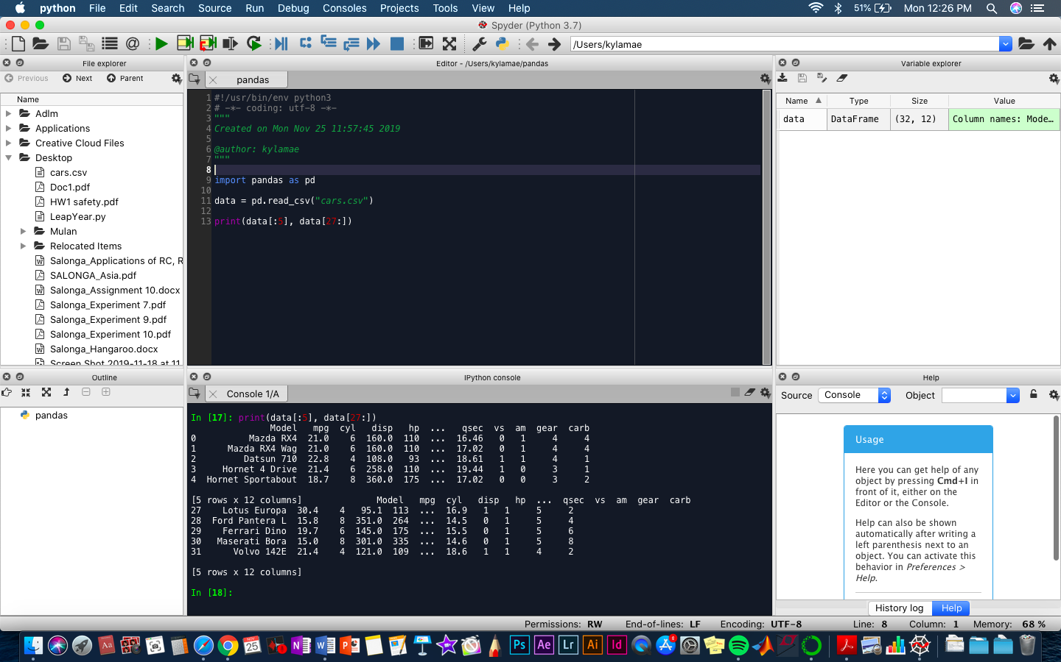

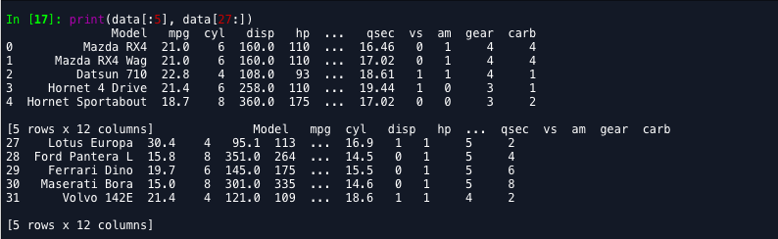

**PROBLEM 2:**

1. **Display the first five rows with odd-numbered columns of cars**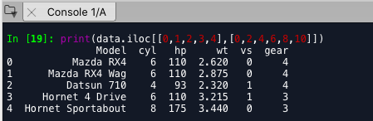
2. **Display the row that contains the model of Mazda RX4**

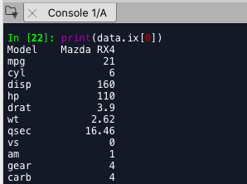

1. **How many cylinders and what gear type does the car model ‘Camaro Z28’ have?**



1. **Determine how many cylinders and what gear type do the car models ‘Mazda RX4 Wag’, ‘Ford Pantera I’, and ‘Honda Civic’ have.**

