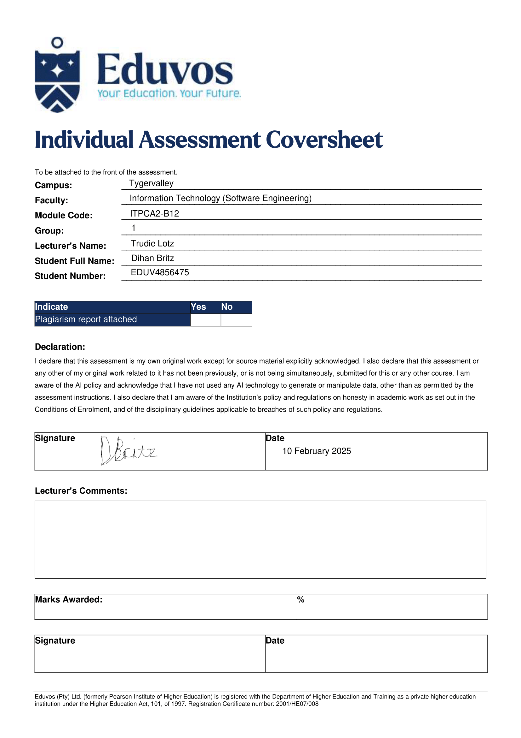



Formative Assignment

Dihan Britz

Module Code: ITPCA2-B12 Due Date: 14 March 2025

# Table of Contents

Table of Contents 1

AI Declaration 2

Disclaimer 3

Question 1 4

Question 2 5

Question 3 6

Bibliography: 7

# AI Declaration

|  |  |
| --- | --- |
| I carefully read the assignment instructions, and the extent to which AI may be used for the assignment. |  |
| I used the following AI system(s)/tool(s): |  |
| I used it for the following: |  |
| If I quoted or paraphrased an AI output, I have referenced the relevant tool, version, and the date I used the tool. |  |
| I still consider this work my own. (i.e., I have not outsourced the final product, or significant portions of it, to AI tools/systems). |  |
| If required, I can defend my argument/perspective, explain my choices and approach, and can show that I am knowledgeable about the details of my work. |  |

# Disclaimer

You can find my full work at my GitHub repository if for whatever reason you cannot access the code that this document comes with.

Link: <https://github.com/DoubledDoge/itpca2-formative>

# Question 1

{Insert code here}

# Question 2

{Insert code here}

# Question 3

1. .
2. .
3. .
4. .
5. .

# Bibliography:

**There are no sources in the current document.**