**Hyper-V Vagrant Setup.**

**Setup Hyper-V**

Open Hyper-V Manager.

1. **Create a Virtual Switch.**

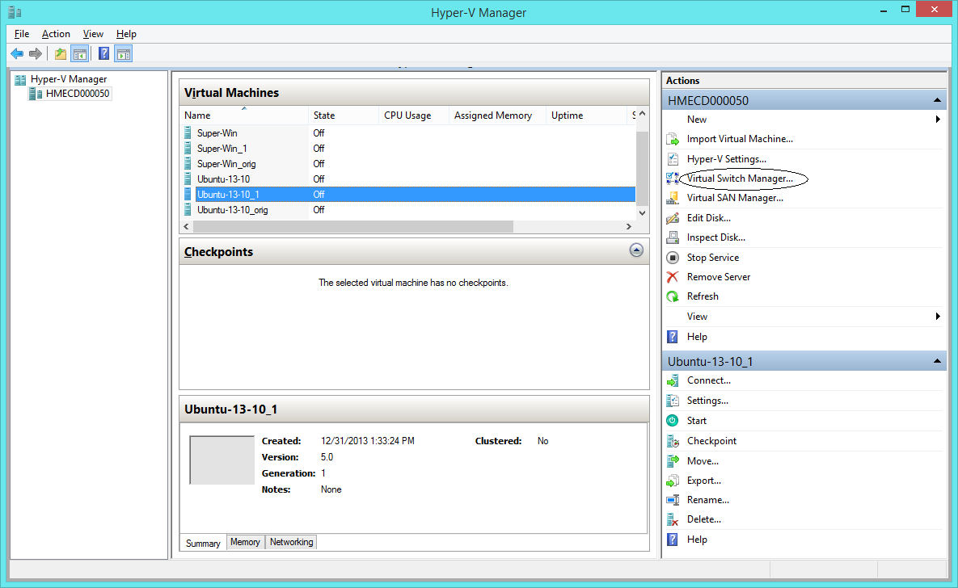

Click on Virtual Switch Manager and Create an External Switch with name External Switch, This has to be assigned to the VM which we will be creating.

Virtual Machines uses this switch to communicate with network.

Choose External and click Create Virtual Switch

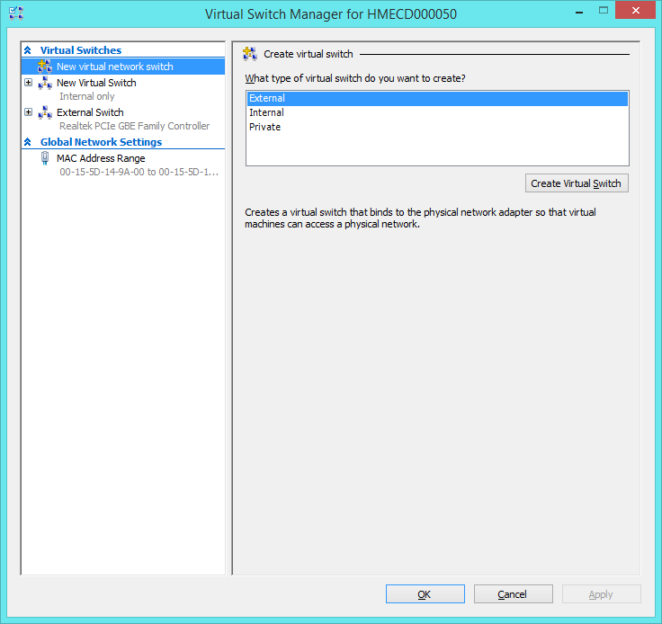

Enter name of the virtual Switch (External Switch) and click OK

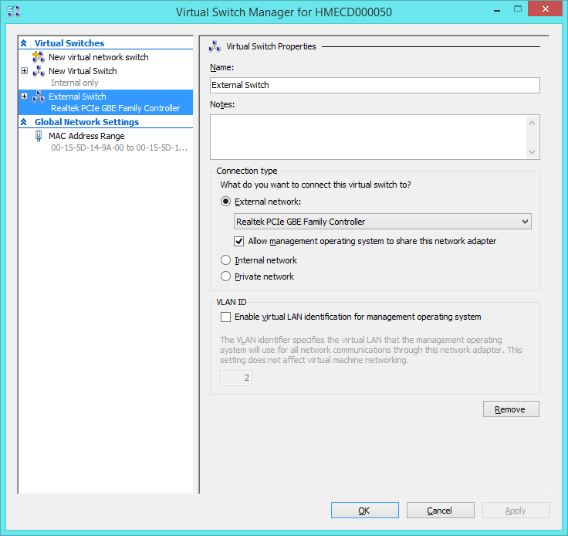

1. **Creating a Virtual Machine.**

Click on New and select Virtual Machine.

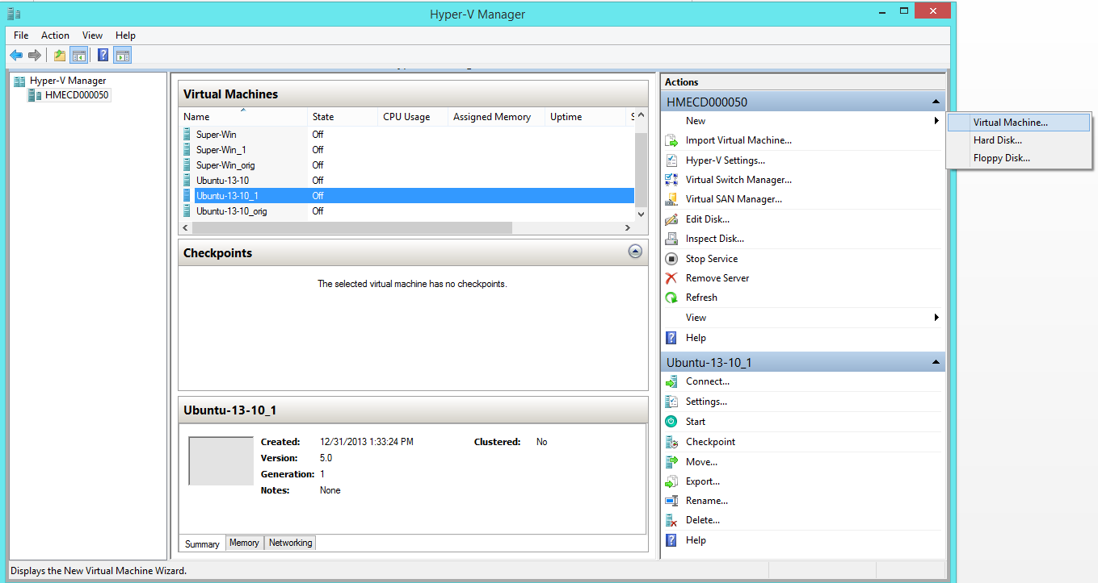

This should be a regular set up,

* Enter Virtual Machine Name
* Choose Generation 1
* Set Memory (RAM)
* When prompted for configuring networking choose the new virtual switch we just created (External Switch)
* Create virtual hard disk, set storage capacity for this virtual machine. 14 GB should be fine
* Under installation options choose the path where the ISO file for this virtual machine is available.
* Finish

1. **Installation**

Now a virtual machine is created with a network, RAM and a hard disk.

Start this machine, right click on the virtual machine name and choose start. This will boot up the machine and start the installation process.

Create a user named vagrant for the virtual machine, and set the default password to vagrant

* 1. **Windows Machine**
* Enable remote PowerShell scripting
  + Open CMD as Administrator and type the following command
  + powershell Enable-PSRemoting
* From the Host machine (Where the Hyper-V is running)
  + Open CMD as Administrator and type the command
  + powershell set-item wsman:\localhost\client\trustedhosts *
  1. **Linux Machine**

Linux machine needs the following packages to be installed

* sudo apt-get install linux-tools-3.11.0-15-generic
* sudo apt-get install hv-kvp-daemon-init

Restart the machine, after restart you should be able to see the IP address of the machine available in the Hyper-V windows under Networking tab.

Add vagrant user under suoders

* sudo visudo

Type the below line to the bottom of the file

vagrant ALL=(ALL) NOPASSWD:ALL

To save this file press ctrl + x and then press y and hit enter

To install cifs-utl for mounting windows SMB mount

* sudo apt-get install cifs-util
* Add a public and private key under /home/vagrant/ssh folder (create .ssh if not exist)

Test if the machine is assessable from other machines using the private key.

1. **Share Folder steps**

Create a local use in the host PC. Folders which are all shared with this local user will be made available in the Guest VM.

1. **VAGRANT SETUP**

**Vagrant Installer**

Download and install the current vagrant from [here](http://downloads.vagrantup.com/tags/v1.3.5) (Using Version 1.3.5) and a regular Installation.

**Install Ruby**

Download ruby for windows from [here](http://rubyinstaller.org/) (Version >= 1.9.3)

**Vagrant-Hyper-V**

Download the develop branch of vagrant-hyper-v from [here](https://github.com/MSOpenTech/vagrant)

Environment setup

* Go to Gemfile and change the path to load vagrant from
* >/ bundle install.
* Install bundler gem if not present.
* Copy a VagrantFile
* Update the vagrant file accordingly.

Creating Vagrant Box File

Export a Hyper-V VM from Hyper-V Manager. (Make sure the VM is in off state while exporting)

To the folder where the VM is exported, create a file named metadata.json which should contain the following line

{ “provider” : “hyperv” }

Being in the folder where the export copy is.

>\ c:\HashiCorp\Vagrant\embedded\gnuwin32\bin\bsdtar.exe -cvf hyperv-opstype.box metadata.json “Virtual Hard Disks” “Virtual Machines”

Adding a Box to vagrant

Open cmd terminal

>/ vagrant box add <box-name> <path_to_the_box_file>

Replace <box-name> with any name how you want to identify this box

<path_to_the_box_file> to the physical location where the .box file got generated from the above step.

**Vagrant commands.**

Open cmd ad Administrator and cd to the path where vagrant-hyper-v code is checkout from git

* Up

>/ bundle exec vagrant up –provider=hyperv

This command will create a new Virtual Machine instance to Hyper-V using the box file.

Start the VM

Share folders between the Host and the Guest VM

Sync folders / files between Host and the Guest VM

* Halt

>/ bundle exec vagrant halt

Will stop (Shut Down) the Virtual Machine

* Reload

>/ bundle exec vagrant reload

Will reload the VM (Stop and then Start)

Start process will be similar to vagrant up, it will execute the Share and Sync commands

* Status

>/ bundle exec vagrant status

Returns the status of the VM, Running / Turned off

* SSH

>/ bundle exec vagrant ssh

Establish a SSH connection with the Virtual Machine.

This command is supported only linux VM Guest

**Limitations**

* + 1. We are in a process of automating the share permissions, until then this process is to be performed manually.

Username here refers to the user which was created in Step 4, also to refer this user the correct format is machine_name\username (Since this is a local user to the host)

* + Right click on a folder name which has to be shared.
  + Select Share with and Specific people.
  + Choose find people from the dropdown
  + Change the location and select local machine.
  + Type the local user name and click check name.
  + If everything is correct the userame will change to <machine_name>\<username>
    1. The shared folder will be mounted to the Guest VM, but when the guest is windows, there is an issue in mapping the drive and remembering the Host’s credentials. One workaround is
       - Open control panel.
       - Choose view by small icons.
       - Click credential manager.
       - Choose Windows credentials.
       - Click add windows credential
       - Type network address as the host IP address (The IP address of the machine where Hyper-V is running)
       - Username: to the name of the username which was created to share folders, (machinename\username)
       - Password: Password of the username
    2. Share folders will not work for the very first time **unless** the above two workarounds are done.