Independent Scientific Manuscript Fixture
Independent Author
2026-07-13
Abstract
This synthetic manuscript tests structures not selected from either project fixture.
Table of contents

Introduction
The workflow has three parts (Figure 1).
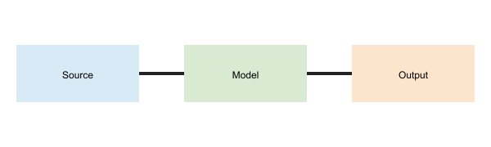
Figure 1: Source, semantic model and output

Structured content
- First stage
  - Authored content
  - Typed metadata
- Second stage
  - DOCX output
  - PDF output
Object | Identifier | Editable
Abstract | region:abstract | Yes
Version | metadata:version | Yes
The model includes the expression
$$R(t)=1−exp(−H(t)).$$

Landscape content
Property | DOCX | PDF | JATS | Expected
Heading | Native | Native | Native | Preserved
Margin | Section | Page | Omitted | Reported

References
The approach follows a synthetic reference [1].
1. A Researcher, M Partner. A synthetic reference for document testing. 2024.

This footnote verifies note preservation.

