Current website
Home page
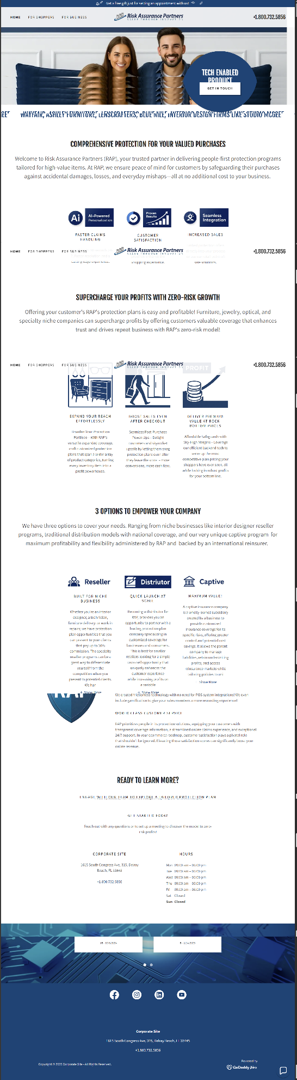

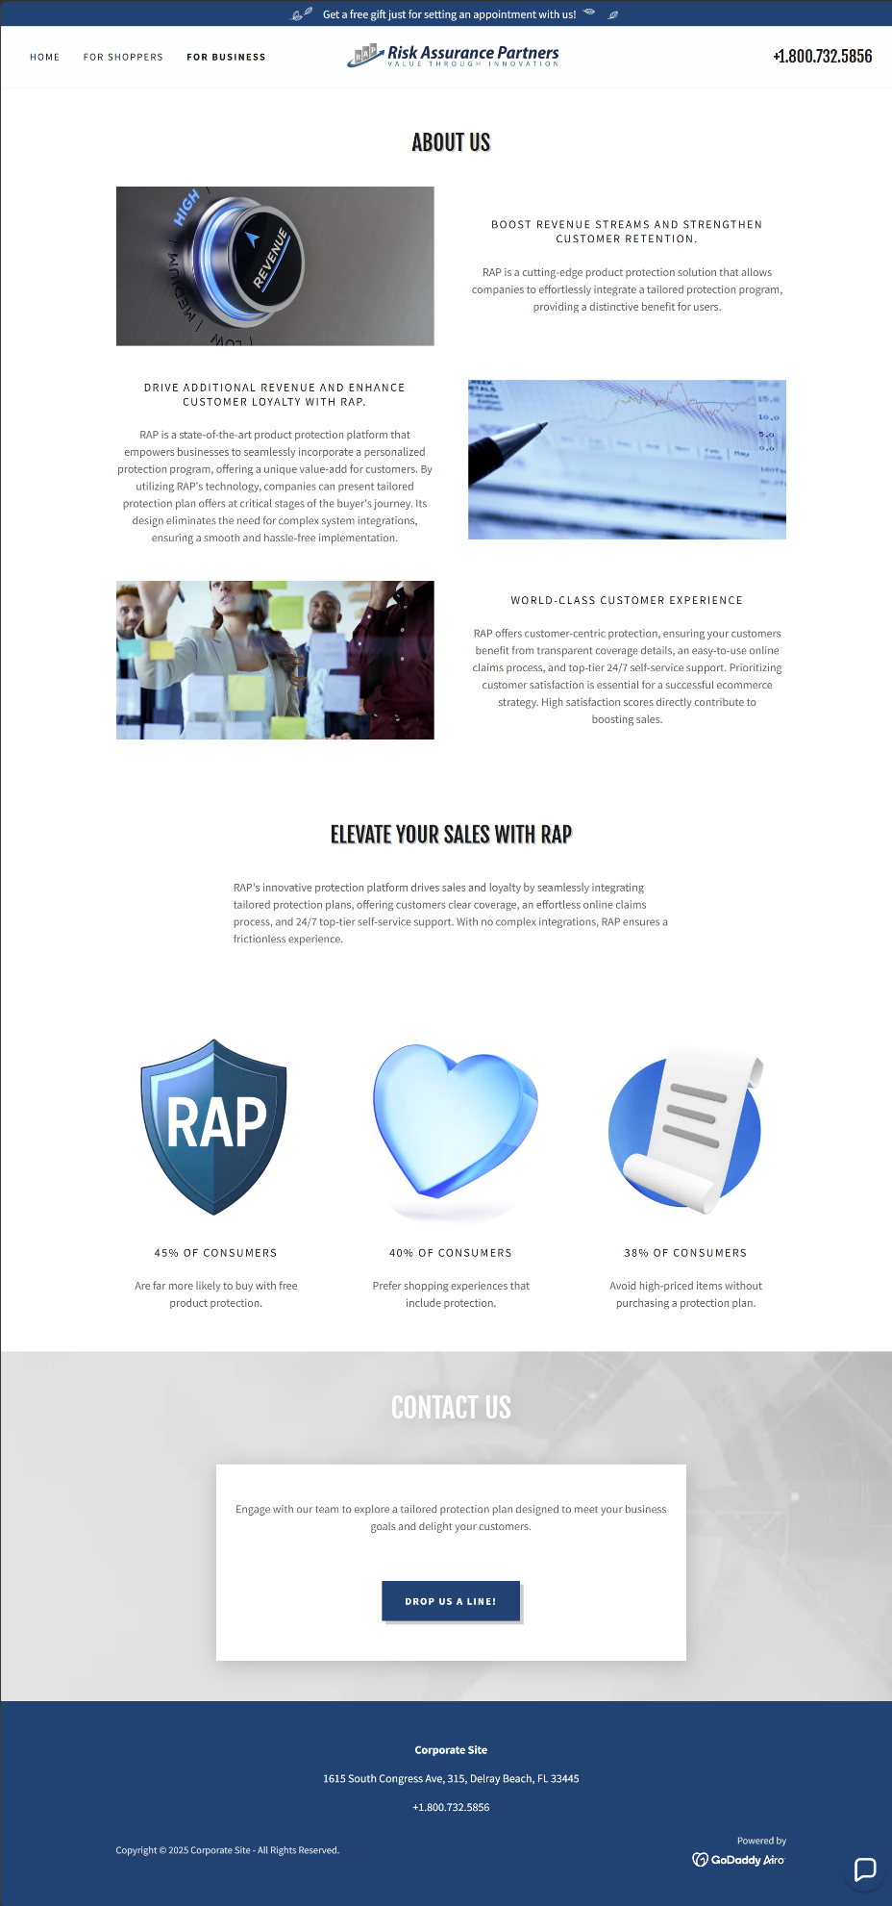
For Business page

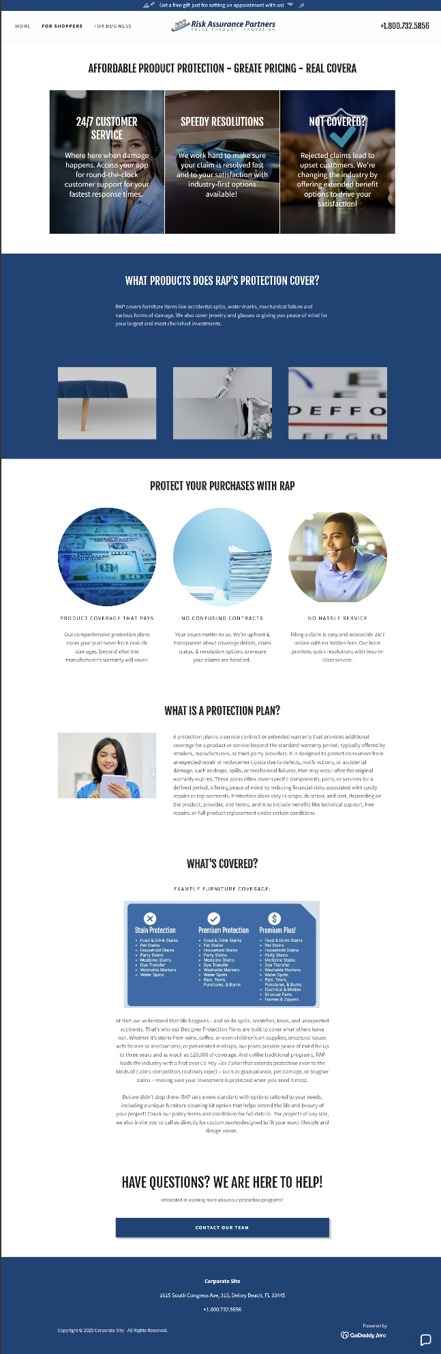
For Shoppers

