Furniture Retail Has Changed. Protection Has to Change With It.
Why a recurring protection model fits the cash-flow reality of furniture retail and the way today's customer increasingly wants to buy.
Research-expanded advertorial / blog draft | August 2026
RESEARCH AT A GLANCE
• Furniture/home-furnishings store sales averaged about $11.20B per month in Jan-Jun 2026, ~4.5% below the 2022 monthly run rate (nominal, seasonally adjusted).
• Existing-home sales were 4.06M in 2025 and the July 2026 pace was also 4.06M, versus 6.12M in 2021.
• Among Houzz renovating homeowners, 48% of Millennials bought large interior furniture in 2024, the highest share of the four age groups measured.
• 77% of U.S. consumers in a 2026 ConsumerAffairs survey said reviews are important; 80.2% said reviews had caused them to avoid a purchase.
• Chargebee found 82% want easy cancellation and 79% want a pause option when deciding whether to subscribe.

Furniture retailers are operating in a market that looks very different from the one that built the traditional protection-plan model.
Housing turnover remains weak. Demand is uneven. Tariff pressure and elevated product costs continue to challenge margins. Promotions are everywhere. Customers are delaying major purchases, trading down, and concentrating their spending around the best deal they can find. The data support the broad direction of that picture: seasonally adjusted U.S. furniture and home-furnishings store sales averaged about $11.20 billion per month from January through June 2026, roughly 4.5% below the 2022 monthly run rate in nominal dollars. The furniture industry also entered 2026 softly; by May, orders had improved to 2% above the prior-year period, but year-to-date shipments were still only flat. [1][3]
Tariffs are also no longer an abstract risk. A 25% Section 232 tariff on certain upholstered wooden products remains in effect during 2026; a scheduled increase to 30% was delayed to January 2027. That does not affect every SKU equally, but it adds another source of cost pressure in a category already operating in a promotional environment. [4]
That matters because the customer who finally decides to buy furniture has often already made a series of difficult financial decisions before the protection conversation even begins.
Research check: Existing-home sales fell from 6.12 million in 2021 to 5.03 million in 2022, then to roughly 4.1 million in 2023. Annual sales were 4.06 million in both 2024 and 2025, and the July 2026 pace was again 4.06 million. In other words, the transaction engine that traditionally feeds furniture demand has been operating near a three-decade low. [2]
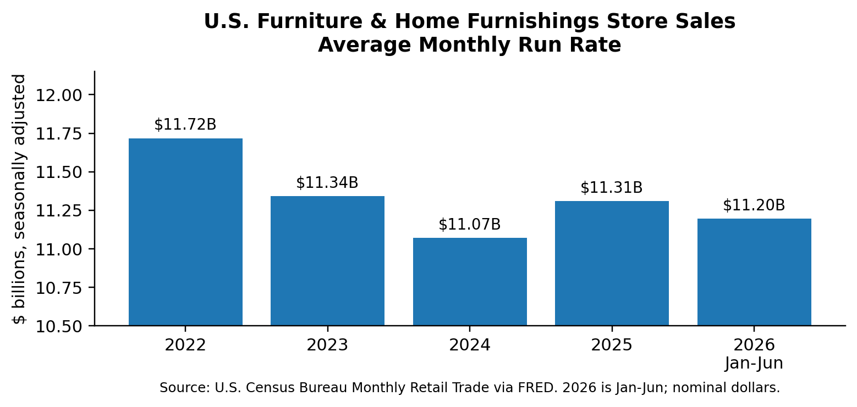
Figure 1. Furniture-store sales remain below the 2022 monthly run rate. The 2026 average shown is January-June and is not inflation-adjusted.
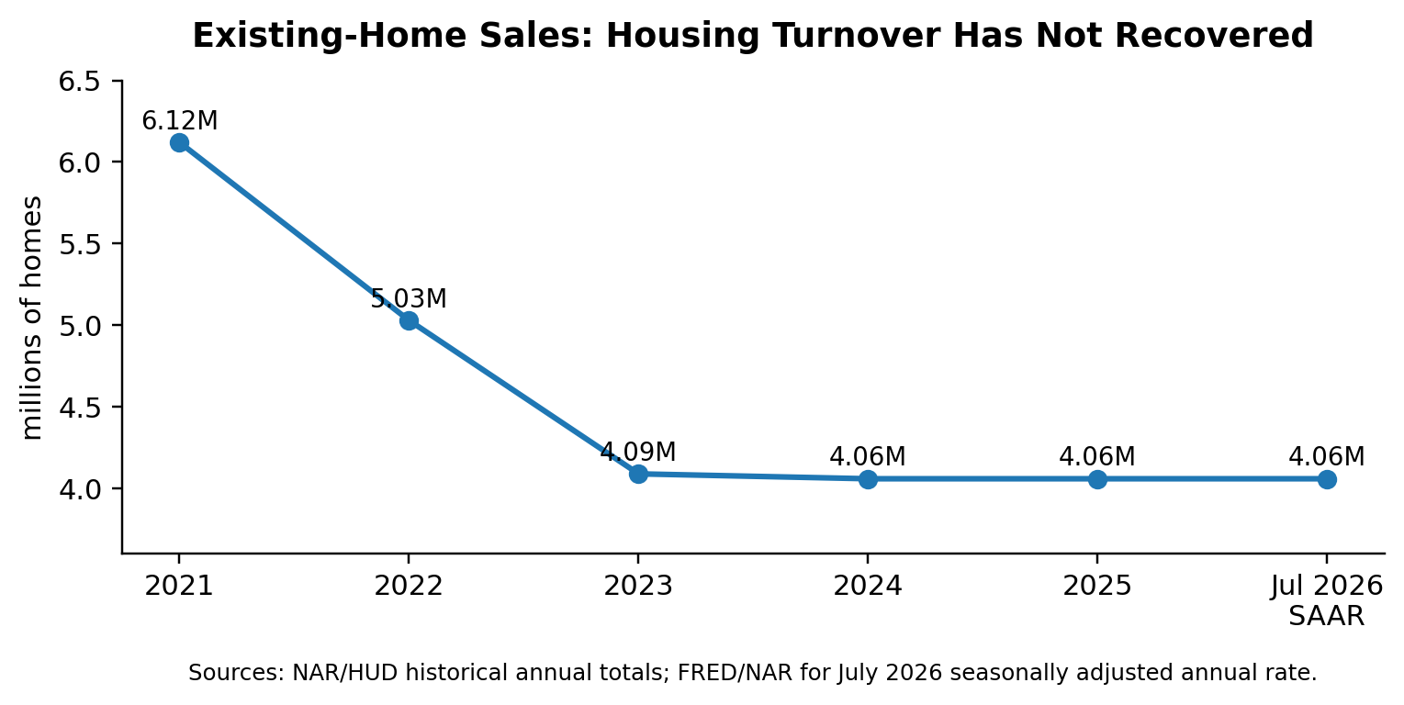
Figure 2. Existing-home sales fell sharply from the 2021 peak and have remained around 4.06 million; July 2026 is a seasonally adjusted annual rate.
They may have financed the sofa. They have accepted delivery charges. They have paid taxes. They may have stretched to complete the room rather than buy one piece at a time. By the time the associate presents a traditional multi-year protection plan, the customer is not necessarily rejecting protection itself. They may simply be rejecting one more large, upfront decision.
That interpretation is consistent with broader purchasing research. ConsumerAffairs' 2026 survey found that only about 14% of Americans felt fully comfortable making a big purchase under current economic conditions, while more than one-third described major purchases as very or extremely stressful. The survey is not furniture-specific, but it helps explain why an additional large checkout decision can encounter resistance even when the underlying product is valued. [5]

The Real Objection Is Often “Not Today”
A customer may want the furniture and understand the value of protecting it. But a conventional protection plan can make the purchase feel materially more expensive at the exact moment the customer is emotionally and financially spent.
That distinction matters.
The dealer’s first job in a difficult market is to close and preserve the merchandise sale. The goal is not to force an add-on decision that causes hesitation, reopens the total-ticket conversation, or makes the customer feel that the room is suddenly out of reach.
In today’s market, the question is not only whether a customer wants protection. It is also:
How does the customer want to buy it?

A Generational and Economic Shift
We believe a generational shift—combined with post-COVID price inflation that has become embedded in home furnishings—has fundamentally changed the market.
Customers have become accustomed to monthly payment choices, on-demand services, and the ability to retain control over recurring commitments. At the same time, they are more conscious of household budgets and less willing to accept a large additional charge at checkout simply because that is how protection has traditionally been sold.
Subscription research suggests that control is part of the value proposition itself. Chargebee's 2025 global consumer report found that 82% said easy cancellation was needed for them to subscribe, 79% wanted the option to pause, and 58% had paused rather than canceled a subscription in the prior year. Recurly's 2026 research similarly reports that 71% of consumers consider easy cancellation essential to subscription decisions. [7][8]
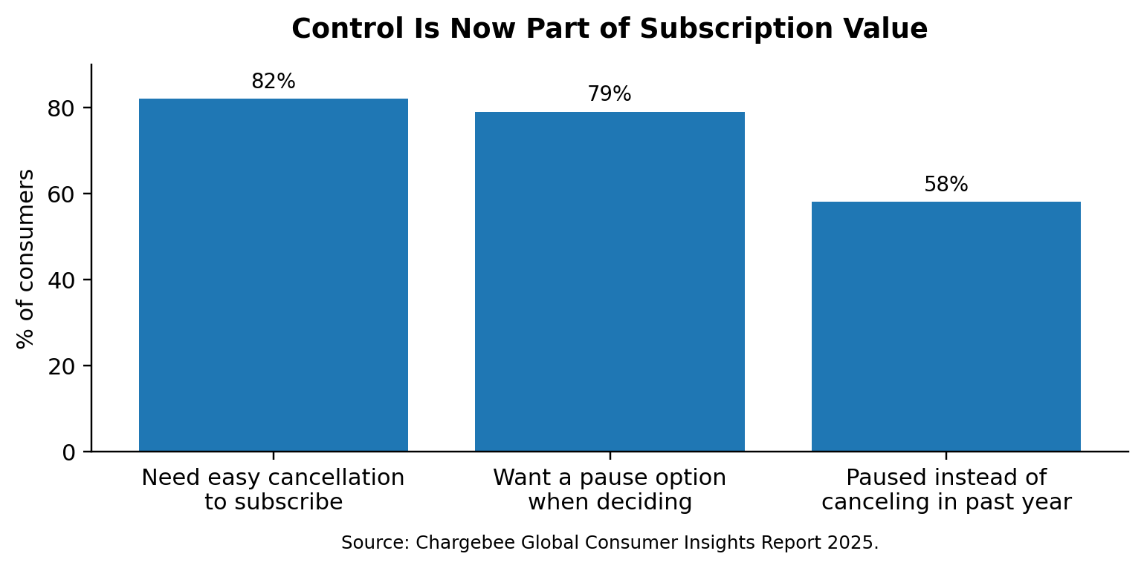
Figure 3. Subscription-control research shows why pause and easy cancellation can reduce the perceived commitment of signing up.
That does not mean the traditional multi-year protection plan is obsolete. It remains the right choice for many customers, particularly those who prefer to make one complete upfront decision.
The point is choice architecture, not replacement. A monthly option can address a different objection than a traditional plan: not 'I do not want protection,' but 'I do not want to make that entire protection purchase today.'
But it does mean that one payment format is no longer enough.

Furniture Retail Needs a New Cash-Flow Engine
The consumer shift is only one side of the story. The other is the dealer’s economic reality.
Furniture retail is capital-intensive. Dealers carry inventory, absorb freight and warehousing costs, operate showrooms, maintain delivery capacity, pay rent and payroll, finance promotions, and invest continually in advertising to keep traffic coming through the door. Those expenses arrive every month, whether sales are strong or weak.
The core furniture transaction, by contrast, is episodic. A household may buy a room of furniture today and not make another meaningful purchase for years.

The Cost of a Flat Market
When sales flatten, the dealer’s challenge is not merely moving more furniture. It is protecting free cash flow.
To maintain traffic, dealers often increase promotions and advertising. Yet more marketing spend can make each purchasing customer more expensive to acquire. Discounting can pressure merchandise margin. Tariffs, labor, freight, delivery, occupancy, and financing costs continue to absorb cash. The latest public data show why the pressure feels persistent rather than temporary. Furniture and home-furnishings store sales have been running in a relatively narrow band, while industry shipment growth has remained muted. Smith Leonard's July 2026 Furniture Insights report showed year-to-date orders up 2% through May but shipments flat with 2025. [1][3]
The result is a difficult equation:
The dealer’s expenses are recurring. The furniture sale is not.
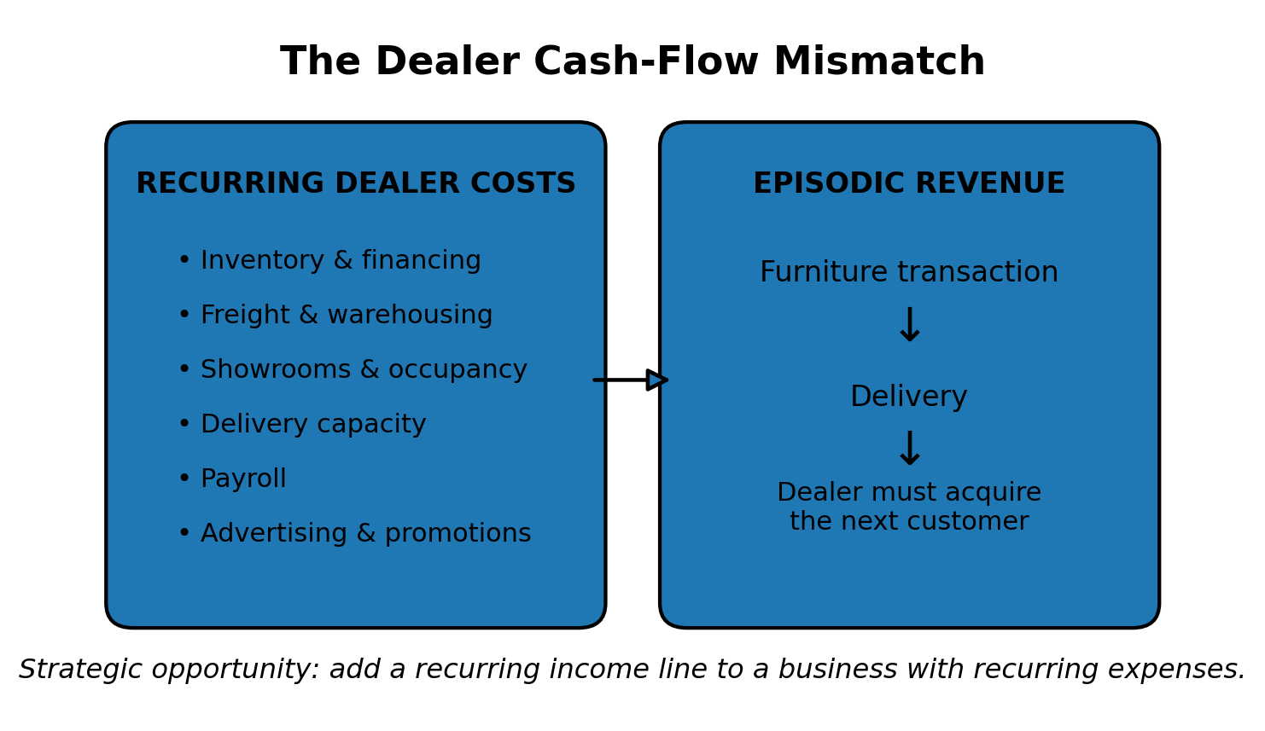
Illustration 1. The core dealer problem: recurring operating costs are funded by transactions that are episodic.

The Traditional Three-Legged Stool
For years, many furniture dealers have supported store-level economics with three income sources:
1. Furniture margin
2. Consumer credit and financing income
3. Protection-plan income
Those ancillary income streams are not incidental. They help dealers offset the fixed cost and capital intensity of selling furniture.
But the protection leg of that stool was built around a different consumer environment: one where a larger upfront protection purchase was more readily accepted at the end of the furniture transaction. Today’s payment-conscious customer may still value protection but reject the traditional purchase format.
That creates a problem for the dealer. Raising furniture prices is not a practical answer in a promotional, highly competitive market. Simply spending more on advertising is not an answer when customer-acquisition costs are already rising. And relying on a one-time upfront protection sale has a natural ceiling when customers are resisting additional cash commitments.

The Unmet Dealer Need
Dealers need a way to generate more free cash flow from every purchasing customer—without raising furniture prices, adding inventory, increasing advertising spend, expanding labor, or requiring a larger upfront ancillary sale.
That is the real need.
A viable solution must:
• Use the customer traffic the dealer already pays to acquire
• Avoid adding inventory, floor space, or material operating overhead
• Create incremental cash rather than merely moving existing income from one bucket to another
• Fit a consumer who is increasingly sensitive to upfront cost and commitment
• Produce value after the furniture transaction rather than ending when delivery is complete

A New Income Line
The strategic opportunity is to create a post-transaction income stream from the purchasing customer already in the showroom.
Traditional furniture economics largely end at delivery. The merchandise is sold. Financing and protection have been decided. The dealer returns to spending money to find the next customer.
The next evolution of the model is different: a completed furniture transaction can become the beginning of an ongoing income relationship—one that creates additional cash contribution without requiring recurring dealer capital.
That is why the form of protection matters. The dealer is not simply looking for another add-on. The dealer is looking for a new income line that works in a market where traffic is expensive, margins are pressured, customers are payment-conscious, and free cash flow matters more than ever.

Protection Must Change With the Market
Protection has long been part of the answer for furniture dealers.
In a capital-intensive business, furniture margin alone has rarely carried the full burden of inventory, freight, showrooms, delivery, payroll, advertising, financing, and the constant cost of keeping traffic coming through the door. Dealers have historically relied on credit and protection to generate the additional cash contribution needed to support the business.
That model worked because protection created meaningful incremental income from a customer the dealer had already paid to acquire.
But the protection leg of the stool is changing.
Traditional protection programs have reached their practical ceiling. Close rates that once supported store economics are becoming more difficult to maintain as consumers face higher furniture prices, higher delivery and financing costs, and greater pressure on household budgets. The traditional program still has a place, but it asks the customer to make another large, upfront decision at the end of an already expensive purchase.
For a growing share of customers, that decision no longer fits.

A Different Customer Is Now in the Showroom
Millennials and Gen Z are not a future furniture customer; they are already a material part of today's furniture market. In Houzz's 2025 study of renovating homeowners, Millennials were the most likely age group to buy large interior furniture, with the share rising from 44% in 2023 to 48% in 2024. A 2025 Consumer Insights Now furniture-shopping study found that 53% of younger Millennials surveyed had purchased upholstery between January and August, compared with 48% of Gen Z, 45% of older Millennials, 36% of Gen X and 21% of Baby Boomers. [6][7]
They are open to the idea of protecting the things they buy, but they are not automatically open to their parents' protection programs.
They are more likely to research the product, the provider, the claims process, and the customer experience before they commit. They are more likely to search online, read reviews, compare complaints, and question whether the value being offered is real. Consumer Insights Now reported that roughly three in ten upholstery shoppers in its 2025 study read online reviews or visited a retailer's website during the shopping journey. [7]
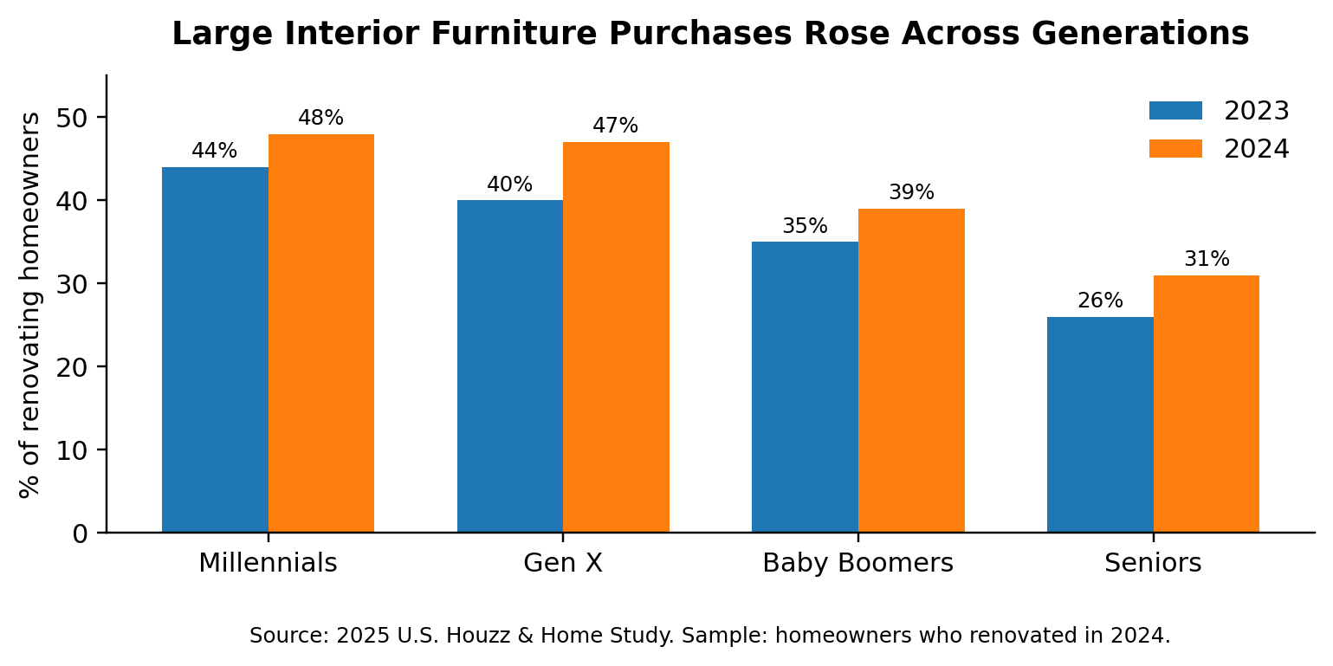
Figure 4. Among renovating homeowners surveyed by Houzz, large interior furniture purchasing rose across generations; Millennials were highest in 2024.
That matters because a protection program is no longer evaluated only at the point of sale. It is evaluated on a phone, in a search result, in online reviews, and in the stories customers tell after a claim.
The more defensible point is not that every competing protection provider has poor ratings; it is that every provider's public reputation is now searchable in seconds, and those signals can affect the retailer that sold the program. In ConsumerAffairs' 2026 U.S. survey, 77% of respondents said reviews are important, 80.2% said reviews had influenced them not to buy a product or service, and 61.6% said Google is their first stop for reviews. RAP's public site currently promotes a 4.5-star Google rating. [5][13]
Those ratings are not merely a provider issue. They can become the retailer's issue because the customer bought the protection through the retailer and can associate the claims experience with the retailer's brand.
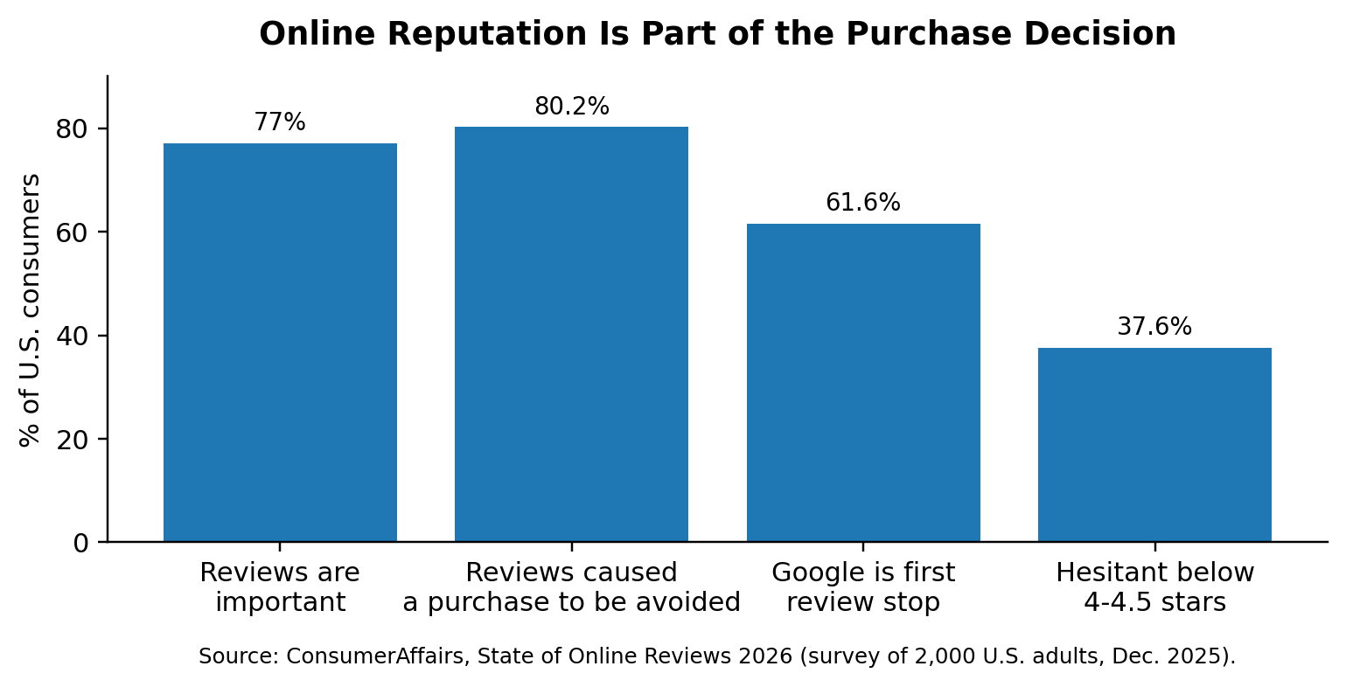
Figure 5. Online reviews can affect both the initial purchase decision and the credibility of a protection provider attached to the retailer.

The Problem With the Old Protection Model
For years, retailers could look past poor claims reviews, customer complaints, and inconsistent service because the traditional program still generated enough cash to justify the relationship.
That is becoming harder to do.
Today’s customer is more price-conscious, more skeptical, and better able to investigate a program before buying it. They may still want protection. What they increasingly reject is an expensive, upfront, inflexible program from a provider whose online reputation does not inspire confidence.
That is why traditional protection close rates are under pressure.
The issue is not simply whether the customer sees value in accidental-damage coverage. The issue is whether the program feels credible, transparent, affordable, and aligned with how the customer now wants to make financial decisions.

Why Dealers May Not See the Problem Clearly
There is another force at work: decision makers often become emotionally anchored to choices they have already made.
Behavioral research describes this through related concepts including confirmation bias, sunk-cost thinking, and escalation of commitment. Nickerson's classic review defines confirmation bias as seeking or interpreting evidence in ways that favor existing beliefs. Arkes and Blumer's sunk-cost research found a greater tendency to continue an endeavor once money, effort or time has already been invested. Staw's foundational escalation study found the strongest additional commitment when decision makers were personally responsible for negative outcomes. These are tendencies, not a diagnosis of any individual dealer, but they provide a useful lens for understanding why familiar programs can be difficult to challenge. [9][10][11]
In a furniture dealership, that can be especially powerful.
An owner or executive may have selected a provider years ago. The team may have invested in training, systems, sales materials, store processes, and a relationship with provider representatives. They may have defended the program in meetings, accepted its explanations for claims complaints, and tied part of the store’s financial model to its income.
At that point, acknowledging that the program is no longer serving the customer—or no longer serving the dealer—can feel like admitting that the original decision was wrong.
So warning signs get rationalized:
• Negative reviews are dismissed as isolated complaints
• Claims frustration is blamed on the customer
• Falling close rates are treated only as a sales-training problem
• A customer’s refusal is accepted as proof that people simply do not want protection
• The existing program is protected because it is familiar, even when the market around it has changed
That is not unusual. It is human.
But it can keep a dealer tied to a model that no longer produces the cash flow, customer confidence, or sales-floor results it once did.

Why the Protection Model Does Not Change
The furniture-protection industry has a paradox.
Dealers need more free cash flow from every purchasing customer. Customers are increasingly price-conscious, research-driven, and resistant to large upfront protection decisions. Traditional protection close rates have peaked and are becoming harder to maintain.
Yet the protection product sold on most sales floors looks remarkably similar to the product sold years ago.
Why?
Because protection vendors generally follow dealer demand. They do not lead it.
A dealer asks for a familiar product: a traditional multi-year plan, a familiar pricing structure, a familiar claims model, and a familiar dealer-income arrangement. The vendor responds by offering a variation of what the dealer already understands. Different branding. Different rates. Different claims administrator. Different reserve structure. But fundamentally, the same model.
That is not innovation. It is vendor substitution.

The Economics Discourage Innovation
Protection-program providers operate in a regulated, claims-sensitive business where the economics are often tighter than they appear from the sales floor.
A provider must fund claims operations, customer service, technology, compliance, insurance or obligor relationships, state filings, licensing, administration, payments, reporting, sales support, and reserves. Inflation in parts, labor, and service costs puts additional pressure on the program. Those obligations are real operating costs. In addition, current tariff policy can affect the cost base of the merchandise itself: a 25% tariff on certain upholstered wooden products remains in effect in 2026, while the planned increase to 30% was delayed until 2027. [4]
A genuinely new protection model is expensive and risky to build. It requires more than a new brochure or plan name. It may require new payment infrastructure, customer enrollment flows, recurring billing operations, customer-service rules, cancellation and reinstatement procedures, compliance review, state-by-state treatment, loss modeling, claims design, reporting, and dealer training.
That takes investment before the provider knows whether dealers will adopt it or customers will buy it.
Most providers therefore do what rational vendors do in a low-margin, risk-sensitive market: they protect the existing model. They optimize the familiar product. They compete on commission, pricing, coverage language, service promises, or sales support. But they avoid making a large, unproven investment in a model dealers have not yet demanded.

Dealers Reinforce the Status Quo
Dealers are not passive in this cycle.
When a traditional program underperforms, the typical response is often to change vendors. The dealer hopes a new claims administrator, a new sales presentation, a new commission arrangement, or a new plan name will produce a different outcome.
But if the new vendor delivers the same fundamental product to the same changing consumer, the result is likely to be more of the same.
The dealer has changed the vendor without changing the model.
That pattern is understandable. Switching a familiar provider feels like action. It creates the appearance of a fresh start without forcing the dealer to confront a more difficult question:
Is the traditional upfront protection model itself still sufficient for the consumer and retail economics of today?

The Emotional Anchor
This is where the emotional anchor becomes powerful.
Owners and executives have often invested years in their protection strategy. They selected a provider. They negotiated the agreement. They trained their teams. They built sales practices around the program. They defended the decision internally. They may have received meaningful income from it.
When the program begins to fall short, the easiest explanation is often that the provider is failing—not that the underlying model needs to evolve.
That does not mean the provider is always performing well. It means that a vendor change can become a way to avoid confronting a bigger structural problem.
Behavioral research describes related patterns as confirmation bias, sunk-cost thinking, and escalation of commitment. The underlying literature supports the broader idea that people can favor evidence consistent with existing beliefs and can give prior investment or personal responsibility too much weight in deciding whether to continue a course of action. The research also has boundary conditions, which is why the useful takeaway is not that every executive behaves this way; it is that prior commitment can make structural change psychologically harder. [9][10][11]
In the protection market, that can look like this:
• The dealer sees declining close rates and blames associate training
• The dealer sees customer complaints and blames an isolated claims issue
• The dealer sees poor online reviews and dismisses them as unhappy customers
• The dealer changes providers, but requests the same kind of program
• The new provider supplies the familiar model because that is what the dealer asked for
• The customer sees the same large upfront decision and says no
Nothing structural has changed.

The Market Shifted. The Model Did Not.
The furniture market has changed. The customer has changed. The dealer’s free-cash-flow need has intensified.
The protection model must now change at the business-model level—not merely at the vendor level.
The question is not:
“Which provider can sell us the best version of the old program?”
It is:
“What protection model can create new cash flow for the dealer while fitting the way today’s customer wants to buy?”
Until dealers ask that question, vendors will continue supplying what dealers have historically requested.
And until the industry changes the underlying model, changing providers will often mean changing the logo on the same answer.

The Model Is Finally Ready
Furniture retailers do not need another version of the traditional protection plan. They need a model that addresses the four issues reshaping the business:
1. A capital-intensive retail model that needs more free cash flow from each purchasing customer
2. A customer base facing higher furniture prices, tighter budgets, and greater resistance to large upfront add-ons
3. A traditional protection model whose close rates have reached a ceiling
4. A vendor market that has largely continued to supply variations of the same legacy product
FurnitureRx was built to address all four.
The market research above does not prove that one specific protection model will win. It does establish the conditions a new model has to solve for: weak transaction volume, payment-sensitive consumers, digitally visible service reputations, and a strong preference for control in recurring relationships.

A New Income Line
FurnitureRx gives dealers a way to create recurring cash flow from customers they already acquired, sold, delivered to, and serviced, without requiring the dealer to add inventory, floor space, advertising expense, billing staff, or upfront program capital.
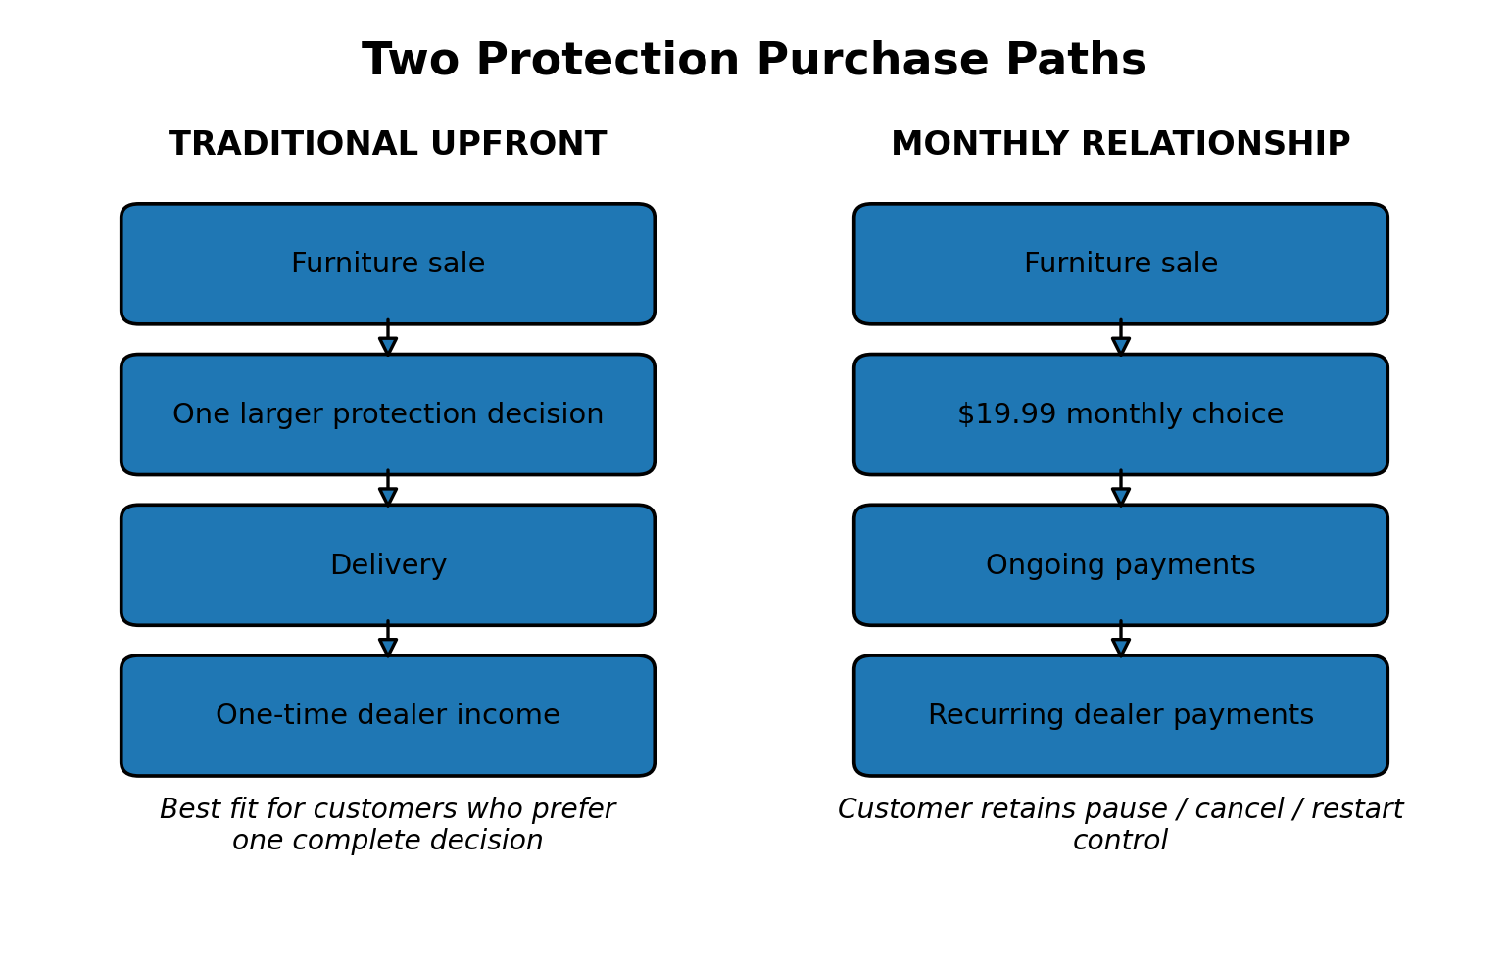
Illustration 2. FurnitureRx is positioned as a second purchase path alongside the traditional upfront plan, not as a mandatory replacement.
Under the FurnitureRx program terms supplied for this article, the customer pays $19.99 per month, the dealer pays nothing to participate, and each successful monthly payment produces an $8 dealer payment through Stripe. Unlike a traditional one-time protection transaction, the revenue opportunity continues as long as the subscriber remains active and payments are successful. [14]
For dealers with an appropriate reinsurance structure, the program can also create recurring reserve contributions instead of a single contribution at original sale. That is optional and dealer-specific; it is not the reason the program exists, but it can materially change the long-term economics of the protection relationship. [14]

A Purchase Format for Today’s Customer
FurnitureRx does not ask the customer to make another large protection purchase after financing furniture, accepting delivery charges, paying taxes, and stretching to complete the room.
It gives the customer an alternative:
Protect the eligible purchase for $19.99 per month. Cancel, pause, or restart anytime.
The significance of pause/cancel/restart is not cosmetic. The subscription research above suggests that the ability to leave or temporarily step away can make customers more willing to enter the relationship in the first place. [7][8]
Under the program terms, one subscription can cover eligible furniture, outdoor furniture, rugs, adjustable beds, mattresses, and lamps in the same transaction, up to the applicable combined retail limit. The customer gets a simpler payment decision and greater control; the dealer retains a credible protection option for the customer who does not want a large upfront commitment. [14]

A Second Way to Create Cash Contribution
FurnitureRx does not replace the dealer’s existing multi-year provider or program.
The traditional plan remains available for customers who want to make one complete upfront decision. FurnitureRx gives the sales associate another path when that format does not fit the customer.
That matters because the dealer does not need every customer to subscribe. The dealer needs a portion of transactions that would otherwise produce no protection income at all to become recurring revenue-producing relationships.
The sales-floor objective is simple:
Keep the traditional sale when it fits. Add a monthly alternative when it does not.
That is how FurnitureRx is designed to create incremental cash contribution rather than merely shifting an existing protection sale from one payment format to another. [14]

A Model Designed for Trust and Control
The traditional protection model asks customers to trust an expensive upfront promise they may not use for years.
FurnitureRx changes the relationship. Customers can manage the subscription online, cancel, pause, or restart when their circumstances change. RAP's public site currently promotes a 4.7-star Google rating, while the retailer can offer a more transparent, controlled buying experience. [13][14]
In a market where customers research programs, providers, claims experiences, and reviews before making decisions, that flexibility matters. The program has to earn the customer’s continued business rather than rely on a one-time upfront decision.

Why Now
Subscription protection has existed in other categories. It is now moving into household products, including furniture.
Amazon and Asurion expanded Asurion Complete Protect in March 2026 as a single $16.99-per-month subscription covering eligible Amazon purchases across electronics, appliances, furniture, and household categories. Asurion says the program includes a $5,000 rolling 12-month aggregate claim limit, can be canceled anytime, and includes up to a $100 annual product-care credit for eligible furniture and major-appliance services. [12]
That is not the same program as FurnitureRx, and Amazon's model is not designed around the needs of an independent furniture dealer. But it is meaningful proof of concept: the country's largest online retailer now sees enough customer value in a monthly, cross-category protection relationship to include furniture within the subscription. [12]
Furniture retailers cannot assume the monthly-protection model is years away. The consumer is already seeing it.

Why FurnitureRx Was Not Possible Before
The idea of subscription protection is simple. Building a viable furniture-retail program around it is not.
A furniture subscription program requires more than taking an annual plan and dividing the price by 12. It requires recurring payment infrastructure, enrollment controls, cancellation and restart logic, customer account management, coverage validation, claims administration, payment-status handling, dealer compensation tracking, reporting, underwriting support, and state-by-state compliance analysis.
Until recently, the underwriting software used by the relevant underwriting partners did not support subscription-program structures. That limitation made it impractical to administer the recurring enrollment, payment, coverage, and reporting requirements needed for a real subscription program.
Recent underwriting-system changes and upgrades now make subscription programs possible, although relatively few underwriters currently have the systems, appetite, and operational capability to underwrite them.
The second development is RAP’s ability to build the technology required to operate a complex subscription model rapidly. RAP’s AI-assisted coding tools make it possible to develop and refine the enrollment flows, Stripe payment integration, dealer dashboards, reporting logic, customer controls, and administrative workflows that a subscription program requires.
The result is not simply a monthly protection plan. It is a new operating model for furniture protection—one that was previously constrained by underwriting-platform limitations and the cost and time required to build the supporting technology.

The Timing Matters
FurnitureRx is available now because the market, the customer, the underwriting infrastructure, and the technology have finally aligned.
The market needs a new source of free cash flow.
The customer needs a more flexible way to buy protection.
The dealer needs a way to add income without adding capital or operational burden.
And the industry finally has the underwriting and technology capability to support the model.
That is why this is not a cosmetic update to traditional protection.
It is a new answer to a new furniture-retail reality.

Learn More
Want to learn more, contact Risk Assurance Partners, ddebonville@raptns.com

Research Sources and Notes
[1] U.S. Census Bureau, Monthly Retail Trade and Food Services, 'Retail Sales: Furniture and Home Furnishings Stores,' seasonally adjusted monthly series via FRED. Data through June 2026 used for the 2026 run-rate chart. https://fred.stlouisfed.org/data/MRTSSM442USS
[2] Housing turnover: HUD/NAR historical totals (6.12 million existing-home sales in 2021; 5.03 million in 2022), NAR 2023-2025 reporting, and FRED/NAR July 2026 existing-home sales SAAR of 4.06 million. https://fred.stlouisfed.org/graph/?graph_id=1401734
[3] Smith Leonard, July 2026 Furniture Insights: May 2026 new orders +8% year over year and +2% year to date; shipments +1% year over year and flat year to date. https://www.smith-leonard.com/2026/08/06/july-2026-furniture-insights/
[4] Federal Register, Jan. 9, 2026: 25% tariff on certain upholstered wooden products remains in place; scheduled upholstered-furniture increase to 30% delayed one year. https://www.federalregister.gov/documents/full_text/html/2026/01/09/2026-00327.html
[5] ConsumerAffairs, State of Online Reviews 2026. Survey of 2,000 U.S. adults fielded Dec. 2025; includes big-purchase comfort/stress and review behavior. https://www.consumeraffairs.com/research/online-review-statistics.html
[6] Houzz, 2025 U.S. Houzz & Home Study. Among homeowners who renovated in 2024, Millennials were most likely to buy large interior furniture (48%, up from 44% in 2023). https://st.hzcdn.com/static/econ/2025-US-Houzz-and-Home--Study.pdf
[7] Home News Now / Consumer Insights Now, Sept. 19, 2025: upholstery purchase incidence and online-review behavior by generation among surveyed furniture shoppers. https://homenewsnow.com/blog/2025/09/19/cin-week-2-looks-at-whats-driving-consumer-furniture-purchases/
[8] Subscription-control research: Chargebee Global Consumer Insights Report 2025 (82% easy cancellation; 79% pause option; 58% paused instead of canceled) and Recurly 2026 State of Subscriptions (71% cite easy cancellation as essential). https://www.chargebee.com/static/resources/downloads/guides/Chargebee-Global-Consumer-Insights-2025.pdf
[9] Raymond S. Nickerson (1998), 'Confirmation Bias: A Ubiquitous Phenomenon in Many Guises,' Review of General Psychology. https://psy.ucsd.edu/~mckenzie/nickersonConfirmationBias.pdf
[10] Hal R. Arkes & Catherine Blumer (1985), 'The Psychology of Sunk Cost,' Organizational Behavior and Human Decision Processes. https://doi.org/10.1016/0749-5978(85)90049-4
[11] Barry M. Staw (1976), 'Knee-deep in the big muddy: a study of escalating commitment to a chosen course of action,' Organizational Behavior and Human Performance. https://doi.org/10.1016/0030-5073(76)90005-2
[12] Asurion, March 3, 2026: expansion of Asurion Complete Protect on Amazon across eligible electronics, appliances, furniture and household categories at $16.99/month, plus current program details. https://www.asurion.com/press-releases/asurion-expands-complete-protect-on-amazon/
[13] Risk Assurance Partners public corporate site; current public marketing states a 4.7-star Google rating. https://riskassurancepartners.com/
[14] FurnitureRx/RAP program-specific pricing, dealer-payment, coverage, reinsurance, underwriting-system and technology descriptions are based on program materials supplied for this article. Independent market-research claims are sourced separately above.
Publication note: This draft is structured as an advertorial / industry perspective. Program-specific FurnitureRx and RAP claims are presented as company program representations; third-party market claims are identified in the research source list.

