Compute, Credit & Couches
AI Data-Center Debt, the 10-Year Treasury, Housing Turnover, and the Outlook for U.S. Furniture Sales
A research briefing • August 25, 2026 • Includes a 24-month housing-turnover outlook and a 2026–2028 furniture-sales scenario model

Executive Summary
- The AI infrastructure build-out has become one of the largest capital programs in U.S. history. The four largest hyperscalers alone have guided to roughly $700 billion of 2026 capital spending, up more than 60% from 2025, and Moody’s projects at least $3 trillion of data-center investment through 2030.
- That build-out is increasingly debt-financed. AI-linked investment-grade bond issuance reached about $220 billion by early August 2026, versus $12.5 billion in the same period of 2025 — including the largest corporate bond sale in history (Amazon, $53.8 billion, March 2026).
- Heavy bond supply — corporate or governmental — pushes bond prices down and yields up. The Dallas Fed estimates 2026 AI-related issuance equals up to $360 billion in 10-year equivalents, roughly one-eighth of expected Treasury duration supply: real, but second-order. The dominant force behind the 10-year yield (4.74% on August 21, 2026) remains federal deficits near $1.9 trillion a year, with debt held by the public headed from 101% to 120% of GDP by 2036.
- Mortgage rates price off the 10-year Treasury plus a spread that is still about 0.3 percentage point wider than its 1990–2019 norm. At 6.65% (August 20, 2026), the 30-year rate keeps the FHFA-documented lock-in effect binding: each percentage point by which a borrower’s existing rate sits below market cuts the probability of sale by 18.1%.
- Existing-home sales have run near 4 million for a fourth straight year (July 2026: 4.06 million SAAR). Our central 24-month outlook: roughly 4.0–4.2 million through mid-2027, improving to only 4.2–4.5 million by August 2028 — still about a quarter below the 2021 pace.
- Housing turnover is the single strongest cyclical driver of furniture demand: home purchases explain 40–75% of the variability in home-related spending across housing cycles, and buyers of new homes spend about seven times what non-movers spend on furnishings in the first year.
- Our scenario model puts 2028 furniture-store sales at $143 billion in the base case, $137 billion if mortgage rates persist at 6.7–7%, and $148 billion if rates fall toward 6% — an $11 billion annual swing that hinges largely on the path of the 10-year Treasury.

1. The Transmission Chain
This paper traces a five-link chain that connects the AI data-center boom to the furniture showroom: (1) hyperscaler capital spending creates enormous financing needs; (2) the resulting bond issuance adds duration supply that competes with Treasuries for investor capital; (3) added duration supply, alongside much larger fiscal deficits, raises the term premium and the 10-year Treasury yield; (4) the 30-year mortgage prices off the 10-year plus a spread, so higher long yields keep mortgage rates near 7%; and (5) expensive mortgages suppress housing turnover, which is the principal cyclical driver of furniture purchases.
One point of mechanics deserves clarity at the outset, because it is often garbled in commentary: heavy borrowing does not push bond rates lower — it pushes bond prices lower, and because a bond’s price and its yield move inversely, yields rise. When corporations and the Treasury together ask investors to absorb more long-duration paper, investors demand more compensation — a higher term premium — to hold it. As the Dallas Fed puts it, "an increase in expected duration supply — whether sourced from Treasury or corporate issuance — puts upward pressure on the term premium". Each link in the chain is examined below against the strongest available evidence.

2. The AI Build-Out and How It Is Being Financed
The scale of the data-center program is without modern precedent. Amazon has guided 2026 capital spending to roughly $220 billion, raised from $200 billion in July, with CEO Andy Jassy noting even that "would not be enough capacity to meet all the demand". Microsoft plans about $190 billion for calendar 2026, up 61% from 2025; Alphabet raised its guidance to $195–205 billion; and Meta narrowed its range to $130–145 billion — roughly double its 2025 outlay of $72.2 billion. Combined, the big four are expected to spend nearly $700 billion in 2026, up more than 60% year over year, even as their combined free cash flow fell from $237 billion (2024) to $200 billion (2025). Looking further out, Moody’s expects at least $3 trillion of data-center-related investment through about 2030, and McKinsey estimates data centers worldwide will require $6.7 trillion by 2030, of which $5.2 trillion is for AI-capable capacity.
Through 2024, this spending was financed almost entirely from operating cash flow. That changed decisively in late 2025. Hyperscaler gross bond issuance topped $100 billion in 2025, mostly at maturities beyond five years. Meta opened the landmark phase with a $30 billion six-tranche deal in October 2025 that drew a record $125 billion of orders; Oracle sold $18 billion in September 2025; Alphabet followed with $25 billion in November 2025; and in March 2026 Amazon completed the largest corporate bond sale in history — about $53.8 billion across U.S. dollar and euro tranches, breaking Verizon’s record that had stood since 2013. By early August 2026, AI-linked investment-grade issuance had reached about $220 billion for the year, versus $12.5 billion in the comparable 2025 period, and signs of investor fatigue were emerging: technology spreads moved 9 basis points wider than the investment-grade market overall — a historic reversal — and Amazon’s July 2026 deal priced at roughly double the spread of comparable paper a year earlier.
The visible bond supply also understates the full financing effort. Moody’s calculates that the five largest hyperscalers carried $969 billion of undiscounted future lease commitments at the end of 2025, of which $662 billion had not yet commenced and therefore sits off balance sheet — equivalent to 113% of their adjusted debt. The BIS documents parallel channels: joint ventures and special-purpose entities with private-credit firms, lease-serviced debt, and data-center securitizations. Private credit extended to AI-related firms has grown from near zero to more than $200 billion, and the BIS cautions that AI loan spreads are statistically indistinguishable from non-AI loans — possible evidence of risk underpricing. The IMF counts hyperscaler debt outstanding near $800 billion and projects AI capital spending could top $3.4 trillion by 2029–2030.
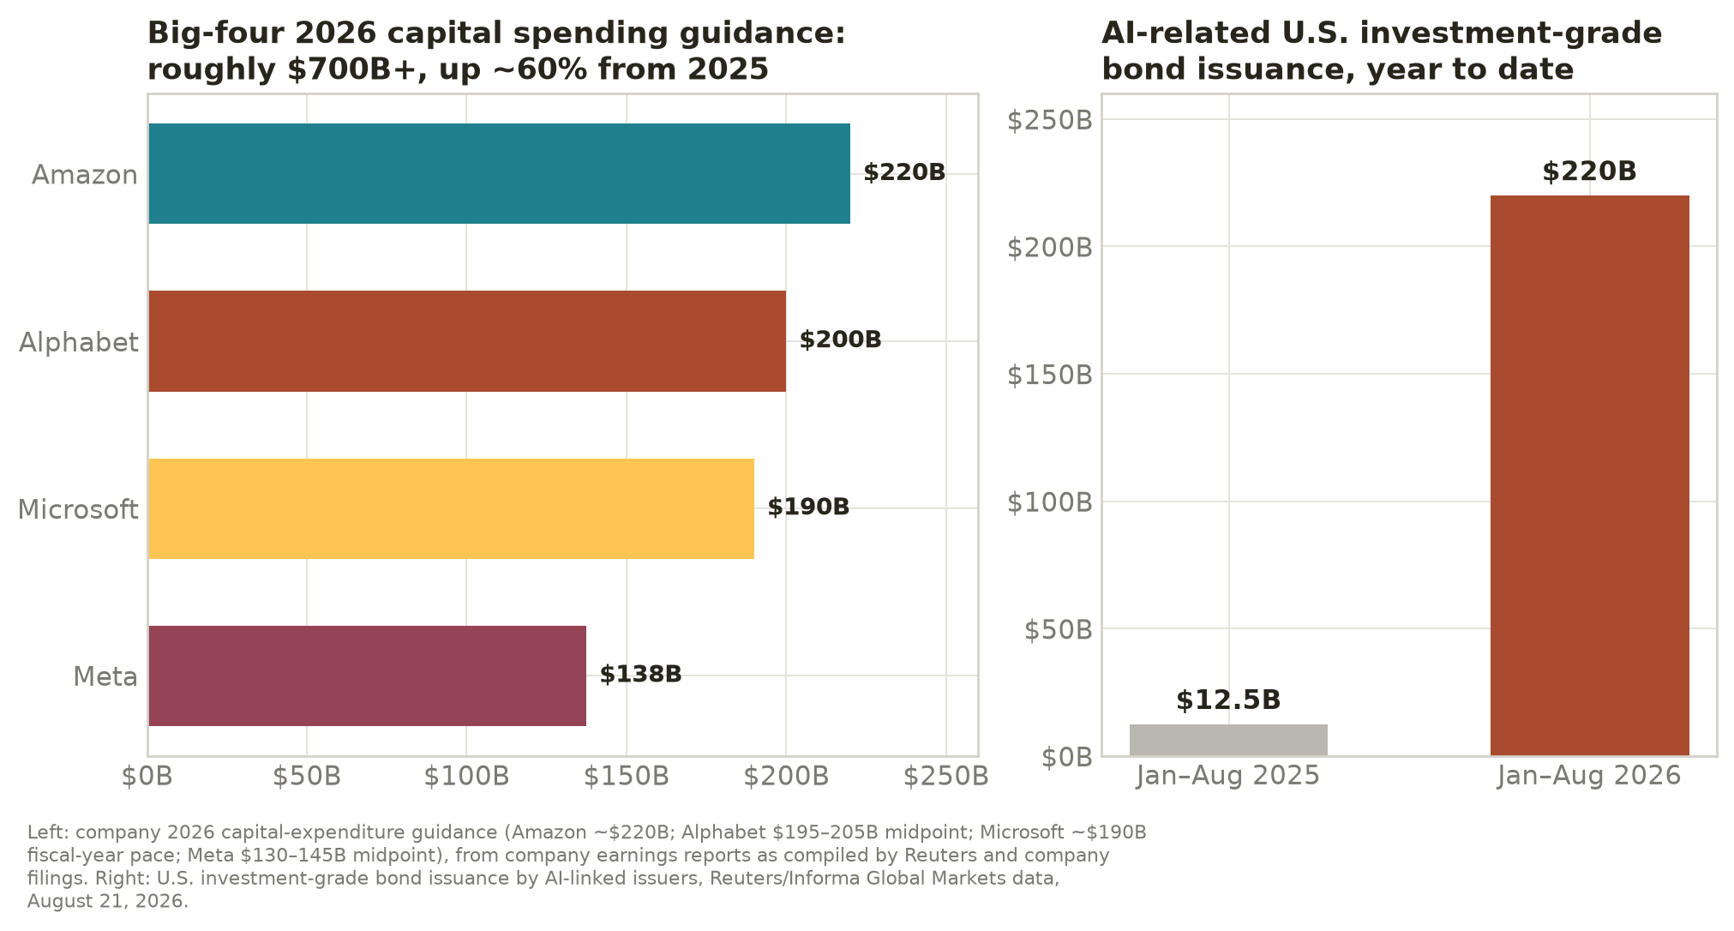
Figure 1. The 2026 hyperscaler capital program and the surge in AI-linked bond issuance.

3. What Is Actually Driving the 10-Year Treasury Yield
The 10-year Treasury yield stood at 4.74% on August 21, 2026, up from about 4.0% in October 2025, and the 30-year touched its highest level since 2007 in mid-August as a global selloff in long-dated government debt gathered pace. Decomposing the move matters for any forecast, because the different drivers have different half-lives.
Fiscal supply is the first-order force. The Congressional Budget Office projects a $1.9 trillion deficit for fiscal 2026 and rising thereafter, with debt held by the public climbing from 101% of GDP to 120% by 2036 — surpassing the World War II record. The stock of marketable Treasury securities reached $31.5 trillion in July 2026, up 8.6% in a year, with $18.9 trillion of gross issuance in the first seven months of 2026 alone. Foreign official demand has not kept pace, leaving more price-sensitive private buyers — households, hedge funds, mutual funds — to absorb the growing float.
The term premium has repriced. The compensation investors demand for bearing duration risk — negative for most of 2016–2021 — has turned decisively positive: the New York Fed’s ACM estimate reached roughly 0.8–0.9 percentage point in August 2026, near a 12-year high, and the Board’s Kim–Wright model shows the same pattern. The Federal Reserve also stopped shrinking its balance sheet on December 1, 2025, ending quantitative tightening — which removed one source of duration supply but also ended any prospect of the Fed re-absorbing it soon.
AI issuance adds to the pressure — measurably, but at the margin. The Dallas Fed expects roughly $300 billion of AI-related investment-grade issuance in 2026, equivalent to as much as $360 billion in 10-year duration equivalents — about one-eighth of expected Treasury duration supply — and notes a compositional effect: technology issuers, unlike financial issuers, generally do not swap their fixed-rate debt to floating, so tech displacing financials raises the net duration the market must hold. As one former Fed economist put it, "Duration is duration. If more corporate duration is issued, it’s going to increase the term premium for U.S. Treasuries". Quantitatively, however, Goldman Sachs estimates AI-related issuance has added only about 5 basis points to broad borrowing costs, and non-AI corporate spreads remain historically tight — hard to square with economy-wide crowding out. A second, subtler AI channel runs through the real economy: New York Fed economists note that a large, productivity-relevant investment demand shock can raise the equilibrium real interest rate itself, keeping the whole yield curve structurally higher.
The synthesis: AI debt is a genuine, newly arrived contributor to long-yield pressure — the direction the market commentary describes is right — but the arithmetic says fiscal supply remains several times larger. The practical implication is the same under either weighting: the forces holding the 10-year in the 4.5–5% range are structural and unlikely to dissipate within the 24-month horizon of this paper.
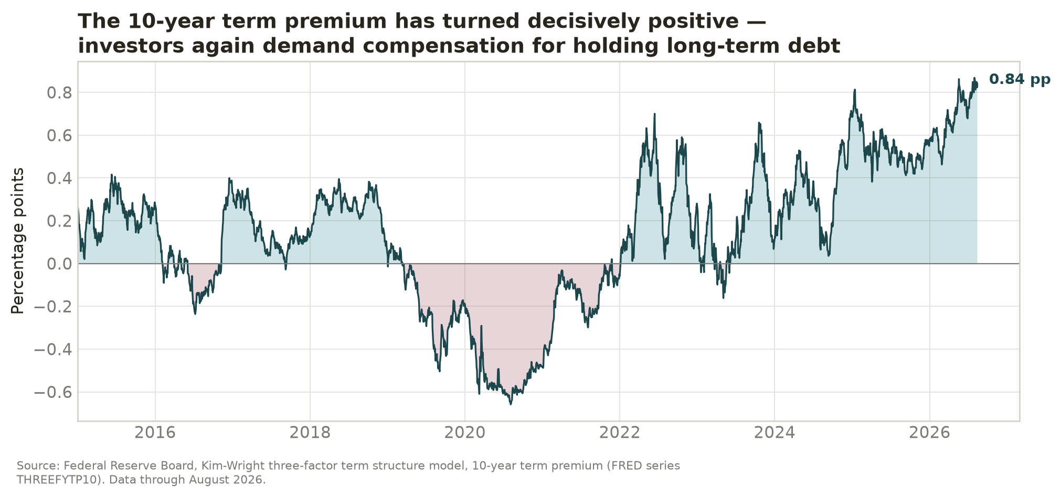
Figure 2. The 10-year term premium (Kim–Wright model) has turned decisively positive.

4. From the 10-Year to the 30-Year Mortgage
The 30-year fixed mortgage is, functionally, a long-duration bond priced off the 10-year Treasury: lenders and MBS investors add a spread covering prepayment risk, credit guarantee fees, and origination costs. The Freddie Mac survey rate averaged 6.65% in the week of August 20, 2026, with the 10-year at 4.74% — a spread of about 1.96 percentage points, still roughly 0.3 point above the 1990–2019 average of 1.66. The spread has narrowed from its 2023 peak near 3 points, but the Fed’s retreat from MBS purchases and elevated rate volatility keep it wide. The consequence is simple arithmetic: a 10-year yield persisting near 4.7–4.8% maps to mortgage rates of roughly 6.4–6.8% even with further spread normalization — and about 7% without it.
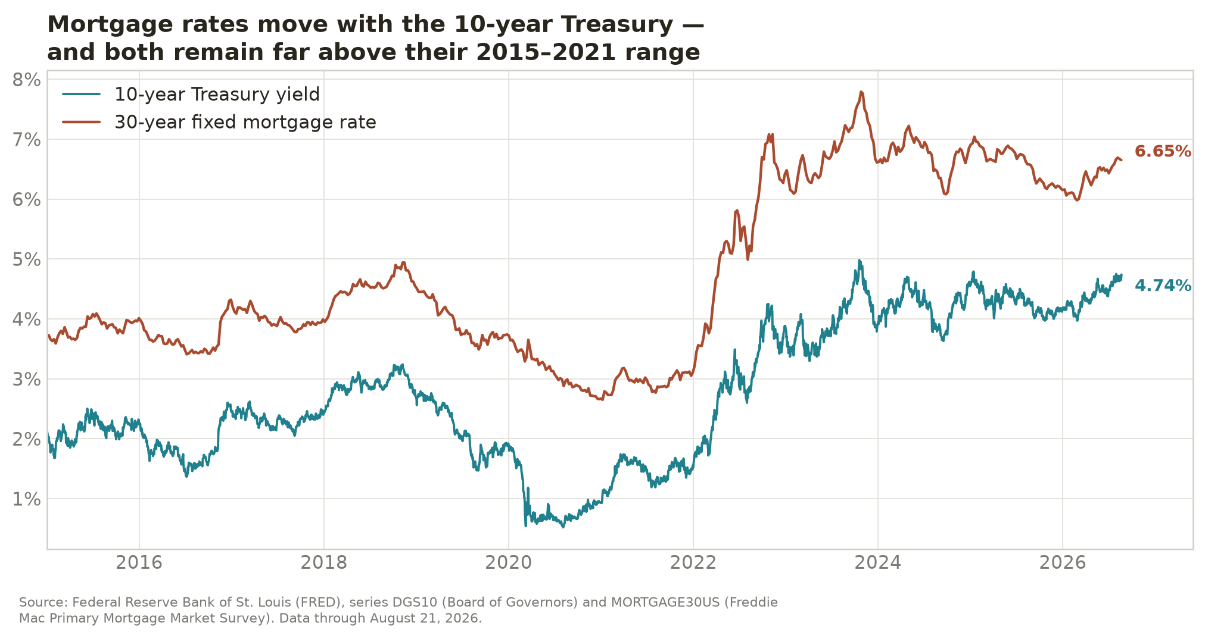
Figure 3. The 10-year Treasury and the 30-year mortgage move together.
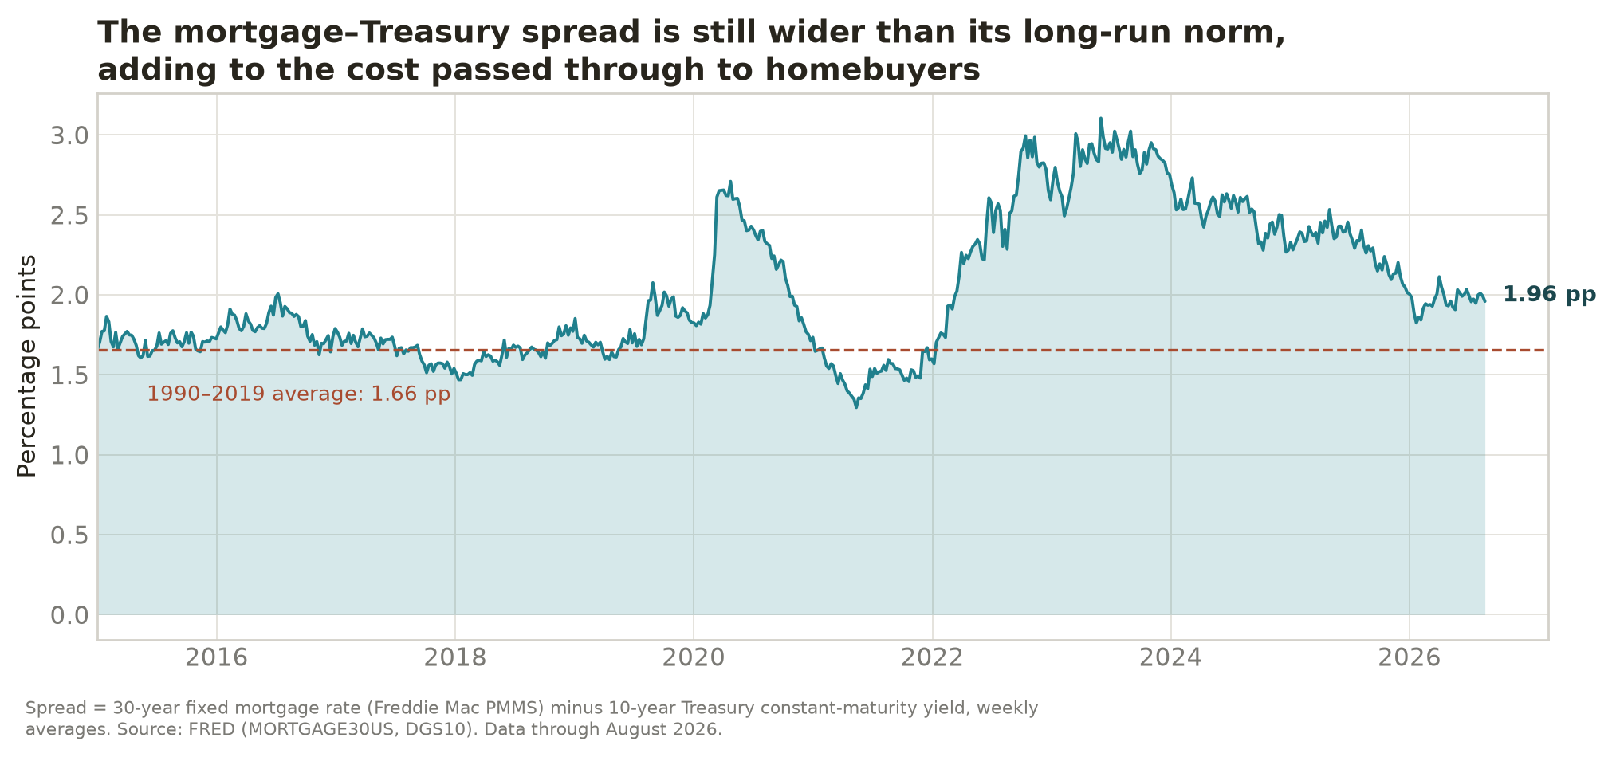
Figure 4. The mortgage–Treasury spread remains wider than its long-run norm.

5. Housing Turnover: Current State and the 24-Month Outlook
Existing-home sales ran at a 4.06 million seasonally adjusted annual rate in July 2026, down 1.7% from June and essentially unchanged from a year earlier, at a median price of $434,100. Annual sales have now printed near 4.06–4.09 million for three consecutive years — the weakest stretch since 1995 — after 6.12 million in 2021. New construction has softened in tandem: total starts fell 12.4% in July 2026 to a 1.239 million annual rate, and new single-family home sales ran near 628,000 in June.
Why turnover is stuck: the lock-in effect. The FHFA’s canonical study quantifies the mechanism: for every percentage point that a borrower’s existing mortgage rate sits below the prevailing market rate, the probability of sale falls 18.1%. The authors attribute more than 1.3 million lost home sales to lock-in between 2022 and 2024. With the market rate near 6.65% and the outstanding mortgage stock still dominated by loans originated at 4% or below, the wedge remains wide. Harvard’s Joint Center adds a slower-moving headwind: household formation has decelerated from about 2 million a year in 2021 to roughly 1.1 million in 2025, with demographic projections near 700,000 a year over the next decade.
What forecasters expect. The table below assembles the August-2026-vintage outlooks of the three most-cited housing forecasters. Note the direction of travel: Fannie Mae’s August forecast cut its 2027 recovery estimate (from 4.40 to 4.27 million) while raising its mortgage-rate path to 6.7%; the MBA similarly raised its end-2026 rate forecast to 6.7% and now holds the 10-year at 4.7% through 2027; and NAR has already cut its 2026 growth forecast from +14% (made November 2025) to +4%.
Forecaster (vintage) | 2026 EHS | 2027 EHS | 2028 EHS | 30-yr rate path
Fannie Mae (Aug 2026) | 4.11M | 4.27M | — | 6.5% end-26; 6.7% 2027
MBA (Jun 2026; Aug rev.) | 4.21M | 4.48M | 4.63M | 6.5–6.7% end-26; 10Y 4.7%
NAR (Jun 2026) | ~4.22M (+4%) | — | — | ~6.5% average
This paper (central) | 4.05–4.15M | 4.15–4.35M | 4.3–4.5M | 6.4–6.9%

Our 24-month prediction (August 2026 – August 2028). Given (a) a 10-year yield held in the 4.5–5% range by fiscal supply, with AI issuance adding pressure at the margin; (b) a mortgage-Treasury spread normalizing only slowly; and (c) the lock-in wedge decaying gradually as loans season and life events force moves, we expect existing-home sales to remain in a 4.0–4.2 million band through mid-2027, then improve modestly to roughly 4.2–4.5 million by August 2028 — a cumulative recovery of perhaps 5–10% from today’s pace, leaving turnover still about 25–30% below the 2021 level. The consensus forecasts above imply the same shape; note that they have been revised toward this view repeatedly, not away from it. Housing starts likely hold a 1.2–1.4 million range with single-family softness. The main upside risk is a faster-than-expected decline in long yields (a growth scare or rapid disinflation); the main downside risk is a renewed inflation or fiscal shock pushing the 10-year above 5%.
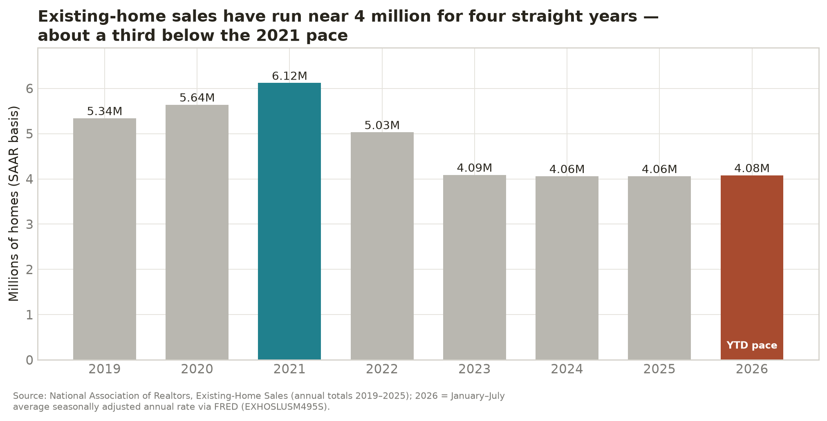
Figure 5. Existing-home sales have run near 4 million for four straight years.
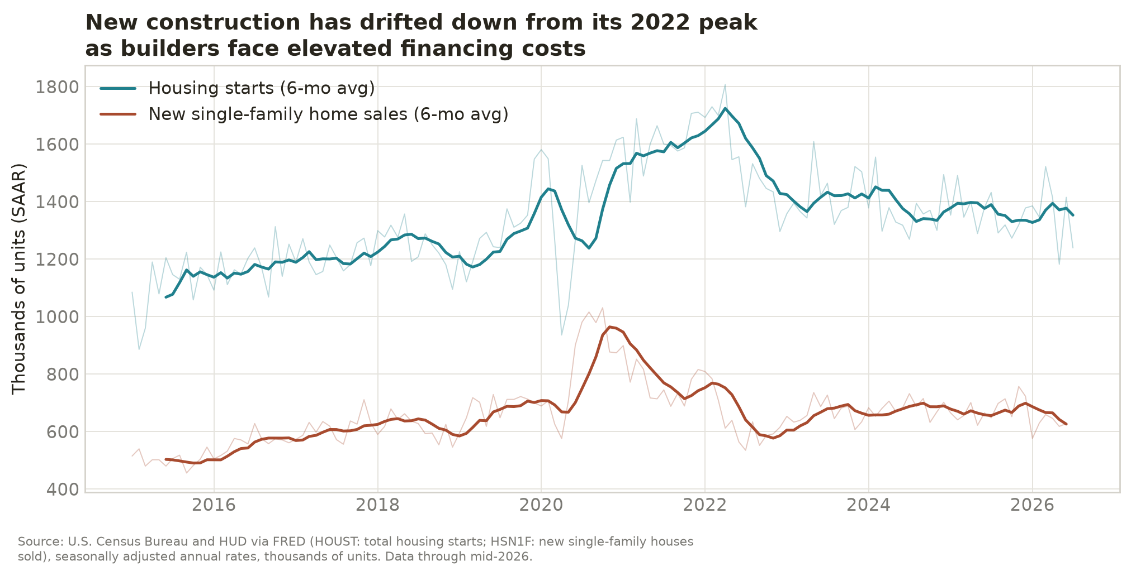
Figure 6. New construction has drifted down from its 2022 peak.

6. How Housing Turnover Drives Furniture Demand
Furniture is the most housing-levered category in retail. The New York Times put it plainly this spring: "America’s furniture stores have been ravaged over the past three years as high mortgage rates and home prices have frozen the housing market". The evidence base behind that statement is unusually strong:
- Move-triggered spending multiples. NAHB’s analysis of Consumer Expenditure Survey microdata (2020–2023) finds buyers of newly built homes spend $8,254 on furnishings in the first year after purchase, existing-home buyers $3,894, and non-moving owners $1,192 — multiples of roughly 7x and 3.3x.
- Causal evidence. A 2025 Federal Reserve Board working paper estimates a home purchase raises furnishings spending by $1,757 from a $1,553 baseline — a more-than-doubling — and finds the correlation between new home sales and home-related expenditure is 0.69. Critically, home purchases account for 40–75% of the total variability in spending across housing booms and busts.
- The often-quoted "~25%" share. No U.S. statistical agency publishes that exact figure. The closest official measurement is Statistics Canada’s: households that bought a home within the prior four years accounted for 22% of total furniture spending. A parallel U.S. calculation — applying NAHB per-buyer spending to roughly 4.7 million annual transactions against $294 billion of total furniture consumption — puts same-year buyers near 7–8% of the level, rising plausibly to 20–25% when buyers from the prior three to four years (whose spending stays elevated) are included. The "25%" shorthand is therefore defensible as a mover-linked share, with the important nuance that non-movers dominate the level of demand while movers dominate its cycle.
- The historical stress test. In the 2005–2009 bust, existing-home sales fell about 40% and furniture-store sales fell 25.2% peak to trough — an arc elasticity of roughly 0.6. Pre-pandemic, industry sales maintained an 80% correlation with existing-home sales.
Today’s data are consistent with a market held down by frozen turnover. Furniture and home-furnishings store sales (NAICS 442) totaled $135.6 billion in 2025, still below the 2022 nominal peak of $140.5 billion, and are running 1.7% below last year through July 2026. Overlaid on weak volumes is a tariff-driven price shock: Section 232 duties of 25% on upholstered wooden furniture took effect October 14, 2025, with the scheduled increase to 30% delayed to January 1, 2027. Furniture-and-bedding CPI accelerated to +4.2% year over year in February 2026 before decelerating to +0.5% by July — meaning even flat nominal sales conceal falling unit volumes. Zelman & Associates estimates the price elasticity of furniture demand at about −0.42 in high-price-increase years, and notes existing-home sales growth on the order of 5–6% would be needed to offset the tariff drag. Industry order books tell the same story of a market moving sideways: new orders were up just 2% year to date through May 2026, with shipments flat, and Harvard’s remodeling indicator points to spending growth of just 0.5% by mid-2027, "until home sales rebound from current low levels".
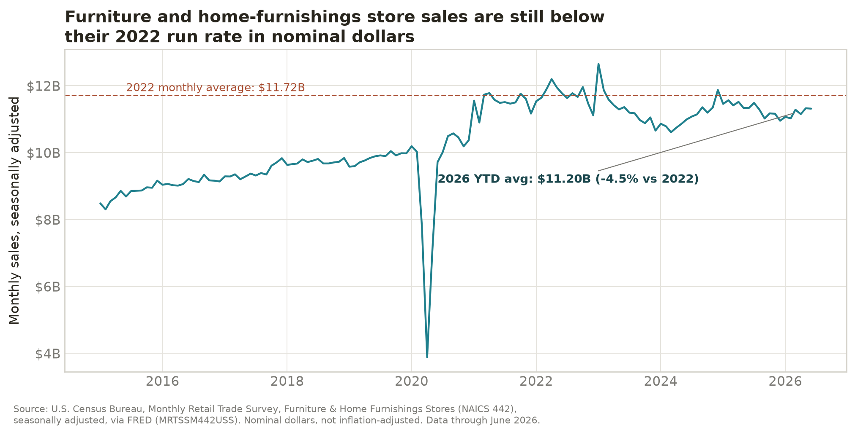
Figure 7. Furniture-store sales remain below their 2022 run rate in nominal dollars.

7. Scenario Model: U.S. Furniture-Store Sales, 2026–2028
To quantify the stakes, we model annual furniture and home-furnishings store sales (Census NAICS 442) as a function of existing-home-sales growth:
Furniture sales growth = 0.7% baseline drift + 0.55 × existing-home-sales growth
The 0.55 coefficient is the midpoint of the historical evidence: the 2005–2009 arc elasticity of about 0.6, the Federal Reserve’s finding that home purchases drive 40–75% of home-related spending variability, and Zelman’s asymmetric estimates around that range. The 0.7% drift captures non-mover replacement demand and net price effects. 2026 is anchored to actual year-to-date data (−1.7% through July, with modest second-half stabilization). Housing paths: the base case blends the Fannie Mae, MBA, and NAR forecasts above; the downside holds mortgage rates at 6.7–7% (existing-home sales roughly flat); the upside assumes rates decline toward 6%, the threshold NAR’s chief economist identifies as unlocking meaningful turnover.
Scenario | Housing assumption (EHS growth) | 2026 | 2027 | 2028
Base | +2% ’26, +5.5% ’27, +4% ’28 | $134B | $139B | $143B
Downside (rates 6.7–7%) | 0% ’26, +1% ’27, +1.5% ’28 | $134B | $135B | $137B
Upside (rates toward 6%) | +3% ’26, +8% ’27, +7% ’28 | $135B | $142B | $148B

Three readings of the table. First, the range is wide: by 2028 the gap between the downside and upside paths is about $11 billion a year of retail volume — and the swing variable is the mortgage rate, which is to say the 10-year Treasury. Second, even the base case only returns the industry to its 2022 nominal peak by 2028; adjusted for cumulative furniture inflation, unit volumes would remain well below 2021–2022 levels in every scenario. Third, the downside is not a tail case: it simply extends the current rate environment, which the MBA’s August revision (10-year at 4.7% through 2027) treats as its central path. A complementary way to size the stakes: the roughly 2 million annual existing-home sales "missing" versus the 2021 pace represent about $8 billion a year of forgone first-year furnishings spending at NAHB’s $3,894 per existing-home buyer — before any multiplier from remodeling and non-mover upgrades.
Model caveats. Figures are nominal; the January 2027 tariff step-up to 30% would mechanically lift prices (supporting nominal sales) while suppressing units. The elasticity is estimated over large cyclical swings and applies less precisely to small annual changes. Some trade observers argue demand is partially decoupling from moves toward "stay-put" room-by-room upgrades, which would soften the linkage in both directions. And the model excludes non-store (e-commerce-only) furniture channels.
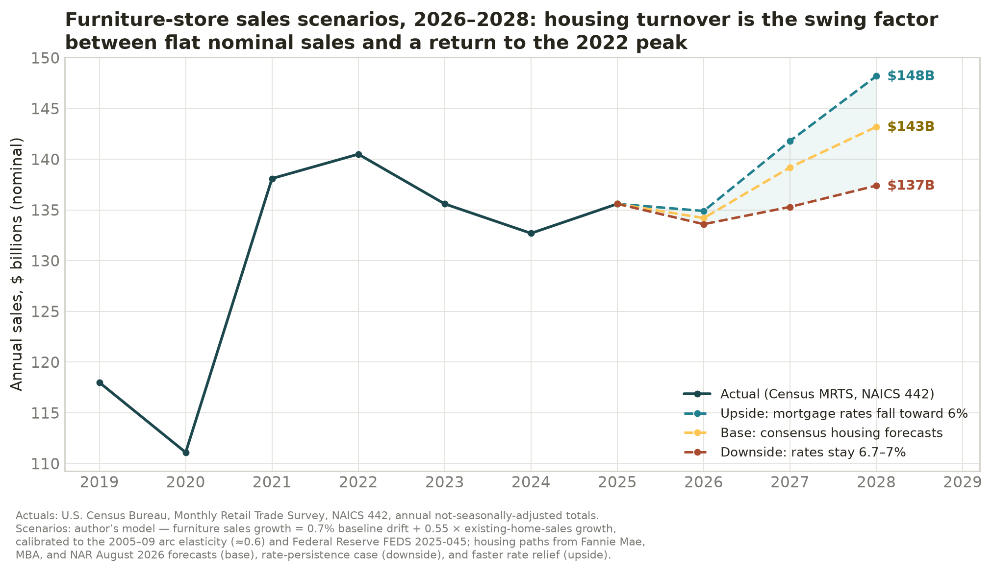
Figure 8. Furniture-store sales scenarios, 2026–2028, under three housing-turnover paths.

8. Conclusions
Weighing each link in the chain against the evidence: the AI-debt-to-Treasury link is real but modest — measured in single-digit to low-double-digit basis points, not the primary force. The fiscal-supply-to-Treasury link is strong and worsening on CBO’s arithmetic. The Treasury-to-mortgage link is mechanical and tight. The mortgage-to-turnover link is among the best-documented relationships in housing economics. And the turnover-to-furniture link is causal, quantified, and large in cyclical terms. The composite conclusion is that the furniture industry’s recovery timetable is being set, at the margin, in the bond market: as long as structural forces — deficits first, AI duration supply second — hold the 10-year Treasury near or above 4.5%, mortgage rates will hold near or above 6.5%, housing turnover will stay in the low-4-million range, and furniture retail will remain a flat-to-modest-growth business in nominal terms and a shrinking one in real terms. The scenario model above translates that thesis into numbers a retailer can plan against: a 2028 outcome between roughly $137 billion and $148 billion, with the base case at $143 billion — and the difference determined almost entirely by whether long-term rates persist or relent.

CNBC, report on big-four hyperscaler 2026 capital spending and free cash flow, February 6, 2026. https://www.cnbc.com/2026/02/06/google-microsoft-meta-amazon-ai-cash.html
Los Angeles Times, "Data centers will need $3 trillion through 2030, Moody’s says," January 12, 2026. https://www.latimes.com/business/story/2026-01-12/data-centers-will-need-3-trillion-through-2030-moodys-says
Reuters, "US corporate AI debt surge tests investor limits as fatigue emerges," August 21, 2026. https://www.reuters.com/legal/transactional/us-corporate-ai-debt-surge-tests-investor-limits-fatigue-emerges-2026-08-21/
IFR (International Financing Review), "Amazon makes market history with largest corporate bond sale ever," March 14, 2026. https://www.ifre.com/bonds/2397565/amazon-makes-market-history-with-largest-corporate-bond-sale-ever
Federal Reserve Bank of Dallas, "How AI debt financing impacts duration supply and interest rates" (De Vere, Ramaswamy and Searls), February 10, 2026. https://www.dallasfed.org/research/economics/2026/0210-searls-aifinancing
Federal Reserve Board, H.15 Selected Interest Rates, 10-year Treasury constant maturity, via FRED series DGS10, data through August 21, 2026. https://fred.stlouisfed.org/series/DGS10
Congressional Budget Office, "The Budget and Economic Outlook: 2026 to 2036," February 11, 2026. https://www.cbo.gov/publication/61882
Freddie Mac, Primary Mortgage Market Survey, via FRED series MORTGAGE30US, data through August 20, 2026. https://fred.stlouisfed.org/series/MORTGAGE30US
Federal Housing Finance Agency, Working Paper 24-03, "The Lock-In Effect of Rising Mortgage Rates" (Fonseca, Liu and Mabille), March 2024. https://www.fhfa.gov/research/papers/wp2403
National Association of Realtors, "Existing-Home Sales Report Shows 1.7% Decrease in July," August 11, 2026. https://www.nar.realtor/newsroom/nar-existing-home-sales-report-shows-1-7-decrease-in-july
Favara, Graham and Li, "Of House and Home-Related Goods: The Home Purchase Channel of Expenditure," Federal Reserve Board, FEDS Working Paper 2025-045, June 2025. https://www.federalreserve.gov/econres/feds/files/2025045pap.pdf
NAHB Eye on Housing, "What Do Home Buyers Purchase After They Move In," analysis of BLS Consumer Expenditure Survey 2020–2023 microdata, July 22, 2026. https://eyeonhousing.org/2026/07/what-do-home-buyers-purchase-after-they-move-in/
Federal Reserve Bank of Dallas, "How AI debt financing impacts duration supply and interest rates" (De Vere, Ramaswamy and Searls), February 10, 2026. https://www.dallasfed.org/research/economics/2026/0210-searls-aifinancing
CNBC, Amazon second-quarter 2026 earnings report, July 30, 2026. https://www.cnbc.com/amp/2026/07/30/amazon-amzn-q2-earnings-report-2026.html
Yahoo Finance, report on Microsoft plans for approximately $190 billion of 2026 capital spending, July 27, 2026. https://finance.yahoo.com/markets/stocks/articles/microsoft-plans-190-billion-capital-214300784.html
Yahoo Finance, report on Alphabet raising 2026 capital-spending guidance to $195–205 billion, July 30, 2026. https://finance.yahoo.com/markets/stocks/articles/alphabet-spend-much-205-billion-083200018.html
Yahoo Finance / Reuters, "Meta narrows annual capex forecast," July 29, 2026. https://finance.yahoo.com/technology/ai/articles/meta-narrows-annual-capex-forecast-200500213.html
CNBC, report on big-four hyperscaler 2026 capital spending and free cash flow, February 6, 2026. https://www.cnbc.com/2026/02/06/google-microsoft-meta-amazon-ai-cash.html
Los Angeles Times, "Data centers will need $3 trillion through 2030, Moody’s says," January 12, 2026. https://www.latimes.com/business/story/2026-01-12/data-centers-will-need-3-trillion-through-2030-moodys-says
McKinsey & Company, "The cost of compute: A $7 trillion race to scale data centers," April 28, 2025. https://www.mckinsey.com/industries/technology-media-and-telecommunications/our-insights/the-cost-of-compute-a-7-trillion-dollar-race-to-scale-data-centers
Bank for International Settlements, Quarterly Review, "Financing the AI infrastructure boom: on- and off-balance sheet borrowing" (Eren, Krohn and Todorov), March 16, 2026. https://www.bis.org/publ/qtrpdf/r_qt2603u.htm
Bloomberg, "Meta sets bond sale at $30 billion, biggest offering of the year," October 30, 2025. https://www.bloomberg.com/news/articles/2025-10-30/meta-sets-bond-sale-at-30-billion-biggest-offering-of-the-year
Reuters, report on Oracle’s $18 billion six-tranche investment-grade bond sale, September 24, 2025. https://www.reuters.com/business/oracle-looks-raise-15-billion-bond-sales-bloomberg-news-reports-2025-09-24/
CNBC, report on big-four hyperscaler 2026 capital spending and free cash flow, February 6, 2026. https://www.cnbc.com/2026/02/06/google-microsoft-meta-amazon-ai-cash.html
IFR (International Financing Review), "Amazon makes market history with largest corporate bond sale ever," March 14, 2026. https://www.ifre.com/bonds/2397565/amazon-makes-market-history-with-largest-corporate-bond-sale-ever
Reuters, "US corporate AI debt surge tests investor limits as fatigue emerges," August 21, 2026. https://www.reuters.com/legal/transactional/us-corporate-ai-debt-surge-tests-investor-limits-fatigue-emerges-2026-08-21/
Fortune (via Yahoo Finance), report on Moody’s analysis of $662 billion in not-yet-commenced hyperscaler lease commitments held off balance sheet, February 25, 2026. https://finance.yahoo.com/news/moody-flags-662-billion-risk-081000616.html
Bank for International Settlements, Quarterly Review, "Financing the AI infrastructure boom: on- and off-balance sheet borrowing" (Eren, Krohn and Todorov), March 16, 2026. https://www.bis.org/publ/qtrpdf/r_qt2603u.htm
Bank for International Settlements, BIS Bulletin No. 120, "Financing the AI boom: from cash flows to debt" (Aldasoro, Doerr and Rees), January 7, 2026. https://www.bis.org/publ/bisbull120.pdf
International Monetary Fund, Global Financial Stability Report, April 2026, Chapter 1. https://www.imf.org/-/media/files/publications/gfsr/2026/april/english/ch1.pdf
Federal Reserve Board, H.15 Selected Interest Rates, 10-year Treasury constant maturity, via FRED series DGS10, data through August 21, 2026. https://fred.stlouisfed.org/series/DGS10
Reuters, "Global bond markets put governments on notice over fiscal, inflation risks," August 18, 2026. https://www.reuters.com/world/china/selling-grips-bond-markets-us-japan-inflation-fiscal-worries-take-hold-2026-08-18/
Congressional Budget Office, "The Budget and Economic Outlook: 2026 to 2036," February 11, 2026. https://www.cbo.gov/publication/61882
SIFMA, U.S. Treasury Securities Statistics, August 10, 2026. https://www.sifma.org/research/statistics/us-treasury-securities-statistics
Brookings Institution (Hutchins Center), "Who’s buying U.S. Treasury debt, and why?," August 20, 2026. https://www.brookings.edu/articles/whos-buying-u-s-treasury-debt-and-why/
Federal Reserve Bank of New York, "Treasury Term Premia" (Adrian–Crump–Moench model), updated weekly. https://www.newyorkfed.org/research/data_indicators/term-premia-tabs
Federal Reserve Board, Kim–Wright three-factor term-structure model, 10-year term premium, via FRED series THREEFYTP10, data through August 2026. https://fred.stlouisfed.org/series/THREEFYTP10
Federal Reserve, FOMC statement announcing the December 1, 2025 conclusion of balance-sheet runoff, October 29, 2025. https://www.federalreserve.gov/newsevents/pressreleases/monetary20251029a.htm
Federal Reserve Bank of Dallas, "How AI debt financing impacts duration supply and interest rates" (De Vere, Ramaswamy and Searls), February 10, 2026. https://www.dallasfed.org/research/economics/2026/0210-searls-aifinancing
Reuters (Jamie McGeever), "Don’t blame US bond market indigestion on AI debt binge," August 19, 2026. https://www.reuters.com/commentary/reuters-open-interest/dont-blame-us-bond-market-indigestion-ai-debt-binge-mcgeever-2026-08-19/
Reuters (Jamie McGeever), "Don’t blame US bond market indigestion on AI debt binge," August 19, 2026. https://www.reuters.com/commentary/reuters-open-interest/dont-blame-us-bond-market-indigestion-ai-debt-binge-mcgeever-2026-08-19/
Federal Reserve Bank of New York, Liberty Street Economics, "AI’s Macroeconomic Challenges and Promises," May 20, 2026. https://libertystreeteconomics.newyorkfed.org/2026/05/ais-macroeconomic-challenges-and-promises/
Federal Reserve Bank of New York, Staff Report No. 674, "Understanding Mortgage Spreads" (Boyarchenko, Fuster and Lucca). https://www.newyorkfed.org/research/staff_reports/sr674.html
Freddie Mac, Primary Mortgage Market Survey, via FRED series MORTGAGE30US, data through August 20, 2026. https://fred.stlouisfed.org/series/MORTGAGE30US
Federal Reserve Board, H.15 Selected Interest Rates, 10-year Treasury constant maturity, via FRED series DGS10, data through August 21, 2026. https://fred.stlouisfed.org/series/DGS10
Freddie Mac, Primary Mortgage Market Survey, via FRED series MORTGAGE30US, data through August 20, 2026. https://fred.stlouisfed.org/series/MORTGAGE30US
Federal Reserve Bank of New York, Staff Report No. 674, "Understanding Mortgage Spreads" (Boyarchenko, Fuster and Lucca). https://www.newyorkfed.org/research/staff_reports/sr674.html
National Association of Realtors, "Existing-Home Sales Report Shows 1.7% Decrease in July," August 11, 2026. https://www.nar.realtor/newsroom/nar-existing-home-sales-report-shows-1-7-decrease-in-july
National Association of Realtors, Existing-Home Sales statistics page, accessed August 25, 2026. https://www.nar.realtor/research-and-statistics/housing-statistics/existing-home-sales
U.S. Census Bureau and HUD, New Residential Construction, July 2026 release, August 18, 2026. https://www.census.gov/construction/nrc/pdf/newresconst.pdf
U.S. Census Bureau and HUD, Monthly New Residential Sales, June 2026 release, July 24, 2026. https://www.census.gov/construction/nrs/pdf/newressales.pdf
Federal Housing Finance Agency, Working Paper 24-03, "The Lock-In Effect of Rising Mortgage Rates" (Fonseca, Liu and Mabille), March 2024. https://www.fhfa.gov/research/papers/wp2403
Harvard Joint Center for Housing Studies, "The State of the Nation’s Housing 2026," June 17, 2026. https://www.jchs.harvard.edu/state-nations-housing-2026
Fannie Mae, Housing Forecast, August 2026 vintage, published August 13, 2026. https://www.fanniemae.com/media/58011/display
Scotsman Guide, "MBA raises rate forecast, slashes refinance outlook," August 21, 2026. https://www.scotsmanguide.com/news/mba-raises-rate-forecast-slashes-refinance-outlook/
National Association of Realtors, "NAR Chief Economist Lawrence Yun Says Home Sales Expected to Improve in Second Half of 2026," June 16, 2026. https://www.nar.realtor/newsroom/nar-chief-economist-lawrence-yun-says-home-sales-expected-to-improve-in-second-half-of-2026
Fannie Mae, Housing Forecast, August 2026 vintage, published August 13, 2026. https://www.fanniemae.com/media/58011/display
Scotsman Guide, "MBA raises rate forecast, slashes refinance outlook," August 21, 2026. https://www.scotsmanguide.com/news/mba-raises-rate-forecast-slashes-refinance-outlook/
U.S. Census Bureau and HUD, New Residential Construction, July 2026 release, August 18, 2026. https://www.census.gov/construction/nrc/pdf/newresconst.pdf
The New York Times, "America’s Furniture Stores Struggle to Survive a Frozen Housing Market," April 9, 2026. https://www.nytimes.com/2026/04/09/business/furniture-stores-housing-market-crisis.html
NAHB Eye on Housing, "What Do Home Buyers Purchase After They Move In," analysis of BLS Consumer Expenditure Survey 2020–2023 microdata, July 22, 2026. https://eyeonhousing.org/2026/07/what-do-home-buyers-purchase-after-they-move-in/
Favara, Graham and Li, "Of House and Home-Related Goods: The Home Purchase Channel of Expenditure," Federal Reserve Board, FEDS Working Paper 2025-045, June 2025. https://www.federalreserve.gov/econres/feds/files/2025045pap.pdf
Statistics Canada, "On the move with homebuyers: Shopping for furniture," Analysis in Brief 11-621-M2004012, 2004. https://www150.statcan.gc.ca/n1/pub/11-621-m/11-621-m2004012-eng.htm
U.S. Bureau of Economic Analysis, personal consumption expenditures on furniture and furnishings, via FRED series DFFFRC1A027NBEA. https://fred.stlouisfed.org/series/DFFFRC1A027NBEA
NAHB Eye on Housing, "What Do Home Buyers Purchase After They Move In," analysis of BLS Consumer Expenditure Survey 2020–2023 microdata, July 22, 2026. https://eyeonhousing.org/2026/07/what-do-home-buyers-purchase-after-they-move-in/
Favara, Graham and Li, "Of House and Home-Related Goods: The Home Purchase Channel of Expenditure," Federal Reserve Board, FEDS Working Paper 2025-045, June 2025. https://www.federalreserve.gov/econres/feds/files/2025045pap.pdf
Harvard Joint Center for Housing Studies, "The State of the Nation’s Housing 2009," housing-markets chapter. https://www.jchs.harvard.edu/sites/jchs.harvard.edu/files/son2009_bw_housing_markets.pdf
U.S. Census Bureau, Monthly Retail Trade Survey, Furniture and Home Furnishings Stores (NAICS 442), time-series file, retrieved August 25, 2026. https://www.census.gov/retail/mrts/www/mrtssales92-present.xlsx
William Blair Equity Research, "Furniture & Home Renovations: Post-Pandemic Normalization," 2025. https://www.williamblair.com/-/media/downloads/eqr/2025/williamblair_furniture-home-renovations-post-pandemic-normalization.pdf
U.S. Census Bureau, Monthly Retail Trade Survey, Furniture and Home Furnishings Stores (NAICS 442), time-series file, retrieved August 25, 2026. https://www.census.gov/retail/mrts/www/mrtssales92-present.xlsx
U.S. Census Bureau, Advance Monthly Retail Trade Report, July 2026. https://www.census.gov/retail/marts/www/marts_current.pdf
U.S. Customs and Border Protection, CSMS bulletin implementing Proclamation 10976 (Section 232 tariffs on timber, lumber, and wood furniture), October 10, 2025. https://content.govdelivery.com/accounts/USDHSCBP/bulletins/3f69699
Sandler, Travis & Rosenberg Trade Report, "Tariff increase delayed on furniture, kitchen cabinets, vanities," January 6, 2026. https://www.strtrade.com/trade-news-resources/str-trade-report/trade-report/january/tariff-increase-delayed-on-furniture-kitchen-cabinets-vanities
U.S. Bureau of Labor Statistics, Consumer Price Index, July 2026 release, Table 2 (furniture and bedding). https://www.bls.gov/news.release/cpi.t02.htm
Zelman & Associates, "Furniture Demand Faces the Elasticity Test, but Housing Turnover and Home Price Appreciation Hold the Key" (Morar), February 13, 2026. https://www.zelmanassociates.com/resources/zelman-insights/2026-02-(1)/furniture-demand-faces-the-elasticity-test,-but-ho
Smith Leonard PLLC, Furniture Insights, July 2026 issue (May 2026 data), August 6, 2026. https://www.smith-leonard.com/2026/08/06/july-2026-furniture-insights/
Harvard Joint Center for Housing Studies, Leading Indicator of Remodeling Activity, July 23, 2026. https://www.jchs.harvard.edu/blog/remodeling-spending-poised-further-slowdown
Harvard Joint Center for Housing Studies, "The State of the Nation’s Housing 2009," housing-markets chapter. https://www.jchs.harvard.edu/sites/jchs.harvard.edu/files/son2009_bw_housing_markets.pdf
U.S. Census Bureau, Monthly Retail Trade Survey, Furniture and Home Furnishings Stores (NAICS 442), time-series file, retrieved August 25, 2026. https://www.census.gov/retail/mrts/www/mrtssales92-present.xlsx
Favara, Graham and Li, "Of House and Home-Related Goods: The Home Purchase Channel of Expenditure," Federal Reserve Board, FEDS Working Paper 2025-045, June 2025. https://www.federalreserve.gov/econres/feds/files/2025045pap.pdf
Zelman & Associates, "Furniture Demand Faces the Elasticity Test, but Housing Turnover and Home Price Appreciation Hold the Key" (Morar), February 13, 2026. https://www.zelmanassociates.com/resources/zelman-insights/2026-02-(1)/furniture-demand-faces-the-elasticity-test,-but-ho
U.S. Census Bureau, Advance Monthly Retail Trade Report, July 2026. https://www.census.gov/retail/marts/www/marts_current.pdf
National Association of Realtors, Existing-Home Sales statistics page, accessed August 25, 2026. https://www.nar.realtor/research-and-statistics/housing-statistics/existing-home-sales
Scotsman Guide, "MBA raises rate forecast, slashes refinance outlook," August 21, 2026. https://www.scotsmanguide.com/news/mba-raises-rate-forecast-slashes-refinance-outlook/
NAHB Eye on Housing, "What Do Home Buyers Purchase After They Move In," analysis of BLS Consumer Expenditure Survey 2020–2023 microdata, July 22, 2026. https://eyeonhousing.org/2026/07/what-do-home-buyers-purchase-after-they-move-in/
Sandler, Travis & Rosenberg Trade Report, "Tariff increase delayed on furniture, kitchen cabinets, vanities," January 6, 2026. https://www.strtrade.com/trade-news-resources/str-trade-report/trade-report/january/tariff-increase-delayed-on-furniture-kitchen-cabinets-vanities
Zelman & Associates, "Furniture Demand Faces the Elasticity Test, but Housing Turnover and Home Price Appreciation Hold the Key" (Morar), February 13, 2026. https://www.zelmanassociates.com/resources/zelman-insights/2026-02-(1)/furniture-demand-faces-the-elasticity-test,-but-ho
Congressional Budget Office, "The Budget and Economic Outlook: 2026 to 2036," February 11, 2026. https://www.cbo.gov/publication/61882
Federal Reserve Bank of New York, Staff Report No. 674, "Understanding Mortgage Spreads" (Boyarchenko, Fuster and Lucca). https://www.newyorkfed.org/research/staff_reports/sr674.html
Federal Housing Finance Agency, Working Paper 24-03, "The Lock-In Effect of Rising Mortgage Rates" (Fonseca, Liu and Mabille), March 2024. https://www.fhfa.gov/research/papers/wp2403
Favara, Graham and Li, "Of House and Home-Related Goods: The Home Purchase Channel of Expenditure," Federal Reserve Board, FEDS Working Paper 2025-045, June 2025. https://www.federalreserve.gov/econres/feds/files/2025045pap.pdf

