System Architecture Blueprint and Version Control Plan
Explainable AI Prototype for Credit Card Fraud Detection
Submitted by:
Douglas Niyonsingiza
Capstone Project University of the People
MSIT 5910
Professor Pavuluri Sirisha
Assignment Due Date: July 2026

System Architecture and Module Design
This document continues the Week 2 capstone plan for the project titled Development of an Explainable AI Prototype for Detecting Suspicious Credit Card Transactions. The system is designed as a seven-week proof of concept that uses a public anonymized credit card fraud dataset to train, evaluate, explain, and display suspicious-transaction predictions. The design follows a modular layered architecture because the project needs clear separation between data handling, model development, explanation, and reporting. Walker (2022) explains that architecture patterns support maintainability and flexibility when components have clear responsibilities. Letaw (2024) also notes that requirements should describe both system behavior and quality attributes, which is important here because fraud detection must be accurate, explainable, secure, and usable.
Figure 1. System Architecture Diagram
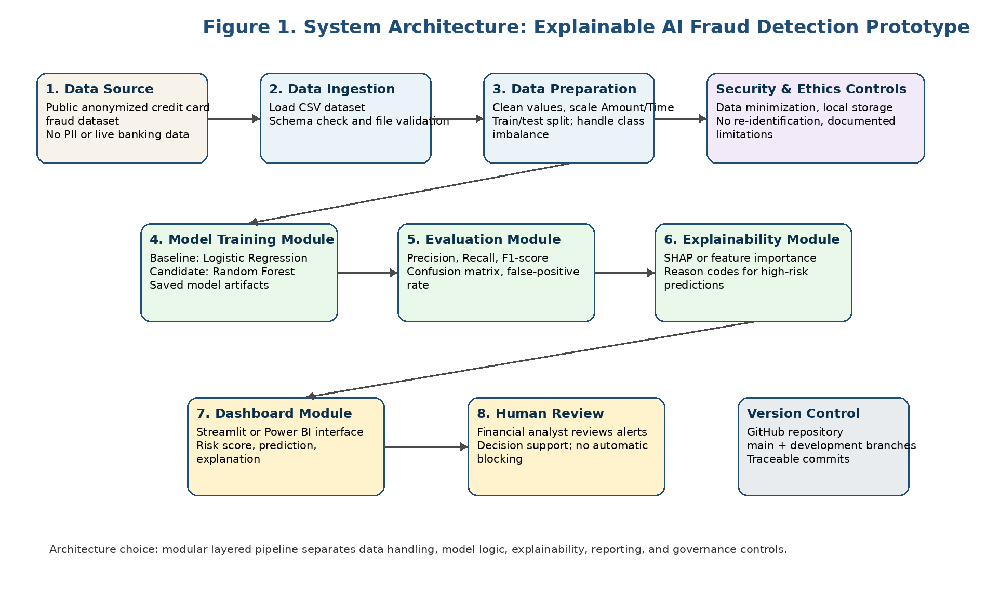

Module-Wise Functional Specifications
Module | Input | Output | Methodology
Data Ingestion | CSV fraud dataset and schema expectations | Verified dataset loaded into memory | Use Pandas to load data, confirm required fields, and reject unusable files.
Data Preparation | Raw transaction fields, amount, time, class label | Cleaned training and testing datasets | Scale numeric values, split data, preserve fraud-label distribution, and document class imbalance.
Model Training | Prepared training dataset | Trained logistic regression and random forest models | Use scikit-learn to train a transparent baseline and a stronger comparison model.
Evaluation | Model predictions and true labels | Precision, recall, F1-score, confusion matrix, false-positive rate | Evaluate performance using measures suitable for rare fraud events rather than accuracy alone.
Explainability | Final model and sample predictions | Feature importance or SHAP explanations | Translate model behavior into reason codes for high-risk transactions.
Dashboard | Predictions, risk scores, explanations, metrics | Simple analyst-facing dashboard | Use Streamlit or Power BI to display results for human review.

Functional and Non-Functional Requirements
ID | Functional Requirement
FR-1 | The system shall load a public anonymized credit card fraud dataset.
FR-2 | The system shall clean, scale, and split data into training and testing sets.
FR-3 | The system shall train at least two fraud-detection models.
FR-4 | The system shall evaluate models using precision, recall, F1-score, confusion matrix, and false-positive rate.
FR-5 | The system shall generate fraud-risk scores and explainability outputs for selected transactions.
FR-6 | The system shall display model results in a basic dashboard for human review.
NFR Category | Design Requirement
Performance | The prototype should process the selected dataset within normal student-computing limits and refresh dashboard outputs without unreasonable delay.
Usability | The dashboard should use plain labels, risk scores, and visual summaries understandable to a financial analyst.
Reliability | The workflow should be reproducible through documented scripts and saved model outputs.
Scalability | Modules should be separable so future work can add models, datasets, or dashboard features.
Security | The project shall use anonymized data, avoid PII, restrict repository exposure, and exclude secrets from version control.
Ethics | The model shall be documented as decision support only and shall not automatically block or accuse customers.

Summers (2020) explains that functional and performance requirements keep system and subsystem design aligned. In this project, that means each module has a defined responsibility and measurable output. NIST (2023) further recommends that AI systems be governed, mapped, measured, and managed. For that reason, the architecture includes privacy controls, model evaluation, explainability, and human oversight instead of treating fraud prediction as a purely technical output.

Version Control and Collaboration Overview
Repository URL: https://github.com/Douglas-Niyo/explainable-ai-fraud-detection-capstone
The project will use GitHub for version control because the capstone requires traceability across code, documentation, and design files. Davies (2024) explains that Git supports project history through status checks, logs, version comparison, and the ability to return to earlier states. The repository will include three top-level folders: /src for Python code and notebook files, /docs for reports and planning documents, and /design for architecture diagrams and requirement files. The dataset itself will not be uploaded if the license or file size makes that inappropriate; instead, the README will provide the source link and data-preparation instructions.
Two branches will be used. The main branch will contain stable and submitted work. The development branch will contain active changes while data cleaning, modeling, dashboard design, and documentation are being updated. Work will first be committed to development using clear messages such as 'Add system architecture diagram,' 'Create data preparation notebook,' and 'Document model evaluation metrics.' When a milestone is complete and reviewed, development will be merged into main. This approach demonstrates collaboration readiness even if the project is completed individually because another reviewer could inspect the branch history, compare changes, and reproduce the project.
Version control improves quality assurance by making every change traceable to a commit. It also protects documentation consistency because the project report, requirements, diagrams, and code can be updated together. If an error is introduced, Git history allows the project to compare versions and restore a previous working state. This is especially useful in a short capstone timeline, where accidental loss of code or undocumented changes could delay implementation.

Architecture Rationale and Data Flow Controls
The design intentionally avoids a microservices architecture because the capstone is a small prototype rather than a distributed production system. A modular layered structure is more appropriate because it allows each subsystem to be designed, tested, and documented without adding deployment complexity. The data module can be verified independently from the model module; the evaluation module can be rerun without changing dashboard code; and the dashboard can be simplified if the schedule becomes tight. This keeps the project aligned with the seven-week timeline and supports the feasibility decisions made in Unit 2.
The architecture also embeds ethical and security safeguards into the data flow. Data enters the system from a public anonymized source, and the ingestion module checks that no personally identifiable information is required. Model outputs are presented as probabilities and explanations rather than final accusations. The dashboard is therefore designed for human review, not automatic enforcement. This is important because false positives can inconvenience legitimate customers and false negatives can miss real fraud. By placing evaluation and explainability before dashboard reporting, the design makes model limitations visible before any user interprets the results.
The requirements are written to support implementation and assessment. Functional requirements define the required behavior of the prototype, while non-functional requirements define the qualities that make the prototype useful, secure, and maintainable. If a requirement cannot be implemented within the timeline, it will be reduced before implementation begins. For example, a complete production dashboard is outside scope, but a simple dashboard that displays risk scores, metrics, and explanations is achievable. This controlled approach protects the project from scope creep while still demonstrating a complete IT lifecycle from requirements to design, implementation, testing, and documentation.
For version control, the GitHub repository will also include a README file that explains the project purpose, setup steps, folder structure, dataset source, and execution sequence. A .gitignore file will prevent temporary files, local environment folders, secrets, and large datasets from being committed accidentally. Each milestone will be tagged or documented in the repository notes so that the final submission can show a clear path from proposal to architecture, model development, dashboard creation, and final report.

References
Davies, S. (2024). Blueprints: Creating, describing, and implementing designs for larger-scale software projects (Version 2.5). University of Mary Washington. https://open.umn.edu/opentextbooks/textbooks/blueprints-creating-describing-and-implementing-designs-for-larger-scale-software-projects-davis
Letaw, L. (2024). Handbook of software engineering methods. Oregon State University. https://open.oregonstate.education/setextbook/
National Institute of Standards and Technology. (2023). Artificial intelligence risk management framework (AI RMF 1.0). https://doi.org/10.6028/NIST.AI.100-1
Summers, B. L. (2020). Effective methods for software engineering. Auerbach Publishers.
Walker, V. (2022, March 16). 14 software architecture design patterns to know. Red Hat. https://www.redhat.com/en/blog/14-software-architecture-patterns

