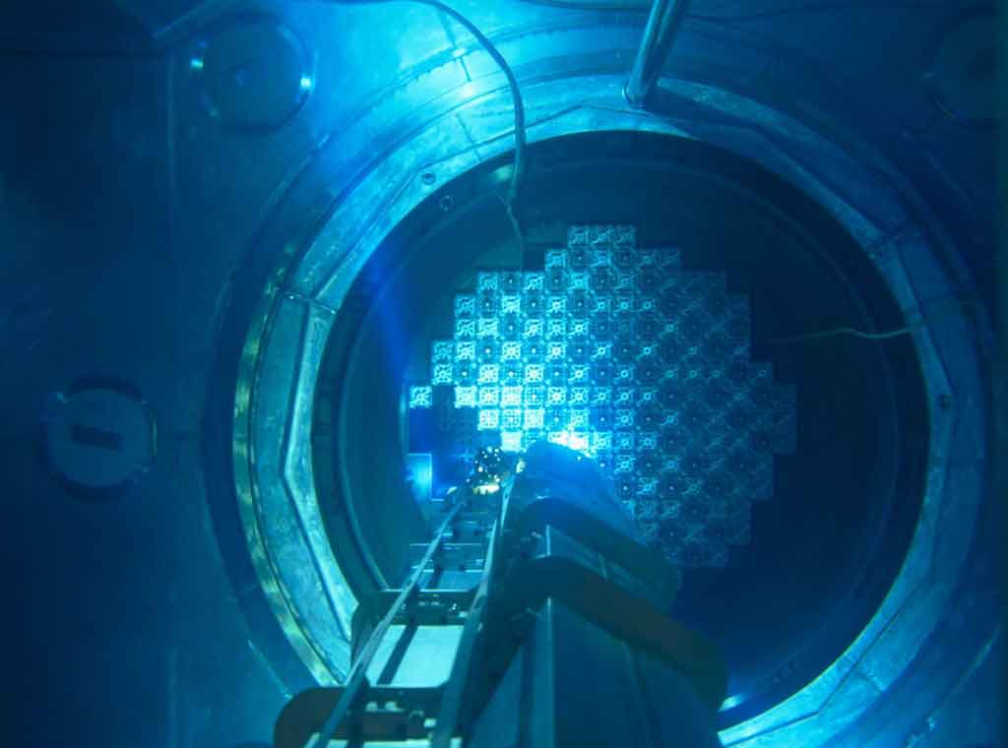

[This Photo](https://www.flickr.com/photos/foronuclear/9405156925) by Unknown Author is licensed under [CC BY-SA-NC](https://creativecommons.org/licenses/by-nc-sa/3.0/)

Alberta Advances in Renewable Technologies

Doug | UpSkilling Data Analytics | May 13, 2024

Contents

Small Modular Nuclear Reactors 2

Renewable Energy Production Limits 2

References 6

Table 1:Types of Renewable Technology 2

Table 2:Ammortization Dissemination 4

# Small Modular Nuclear Reactors

Edmonton’s Capital Power Corp. and Ontario Power Generation are joining together to assess the feasibility of developing small modular nuclear reactors to help power Alberta’s electricity grid.

“Nuclear energy is, and must be, a critical part of the clean energy transition, and part of our power generation fleet here in Alberta if we are to become carbon neutral.”

In Canada, four provinces — New Brunswick, Ontario, Saskatchewan and Alberta — have agreed to collaborate on the advancement of SMRs as a clean energy option, and Canadian researchers are working on new materials and designs that could make SMRs practical in a large range of new uses.

SMRs have even been touted as a potential solution for Alberta’s oilsands, one that could replace the vast volumes of fossil fuels burned in the oilsands production process.

Alberta, which has very little hydroelectric generating capacity but a rapidly expanding wind and solar power footprint, still depends heavily on fossil fuels in the form of natural gas for electricity generation.

SMRs are appealing, Neudorf said, because they provide the type of consistent base-load power that will be needed to backstop more intermittent clean power sources such as solar and wind in the future.

“SMRs will soon play a role in growing our economy and reducing our emissions,” Neudorf said.

“I think it makes it makes great sense for Alberta to be looking at this, especially given their investment in renewables,” said Jacquie Hoornweg, a clean energy expert with the Canadian Global Affairs Institute.

“The potential here is huge, in terms of being an enabler of decarbonization in Alberta.”, (Stephenson, 2024)

# Renewable Energy Production Limits

The federal minister responsible for innovation and industry says Canada could be at risk of losing out on attracting green industries if it doesn’t consider all options for renewable electricity, which he says include nuclear power.

“Nuclear, definitely,” Champagne said on Friday. “For me, we have to look at hydro, we have to look at nuclear, we have to look at small modular reactors, we have to look at wind, we have to look at solar.”

Table 1:Types of Renewable Technology

|  |  |
| --- | --- |
| Hydro | Nuclear |
| Wind | Solar |

Small modular reactors are a type of advanced nuclear power plant that the International Atomic Energy Agency says can be prefabricated and shipped to sites unsuited to larger conventional reactors. The federal government has previously said it wants to become “a global leader in SMR deployment.”

Champagne said in a previous interview that Canada was reaching its renewable energy production limits, something he reiterated in Vancouver while pointing to nuclear technology as a key part of the solution.

“Yes, compared to fossil fuel sources (nuclear) is relatively low carbon, depending on certain assumptions,” Winfield said. “But it carries with it a huge, a very serious range of negative trade-offs. It essentially fails every other test of sustainability.”[1]

He said he also worries about the management of nuclear waste “on time scales of a million years” as well as the impact of uranium mining.

Industry proponents point to nuclear power’s dependable nature, since it doesn’t rely on weather conditions that can affect solar and wind generation.

Christidis said while nuclear plants have high initial capital costs, those costs are amortized over a longer period compared to other power plants, meaning more stable costs than facilities at the whim of fluctuating fossil fuel prices.

He said the potential for small modular reactors is huge, as other countries will look to Canada to produce such reactors for decarbonizing power generation, (Chiang, 2024).

<https://www.foronuclear.org/en/press-room/press-releases/nuclear-power-plants-are-not-amortized-and-nuclear-generation-is-currently-incurring-losses/#:~:text=Nuclear%20power%20plants%20are%20not%20amortized.>

Table 2:Ammortization Dissemination

Within Canada, smaller nuclear reactors of various sizes are being planned or explored in Ontario, Saskatchewan and Alberta, and Christidis said they could be “fundamental to shifting away from the use of coal” in these provinces.

“The applications (of SMRs) to widen the transition into these clean energy solutions in the small reactor space, they’re very real,” he said.

Winfield said, even beyond the cost and waste management aspects, nuclear power presents too much risk to warrant consideration as part of Canada’s bid to bring more green industry online.

“You have catastrophic accidents, safety, security, weapons proliferations, risks that just don’t exist in relation to any other energy technology … all of which would suggest that this technology would be an option of absolute last resort when all other options around decarbonization have been fully developed and optimized,” he said.

# References

Chiang, C. (2024, April 6). *Federal minister says nuclear power is key part of renewable energy expansion.* Retrieved from The Canadian Press: https://edmonton.citynews.ca/2024/04/06/nuclear-power-key-renewable-energy-expansion/

Stephenson, A. (2024, January 15). *Capital Power and Ontario Power Generation to Assess Use of Small Modular Nuclear Reactors in Alberta.* Retrieved from Capital Power and Ontario Power Generation to Assess Use of Small Modular Nuclear Reactors in Alberta.: https://globalnews.ca/news/10226265/alberta-capital-power-ontario-nuclear-reactors/

1. It’s interesting to think that nuclear energy fails every test.