Orientation with the Lidar: Task 1

This task was to filter out data points from the original point cloud, obtained from the hokuyo lidar. The filters being used are PassThrough and StatisticalOutlierRemoval filters, which are provided by PointCloudLibrary. The PassThrough Filter is used to remove data points that fall out of the starting area in the arena. If we place the lidar on the rightmost part of the collector bin, this would leave us with a range of 2.6775 meters to the left and 1.1025 meters to the right. This range describes the width of the arena from te perspective of the lidar. Meanwhile, the SatisticalOutlierRemoval filter is being used to remove noisy data points from the lidar scan. These test cases are going to try these filters in different settings such as different lighting conditions, different object sizes and different angles to placing the objects.

Conclusion:
After testing the filters with the lidar we were able to determine that the lighting conditions did not affect the outcome of the filters. We were able to detect the objects in the lidar scan and were able to filter out points cleanly. We tested in dim light, mildly lit and very bright conditions and these lighting conditions had no effect on the final lidar data set.

In the additional test cases section we tested placing object in different positions from the perspective of the lidar. In test case 14 and 17, we see that an edge of the object has not been properly scanned since it is not a dense cluster of points. This test case showed that the outermost edge of the range of the PassThrough filter and showed that we are still able to detect an object near the edge of range of filtering points. Thus placing an object in different areas within the range was still effective.

There was one test case, test case 4, where the distance between the lidar and the object was an issue as it truncated some of the points of the object in testing. This distance was beyond 2 meters which is out of the starting region in the arena. Then we moved the object slightly forward to about 1.875 meters and the object was clearly detected and no points were truncated after the filters were applied. These test cases showed that distance may affect the end result but within the starting area, about 1.5 meters from the lidar, we will have no issues detecting an object of a decent size.

Summary of Test Cases
 | Lighting | Distance | Size | Outcome
Case 1 | Natural but mildly lit | 0.889 m to the front and 0.5334 m to the right | 0.3556 m length by 0.3556 m wide | The object was detected with no issues.
Case 2 | Natural but mildly lit | 1.7653 m to the front and 0.508 m to the right | 0.3556 length by 0.3556 wide | The object was detected and no issues were present
Case 3 | Natural but mildly lit | 0.9493 m to the front and 0.381 m to the left | 0.1842 m length by 0.254 m wide | The object was detected and no issues were present
Case 4 | Natural but mildly lit | 1.8637 m to the front and 0.0762 m to the right | 0.1842 m length by 0.254 m wide | The object was detected and no issues were present
Case 5 | Natural but mildly lit | 0.6477 m to the front and 0.0127 m to the right | 0.2032 m length by 0.2032 m to the right | The object was detected and no issues were present
Case 7 | Natural but mildly lit | 0.6477 m to the front and 0.0127 m to the right | 0.2032 m length by 0.2032 m to the right | The object was detected but after the filters were applied some points were truncated
Case 8 | Natural but mildly lit | 0.7336 m to the front | 0.2032 m length by 0.1016 m wide | The object was detected and no issues were present
Case 9 | Natural but very dim | 0.7336 m to the front | 0.2032 m length by 0.1016 m wide | The object was detected and no issues were present
Case 10 | Natural but very dim | 0.7366 m to the front and 0.1397 m to the right | 0.2032 m length by 0.2032 m wide | The object was detected and no issues were present
Case 11 | Natural but very dim | 0.8509 m to the front and 0.4826 to the right | 0.3556 m length by 0.3556 m wide | The object was detected and no issues were present
Case 12 | Natural but very dim | 1.092 m to the front and 0.5207 m to the right | 0.1841 m length by 0.254 m wide | The object was detected and no issues were present
Case 13 | Artificial bright light | N/A | 0.3556 m length by 0.3556 m wide | The object was detected and no issues were present
Case 14 | Artificial bright light | N/A | 0.3556 m length by 0.3556 m wide | The object was scanned but there was an edge of it was not a scanned thoroughly. This edge was not a dense cluster.
Case 15 | Artificial bright light | N/A | 0.3556 m length by 0.3556 m wide | The object was detected and no issues were present
Case 16 | Artificial bright light | N/A | 0.3556 m length by 0.3556 m wide | The object was detected; no issues
Case 17 | Artificial but bright | N/A | 0.3556 m length by 0.3556 m wide | The object was scanned but there was an edge of it was not a scanned thoroughly. This edge was not a dense cluster.

Test Cases

Test Case 1
Lighting: Natural but mildly lit
Object Size: 0.3556 m length by 0.3556 m wide
Distance from lidar: 0.889 m to the front and 0.5334 m to the right

Original Scan:
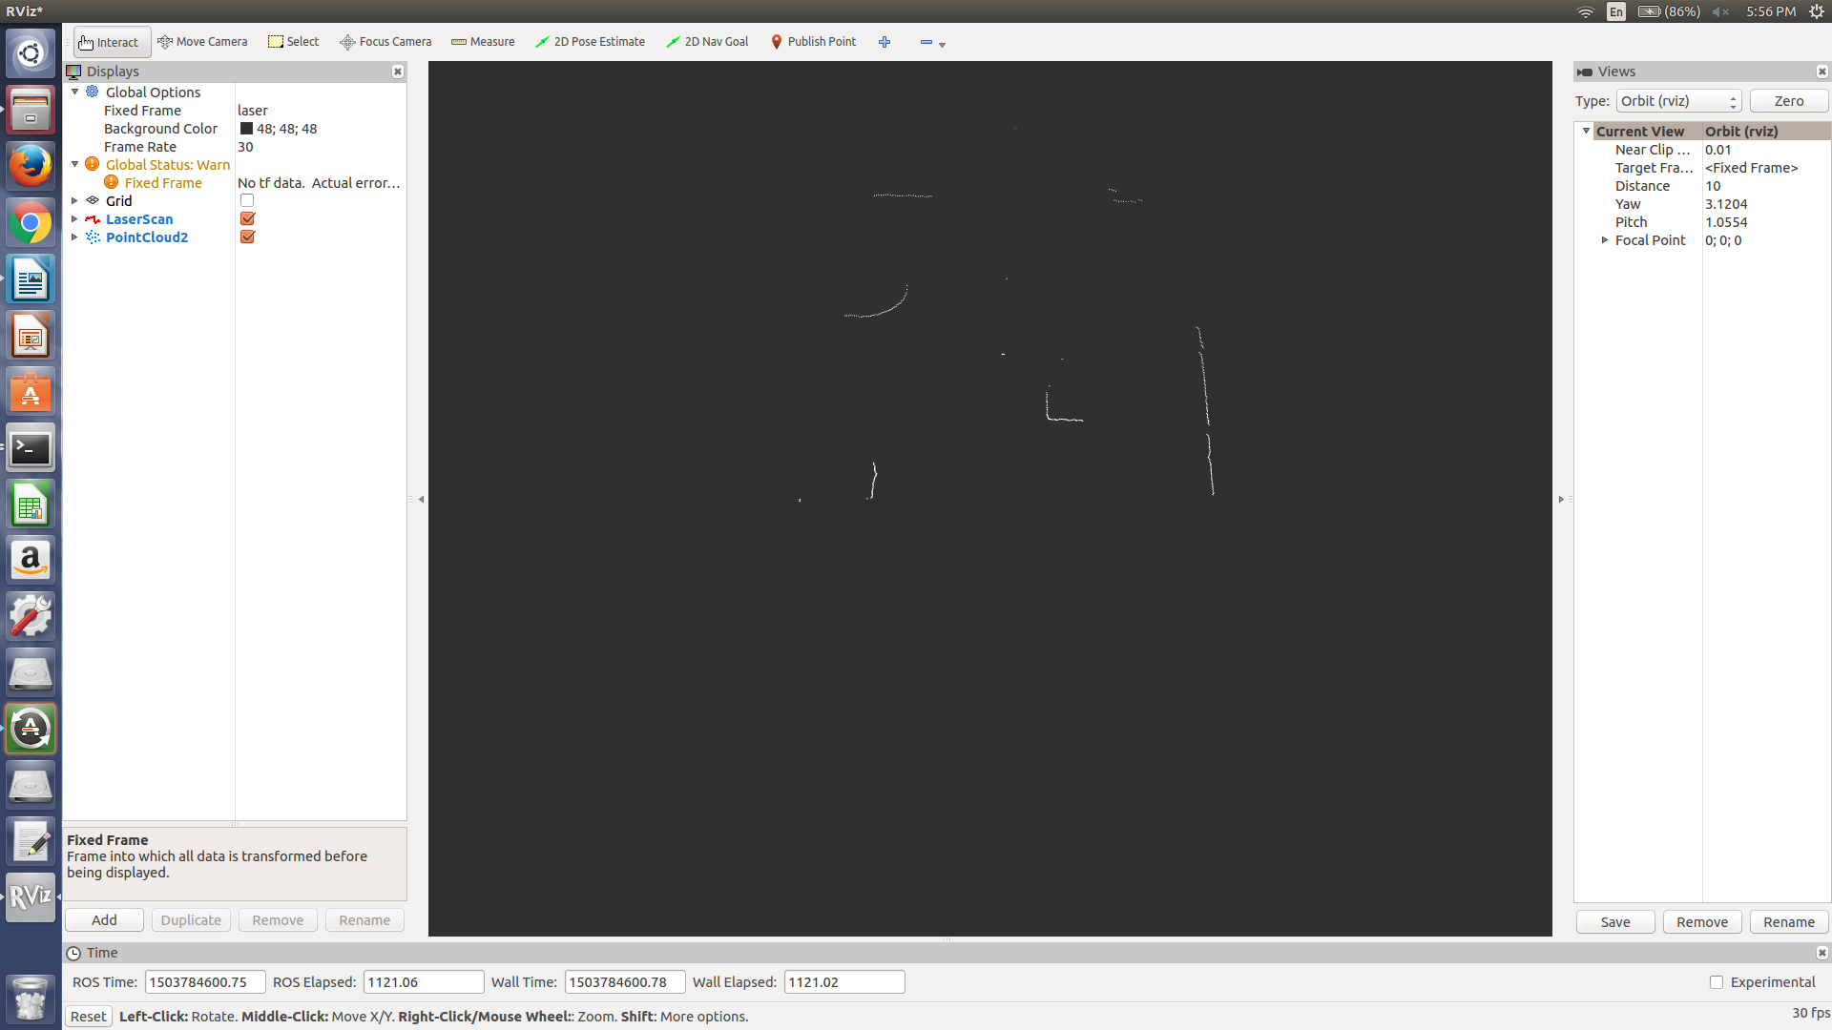
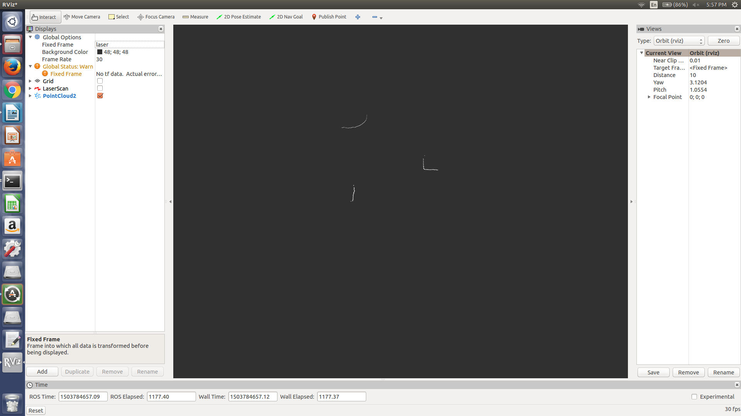
PassThrough and StatisticalOutlierRemoval Filter applied:
Test Case 2
Lighting: Natural but mildly lit
Object Size: 0.3556 length by 0.3556 wide
Distance from lidar: 1.7653 m to the front and 0.508 m to the right

Original Scan:
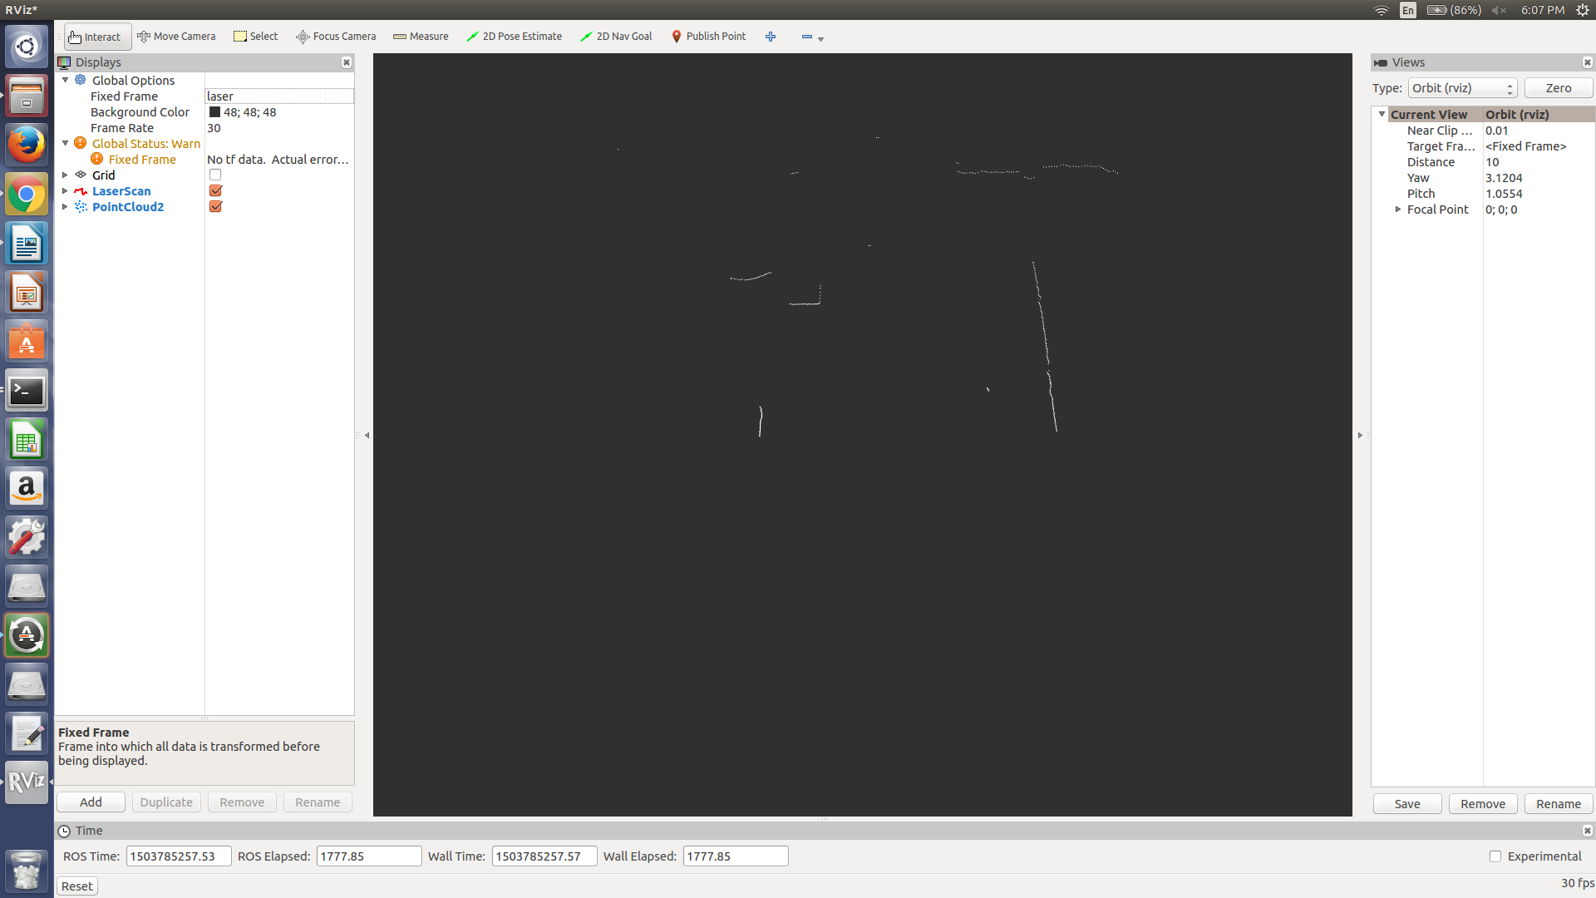
Passthrough and StatisticalOutlierRemoval Filter applied:
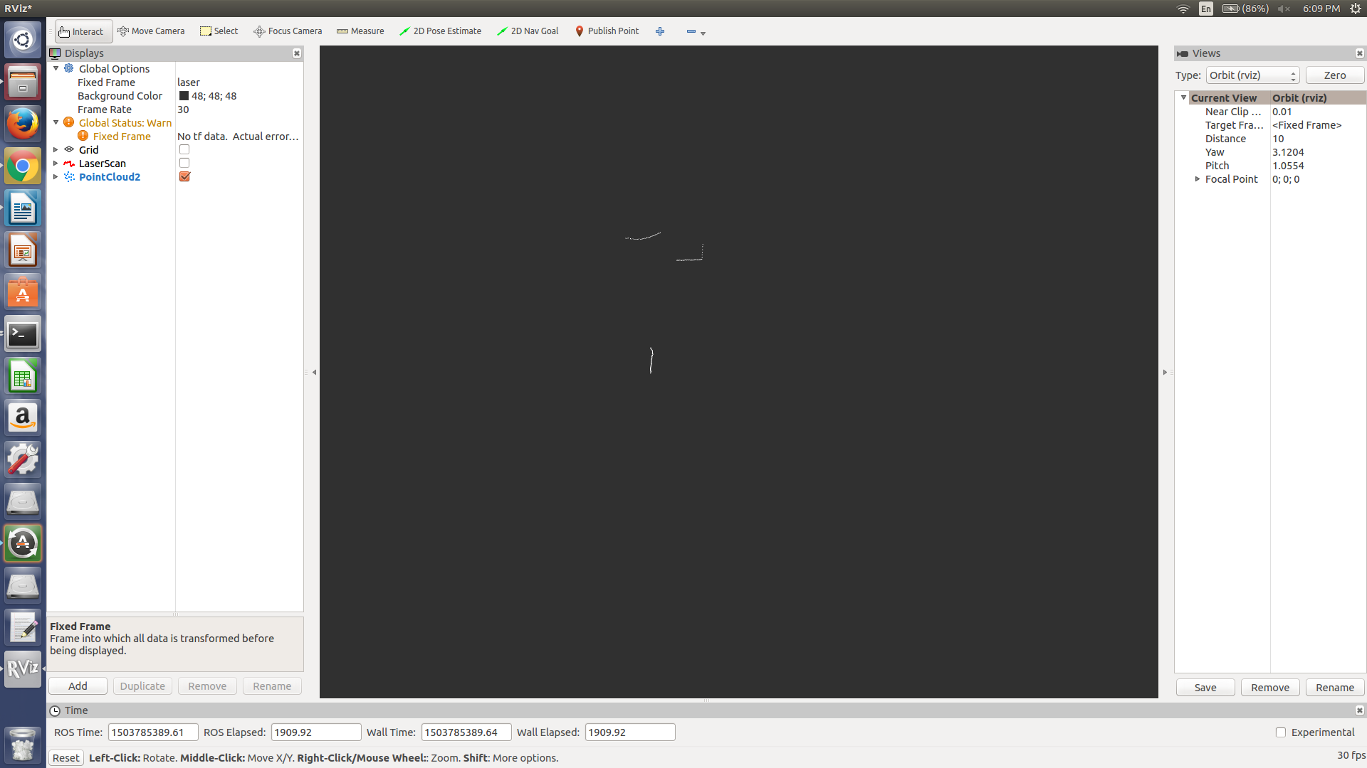
Test Case 3:
Lighting: Natural but mildly lit
Object Size: 0.1842 m length by 0.254 m wide
Distance from lidar: 0.9493 m to the front and 0.381 m to the left

Original Scan:
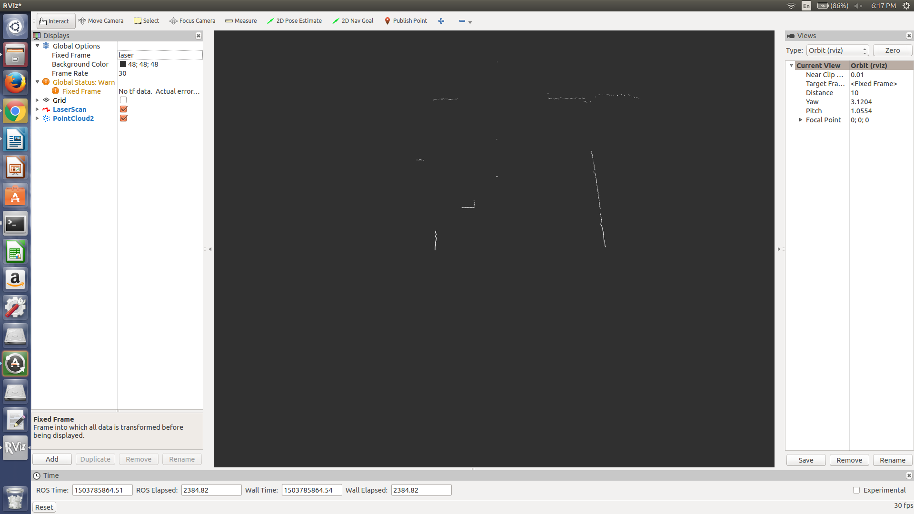
PassThrough and StatisticalOutlierRemoval Filter applied:
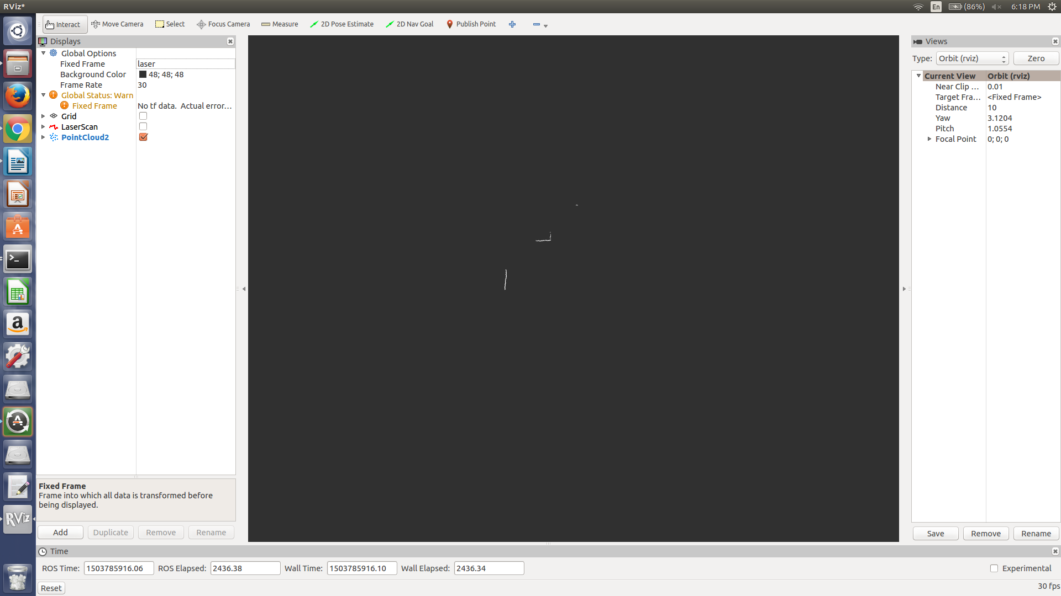
Test Case 4:
Lighting: Natural but mildly lit
Object Size: 0.1842 m length by 0.254 m wide
Distance from lidar: 2.413 m to the front and 0.0762 m to the right

Original Scan:
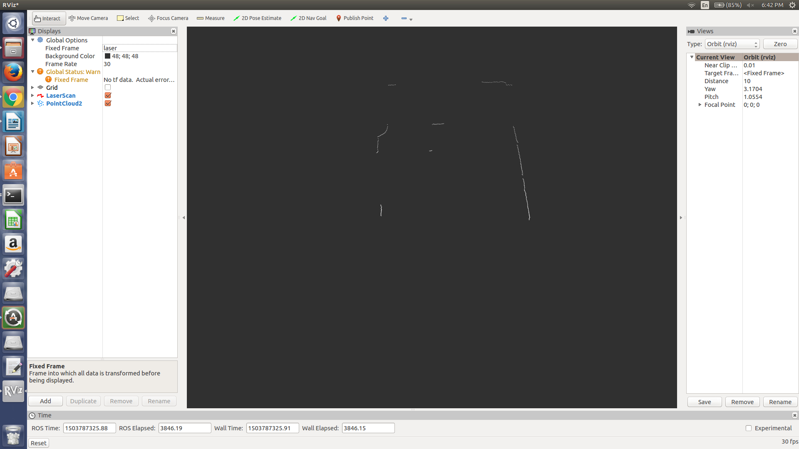
PassThrough and StatisticalOutlierRemoval Fitler applied:
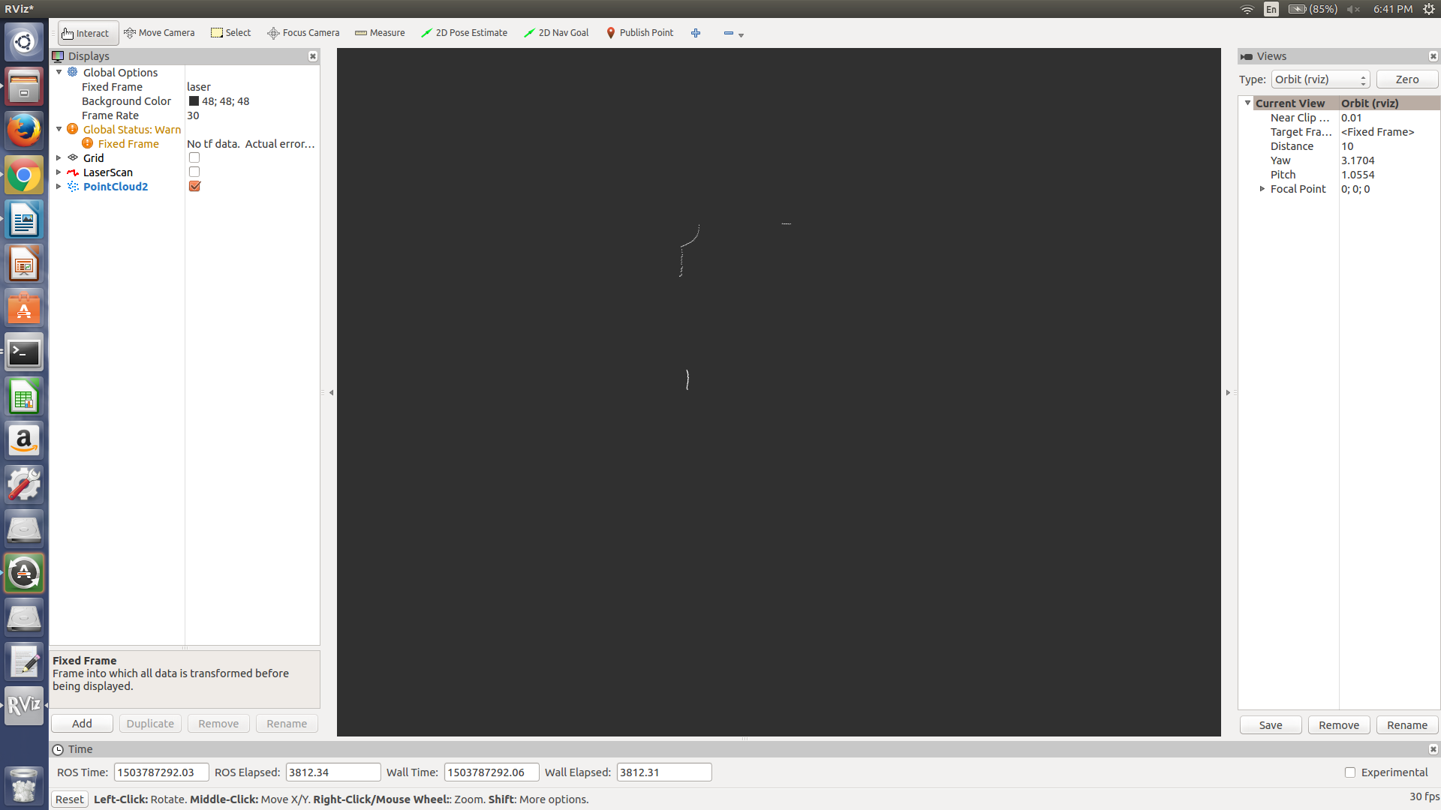
Test Case 5:
Lighting: Natural but mildly lit
Object Size: 0.1842 m length by 0.254 m wide
Distance from lidar: 1.8637 m to the front and 0.0762 m to the right

Original Scan:
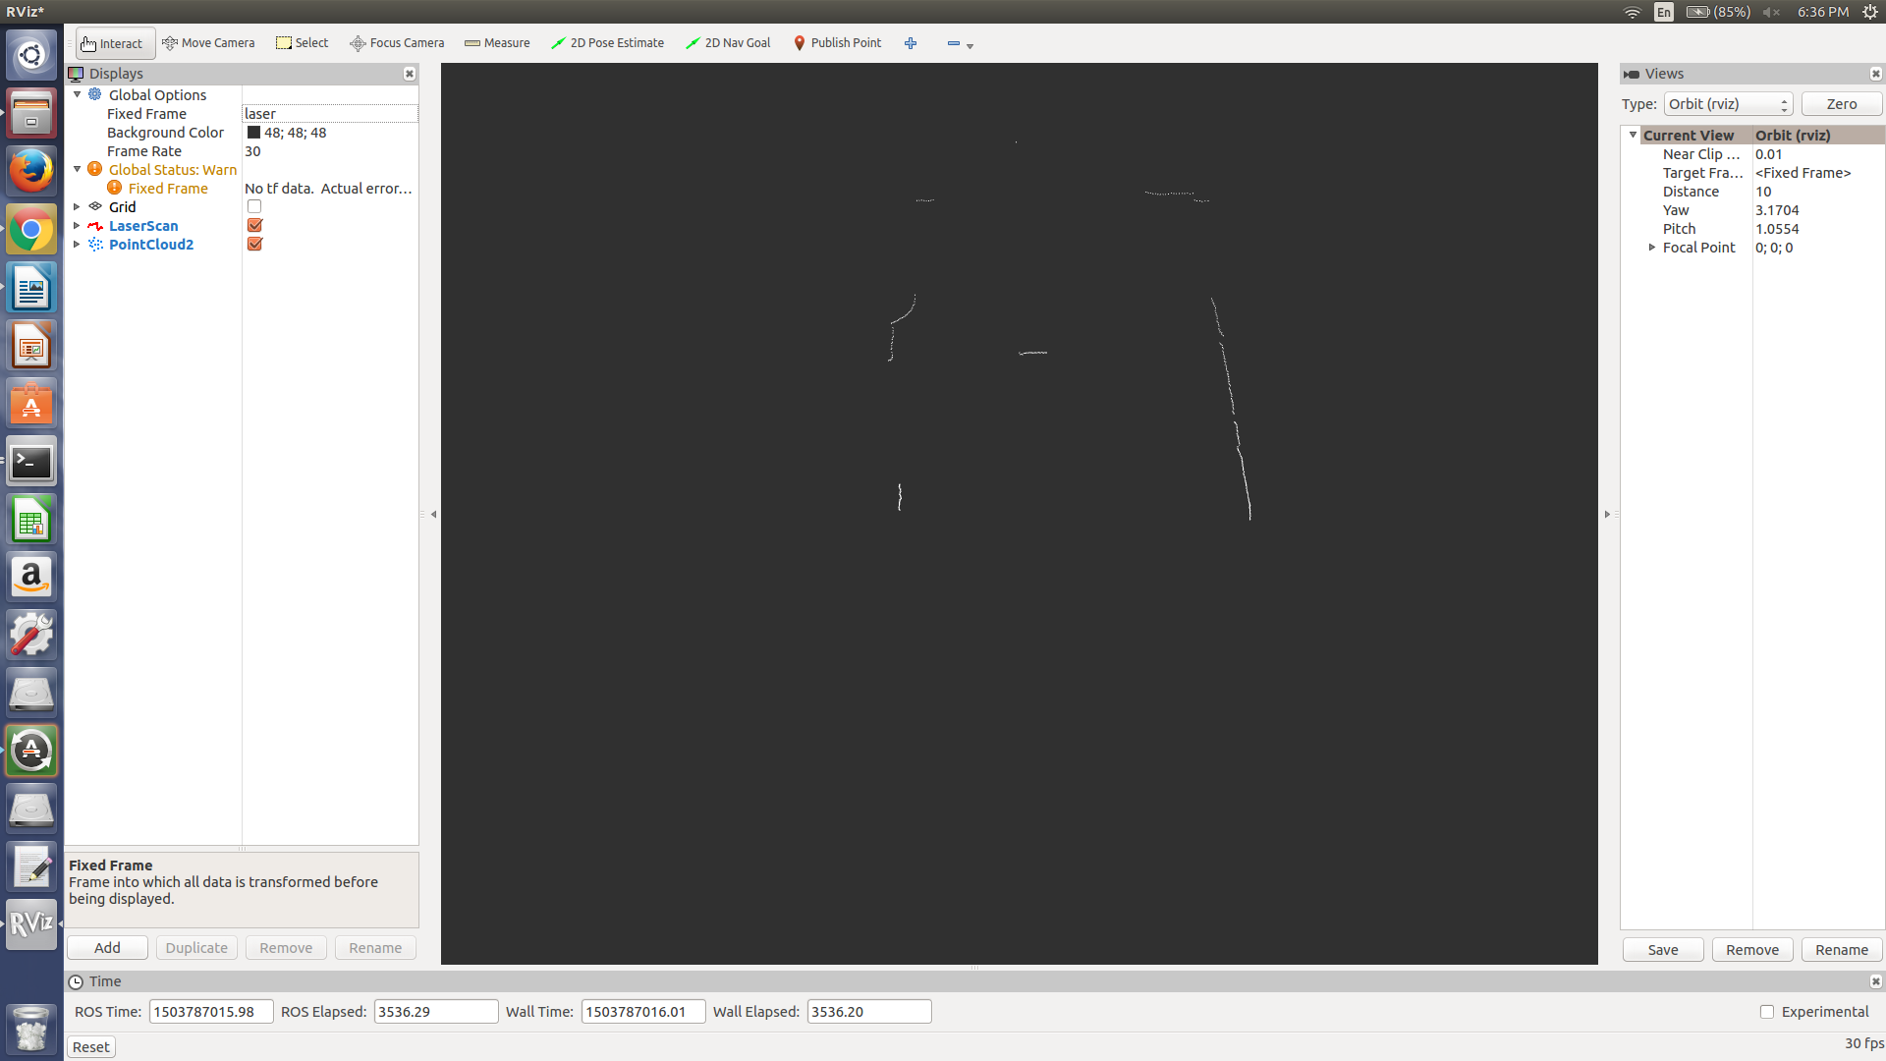
PassThrough and StatisticalOutlierRemoval Filter:
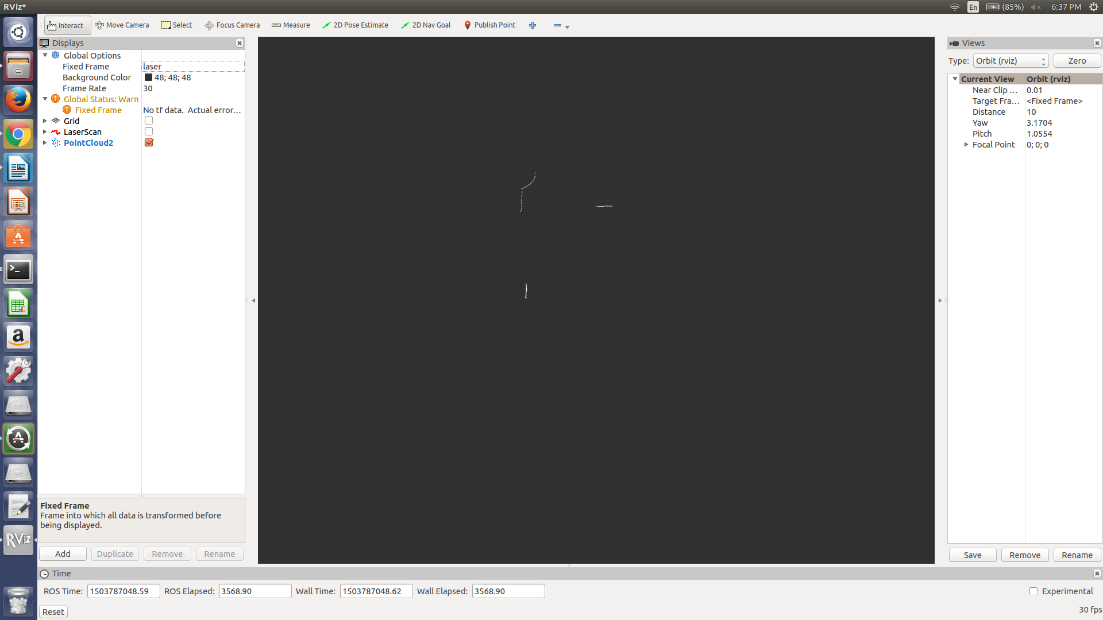
Test Case 6:
Lighting: Natural but mildly lit
Object Size: 0.2032 m length by 0.2032 m to the right
Distance from lidar: 0.6477 m to the front and 0.0127 m to the right

Original Scan:
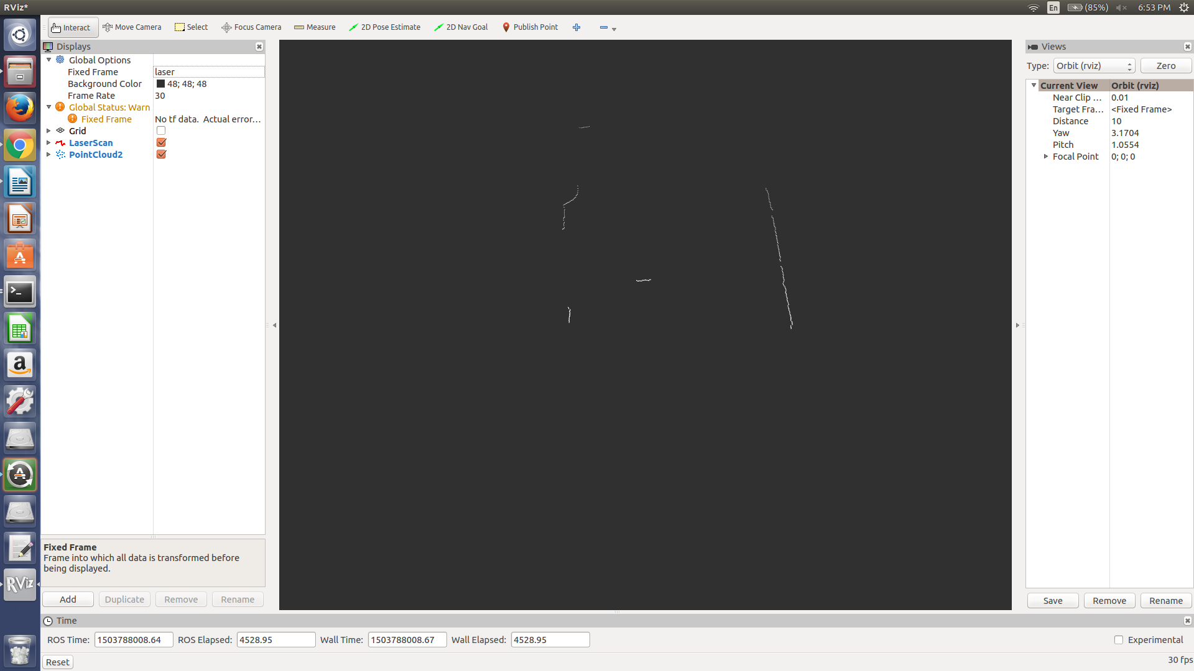
PassThrough and StatisticalOutlierRemoval Filter:
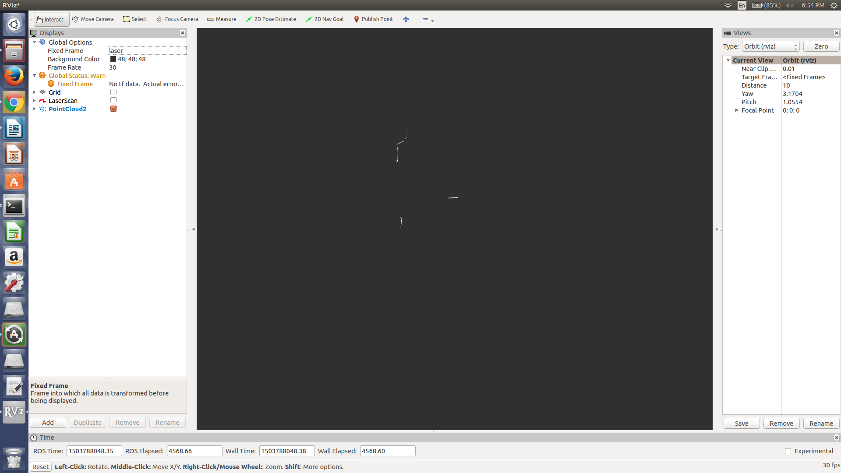
Test Case 7:
Lighting: Natural but mildly lit
Object Size: 0.2032 m length by 0.1016 m wide
Distance from lidar: 0.7336 m to the front

Original Scan:
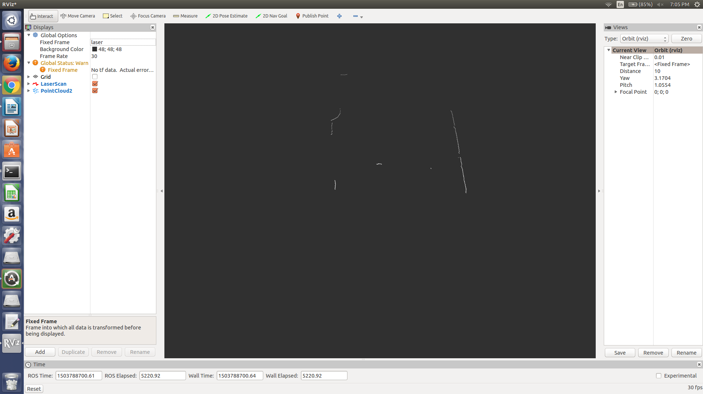
PassThrough and StatisticalOutlierRemoval Filter applied:
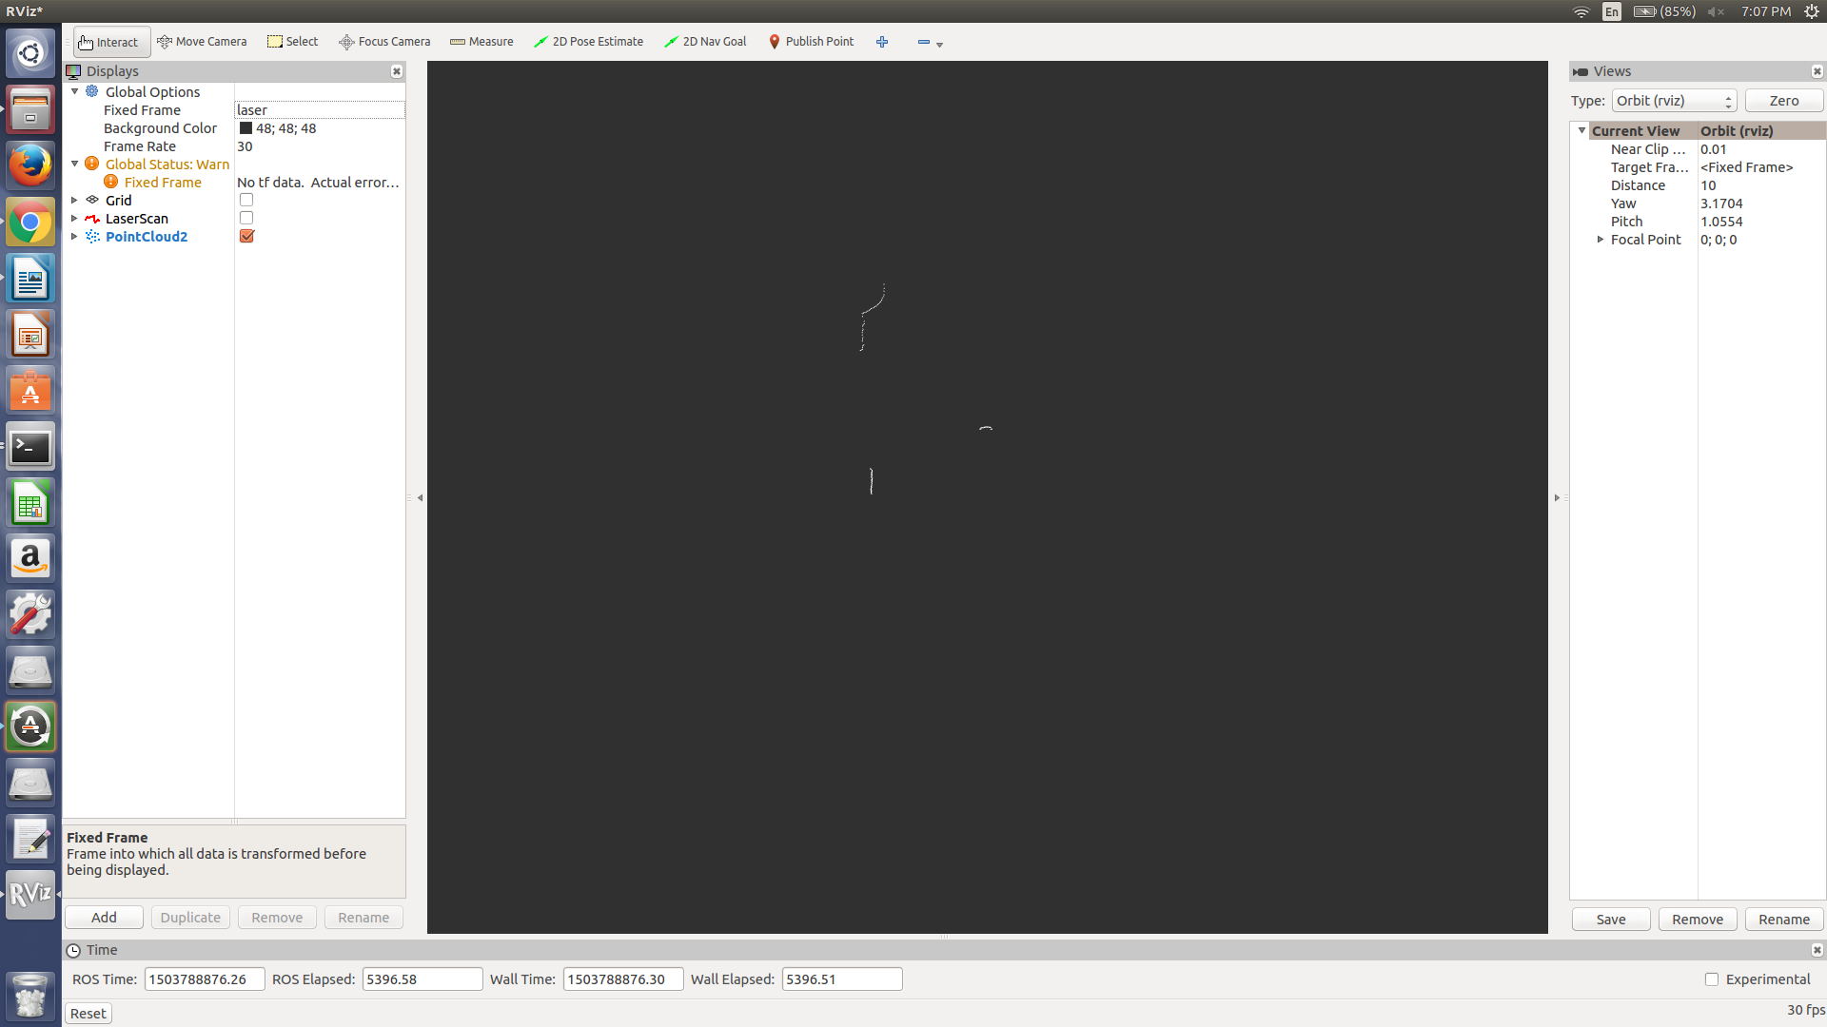
Test Case 8:
Lighting: Natural but very dim
Object Size: 0.2032 m length by 0.1016 m wide
Distance from lidar: 0.7336 m to the front

Original Scan:
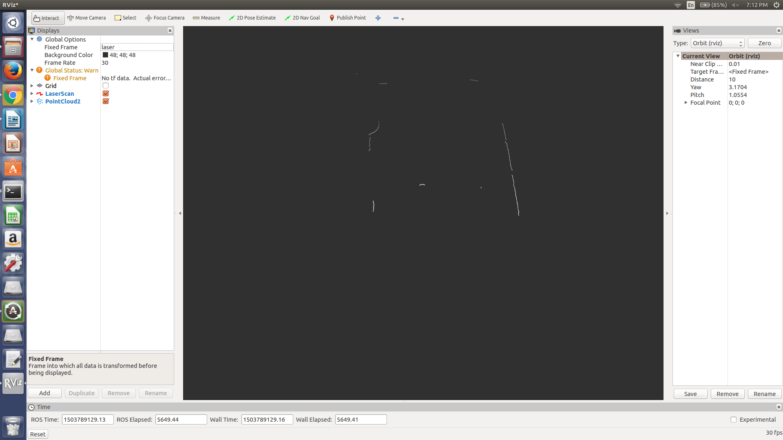
PassThrough and StatisticalOutlierRemoval Filter applied:
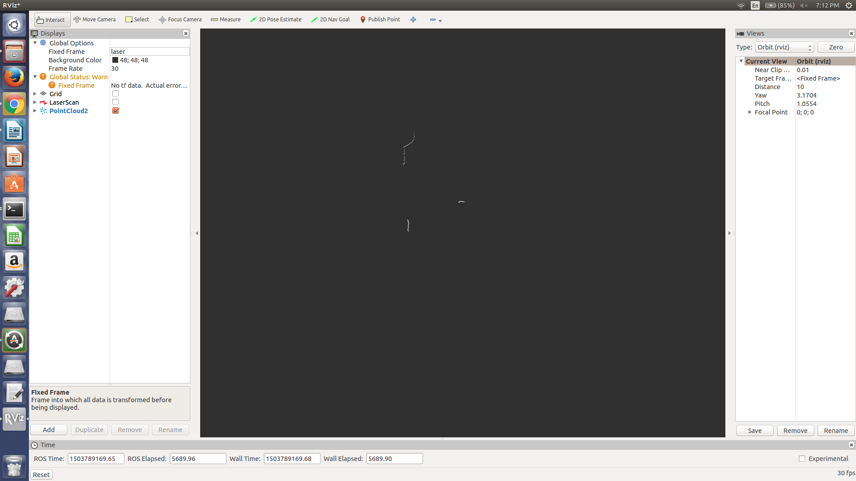
Test Case 9:
Lighting: Natural but very dim
Object Size: 0.2032 m length by 0.2032 m wide
Distance from the lidar: 0.7366 m to the front and 0.1397 m to the right

Original Scan:
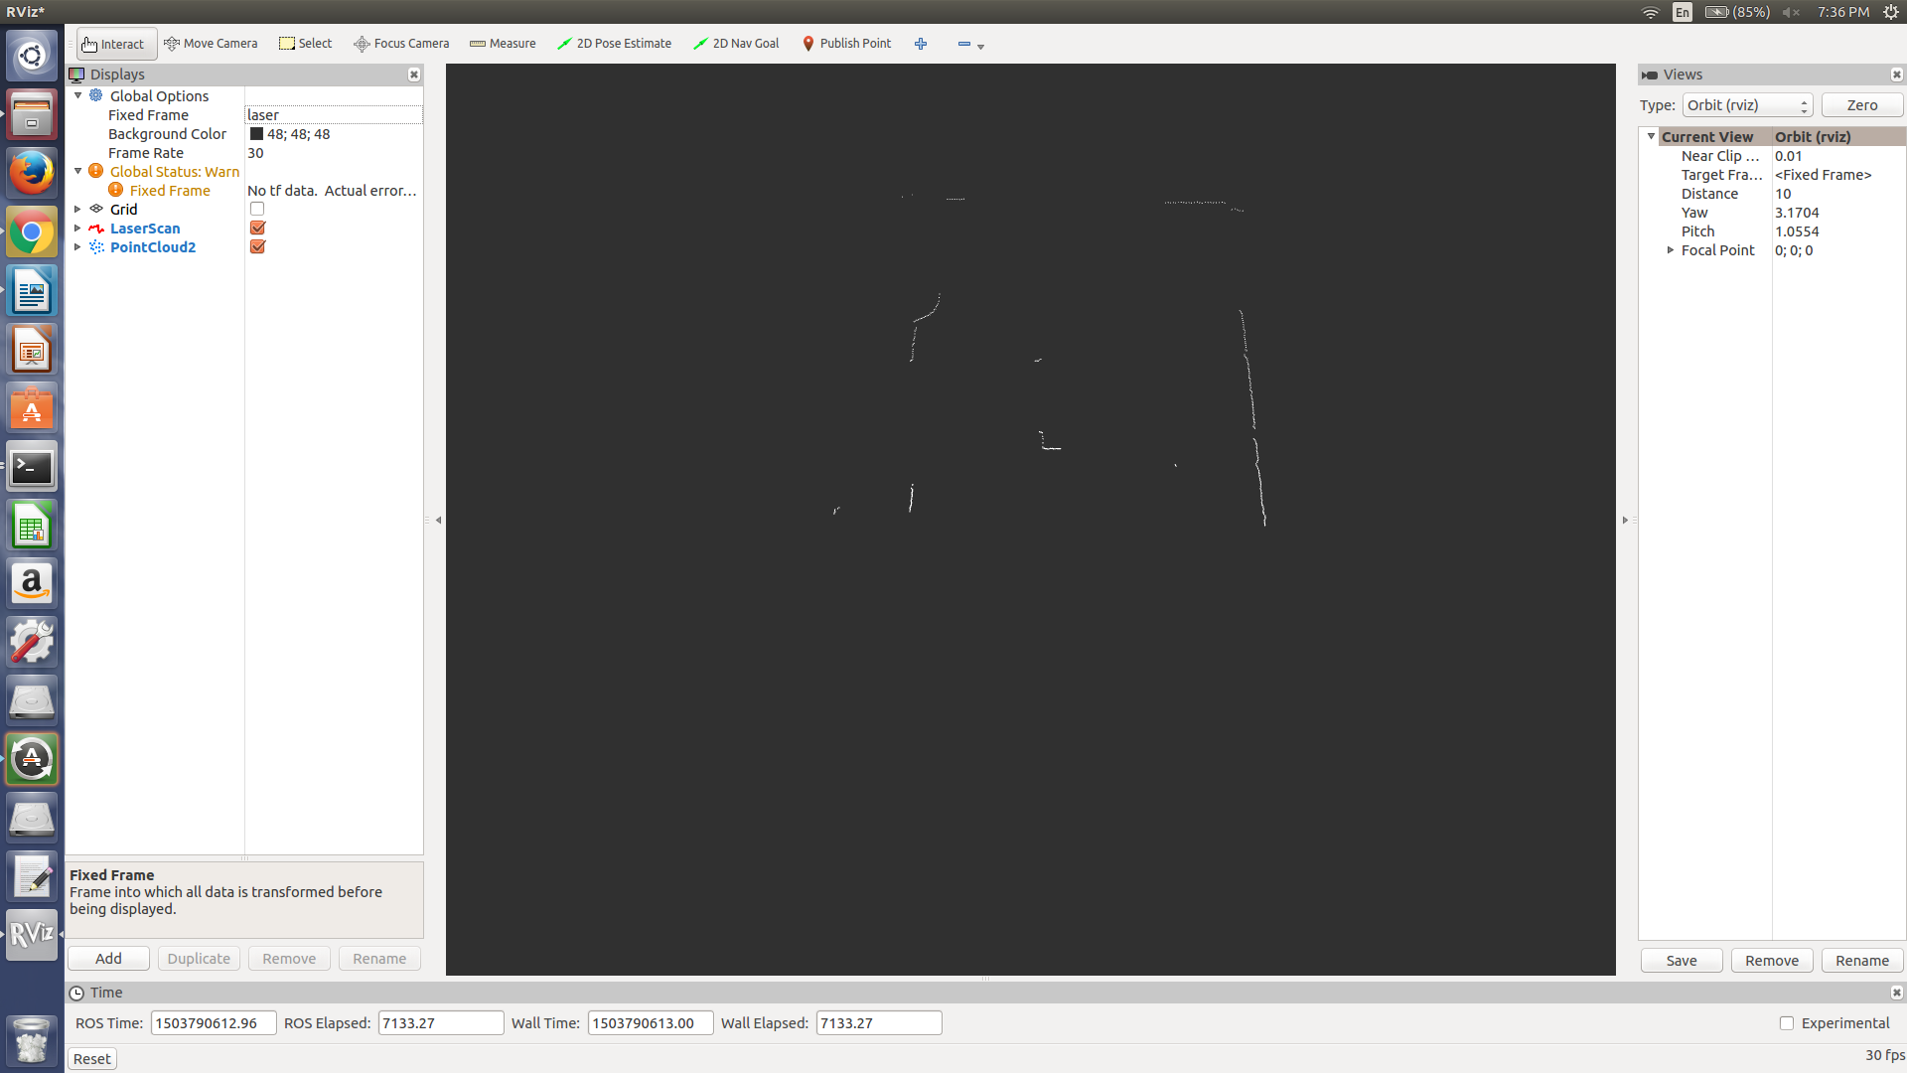
PassThroughFilter and StatisticalOutlier Removal Filter:
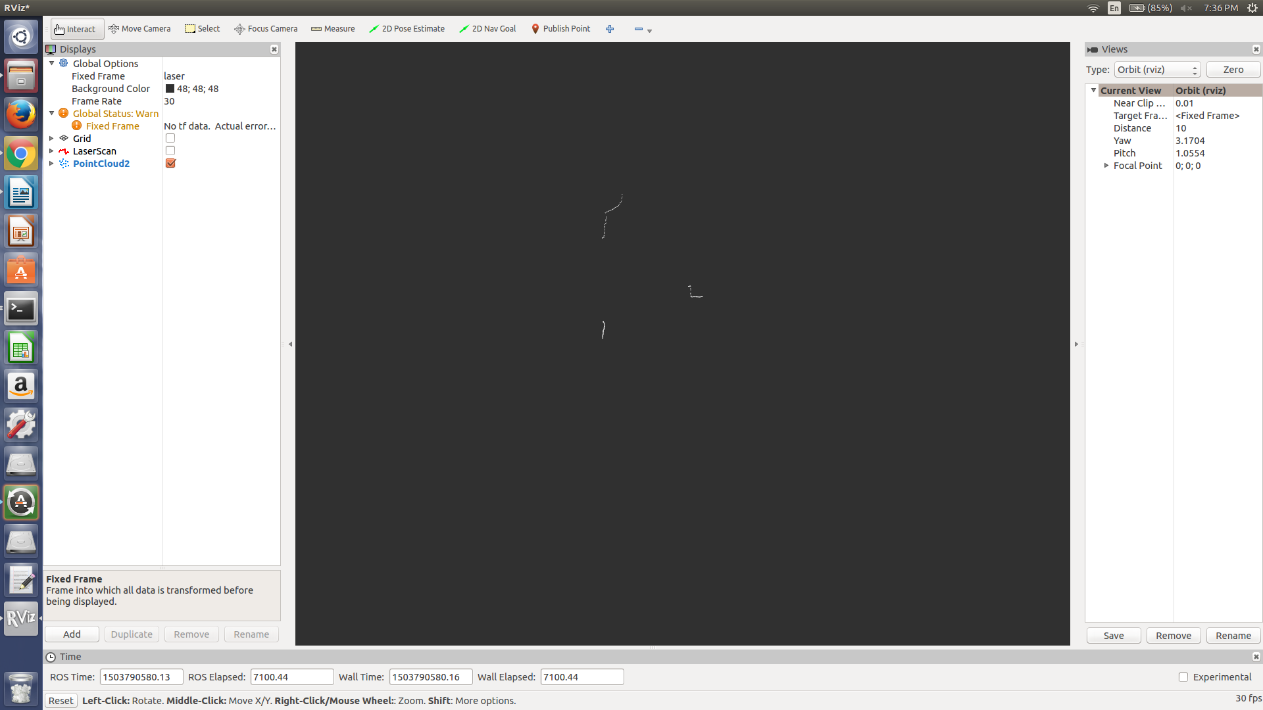
Test Case 10:
Lighting: Natural but very dim
Object Size: 0.3556 m length by 0.3556 m wide
Distance from the lidar: 0.8509 m to the front and 0.4826 to the right

Original Scan:
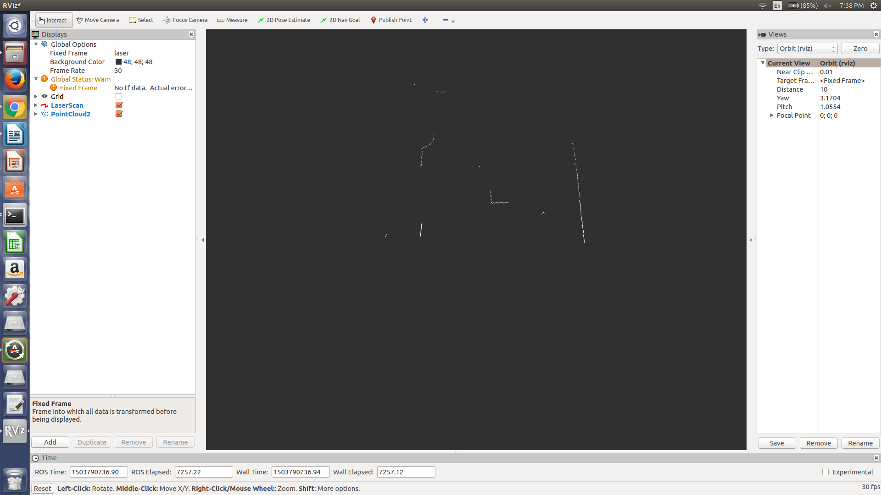
PassThroughFilter and StatisticalOutlierRemoval Filter:
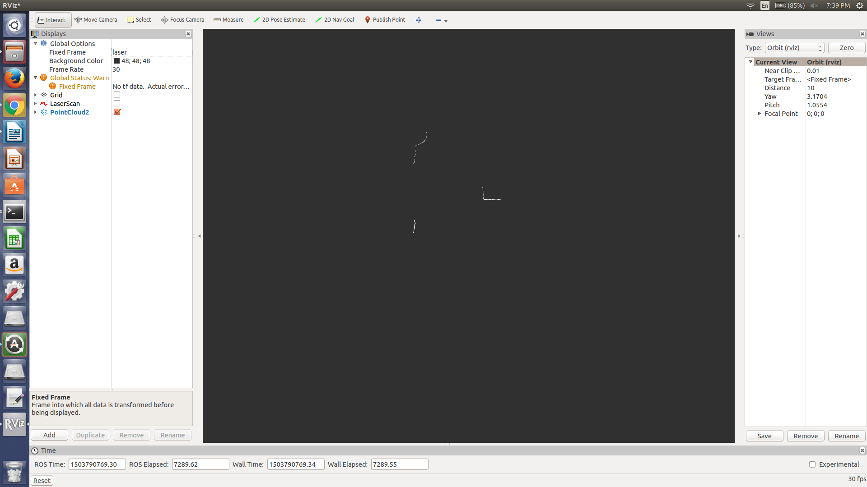
Test Case 11:
Lighting: Natural but very dim
Object Size: 0.1841 m length by 0.254 m wide
Distance from object: 1.092 m to the front and 0.5207 to the right

Original Scan:
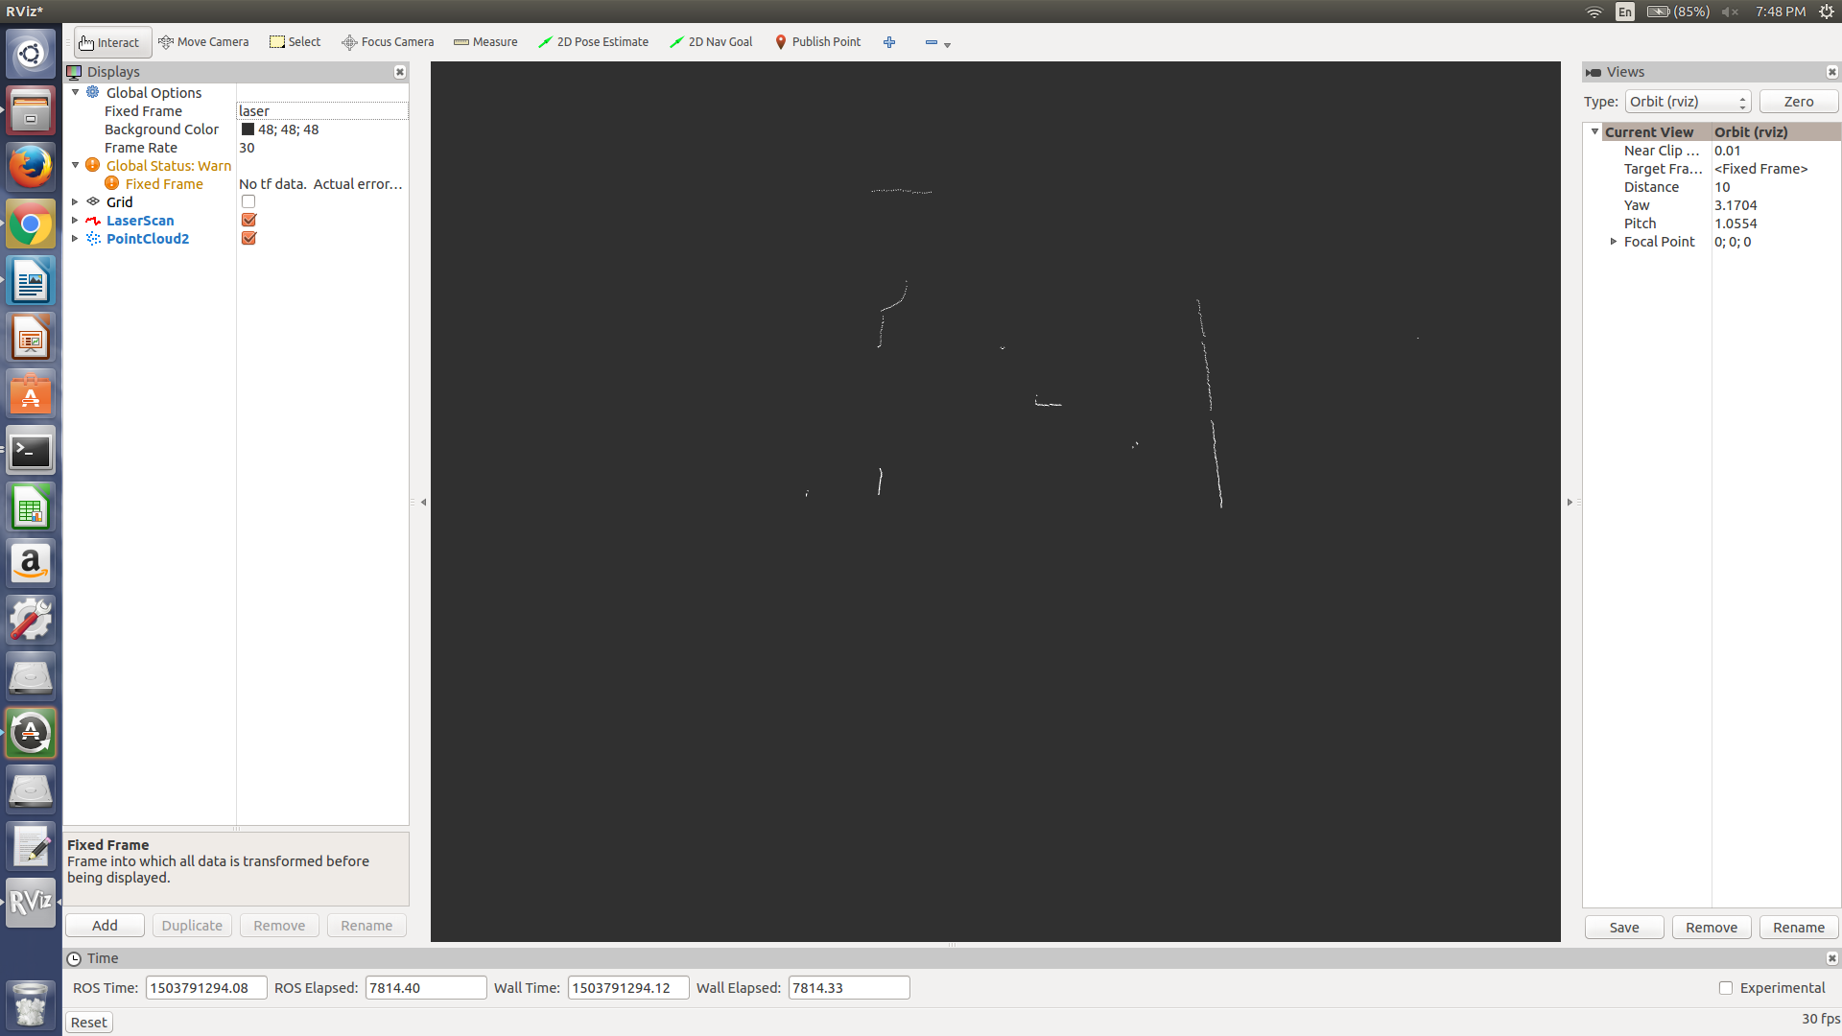
PassThrough and StatisticalOutlierRemoval Filter:
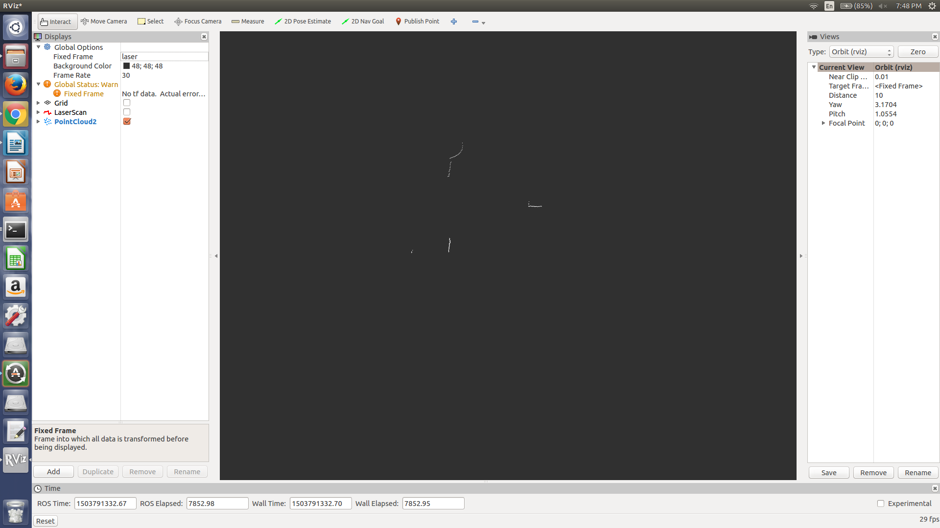
Additional Test Cases:

These additional test cases used the same object but moved around to different positions in order to test if the lidar can recognize an object at different positions.

Conditions of the test:

Lighting: Artificial light but it was bright
Object Size: 0.3556 m length by 0.3556 m wide

Test Case 12:

Original Scan:
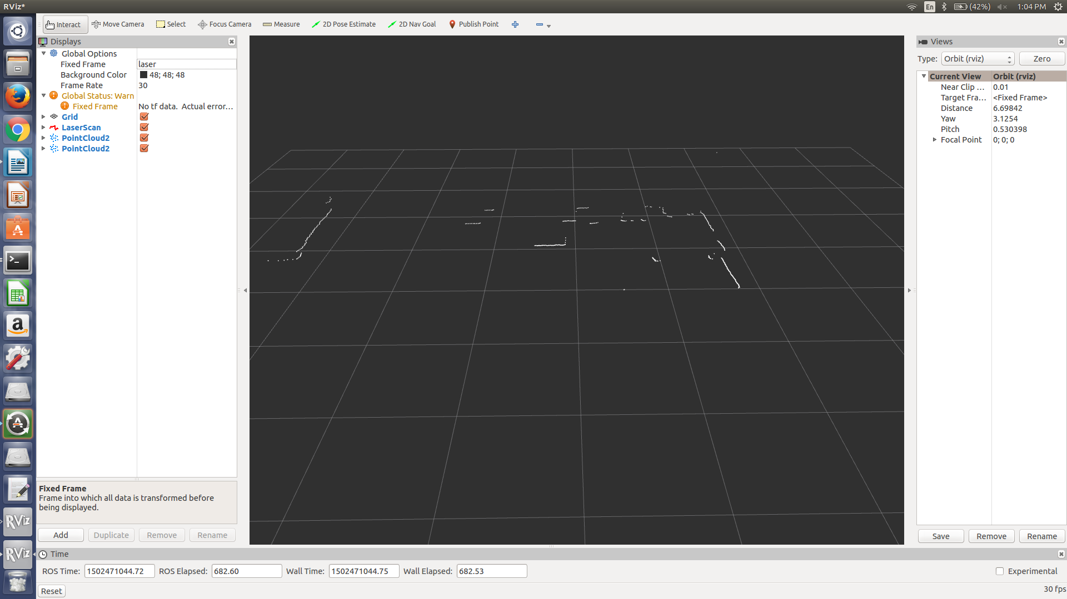
PassThrough and StatisticalOutlierRemoval Filter applied:
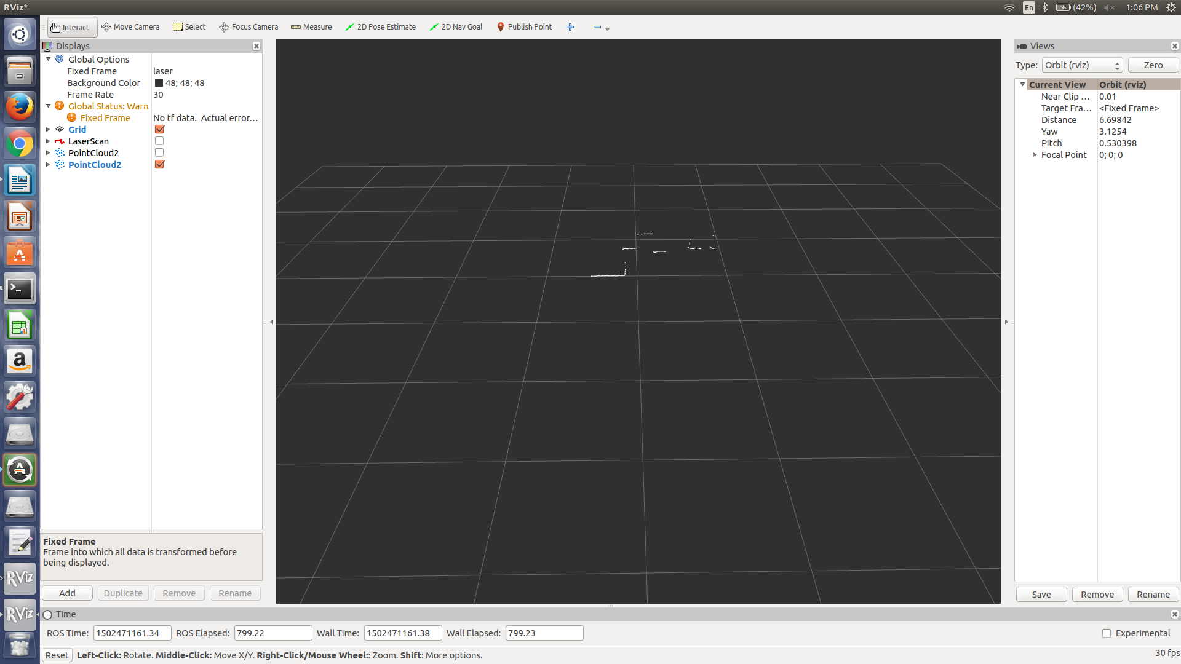
Test Case 13:

Original Scan:

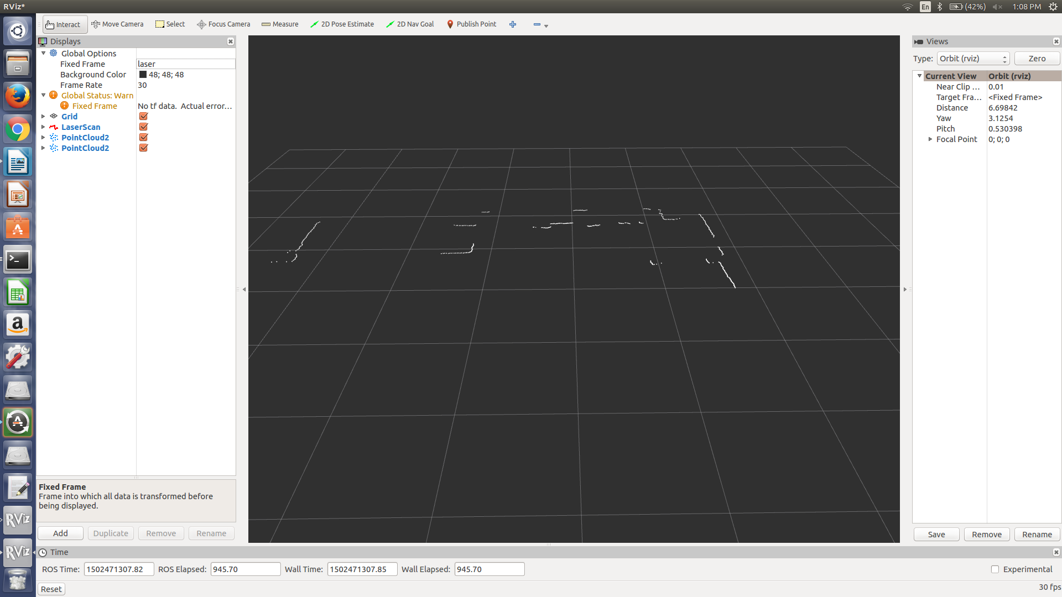
PassThrough Filter and StatisticalOutlierRemoval:

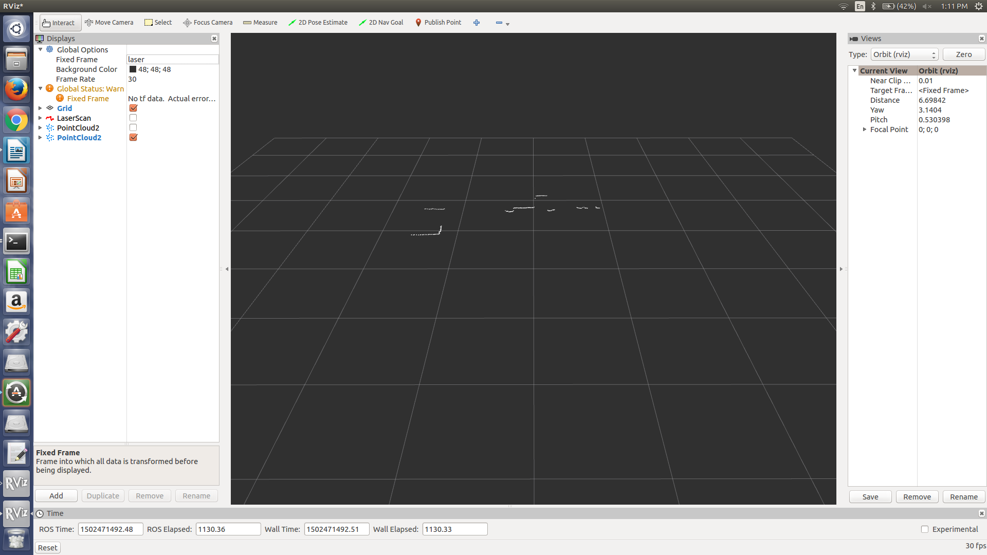
Test Case 14:

Original Scan:

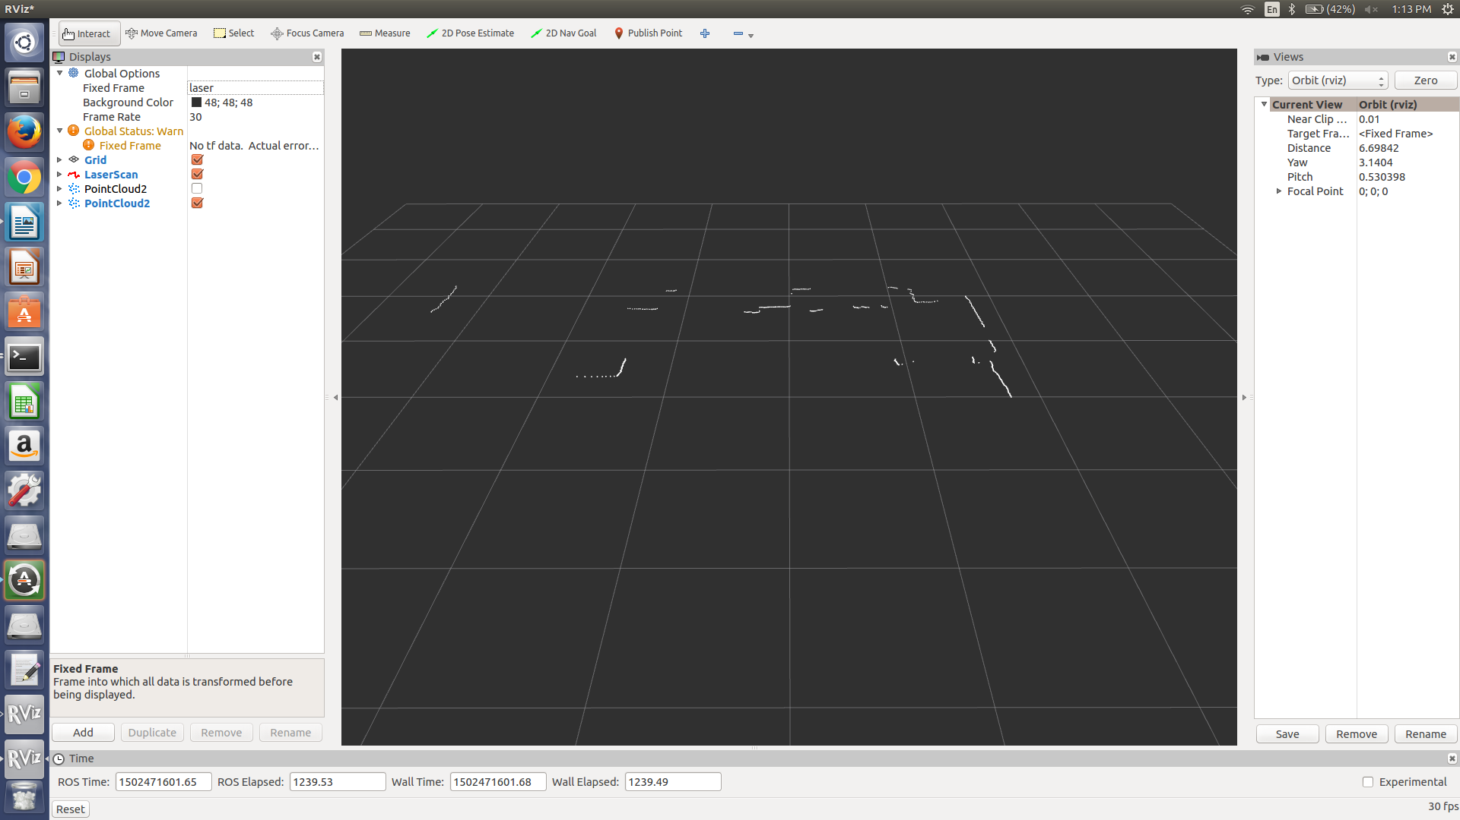

PassThrough Filter and StatisticalOutlierRemoval Fitler applied:

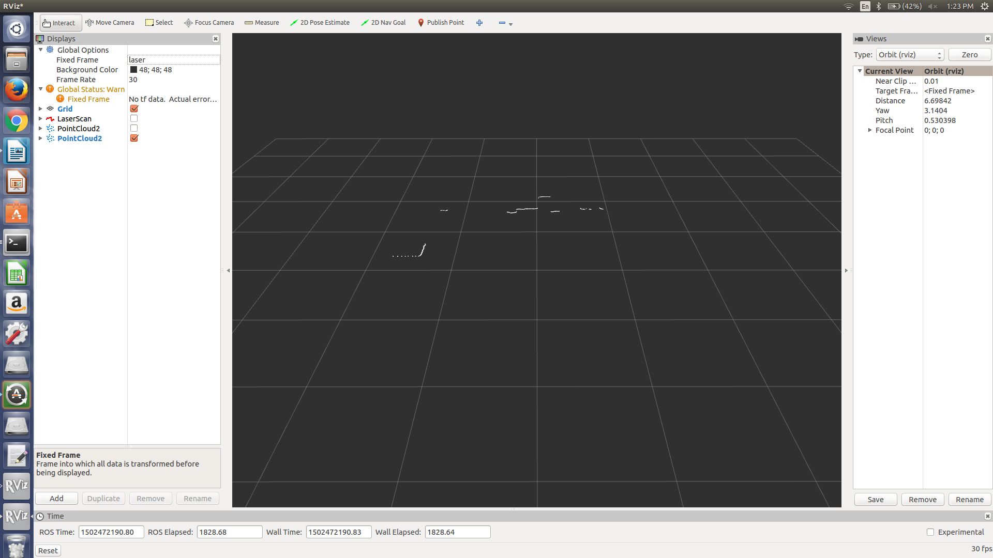

Test Case 15:

Original Scan:

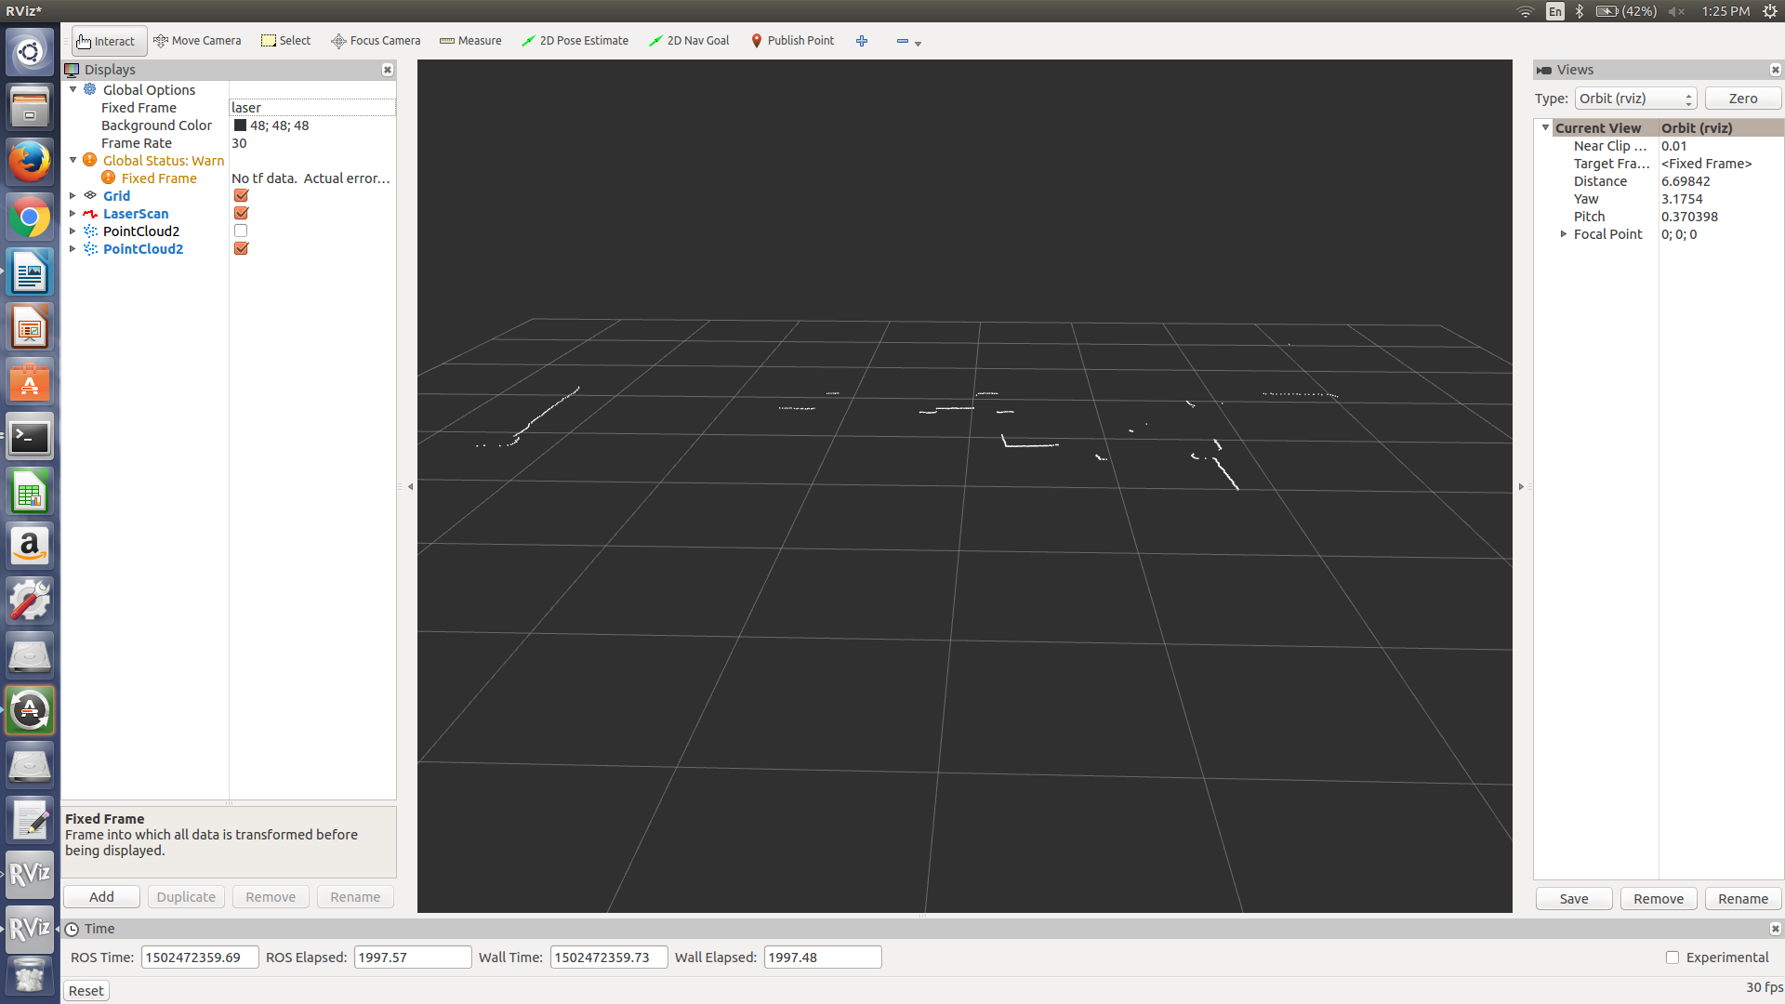

PassThrough and StatisticalOutlierRemoval Filter:

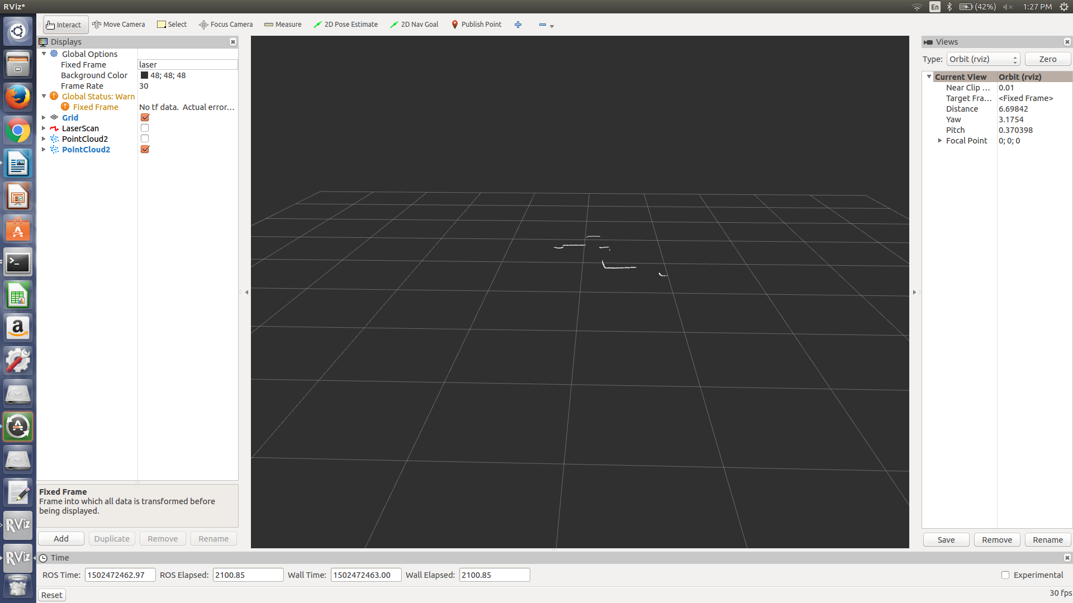
Test Case 16:

Original Scan:

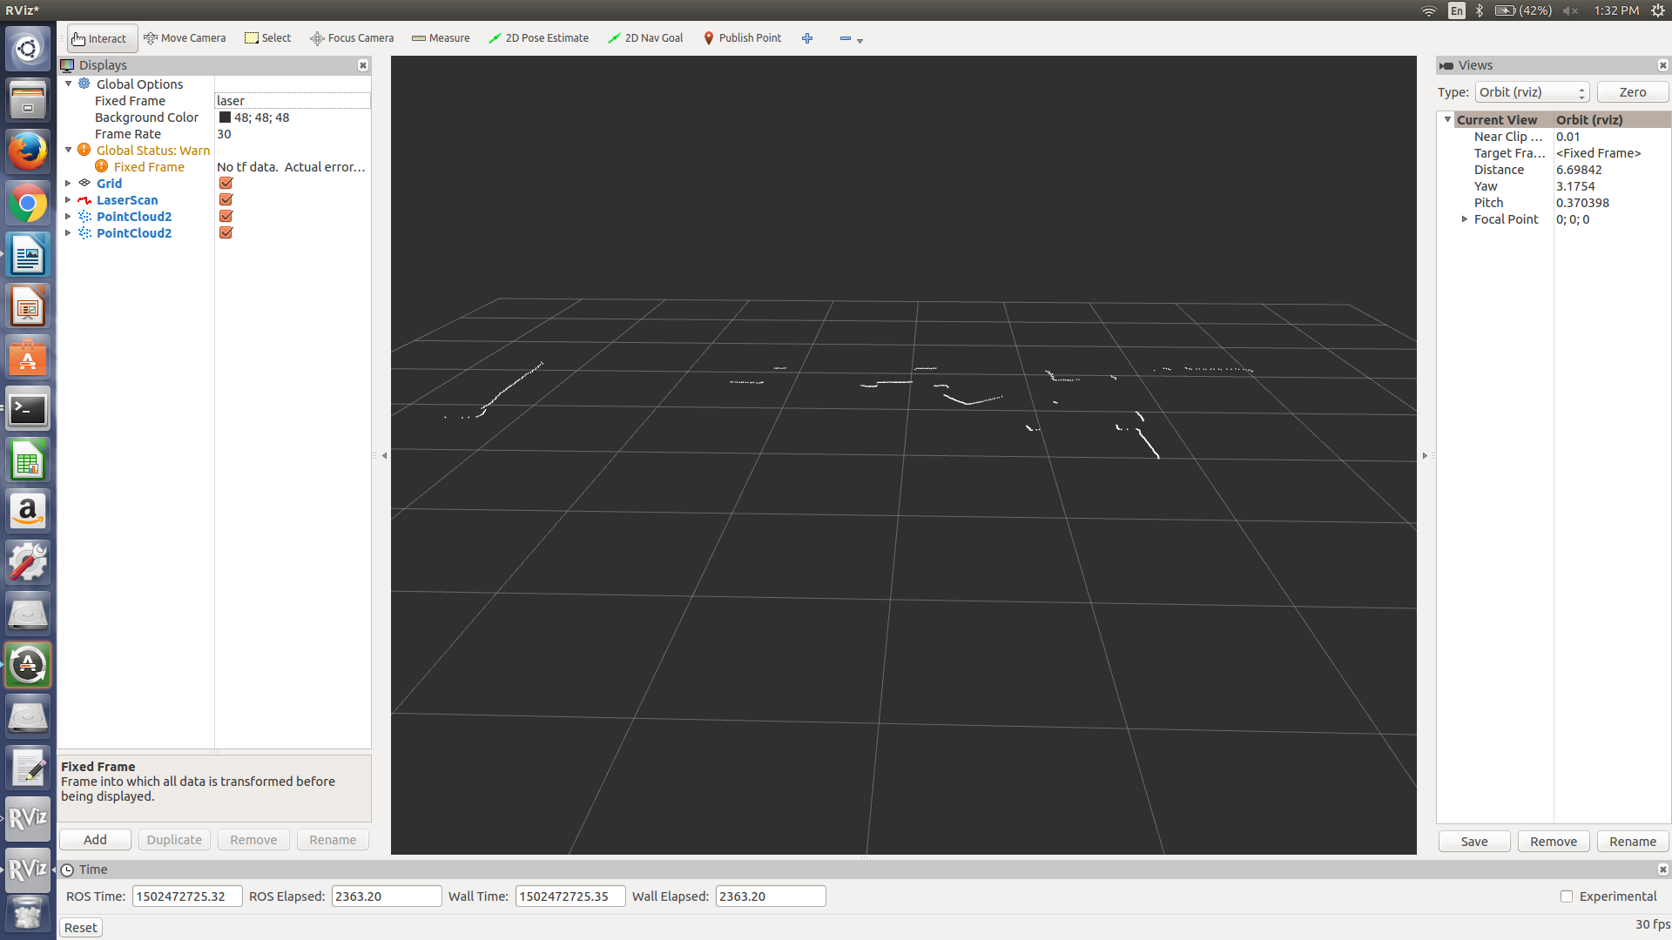

PassThrough and StatisticalOutlierRemoval Filter applied:

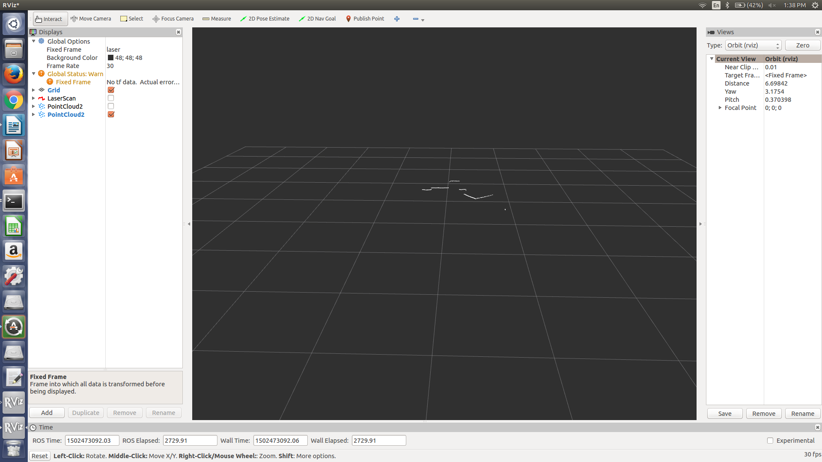
Test Case 17:

Original Scan:

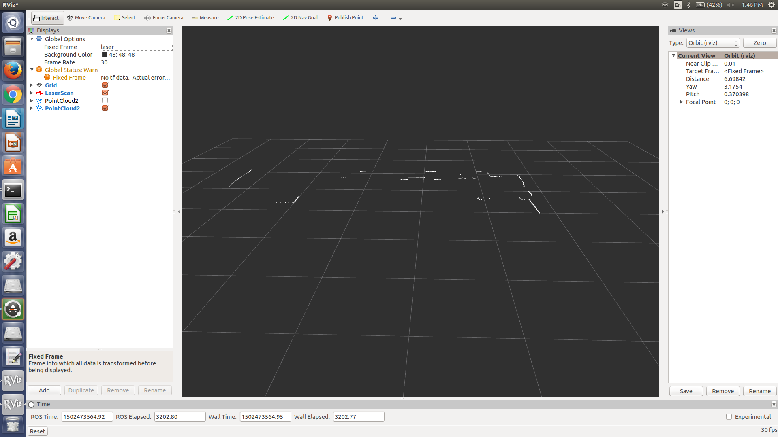

PassThrough and StatisticalOutlierRemoval Filter:



