Orientation with the Lidar: Task 2

This task was to use the filters implemented in the first task and extract an object from a cluster of points. This was done using the SAC_Segmentation and Extract Indices, which are provided by PointCloud Library. The SAC_Segmentation allows us to obtain the best line in a set of data points, which in a 2D scan would represent our object. Then we use the Extract Indices filter in order remove the points that form a line from the original point cloud and analyze the points to check if the line indeed represents our object. If it doesn't represent our object we then use Extract Indices to remove this line from the original cloud, giving us the remaining cloud. We then perform the process again until we find our object, and if we don't detect our object we then analyze the new pcl scan. We compute the euclidean distance of the minimum and maximum values of the extracted object, and then compare the result with the object length to ensure that we have extracted our object.

Conclusion:
During testing it was noticeable that lighting had no effect on the outcome of the detection and extraction of an object. The lidar was able to extract the desired object in both natural and artificial lighting conditions. In addition, we have tested in well lit areas and in dim lighting.

The factors that did affect the ability of the lidar to extract the object accurately is the size of our desired object. In test case 1 and test case 2 our object was not extracted from the point cloud. These objects were 0.1143 m and 0.1905 m, respectively. In test case 3, we tested an object of 0.6858 m and we were able to extract the object. Due to limitations in objects of specific dimensions, it was hard to determine the exact dimension where the lidar can extract an object correctly. Therefore in this testing process we make the assumption that the minimum object size is 0.6858 m.

In addition, the calculation of the length of the extracted object was roughly accurate. Despite the lidar being able to extract the object, it was fairly common for the object length to be calculated +/- 0.05 meters of the original length. Although, there are times when we are looking at our object that we are off by more than 0.10 meters. Despite this limitation, we can find and extract our object if we crosscheck our extracted object with a range of +/- 0.05 meters of the original length. By doing this we ensure we have found our object.

When testing our object in the living room (Figure 1) we were able to test the assumption that if we crosscheck our object with a range of +/- 0.05 meters from the object length. During testing it was noticeable that we were able to find our object every time and when the object was not placed we would return nothing. Thus it was accurate, if we make the assumption that we will have no objects that are within 0.05 meters of each other.

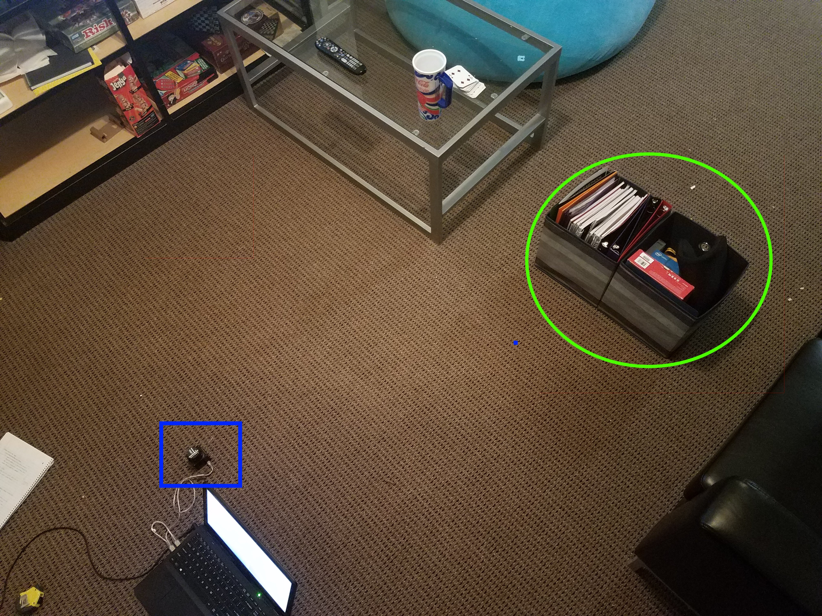
Figure 1.
The blue square references the positioning of our lidar. The green eclipse describes the positioning of our object in front of the lidar.

Test Cases

Test Case 1
Lighting: Natural and well-lit
Object Size: 0.1143 m length by 0.0762 m wide
Distance from lidar: 0.6858 m to the front and 0.1016 m to the right

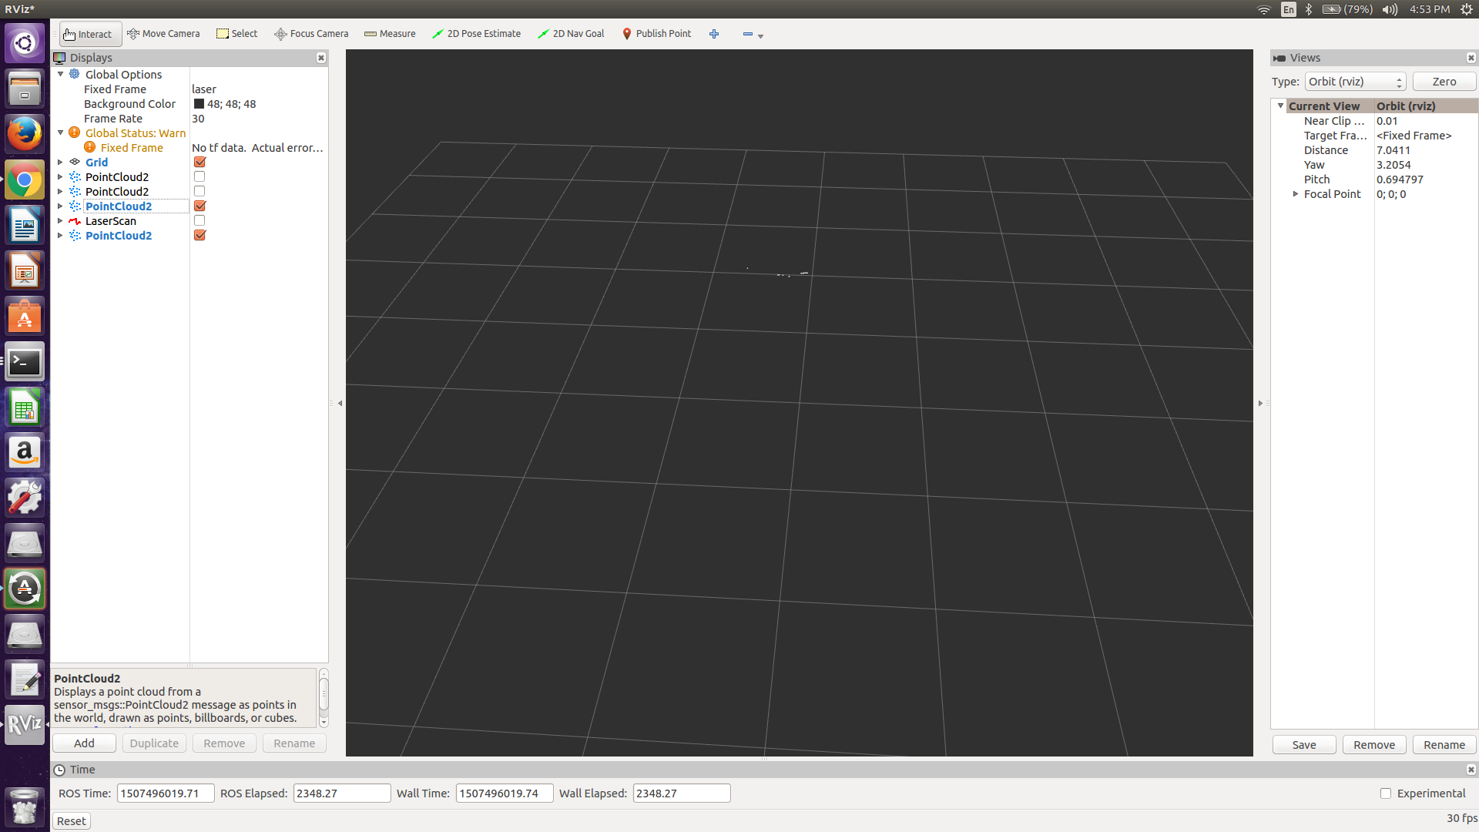
The object was not found consistently and could not be represented accurately.

Test Case 2
Lighting: Natural and well-lit
Object Size: 0.1905 m length by 0.0762 m wide
Distance from lidar: 0.6858 m to the front and 0.1016 m to the right

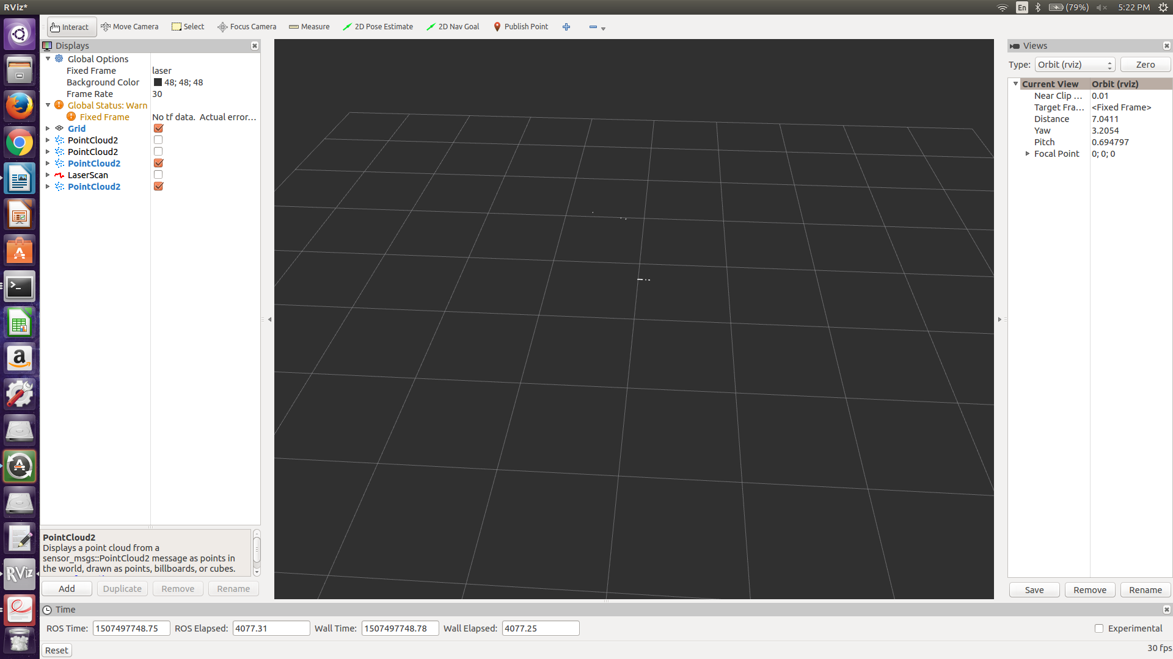
Object is detected occasionally. When represented it is an accurate placement and orientation of the object.

Test Case 3:
Lighting: Natural and well-lit
Object Size: 0.4000 m length by 0.0508 m wide
Distance from lidar: 0.6858 m to the front and 0.2794 m to the right

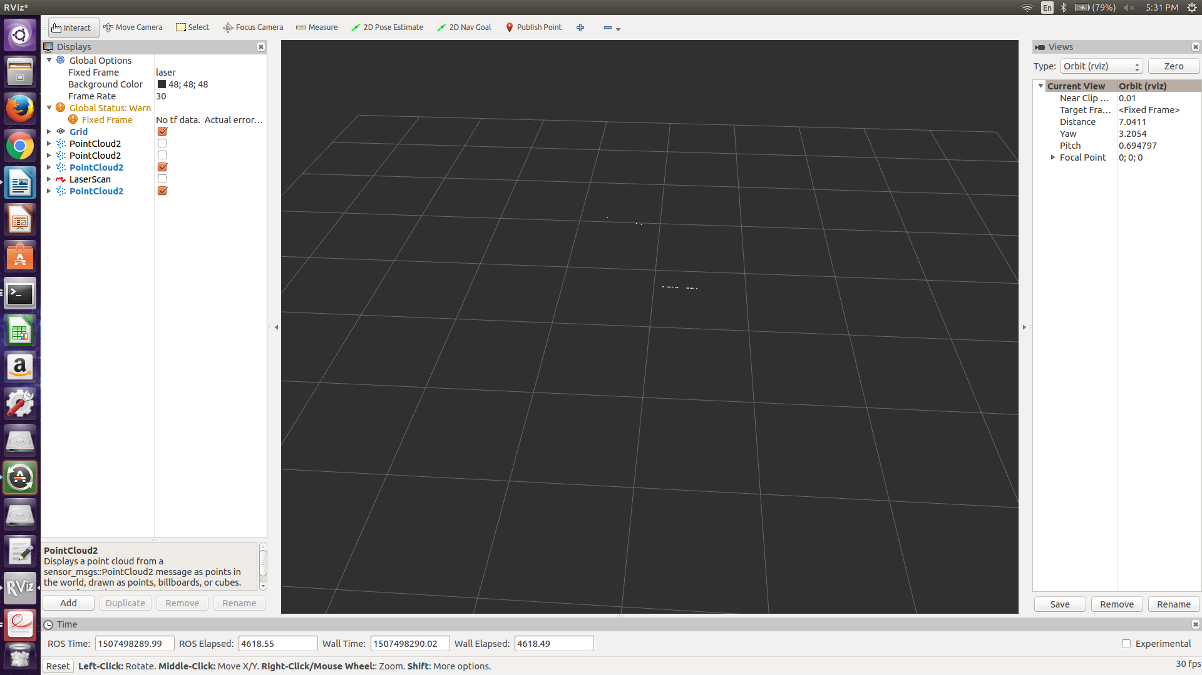
The object is detected and represented consistently. The blue arrow represents our object and it is consistently found.

The calculated length of the object is:
0.341623 0.347017
0.306296 0.369689
0.391298 0.35411
0.402162 0.336607
0.365407 0.28886
0.348818 0.339324
0.407432 0.339689
0.253845 0.362355
0.351013 0.396204
0.358597 0.379856
0.356922 0.390163
0.379674 0.373816
0.337394 0.394631
0.40402 0.389945
0.26728 0.345846

Therefore the calculated length falls between 0.26728 and 0.407432. The majority of values are within 0.05 meters. Thus our object is represented roughly well, with a maximum percent error of 33%.
Test Case 4:
Lighting: Natural and well-lit
Object Size: 0.4000 m length by 0.0508 m wide
Distance from lidar: 0.635 m to the front and 0.6096 m to the right

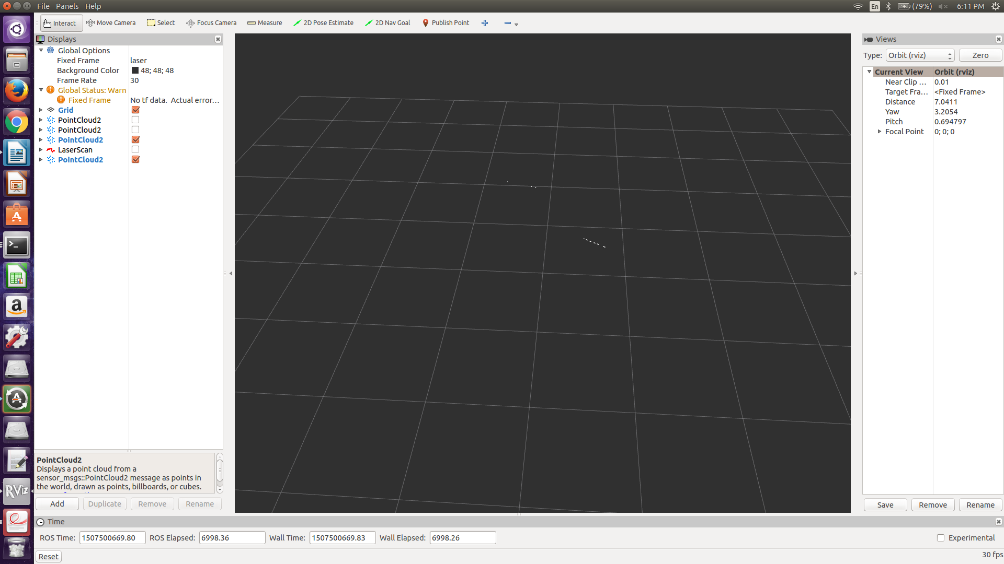
The object is detected consistently. The blue arrow represents the object and it is consistently found.

The calculated length of the object:
0.337882 0.34524
0.349081 0.388308
0.387722 0.364315
0.365898 0.379808
0.355411 0.242994
0.250918 0.346295
0.352413 0.350631
0.309994 0.357837
0.347372 0.379034
0.316151 0.363876
0.372066 0.396486
0.392354 0.384039
0.326428 0.380658
0.376824 0.377414
0.343552 0.38366

Therefore the range of length values calculated is from 0.242994 to 0.387722. The majority of values are within 0.05 meters. The maximum percent error is 39%.
Test Case 5:
Lighting: Natural and well-lit
Object Size: 0.4000 m length by 0.0508 m wide
Distance from lidar: 0.7112 m to the front and 0.6604 m to the left

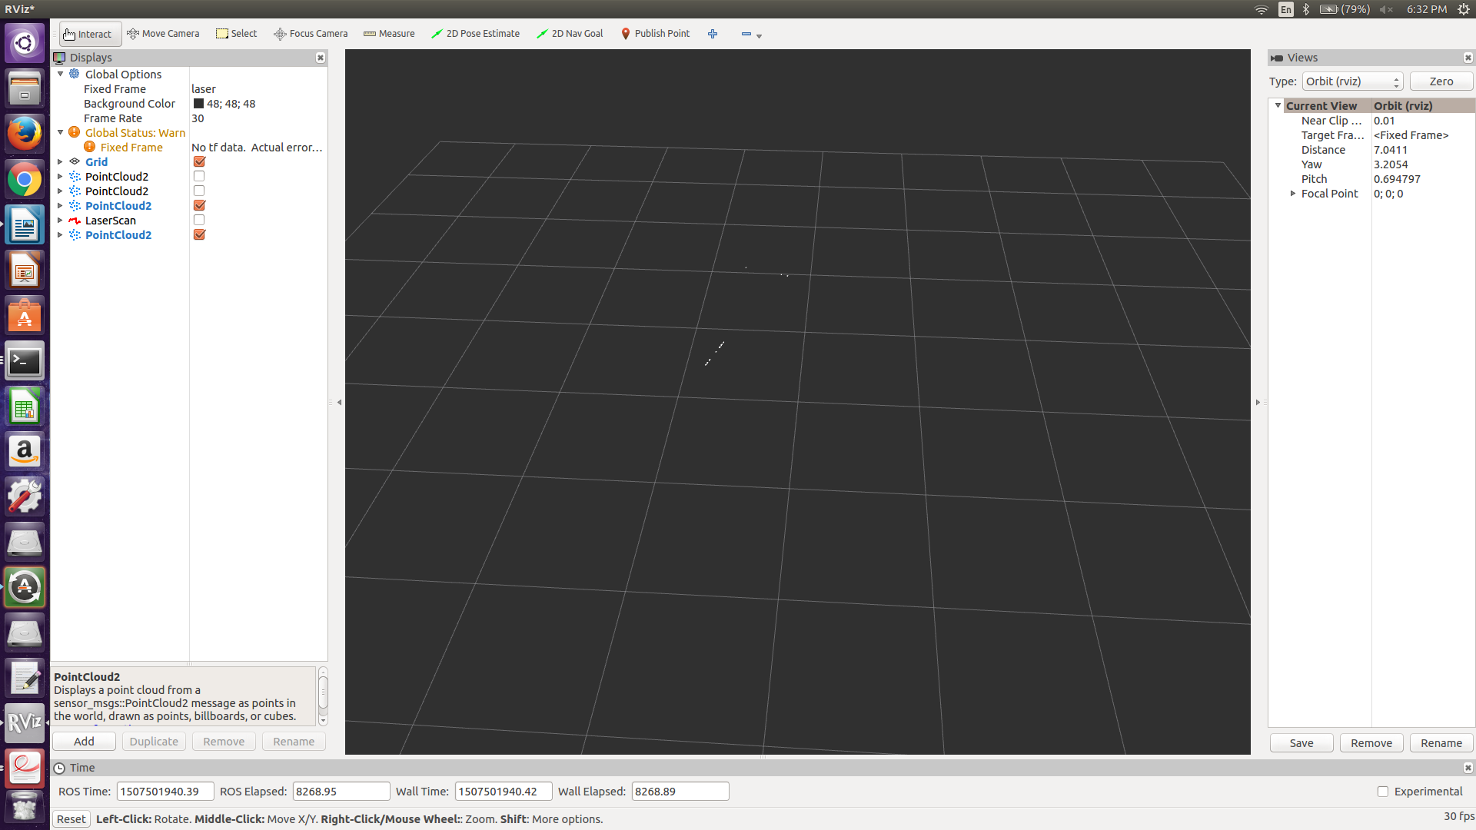
The object is detected consistently. The blue arrow points to the point cloud that represents the object.

The calculated length of the object:
0.333378 0.33384
0.312477 0.390185
0.389525 0.380191
0.38442 0.292493
0.331729 0.371902
0.326378 0.287265
0.330963 0.239233
0.357096 0.309461
0.345035 0.301571
0.327136 0.392069
0.342283 0.310607
0.345735 0.37992
0.321112 0.387852
0.386604 0.349458
0.34746 0.358943
0.384593 0.316639

The range of values of the calculated length is from 0.239233 to 0.390185. The majority of values are within 0.06 meters of the actual length of the object. The maximum percent error in this range is 40%.
Test Case 6:
Lighting: Natural and dimly lit
Object Size: 0.5334 m length by 0.254 m wide
Distance from lidar: 0.558 m to the front and 0.2794 m to the left

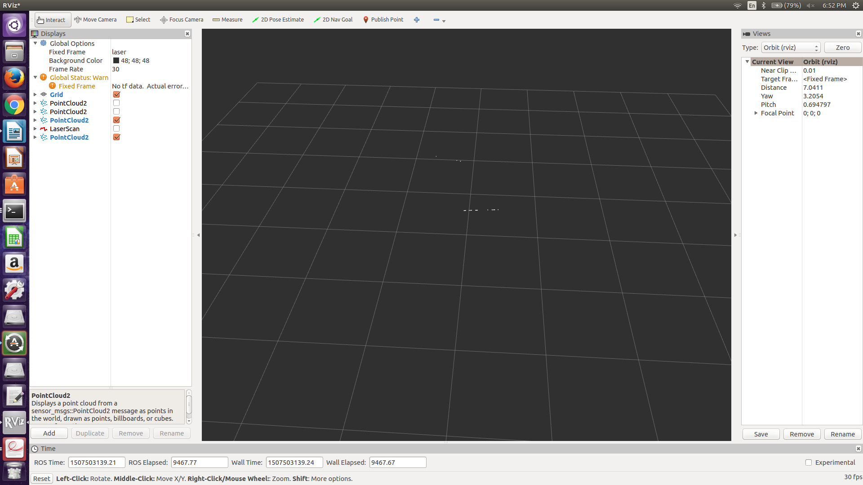
The object is found consistently. The blue arrow points to the object that is being detected.

The calculated length of the object:
0.437043 0.421822
0.474223 0.495677
0.45505 0.529944
0.400472 0.523885
0.4704 0.386152
0.392461 0.408426
0.389986 0.515143
0.420569 0.477105
0.523148 0.480806
0.434307 0.47423
0.492195 0.471039
0.415313 0.434332
0.487662 0.546951
0.431388 0.456776
0.43068 0.47381
0.443549 0.497983

The values range from 0.389986 to 0.529944. The majority of values are within 0.07 meters. The maximum percent error of the total range is 26.8%.
Test Case 7:
50.5 front and 21.75 to the right
Lighting: Natural and dimly lit
Object Size: 0.5334 m length by 0.254 m wide
Distance from lidar: 1.2827 m to the front and 0.55245 m to the left

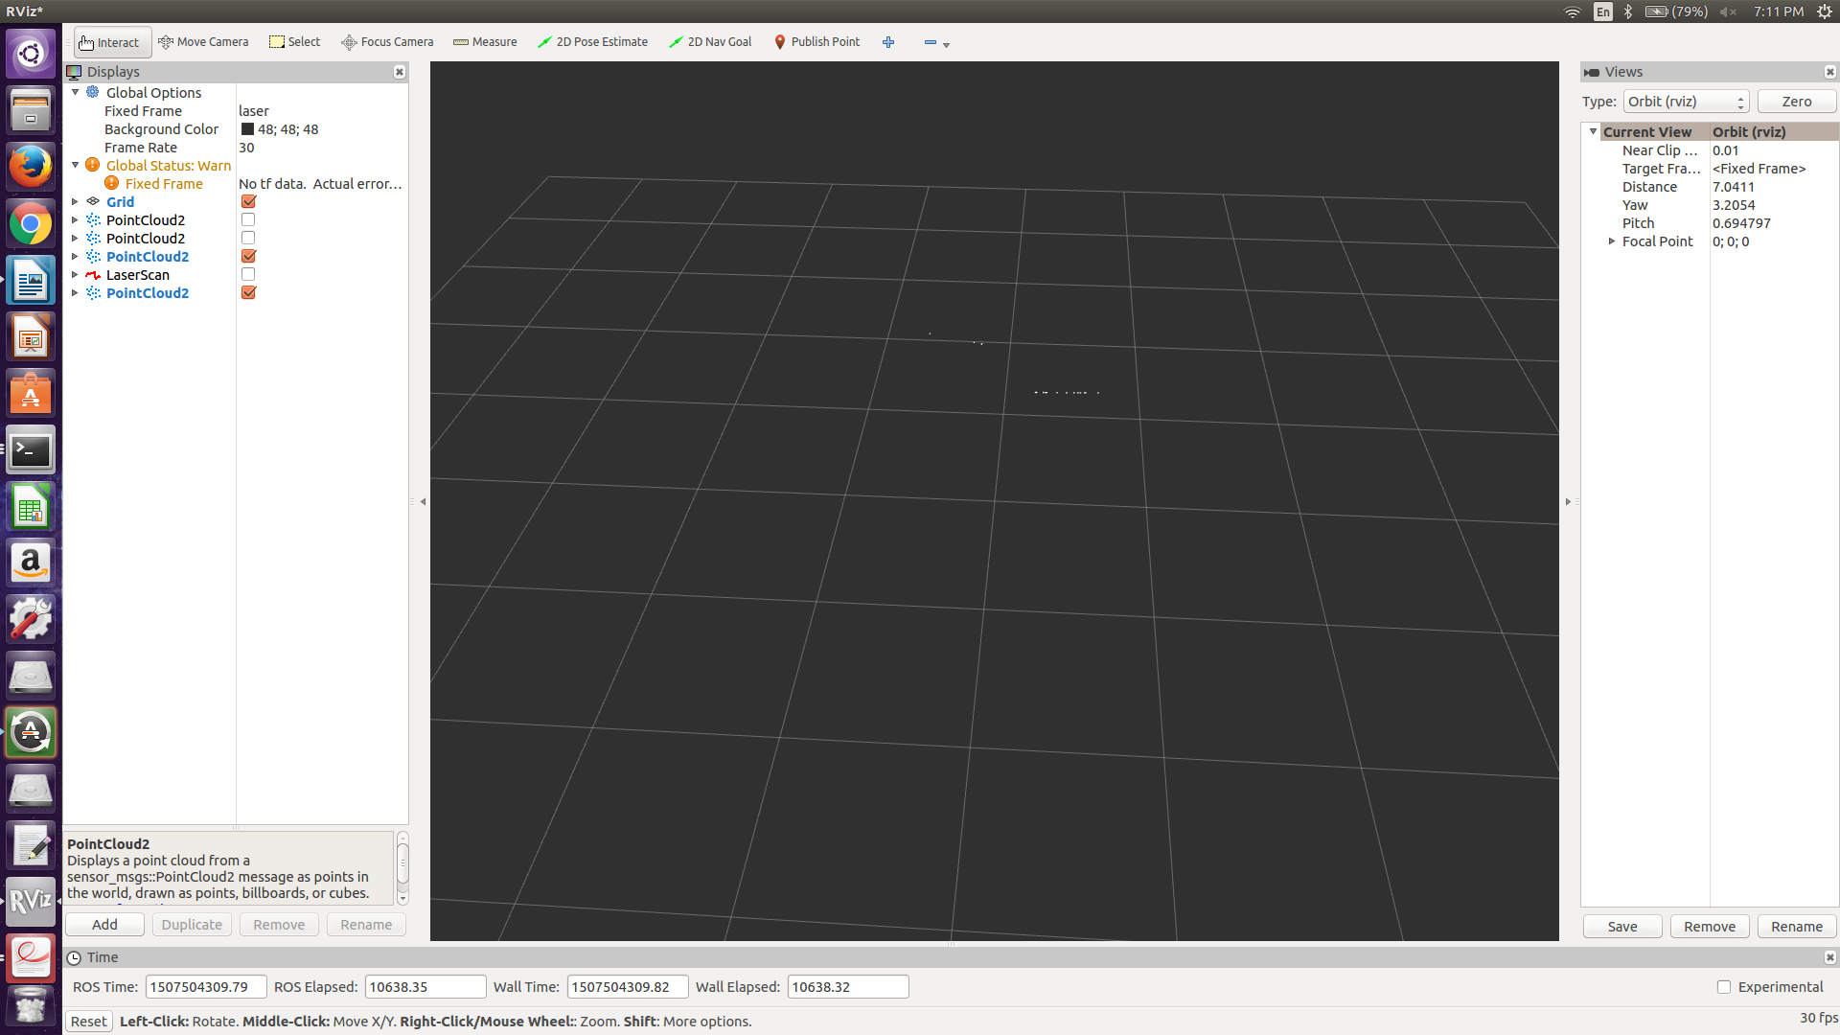
The object is detected and extracted consistently. The blue arrow points to the objects location.

The calculated length of the object:
0.512013 0.5011
0.524003 0.491355
0.513167 0.523676
0.500464 0.497681
0.340686 0.418062
0.475488 0.420459
0.471814 0.482665
0.477304 0.482697
0.523715 0.488349
0.438581 0.463866
0.470864 0.520364
0.516922 0.524774
0.524869 0.513377
0.505383 0.407852
0.49325 0.48895

The range of values is from 0.340686 to 0.54774. The majority of values are within the 0.06 meters of the original length. The maximum percent error is 36%.

