Orientation with the Lidar: Task 1

This first task was to filter out data points from the original point cloud, obtained from the hokuyo lidar. The filters being used are PassThrough and StatisticalOutlierRemoval filter.

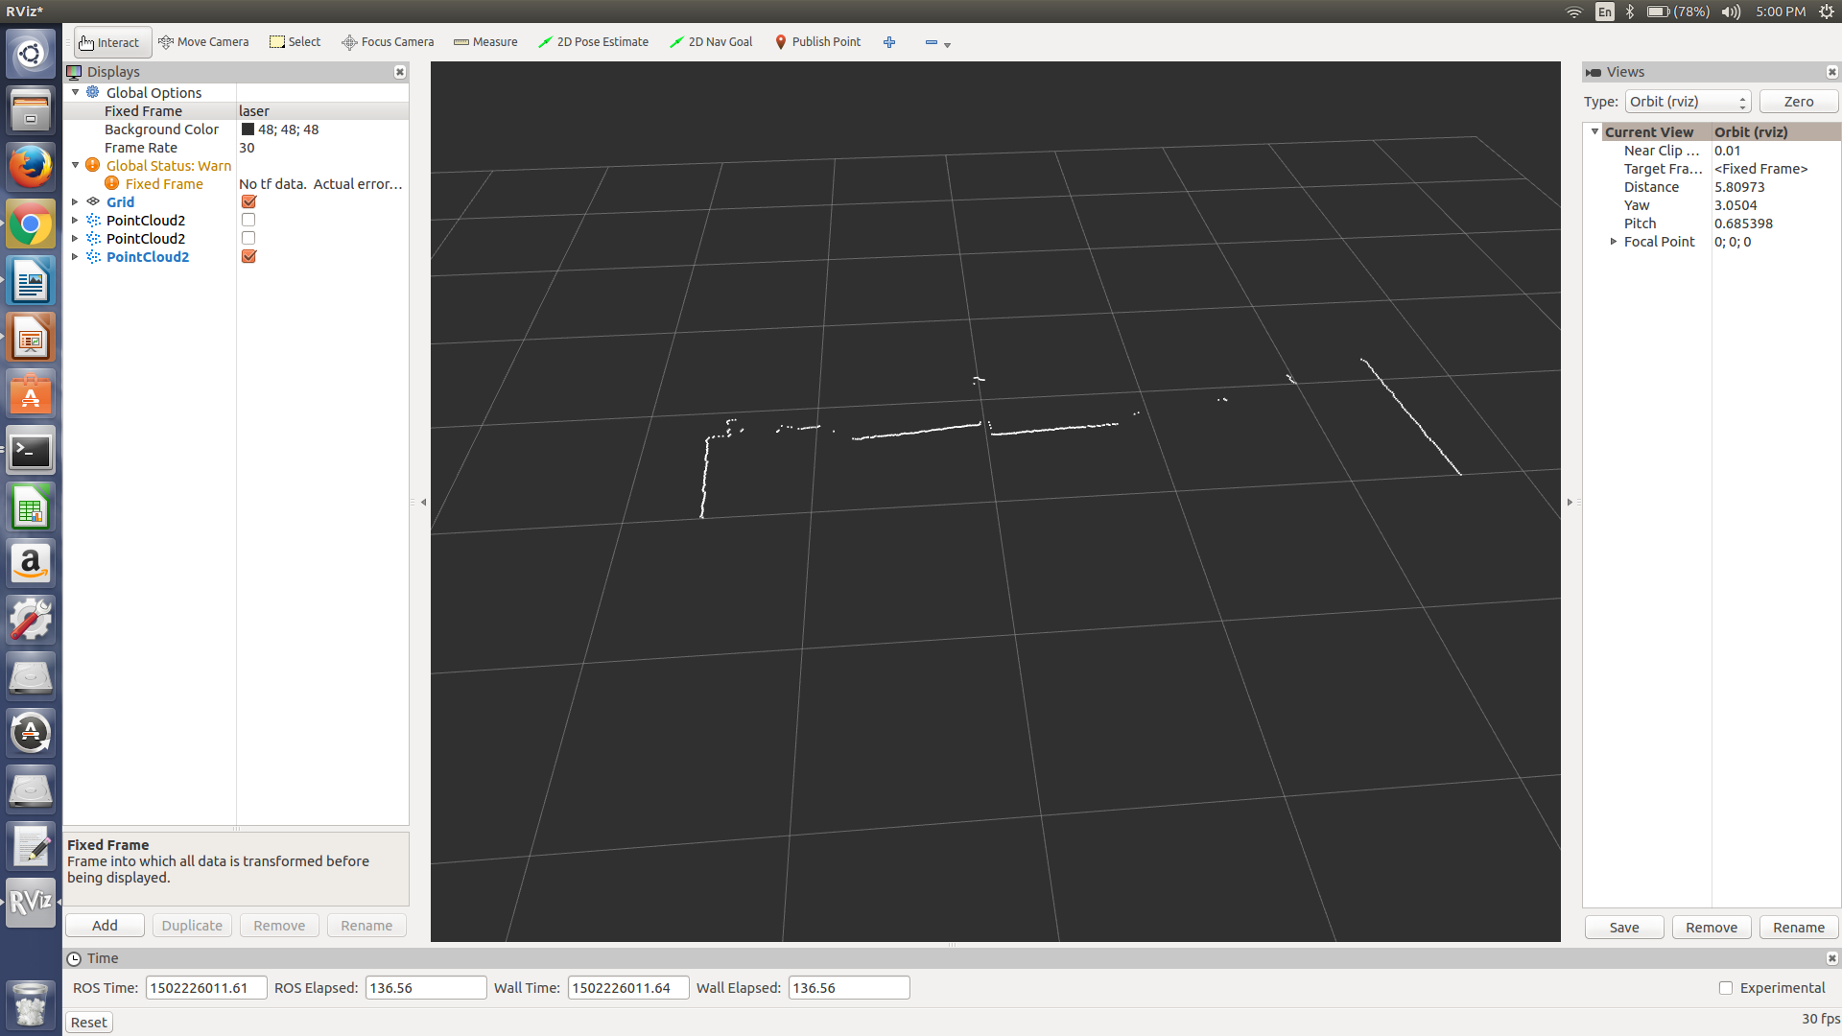
The image above is the initial lidar scan. The long and well-defined lines on the left and right represent walls. In front of the lidar, the cluster of points represent cabinets, which can be considered a wall with different extrusions. The scan also has points which do not represent defined objects and can be referenced as noisy points.

First we are going to run a PassThrough Filter and then a StatisticalOutlierRemoval filter.

PassThrough filter:
This filter is used to remove data points that fall out of the starting area in the arena. If we place the lidar on the rightmost part of the collector bin, this would leave us with range of 2.6775 meters to the left and 1.1025 meters to the right. This range describes the width of the arena from the perspective of the lidar. Therefore we are going to filter out points that are not within the specified range.

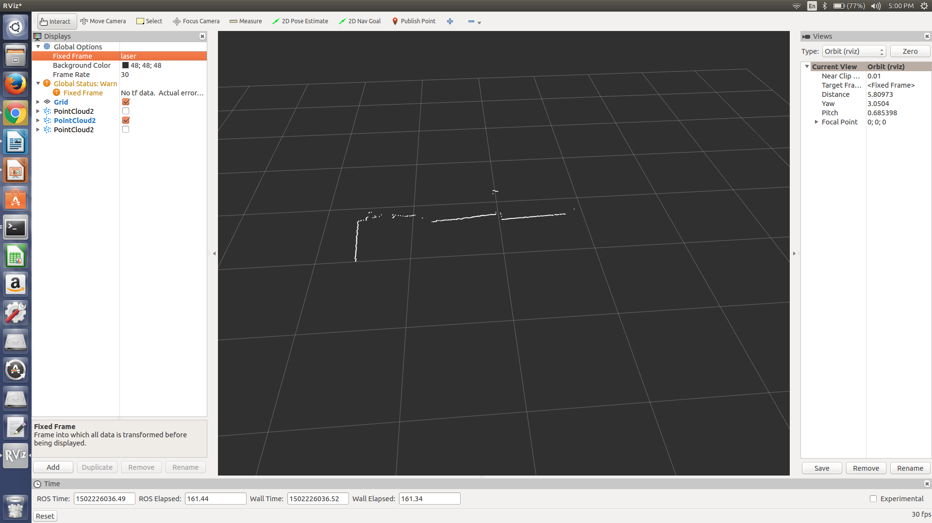

The image above is after the PassThrough filter is passed on the data points. There are points that are removed from the data set, these points where outside of the given range. The wall on the right of the lidar was removed due to the fact that it is outside of the specified, therefore limiting our data set.

StatisticalOutlierRemoval filter:
This filter is used to remove noisy data points. This filter will remove data points that are scanned by the lidar but do not necessarily represent objects.
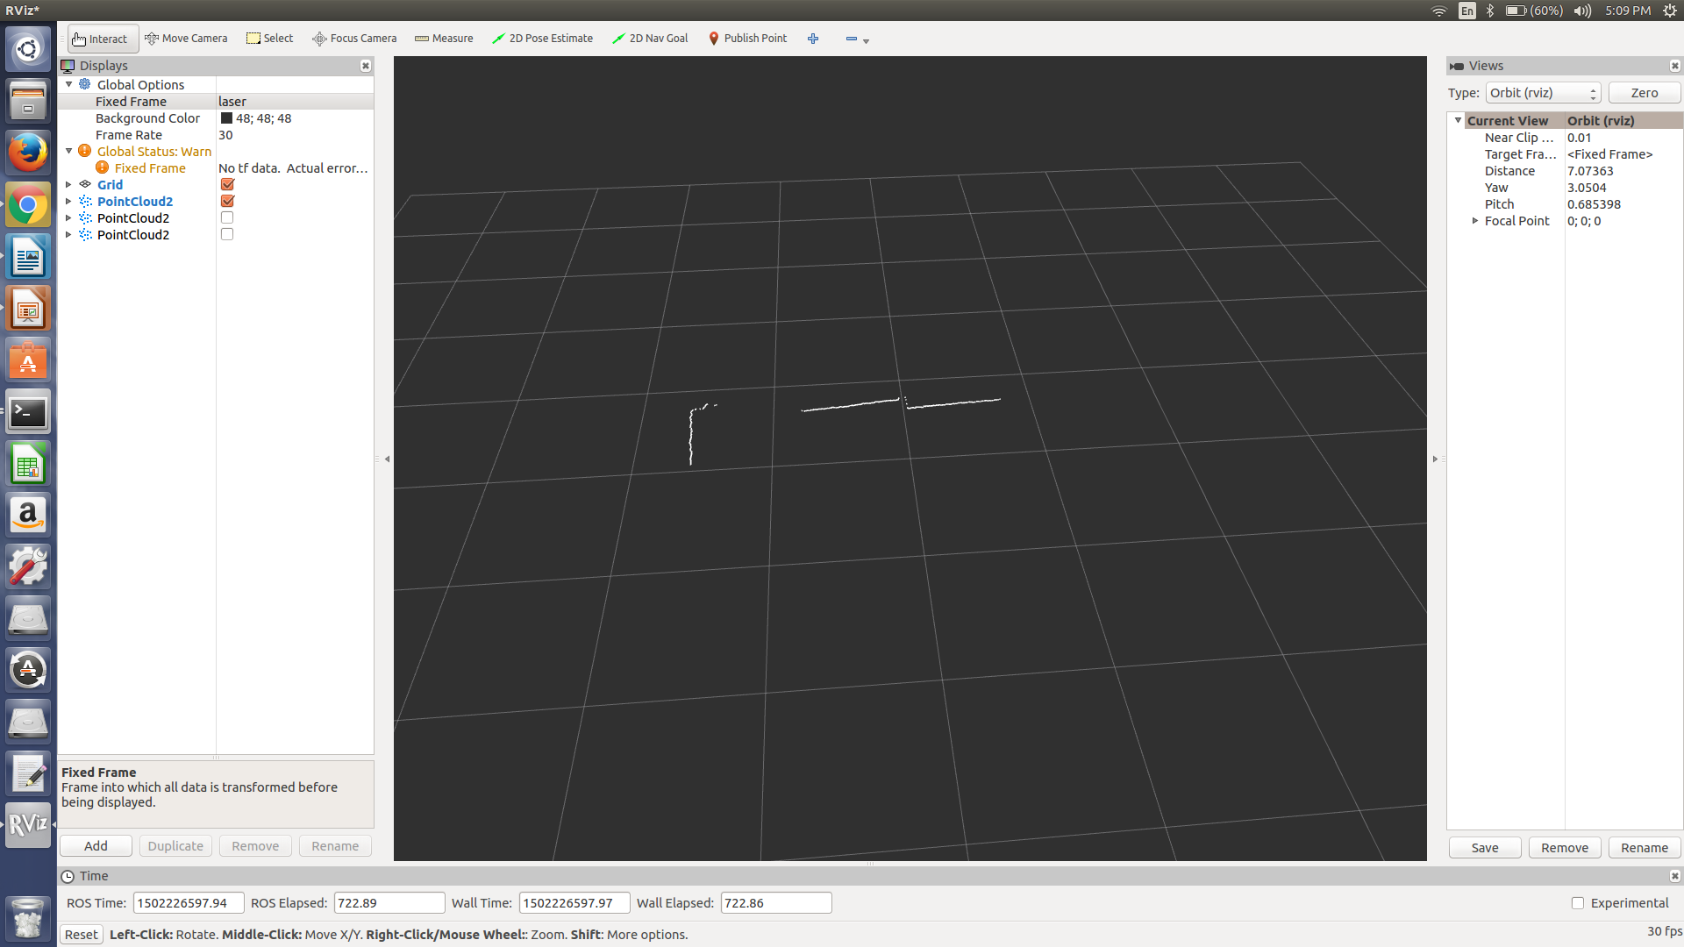

The above image represents the point cloud after a StatisticalOutlierRemoval filter has been applied. As we can see multiple points were removed from the data set and all that we are left with are lines that represent objects. Therefore just leaving us with a front wall and a wall on the left of the lidar.

Overall, these filters were effective in reducing the data set and leaving us a cluster of points that only represent objects within our desired region.

