

**Legend**

**Goal** 1

**Features** 2

**Technical Stack** 2

**Website Information** 2

Domain 2

**Wires and Mocks** 3

NES Game Storyboard 3

Scene 1 3

Scene 2 3

Scene 3 4

Scene 4 4

# **Goal**

To create a “clicking timer” web application that allows users to test their speed pressing buttons. Primary intent being to test a user’s ability to shoot quickly in shoot-em-up video games.

# **Features**

*In order of importance.*

1. Get “Clicks per second” and relay info to user
2. Ability to use various clicking devices on desktop
   1. Gamepad
   2. Mouse click
   3. Keyboard key press
3. Tap on mobile devices
4. Leaderboards
   1. Opt-in
   2. Arcade style 3 character names
5. Multiple Modes
   1. 10 Second Test
   2. Endurance
6. Sharing Your Score
   1. Facebook
   2. Twitter
7. ROMs for consoles

# **Technical Stack**

* PHP (Symfony)
* React
* SASS

# **Website Information**

## Domain

[www.ShmupSpeed.com](http://www.ShmupSpeed.com)

**DNS Cost:** $17/yr

DNS purchased through Google Domains. Currently forwarding to [www.douglasglover.ca](http://www.douglasglover.ca).

# **Wires and Mocks**

## NES Game Storyboard

Working with KHAN Games to create an NES rom for emulators and flash carts!

### Scene 1

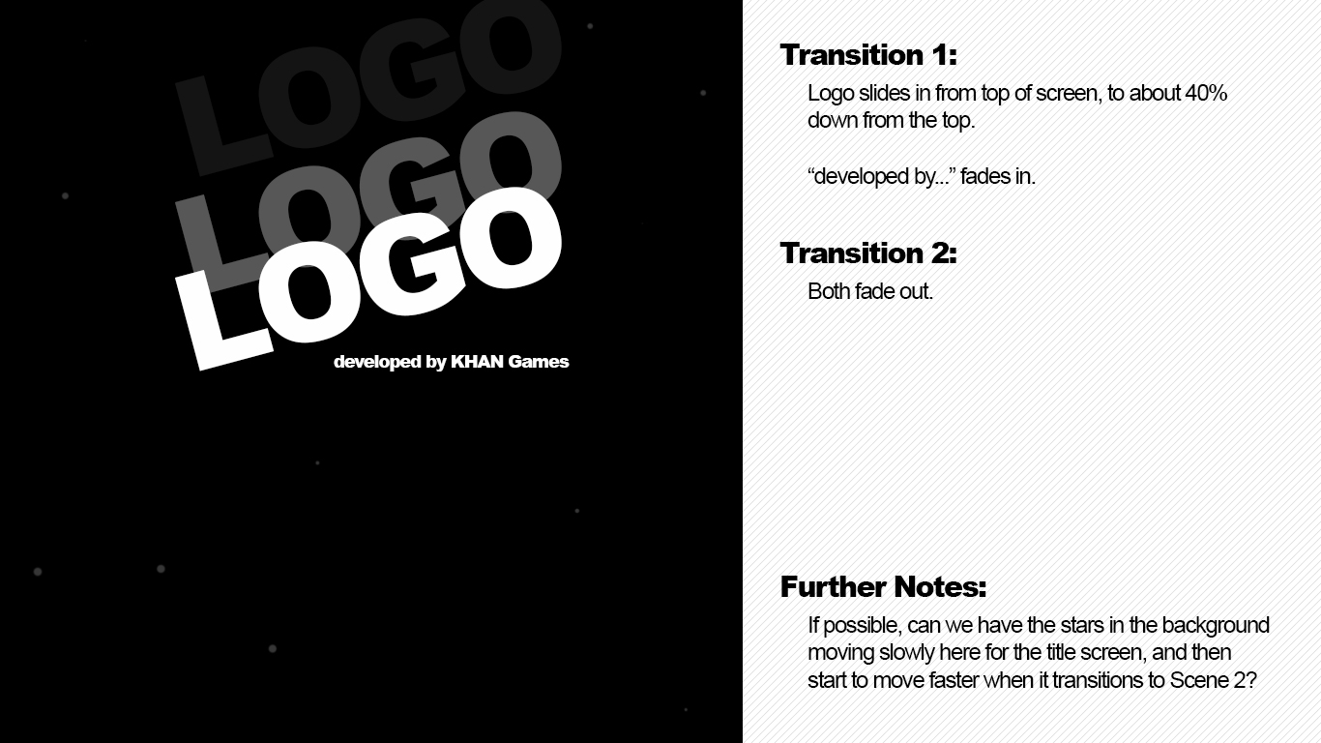

### Scene 2

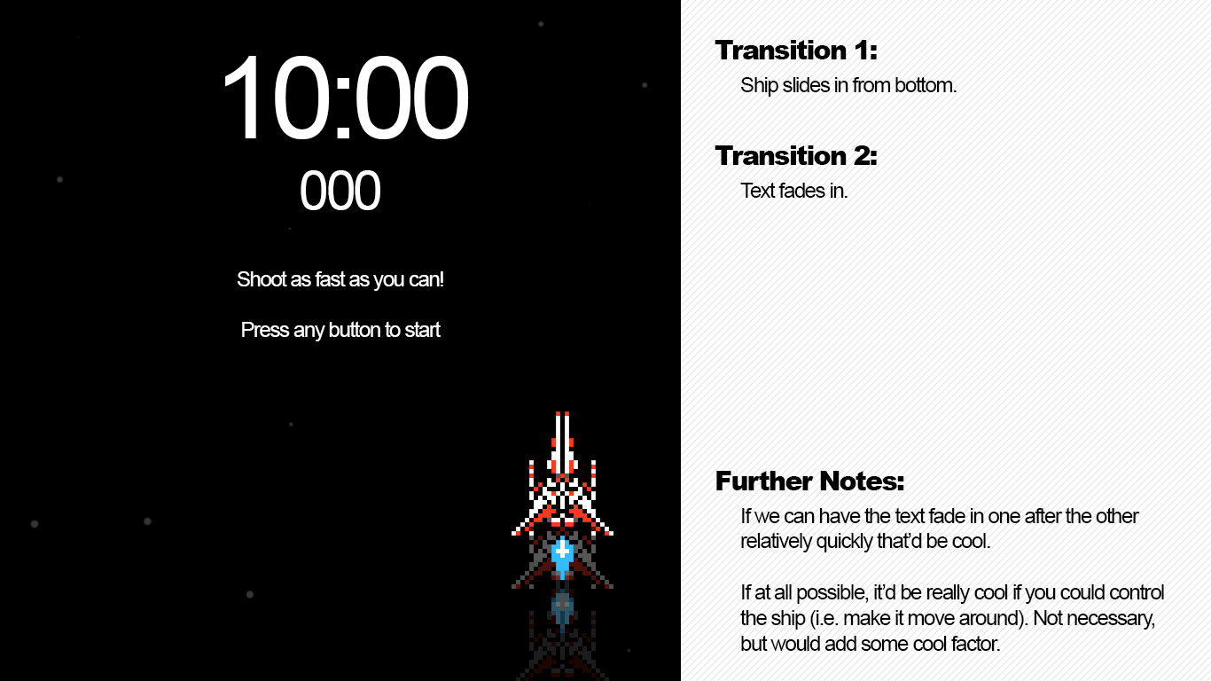

### Scene 3

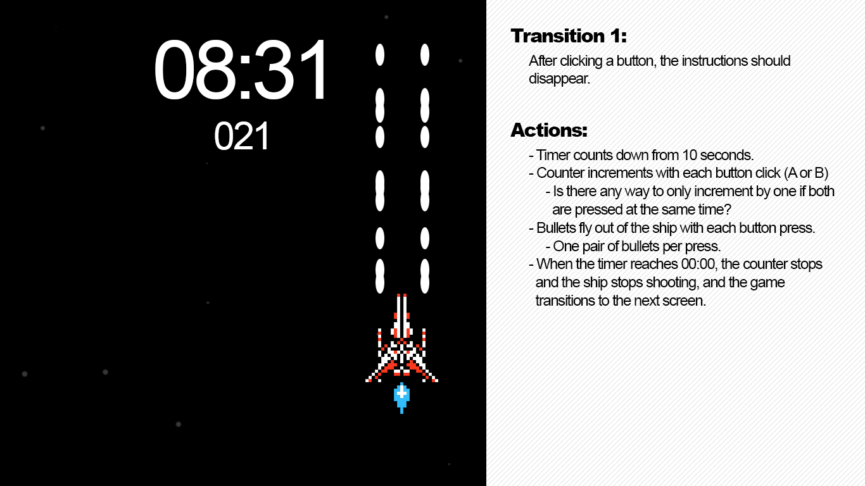

### Scene 4

