CSIS 4495 – 050

Applied Research Project

Project Progress 2

**Career Streak**

**Strike success**

***“A complete solution for professional success”***

By:

|  |  |
| --- | --- |
| Name | Student ID |
| Karamjeet Singh Jandu | 300305341 |
| Arsh Sharma | 300343131 |
| Sandeep | 300329060 |

Table of Contents

Executive Summary 2

Statement of the problem 2

Significance of the study 3

Features 3

Research Component 4

Technologies 4

Use Case Diagrams 5

Admin 5

Employer 5

User 6

Project Implementation & Timelines 7

Gantt Chart 7

# Executive Summary

Tech market is booming, and employers are in rush to get the best candidate for their organizations. With our platform focusing only on roles of tech, it gives the hiring managers ability to see candidates via their skill sets on profile page and directly chat as well. In addition, the public profile of the users will provide the in-depth glance of technical skillsets and projects developed along with other required details. Hiring challenges will be reduced and onboarding talented folks’ pace will be fastened. Direct interaction and assessments can be done with the candidate. This will also be assisting employees find the right organization as salary transparency and detail-oriented job posting will be mandatory. Overall, this platform is a full tool for both employee as well as employer for great opportunities.

# Statement of the problem

In this new world of technology where we are advancing day by day, but there still some drawbacks. Where recent pandemic taught us that we need to be more advance and for the current time where both employee and employer are suffering this project will help them to get back on track.

Our main motive is to use innovative technologies and to learn something new so we decide to make a web application which will be interactive and faster in terms of response. By using some new and better technologies we can want to make this project interesting and challenging for us and to provide a better platform to customers or employees and employer so that they can have better and flawless experience.

We are also going to follow agile methodology for faster development with sprint of 2 weeks. This will assist us with keeping track with phases and tasks.

Some of its advantages includes:

* Better control
* Improved project predictability
* Reduced risks
* Continuous improvement

Implementing such a huge project with microservices increases the service development of features individually. Microservice is an architectural and organizational approach to software development where software is composed of small independent services that communicate over well-defined APIs.

Some of its advantages includes:

* Easy deployment
* Minimal configuration
* Simple scalability
* Reduced production deployment time

Additionally, we are implementing MERN stack which stands for MongoDB, Express.js, ReactJS and Node.js. Some of its features are:

* MongoDB is a NoSQL database to store data for web applications.
* Express.js eliminates the need to write repeated server code. Additionally, it builds fast web applications and APIs
* ReactJS build user interfaces rendered in HTML.
* NodeJS is asynchronous event-driven JavaScript runtime leading to faster web development

We are for analytics and recommendation system we will be using Python which will provide graphical and eye-catching informative visuals for both employers and employees.

For employer the benefits include:

* Analytics providing selected employees skill levels which will assist in quick selection for interviews
* In addition, recommendation engine will give relevant employees based on the job posted by the organization for reaching out.
* Applicant Tracking System (ATS) system implementation for filtering the applied candidates

For employee the benefits include:

* Analytics providing best profile matching based on the opportunities provided by the selected organizations.
* Recommendation engine for improvements in profile, job applications and resume improvement.
* Employees can also see analytical information like average profile strength of applicants, skill level of the applicant on the mentioned skills.

# Significance of the study

Job platforms are extremely critical part for keeping the workforce demand in the modern era. This platform will be beneficial for:

* Employees looking for opportunities in the technology companies as they can see the job postings from the companies they desire and being able to go through the technology that company uses.
* Employers able to get deserving candidates for relevant open positions by going through employee skills and previous experience.

This project implementation will provide learning opportunity of innovative technologies utilized in today’s world for full stack web development such as Node JS, React JS, Flask, JWT (JSON Web Token) authentication, REST API and others.

## Features

* Applicant Tracking System (ATS) System for resume clearance after job application
* Activities and notifications are updated on the blog section dedicated for each organization
* Review Section for the employees to share experiences and information regarding organizations
* Recommendation Engine which works by providing jobs posting and information of the organizations
* Employee are provided recommended employees based on profile score and relevant skills of the posted job opportunities of the organizations
* Common spots for different employees to interact and post information in groups.
* Profile improvement recommendation system for better chances of successful job application
* After a failed job application, a service for providing informed and responsible information for improvement
* Detailed and informative profile for both employee and organization
* Analytical visuals providing below information
  + Profile strength
  + Job application required skills comparing with current skills
  + Skills analytics on the profile using the in-demand skills in the market
* Chat functionality for interaction between employee and employer with recommended professional interactions
* Special module for assessment provided from the employer to employee for after ATS and manager clearance for next step in hiring.
* Job application system for employee
* Job posting system for employer
* Search engine implementation
  + Relevant and recommended opportunities for employees
  + Deserving candidates using engine for employers
* Transparency of the complete process with job tracking.
* Employees have dedicated section for storing favorite jobs, posts and articles.
* Home page for jobs for application for the employee

# Research Component

* Creating recommendation system using Python
* Analytical component for visual information using Python
* Microservice architecture development and implementation
* REST API development for independent services
* Using different frameworks implementation in integrated application like Fast API, Flask
* Optional guided messages during the interaction for professional conversation

# Technologies

The full stack web development for the job portal website requires different technologies and will enhance the experience of users.

* Programming Languages
  + JavaScript
  + SQL
  + Python
* Library
  + React JS
* Database
  + PostgreSQL
  + MongoDB
* Framework
  + Flask
  + Express JS
  + Fast API
* Runtime
  + Node JS
* Testing
  + Unit test
  + Integration Test
* Security
  + JSON Web Token (JWT) Implementation for authentication on every request.
  + OAuth for single sign-on using LinkedIn, GitHub, and Google.

# Use Case Diagrams

## Admin

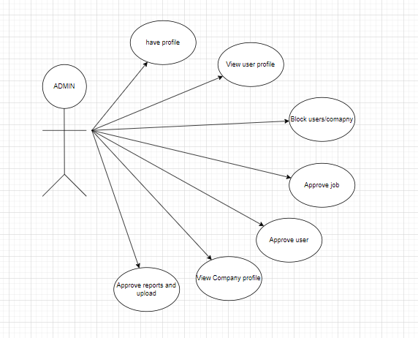

## Employer

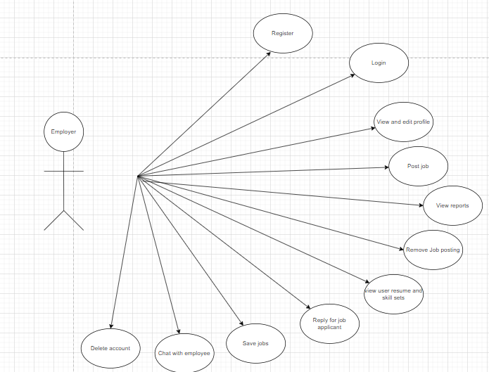

## User

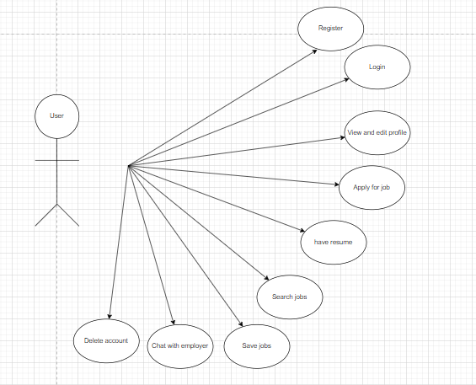

# Project Implementation & Timelines

Before midterm, we are planning to complete the following modules:

1. Initialization of GitHub repository and environment setup.
2. Setting up libraries and framework
3. User authentication using JWT
4. Login set up using OAuth
5. Home page for job posts
6. Job application and related process
7. Continuing efforts for backend development

After midterm, our plan is to deliver working final project as per the proposal commitment. The work after midterm as follows:

1. Chat module for employee and employer
2. Email confirmation on job application
3. Profile improvement modules
4. Search functionality for relevant jobs
5. Assessment module development
6. Application Testing and reports

At the end we want a fully functional web application for client on which they can work on flawlessly and help community to get jobs and make community better place for everyone.

## Gantt Chart

## Implementation

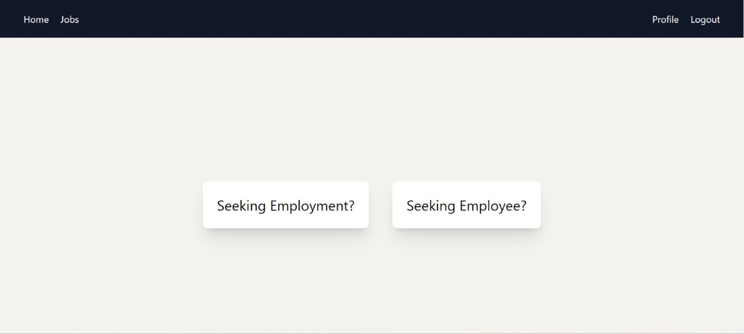

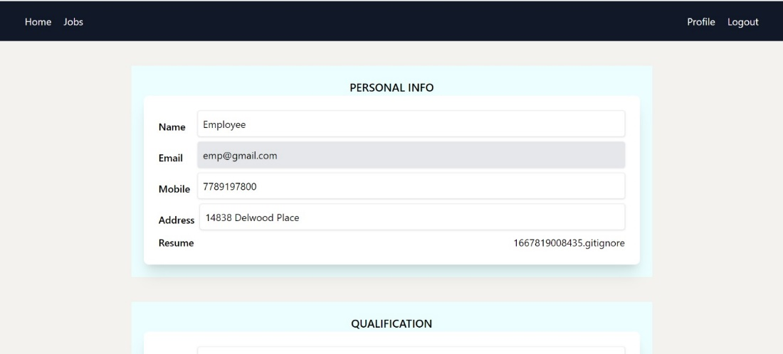

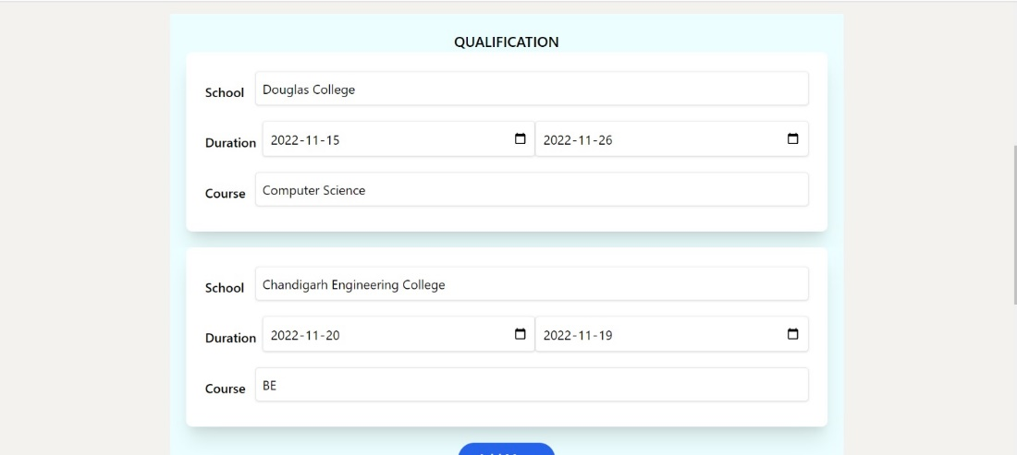

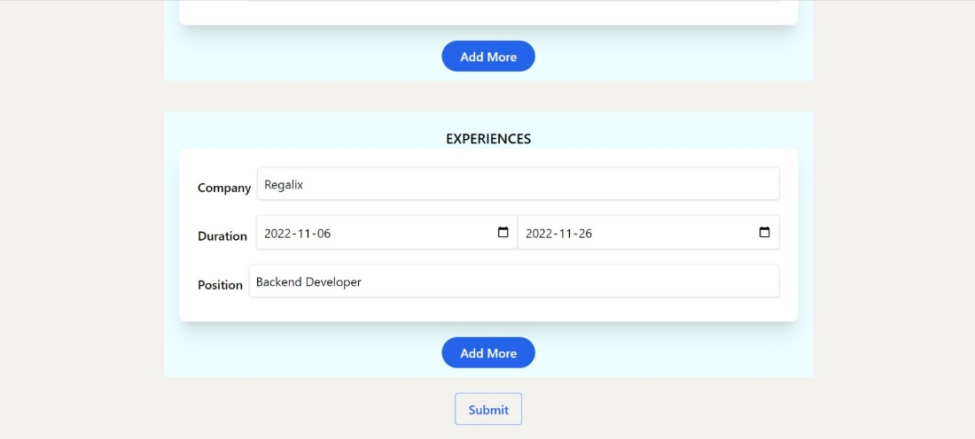

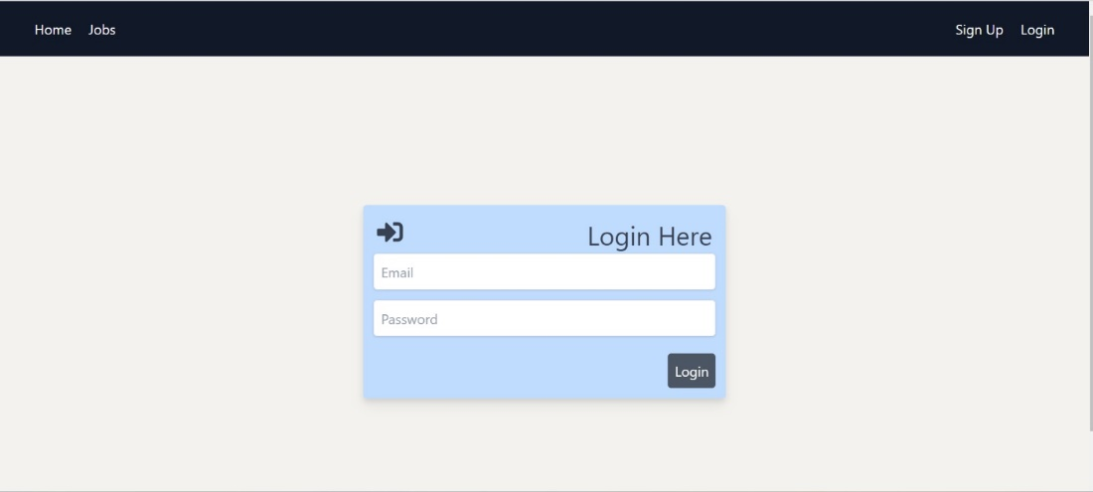

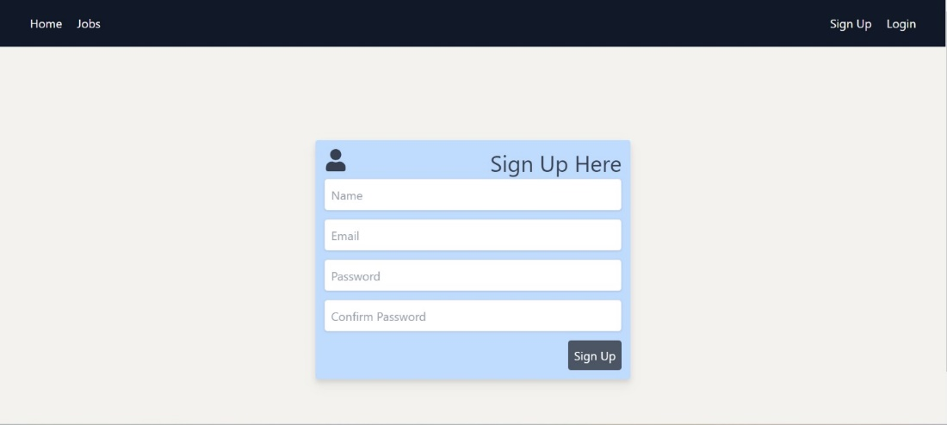

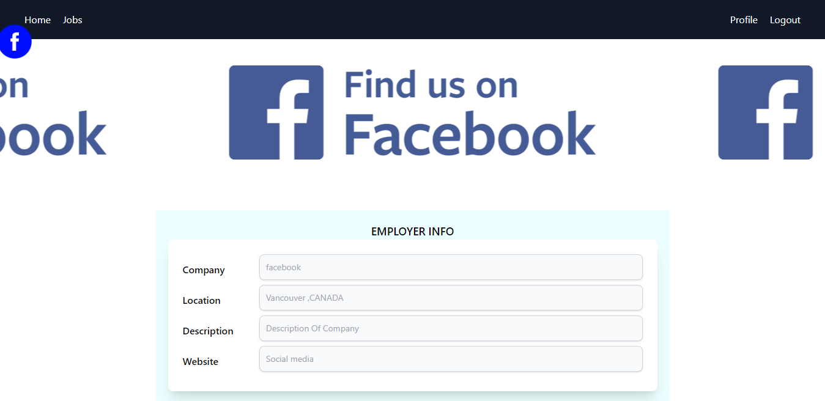

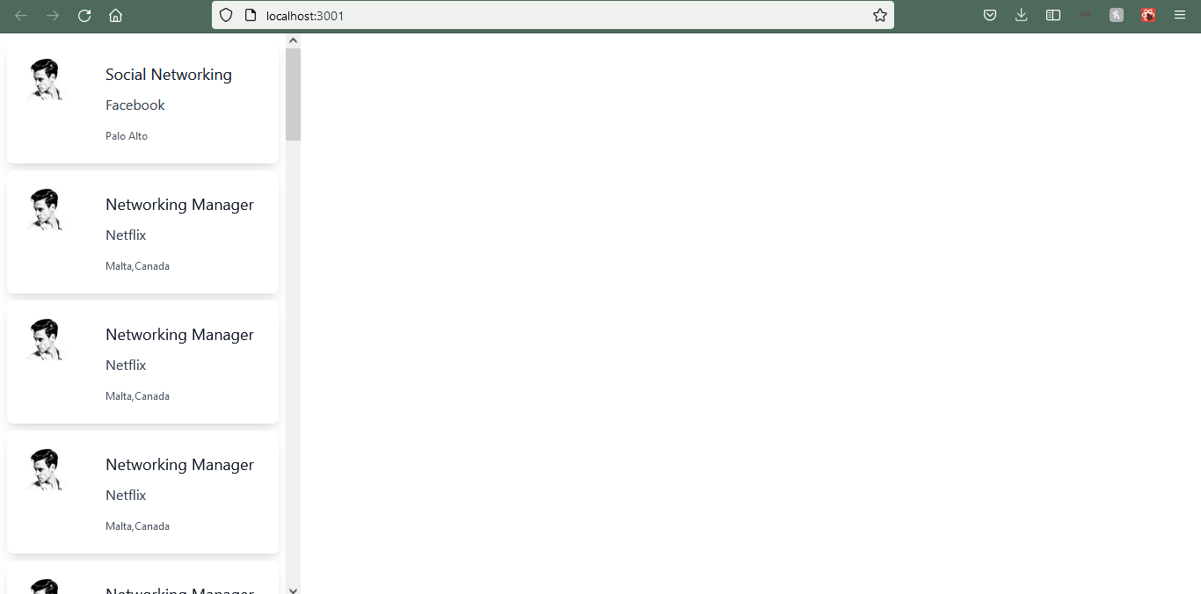

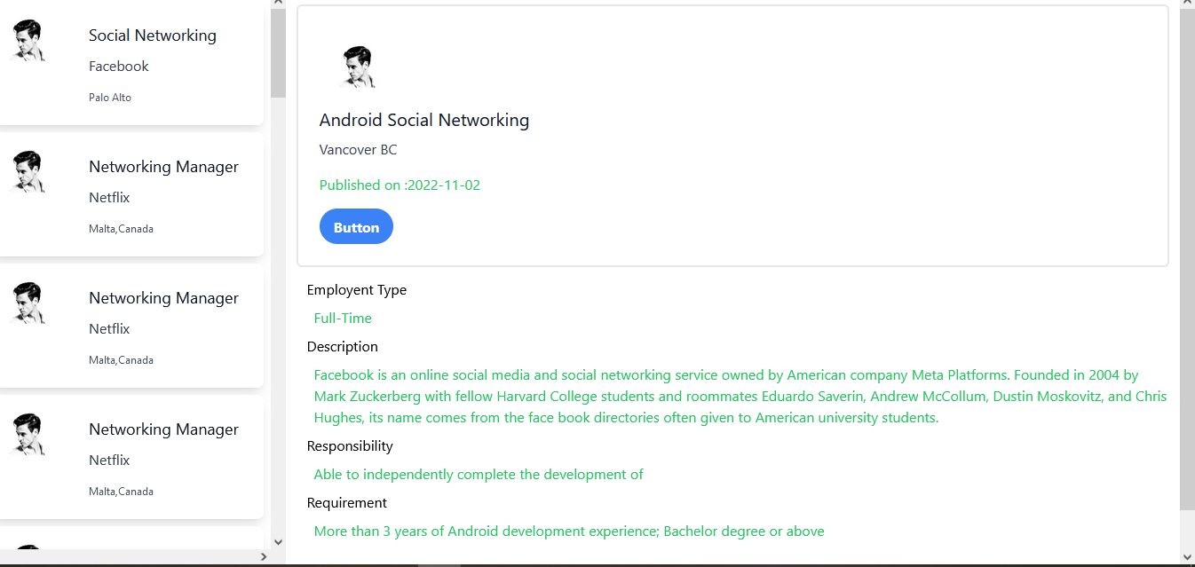

Docker File for frontend:

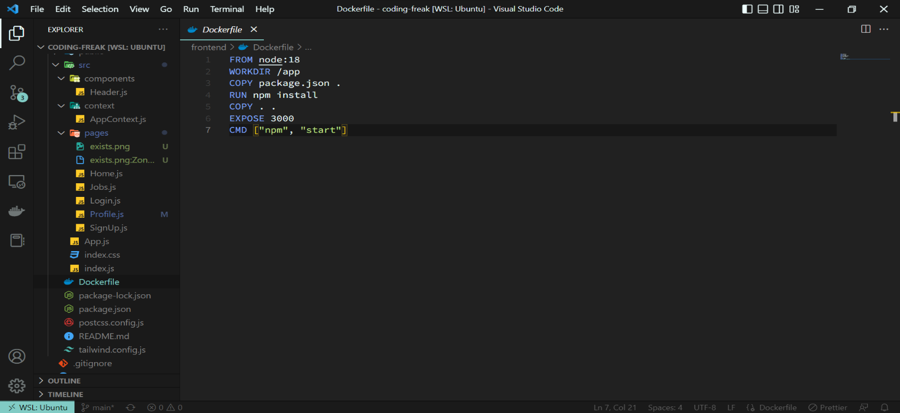

Docker File for backend:

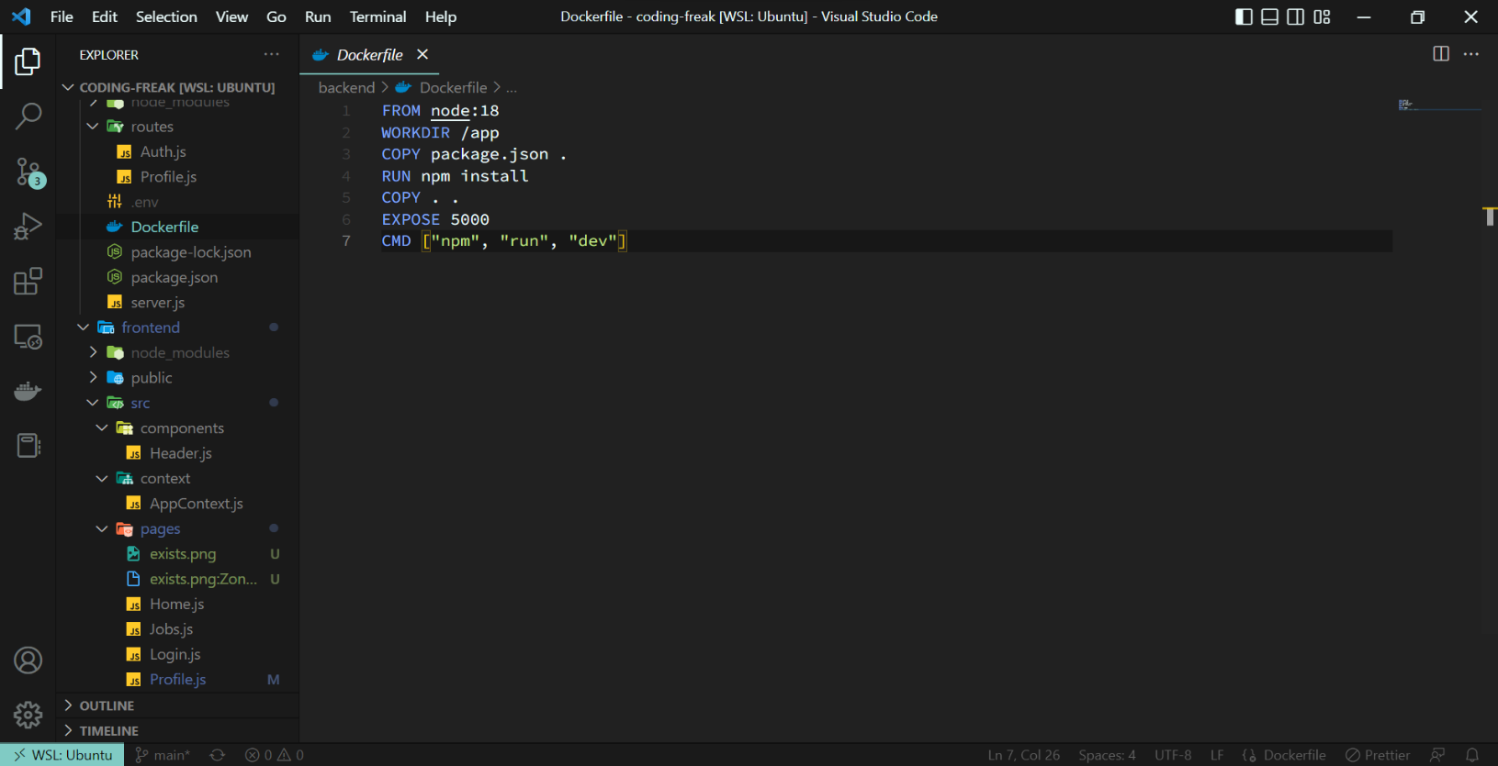

By :Karamjeet , By Sandeep

## Previous project implementations

Chat app and simple login signup

For Now:

We have updated the fontend .

Login and signup successfully

Employee and employer profile and updation

Backend for user and employee is done.

## Pending implementation

In addition, we have almost completed blog app with some bugs which are still in fix.

Private chat app needs some UI upgrades before being part of the website ecosystem.

Frontend for employer job application and employee part after accepting the job.

ATS system .

And search foe jobs.

## Software Design Architecture

Software Design Architecture: Branch pattern (A design pattern used to simultaneously process the requests and responses from two or more independent microservices.)

## Proposal Revision

None