**Demographics of 202 Neurological Facial Pain Patients at a Social Networking Website**

Richard A. Lawhern, Ph.D.  
Site Moderator, "Living With TN"  
April 2012

**Abstract**

A[1] demographic analysis was performed on 202 consecutive member registration records accumulated between February 4 and March 18, 2012 at an on-line social networking website focused on trigeminal neuralgia and trigeminal neuropathic pain ("Living With TN": http://www.livingwithtn.org). This analysis was conducted as a consistency check on an earlier and larger assessment of patient demographics and treatment outcomes. [2] Age and gender demographics in this limited sample were consistent with the earlier large-scale report. Patient outcomes of diagnosis and treatment by dental practitioners were also consistent. Additional analysis of the limited sample assessed the average length of time between first emergence of chronic face pain, versus definitive diagnosis by a medical practitioner. In 110 patient records where an explicit time to diagnose could be extracted, about one-third reported a definitive diagnosis in less than one month, and one-fifth reported suffering more than one year before their pain was medically characterized. Among 81 records where time to diagnose was not explicit or the diagnosis had not yet been made, at least four patients had suffered facial pain for several years without resolution.

**Introduction to Trigeminal Neuralgia**

This introduction is extracted from the earlier report of Reference 1. The intention of both reports is to cast light upon two questions:

1. Who gets face pain of neurological origins and at what ages?

2. How wide-spread are difficulties in obtaining accurate diagnosis and effective treatment?

Trigeminal Neuralgia (TN or "Tic Douloureux") is a relatively rare neurological disorder that produces intense pain in one side (or in a few cases both sides at different times) of the face. The disorder has sometimes been called "the suicide disease"[3],[4] and is widely considered to comprise the most debilitating form of pain known in medical practice[5]. TN is also relatively rare, with an estimated incidence rate of new cases on the order of 12 per hundred thousand population per year [6]. Some practitioners recognize two forms of the disorder. "Type I" or "Classic" TN is said to present as volleys of intense, brief, sharp, electric-shock jabbing pain, each jab lasting up to 90 seconds and volleys tapering off after one to two hours. "Type II" or "Atypical" TN pain is described as less-intense, constant 24-7 burning, boring, aching pain. [7] Distinct medical mechanisms for these two forms of pain do not appear to have been established in medical literature. Application of the term "neuralgia" itself may not be fully accurate, given that both types of pain have characteristics not obviously attributable to an inflammatory process.

Many sources indicate that more patients are female than male. [8] Estimated age demographics vary by source. Some sources assert that Trigeminal Neuralgia most often first presents in the sixth decade of life[9],[10]. Other papers show a skewing of patient populations toward even older age. [11]

Because of its relative rarity and overlaps of symptoms between TN and other neurological or dental problems, the disorder may present challenges to accurate diagnosis. [12] In a National Patient Registry created by the Trigeminal Neuralgia Association in 1999-2002, over 11,000 surveyed patients reported that they had been seen by an average of six different dental or medical practitioners before obtaining a diagnosis. Many physicians in general practice also relate that they have never personally seen a case of trigeminal neuralgia during 30 or more years of practice. [13]

**Findings in A Limited Consecutive Sample**

A demographic analysis was performed on 202 consecutive patient registration records accumulated between February 4 and March 18, 2012 at an on-line social networking website focused on trigeminal neuralgia and trigeminal neuropathic pain ("Living With TN" -- http://www.livingwithtn.org). This analysis provides a consistency check on an earlier and larger assessment of records for 1900+ members registered at the site between October 2008 and February 4, 2012. [14]

Eleven registration records were eliminated from the small-sample demographic analysis because the patient and the site member were different people and age data on the patient were imprecise or missing. In the 191 records retained for the analysis, 181 had been entered by patients themselves, and 10 by relatives supporting the patient with online research. Members in the analyzed demographic were registered from the US (137), United Kingdom (34), Canada (10), Australia (5), New Zealand, India, Singapore, Cyprus, Ireland, Israel and Switzerland.

Estimated average age of patients when pain first emerged was 43.3 years, with the youngest at eight years old and the eldest at 80. Half of all patients first experienced pain between age 35 and 52. Pain first presented at 30 years of age or younger for thirty patients (15.7%) and at age 60 years or older for 13 patients (6.8%). These statistics compare with 21.4% and 6.3% respectively for the earlier large sample.

In 32 records where the member did not enter an explicit age at which pain first emerged, the age at diagnosis (when available in narratives) or the patient's age on registration (when age at diagnosis was unavailable) were taken as upper bounds on age when pain first presented. These approximations introduced some degree upward bias in the estimate of median age when pain first presented. However, estimated median age at first presentation of pain was within two years of the comparable figure in the initial 1727-patient demographic analysis, using the same method. The general shape of the demographic curve (Figure 1) for number of patients versus year group was also generally Gaussian and symmetric around the median, though somewhat less regular than in the larger population of the earlier study and possibly exhibiting "sidelobes" among younger and older patients. The trend line in the data of Figure 1 was developed as a symmetrical 5-point moving average.

121 patients in the small sample study registered as female or could be assigned a gender from email naming conventions, versus 29 male patients; gender could not be determined from 41 patient records. Females comprised 81% of patients for whom gender was entered or could be inferred. This outcome tracked closely with results of the original demographic analysis of Reference 1.

**Figure 1: Demographic Curve for Patient Age at First Pain Presentation**

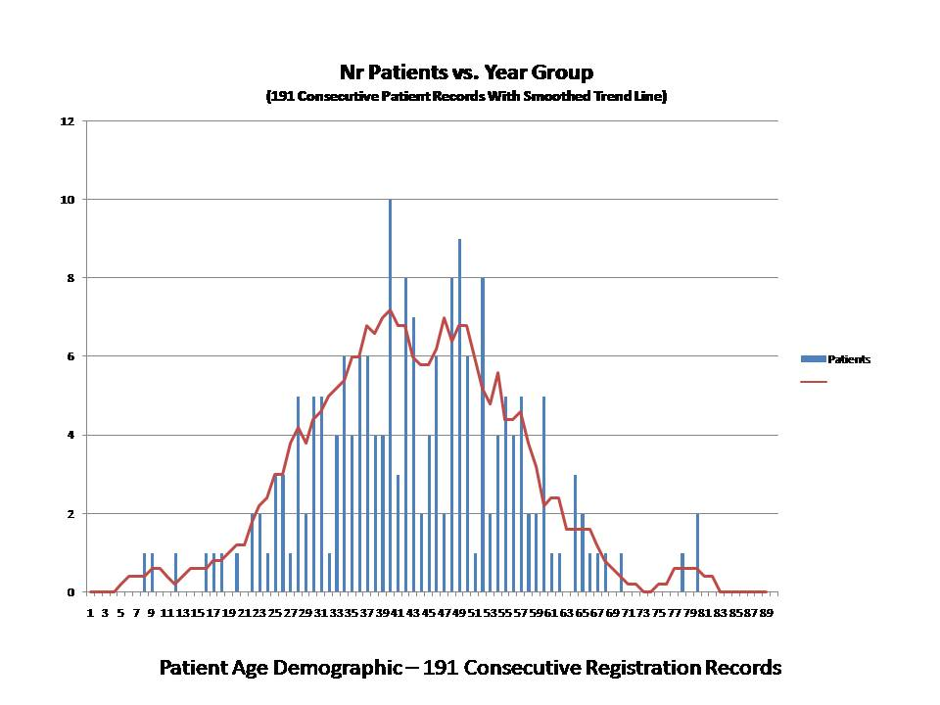

The member registration form provided check boxes for one or more of the following types of experienced pain. Some members checked all of the boxes and most checked more than one. It was apparent from narratives that the patient registration records reflected a combination of self-diagnosis and physician diagnosis. Many patients registering with the website did not yet have a definitive diagnosis and were seeking information which might inform their medical consultations or treatment choices.

**Table 1: Types of Facial Pain Reported**

- Type I TN (sharp jabs or electric shocks) [83 occurrences]

- Type II (Atypical) TN (burning, boring 24-7 pain) [71 occurrences]

- Trigeminal Neuropathic Pain [50 occurrences]

- Atypical Facial Pain [21 occurrences]

- Other / Not Sure [44 occurrences]

In the same manner as done for the earlier large-sample demographic analysis, keyword search was performed for text strings in this smaller follow-on series. By this means, it was confirmed that at least 26 people who had registered for the site had a history of one or more medical issues only indirectly related to idiopathic trigeminal neuralgia. These conditions included cyst (2), trauma (2), fibromyalgia (6), tumor (7) and automobile accident injury (9). Although the terms "MS" and "multiple sclerosis" occurred several times, all but three of those occurrences related to physician efforts to eliminate MS as a diagnosis. The terms "TMJ" or "TMD" occur in 14 patient narratives -- most often in a context of either misdiagnosis or positive elimination of TMJ as a factor. The term "migraine" occurred in 20 records, in various contexts.

Terms relating to dental issues (tooth, teeth, canal, bite, mouth, extract, pull, TMJ) occurred in 69 patient narratives. The terms "dental" or "dentist" appeared in 71 patient records. Patient narratives were read by the author, for records containing "dentist" or "dental", to characterize diagnosis and treatment outcomes into five broad categories intended to be mutually exclusive:

- Mention of dentist or dental was peripheral or context was unclear in 20 records.

- Dental practitioner(s) determined that pain was non-dental in origin and promptly referred the patient to a medical doctor or neurologist in 11 records.

- Dental practitioner(s) found no evidence of dental problems and discharged the patient without treatment or referral in 12 records.

- Dental practitioners performed one or more dental procedures, extractions, root canals, splints, night guards, grinding down of teeth, or TMJ therapy in 18 records.

- The patient reported that severe facial pain began after a routine dental procedure, or otherwise attributed their chronic trigeminal pain to the actions of a dental practitioner in 10 records.

There was significant conceptual imprecision in many of the patient narratives relating to dental work. However, an overall picture still emerges for outcomes of diagnosis and treatment by dental practitioners. In many cases, symptoms of trigeminal neuropathic pain or trigeminal neuralgia described by the patient overlapped those of common dental problems (abscess, cracked tooth, TMJ, misaligned bite). In a few cases, the patient had no significant face pain until one or more dental extractions or root canals had been performed -- possibly adding to whatever degree of damage or predisposition for neuralgia that may have already pre-existed in the trigeminal system. It is impossible to definitively assign cause and effect in these cases, working solely from the registration data and narratives.

However, in almost half of the cases seen by a dental practitioner, the patient was discharged without diagnosis or referral, or otherwise treated for dental problems without resolving the pain. Many patients saw several dental specialists and medical doctors before having their pain recognized as neurological rather than dental in origin. Several patients were self-diagnosed before a doctor rendered the same diagnosis. Others who registered at the website were still searching for information by which to diagnose themselves, in the absence of a definitive diagnosis or effective treatment plan.

Some imprecision was also found in patient narratives relating to the time required to obtain a diagnosis of face pain. Of the 191 patient narratives analyzed in this sample, it was possible to extract information from 110 records, concerning period between first pain presentation rendering of a formal diagnosis. Time to diagnose ranged from "immediate" on the first visit to a physician, through "20 years without a diagnosis". Thirty-five out of 110 patients (31.8%) reported two months or less and 40 patients (20.9%) reported a year or more -- having been seen by multiple doctors and dental practitioners before diagnosis.

**Diagnostic and Treatment Issues -- In Patients' Own Words**

Although the visibility of trigeminal neuropathic pain in public and medical literature sources has almost certainly improved greatly in the past 20 years[15] chronic neurological or neuropathic face pain conditions are still among the most difficult to accurately diagnose and treat among all medical complaints. There are no standardized tests for Trigeminal Neuralgia. Diagnosis is most often made from the patient's reported symptoms and history, sometimes confirmed by a positive response to a short course of one of the anti-seizure medications. Assessment of face pain can be particularly difficult in patients with constant burning, boring, achy pain, sometimes called Atypical (Type II) Trigeminal Neuralgia. Diagnostic difficulty can also be compounded by the attitudes or expectations of an examining physician.

Patients' own words may offer cautionary training to physicians who interact with this population. In the 17-year experience of the author in patient support and advocacy, the spectrum of narrative comments below is representative, rather than weighted toward the most refractory cases. All quotations are drawn from the 191 website registration records processed for this limited series report.

" The week before I was diagnosed, I ran into my neighbor at our new house. She is a hospital nurse. I was in distress and explained what I was going through. She said "have they looked at the trigeminal nerve?" My doctor didn't know, but my neighbor did..." -- Patient D.R.

" I had dental work 12 days before my TN started again. I had 4 shots of novacaine and it still did not work - the dentist refused to give me more without my doctors approval because of an increased heart rate. [In] my previous episodes I was told it a TMJ disorder, it was all in my head, I was crazy, I was lying, and the worst and most heard - I was a drug seeker!" -- Patient S.

" I was diagnosed at my first visit with the neurologist, although I had seen other specialists over a six month period. I've had pain for a couple years, intermittently, mostly in the right ear." -- Patient M.

" I was 36 when I first experienced lasting facial pain. I had them for 5 weeks before a "new" young doctor said he knew what I had." -- Patient ML.

" I was 54 when diagnosed. I had been experiencing pain for about 2 months. I thought it was due to dental issues. When the dentist couldn't find anything, I was referred to an endodontist, then to an ENT who made the diagnosis of TN and referred me to a neurologist."

" I don't have a diagnosis yet. I have had three "pain episodes" in four months. In all three instances, it was triggered by blowing my nose. Each episode has lasted an hour and a half. I also have many symptoms of MS..." -- Patient AJ.

" I tried almost every possible med, but always [had] too [many] side effects. Actually I'm on Lyrica (2 x 300 mg; tried 2 x 600 mg -- was hell) and Baclofen (3 x 5 mg). Had Amytriptilin for years (30mg at night), but I was too sleepy during the day. Also tried Ritalin for 3 years, but I felt better as I stopped it..." -- Patient CG.

" I was 26 years old when I first felt it. It was first written off as a sinus infection and I was given abx [antibiotics]." -- Patient NW

" I've tried all of the various medications that are traditionally used to treat TN such as Tegretol, Neurontin, Lyrica etc, none of which helped at all. In fact, some even made me worse including a drug called Nortriptyline, which made me lose 20% of the vision in my only sighted eye. The only medications that help at all are Fentanyl, Oxicodone and Methadone, which are next to impossible to get anyone to prescribe..." -- Patient W.

" Pain used to occur every 4-5 weeks and last for 4-5 days. NOTHING worked, so I just rode it out in bed on painkillers until it ended after the 4-5 days on its own time table. I lost chunks of my life each time it happened. Sought help from dentist [and] root canal specialist, thinking it was tooth root hitting a nerve. Radiographs all showed nothing. Saw periodontist who ground down all teeth on left side to "improve my bite". Also had a mouth guard made to prevent any clenching of jaw. No improvement at all. Saw ENT. Sinus CAT scans negative. Saw eye specialist. MRI of eye and brain negative. Treated for TMJ with muscle relaxers. No help. My neurologist who has long treated my migraines diagnosed it the moment I related my symptoms to him." -- Patient ZS.

Whether or not we accept patient assertions of medical cause and effect at face value, it is impossible to come away from reading patient's narratives of their treatment history, without realizing that many are *not* being well served by medical or dental practitioners.

**Observations**

A reading of 191 registration records written by face pain patients while joining a peer-to-peer social networking website suggests the following overall findings:

1. Demographics of spontaneous emergence of trigeminal nerve pain are substantially younger than reflected in much of the medical literature, with an average age of 41-43 years, and the number of patients under 30 in the range of 15-20% of the patient population. As many as 80% of patients are female. Internet search on face pain symptoms is bringing increasing numbers of patients to Internet information resource sites, before they are assessed by a physician.

2. Chronic facial pain patients often have great difficulty in obtaining a definitive diagnosis. At least a third of these patients experience more than a year of suffering and multiple medical and dental consults, before neurological origins of facial pain are recognized by a professional.

3. There are reasons to believe that a fraction of chronic face pain cases are iatrogenic in origin, involving facial nerves injured during otherwise routine dental procedures. Likewise many trigeminal neuralgia patients receive root canals or extractions even when radiological evidence of abscess or cracked tooth is lacking. Some patients are treated for TMJ Disorder or bite problems that they may not actually have.

4. Some patients experience callous or misinformed attitudes on the part of medical and dental professionals who fail to recognize the sources of their chronic face pain. Such patients may be written off as "head cases" or occasionally as "drug seekers", or otherwise assigned an uninformative diagnostic label of "atypical facial pain". Even when face pain is recognized as non-dental in nature, some dentists do not refer patients for competent neurological workup.

All of the conditions summarized above have implications for medical and dental school curricula and for the continuing education of medical/dental professionals.

**About the Author**

Richard A. Lawhern is the spouse of a trigeminal neuralgia patient who has symptoms of both typical and atypical forms of this disorder, with pain on both sides of her face. His graduate degrees are in Engineering Systems (Ph.D. UCLA, 1976). Since 1996, Dr. Lawhern has researched and authored multiple on-line articles and websites on behalf of chronic face pain patients, corresponding with over 3,000 patients, family members and medical professionals. Dr. Lawhern supports “Living With TN” (http://www.livingwithtn.org) as a site moderator, content author and resident research analyst.

1.
2. Richard A Lawhern, "Demographics of Neurological Face Pain at a Social Networking Website", Web published at http://www.livingwithtn.org/page/who-gets-tn, March 16, 2012.
3. Wikipedia, "Trigeminal Neuralgia", 2012: http://en.wikipedia.org/wiki/Trigeminal_neuralgia
4. Yam dela Cruz, "Salamat doc -- the Suicide Disease", ABS-CBN News, October 30, 2011, http://www.abs-cbnnews.com/current-affairs-programs/10/30/11/salamat-dok-trigeminal-neuralgia-suicide-disease
5. Medicine.org -- Trigeminal Neuralgia, 2012, http://medicine.org/trigeminal-neuralgia-the-suicide-disease-may-be-the-most-painful-condition-known-to-medical-science/
6. Koopman JSHA, Dieleman JP, Hygen FJ, deMos M, Martin Carola GM, Stirkenboom Miriam, "Incidence of Facial Pain in the General Population", *Pain*  (2009)
7. Jorge L. Eller, M.D.; Ahmed M. Raslan, M.D.; Kim J. Burchiel, M.D., "Trigeminal Neuralgia -- Definition and Classification", Neurosurgical Focus. 2005;18(5) © 2005 American Association of Neurological Surgeons
8. Silvia RDT Siqueira, Manoel J Teixeira, and José TT Siqueira "Clinical Characteristics of Patients with Trigeminal Neuralgia Referred to Neurosurgery", European Journal of Dentistry, 2009 July; 3(3): 207–212. Web Reference: http://www.ncbi.nlm.nih.gov/pmc/articles/PMC2741192/
9. University of Pittsburgh, Department of Neurological Surgery: http://www.neurosurgery.pitt.edu/imageguided/tn_facts.html
10. Op Cit, Koopman et al (Mean patient age in demographic sample was 51.5).
11. Op Cit, Silvia RDT Siqueira et al, see Figure I.
12. Drangsholt, M, Truelove, EL,"Trigeminal Neuralgia Mistaken as Tempro-Mandibular Disorder", J Evid Base Dent Pract 2001;1:41-50.
13. Richard A Lawhern, 2003. Observations as co-author of the 2001 TNA Patient Registry survey form and a member of the data reduction team [survey results unpublished].
14. Op Cit, Richard A Lawhern, 2012.
15. Op Cit, Lawhern 2012