1. Introduction
   1. Overview

This online shopping mall provide a platform for sneaker trade. The interaction between vendors and customers can be stated as follows. The vendor provides descriptions and images of their selling sneakers. This website will display that information in a list for customer. Customer can select product items, place orders and make purchases.

This project aims at providing an elegant online shopping experience to both vendor and potential customer.

* 1. Objectives

All the functions we desire to implement are listed below.

The front page of the shopping mall shows a **product list**.

* (A1) A customer may browse products in a list of products. The list shows basic information of products, including product name, brand, price and a thumbnail image. Each product belongs to one of the pre-defined brands
* (A2) The product list supports **paging**. The customer can navigate the product list by ‘page up’, ‘page down’ and jumping to a specific page. Paging works properly after applying filter or sorting listed below.
* (A3) The customer can **filter** the product list **by brand**. He/she can also list products of all brands.
* (A4) The customer may filter the product list by **searching keywords** in product name. This function work correctly with the brand filter.
* (A5) The customer may **sort** the product list **by price**.

**The product detail page** shows detail information about one product.

* (A6) The customer may select a product in the product list to go to the product detail page. The product detail page shows information for one product, which includes the product name, brand, price and a thumbnail image. In addition, the product detail page also shows detail description as a list of at least two properties. For example, the product detail page for a book may show authors, ISBN, publisher, release date and number of pages.
* (A7) The product detail page supports display of **one or more detail photo** of the selected product.

The system has basic **account management** for customers.

* (B1) A customer may **register a new account**. He/she has to provide full name, email address, password and shipping address. After registration, the user is logged in automatically.
* (B2) A customer may **log in** and **log out**, and the interface shows the name of the current user. The product list and product detail page are accessible to customers without login. On the other hand, the shopping cart and purchase tracking are only accessible after login.
* (B3) The customer can **change password**. There is strength requirement for password. The password should contain at least 6 characters, in which there are at least 1 digit and 1 capital letter.
* (B4) If a customer tries to add a product to the shopping cart on the product detail page without first logging in, the system **redirects** the user **to the login page**. After successful login, the system redirects the user back to the original product detail page.
* (B5) The server only saves hash values of customers’ passwords. Passwords are never saved in plain text in the server.

To make any purchase, a customer must add products to his/her shopping cart. The customer can check out all items in the cart to place an order.

* (C1) The customer adds a product to his/her shopping cart by clicking a button in the product detail page. The quantity to buy is assumed to be 1. The items in shopping cart are persisted across user sessions. Next time the customer logs in, he/she can still see the items in the shopping cart.
* (C2) The customer can list the products in his/her shopping cart in a shopping cart page. In this page, the entry for each product shows the product name, price and the quantity to buy. The page also shows the total order amount (i.e. how much the customer has to pay in total) in the shopping cart. The customer can click an item in the shopping cart to go to the product detail page of the entry.
* (C3) The customer can press a button in the shopping cart page to check out all items in the shopping cart. This action creates a purchase order with a newly allocated unique P.O. number, and clears the content of the cart. After checkout, the system shows the purchase order detail page of the newly created purchase order. (refer to requirement D3).
* (C4) The shopping cart page allows the customer to change the quantity of an item. This allows the customer to order more than one piece of a product (e.g. buy two copies of a book).
* (C5) The customer can remove an item from the shopping cart.
* (C6) If the customer adds a duplicate product to the shopping cart, the application will give a warning message and does not change the content of the shopping cart.

Purchase tracking: After placing an order, the customer can trace the processing status of the order in a purchase tracking page. For simplicity, we assume that each purchase order is fulfilled in a single shipping package. The purchase order status describes the various stages of order processing. Possible values include ‘pending’, ‘shipped’, ‘hold’, and ‘cancelled’.

* (D1) The purchase tracking page lists the purchase orders that the customer has placed. This page shows the following for each purchase order: The P.O. number, the purchase date, the total order amount and the purchase order status. The purchase orders are displayed in reverse chronological order of purchase date. When the customer clicks an entry in the list, he/she can see the detail in a purchase order detail page.
* (D2) The customer can filter the list of purchase orders in two ways. First, the page only shows ‘current purchases’ with status ‘pending’ and ‘hold’. Second, the page only shows ‘past purchases’ with status ‘shipped’ and ‘cancelled’.
* (D3) The purchase order detail page shows the P.O. number, the purchase date, the customer name, the shipping address, the total order amount and the purchase order status. If the order is shipped, this page shows the shipment date. If the order is cancelled, the page shows the order cancel date and who (customer or vendor) cancels the order. The page also includes, for each product in the purchase order, the product name, the quantity, the unit price and the subtotal.
* (D4) Before a purchase order is shipped, the customer can cancel the order. This can be done by clicking a button in the purchase order detail page. This action will change the status of the purchase order to ‘cancelled’. Note that this action is only available for purchase orders in the status ‘pending’ or ‘hold’.

The vendor maintains a product catalog in the shopping mall. He/she can also process purchase orders from customers. Because there is only one vendor, the system only needs to implement a single vendor user account. No account management of vendor accounts is necessary in this project. The application provides the following functions.

Product catalog maintenance: The vendor can browse the product catalog, edit some properties of a product, and add new products.

* (E1) The vendor may browse the product catalog in an interface similar to product list for customers. (Refer to requirements A1, A2, A3 and A6). The vendor is not a customer, and no shopping cart or ‘add to cart’ button should be shown.
* (E2) The vendor can find products by searching keywords in product names. He/she can also find a specific product by entering a unique product ID.
* (E3) The vendor may add a new product to the catalog. The vendor enters basic information of the product, including product name, brand, price and a thumbnail image. He/she can enter detail information of the new product as a list of properties. (Refer to requirement A6)
* (E4) In addition to the thumbnail image, the vendor can upload 1 to 4 detail photos for a product. These photos are usually of higher resolution and are displayed in the product detail page in a user-friendly interface. (Refer to requirement A7)
* (E5) The vendor can edit information of a product in a product detail page. He/she can change the product name and product brand. He/she can also change detail information as a list of properties. (Refer to requirement E3).
* (E6) The vendor can change the thumbnail and detail photos for a product. He can add or remove photos.

Purchase order processing: The vendor can list purchase orders by different status. He/she may ship, hold, or cancel a purchase order in the purchase order processing page.

* (F1) The purchase order list page lists purchase orders received by the application. It shows the P.O. numbers, purchase dates, customer names, total order amounts and purchase order status. The purchase orders are sorted in descending order of purchase date. The vendor can click an entry to open a purchase order processing page.
* (F2) The vendor can filter the purchase order list in three ways. He/she can show only the ‘pending orders’ (with status ‘pending’). He/she can show only the ‘orders on hold’ (with status ‘hold’). Finally, the vendor can select to show ‘past orders’ (with status ‘shipped’ or ‘cancelled’).
* (F3) The purchase order processing page shows similar information as the purchase order detail page (refer to requirement D3). In addition, the vendor can click a button to ship a purchase order. This action changes the status of the purchase order from ‘pending’ to ‘shipped’ and starts the shipping process.
* (F4) The vendor can enter a P.O. number to view and process a specific purchase order.
* (F5) In the purchase order processing page, the vendor can click a button to hold a purchase order. This is useful, for example, if some product in the purchase order is temporarily out-of-stock. This action is only available when the status of the purchase order is ‘pending’, and this action changes the status to ‘hold’.
* (F6) In the purchase order processing page, the vendor can click a button to unhold and ship a purchase order. This action changes the status of the purchase order from ‘hold’ to ‘shipped’ and starts the shipping process.
* (F7) In the purchase order processing page, the vendor can click a button to cancel a purchase order. This is useful, for example, to inform the customer that the ordered products are no longer available. This action is only available for purchase orders in the status ‘pending’ or ‘hold’. This action changes the status of the purchase order to ‘cancelled’.

These advanced features are also designed and implemented.

* (Z1) The vendor needs to analyze the sales of the products and find out the best selling products. The report measures sales by both sales quantities (number of items sold) and sales amount (the dollar amount received in sales). The default reporting period is the last 30 days, but the vendor may also customize the reporting period.
* (Z2) Design a notification feature to make it to easier for a customer to track the change of status of purchase orders. For example, when the vendor ships a purchase order, the customer will receive a notification message. The interface should distinguish between read and unread notifications.
* (Z3) A customer can express his/her satisfaction of a product with customer’s rating. A customer who has purchased a product successfully can rate it on a scale of 1 to 5 stars after the purchase is shipped. Decide whether a customer can rate one product more than 1 times, and whether he/she can change the ratings afterwards. The product detail page shows customers’ average rating as a decimal number (e.g. 3.5 stars). Pay special attention when number of ratings is smaller (e.g. less than 2). Consider how to use the average ratings in product list for customers and the vendor.
* (Z4) In addition to star ratings, customers also want to write short reviews for products in the shopping mall. Design a feature to allow a customer to write short review for a product. Consider how to show these reviews to other customers and the vendor.
* (Z5) Design how to implement price change of products. This is useful, e.g., for promotional price reduction or regular price adjustment. Price change should not affect the price in existing purchase order and other historical records.

1. Background and Related Work
   1. Background

E-commerce is trading in products or services using computer networks, such as the Internet. Electronic commerce draws on technologies such as mobile commerce, Internet marketing, online transaction processing, and automated data collection systems. Modern electronic commerce typically uses the World Wide Web for at least one part of the transaction's life cycle.

No matter what a shopping website sells, it should provide value and quality, make shopping easy, deliver products on time, and provide good customer support. General functions of our online shopping mall are:

* **Sign** (Log in, Log out, Sign up)

Website should provide user private accounts. A guest login function should also be available for customers who do not want to sign up to the website.

* **Search**

Customers can search what they want by name. Website should also provide advance search.

* **Payment Options**

Website should provide user options of payment, such as VISA, MasterCard, American Express, or PayPal.

* **Check out**

Customers can add the items to cart, set the mail address, and pay.

* **Consumer Reviews**

Customers can write reviews for products they buy. They can also see other’s reviews.

* **Customer Support**

Customers who browse products online and intend to complete a purchase will need peace of mind to ensure that there is help available when required while placing an order Customer support contact details should be easily found.

* **Website Security**

An ecommerce store has to be secure for customers to browse and should protect their privacy when they purchase products using a credit card or an electronic payment method.

Therefore, this online shopping mall focuses on selling sneaker rapidly, security and conveniently.

* 1. Related work

1. System Design
   1. Data modelling

The data modeling exhibits the database layout of our software system. The *Figure 1* is the ER diagram. It includes sex tables, namely Cart, User, Rating, Item, orderItem, Orders.

Following tables show the data structure specification.

User(User_id, Username, First_Name, Last_Name, email, address, password, Type)

|  |  |  |
| --- | --- | --- |
| table | column | description |
| user | user_id | the unique id of user |
| user | username | user's full name |
| user | first_name | the first name of user |
| user | last_name | the last name of user |
| user | email | user's email for sending mails |
| user | address | address that the product send to |
| user | password | the password of user account |
| user | type | is user vendor or customer |
| cart | itemid | the unique id of product, foreign key to itemid of item |
| cart | uid | the user id of product in shopping cart, foreign key to user_id of table user |
| cart | quantity | the quantity of the product in shopping cart |
| item | itemid | the unique id of product |
| item | name | the name of product |
| item | brand | the brand of product |
| item | price | the unit price of product |
| item | thumbnailimage | the url of a thumb nail image |
| item | description | list description of product |
| item | detailphoto | the images of the detail of product |
| item | category | the category of product |
| orderitem | poNum | the purchase order number, foreign key to poNum in orders |
| orderitem | itemid | the item id of product in this purchase order, foreign key itemid in item |
| orderitem | quantity | the quantity of the product in purchase order |
| orders | poNum | the purchase order number |
| orders | purchaseDate | the purchase date of the order |
| orders | canDate | the canceled date of the order |
| orders | canType | indicate who cancel the order, vendor or customer |
| orders | shipDate | the ship date of order |
| orders | shipAddress | the ship address of order |
| orders | status | the status of order, could be pending, hold, shipped, canceled |
| orders | uid | the user id of product in order, foreign key to user_id of table user |
| rating | user_id | the user id of product in rating, foreign key to user_id of table user |
| rating | poNum | the purchase order number, foreign key to poNum in orders |
| rating | itemid | the unique id of product, foreign key to itemid of item |
| rating | stars | the rating score of the product |

../Documents/ISIproject/ER%20diagram.png

Figure 1

* 1. Dynamic modeling

State diagram

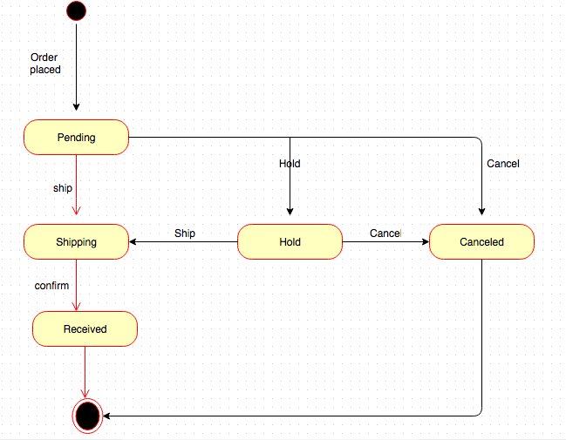

1. System Implementation
   1. Platforms

We use Visual Studio 2013 on Windows System. The languages we use are C# and Java script.

4.2. Architecture

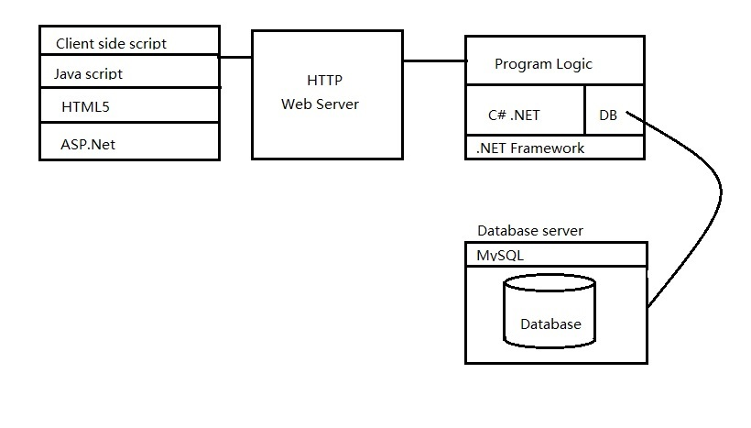

4.3.Module design

Activity Diagram

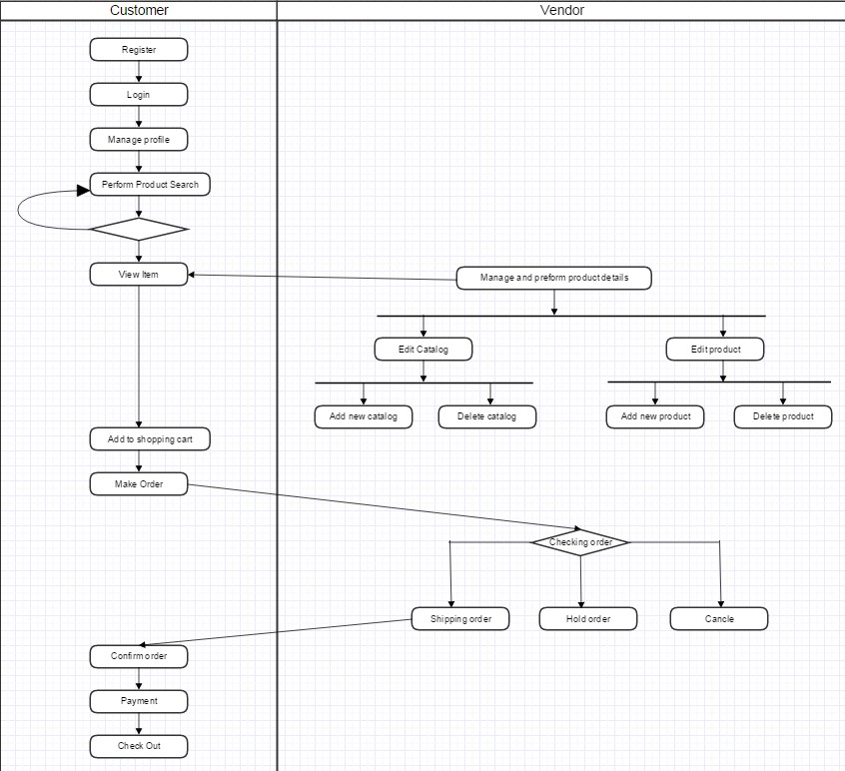

1. Results and Discussion
   1. Project Outcome

This is the home page of out website.

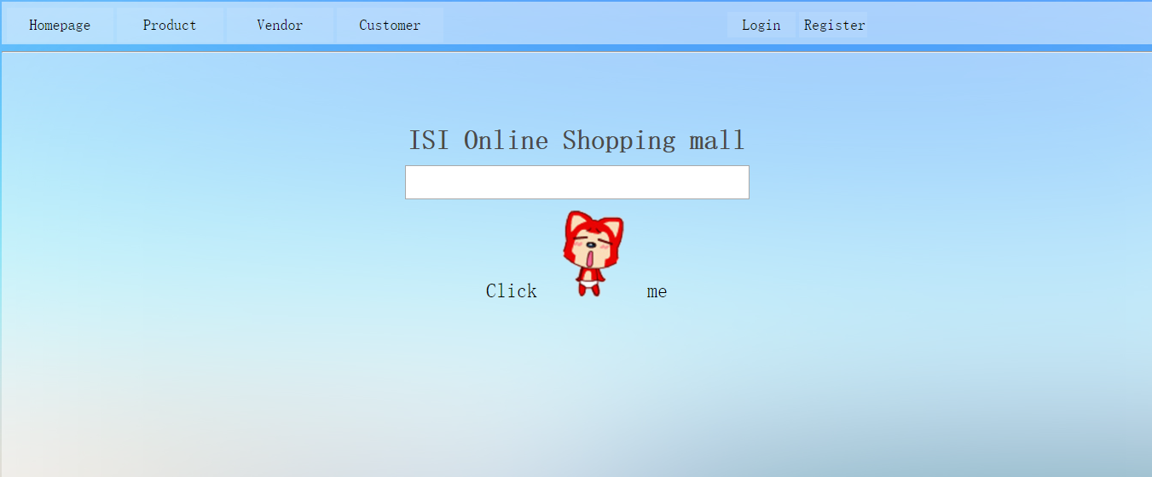

5.2. Testing

We use stress tests to evaluate our website.

1. Conclusion and Further work

Finally, we completed our online shopping website. Although we don’t upload it on the Internet and we don’t have a domain name.

References

Appendix

Project plan

Douglas, Rancho, Tim, Jack and Price

January 20, 2016

1. Project description

1.1 Overview of this project

The Web has provided a unique opportunity for retail businesses. Customers

may do window shopping over a wide range of products without limitation on

business hours and transportation. Vendors save huge expense by not running a

brick-and-mortar shop and can provide services for both large and niche markets.

Online shopping sites like Taobao, Amazon and (to a lesser degree) eBay are

some successful examples. In addition, open-source e-commerce systems (e.g.

Magento, osCommerce and OpenCart) provide low-cost solution to set up an

online store.

This project Online Shopping Mall web application is aimed at you providing

an online shopping experience to customers. The vendor displays their products

in a manner that is easy for potential customers to select and make purchases.

1.2 Team members

Douglas

Tim

Jack

Price

Rancho

1.3 Supervisor

Andrew Siu

1.4 overall development time period

12 weeks

2. Time schedule

requirement specification : week 1

requirement validation : week 1

architectural design : week 2

component/module design : week 3

database design : week 4

interface design : week 4

coding & unit testing : week 7

code integration & testing : week 8

test plan design : week 10

report writing-requirement specification : week 11

report writing-design : week 12

report writing-test plan : week 13

report writing-overall : week 13

user acceptance test : week 14

3. Job distribution

3.1 Function requirement

Function requirement A & Z1 : Jack

Function requirement B & F1 & F2 & Z2 : Tim

Function requirement C & F3 & Z3 : Douglas

Function requirement D & F4 & F5 & F6 & Z4 : Rancho

Function requirement E & F7 & Z5 : Price

3.2 Technical specification

ER diagram : Rancho & Price

User case : Douglas

Architecture design : Rancho

Activities diagram : Jack

State diagram : Tim

3.3 Other jobs

Research study : Price

Report writing : Douglas

Project coordination : Douglas

Pear Assessment Form