# *AICVS 1.0: Everything about the Eaton Pratibha Excellence Award*

AICVS hosted its fourth session of the webinar series AICVS 1.0 on 8th July 2020 on “***Everything about the Eaton Pratibha Excellence Award***”. Our fourth speaker wasEsha Chiplunkar**.** Esha is currently a final year student of Computer Engineering in our college. She is the recipient of the Eaton Pratibha Excellence Award 2020. Esha has completed an internship as a Summer Analyst at Citi**.** She was also a participant of the Citi Bridge Program 2020; which is an astounding training program conducted by Citi. Her projects include a Smart Traffic Signal System and the creation of a small-scale shredder. Both of these projects received the 2nd runner up prize in the E-cell YUKTA competition conducted by Cummins College. Her interests include NLP and Data Science.

The session started with information about the Eaton Pratibha Excellence Award. ***Pratibha*** *-Eaton Excellence award* is a unique program that aims at encouraging multifaceted women engineering talent in India through an educational scholarship at both graduate as well as post-graduate levels. It’s a scholarship that aims to recognize exceptional women engineers in leading engineering institutions in our country. Assessing them based on academic excellence as well as co-curricular achievements. It’s based on the motive: ‘*Power of Perspectives’*. Esha talked about how she got introduced to this scholarship program. She got to know about it while filling the placement form.

Esha then briefed about the Eligibility Criteria to participate as well as the selection process. The criteria to participate in the scholarship program:

1. You should be a student of Cummins College, Pune or COEP.

2. You should be currently enrolled as a 3rd or 4th year student from either Computer, IT, Mechanical, Instrumentation, E&TC, or Electrical branch.

Three students from each college get the benefits of this scholarship. The *Selection Process* is based on your excellence in academics (CGPA), your involvement in community services like working with NGOs, contribution towards society; and your co-curricular achievements. Even though there is a certain CGPA criterion your application does not solely depend on CGPA or academic merit.

Esha then described the *stages of evaluation* and its *process*:

1. *Application Process* – There is an extensive application form (around 4-5 pages) to collect details about your education, social work, co-curricular activities, etc. The key part is to describe your work honestly in the application form. You have to submit your resume along with your application. The selected students are informed after 2-3 weeks.

2. *Choosing a topic and making a presentation* – In this stage, only 10 people are shortlisted from a pool of about 500 students. A list of topics from various domains is announced. Selected students have to concoct a complete presentation on their chosen topic.

3. *Final presentation at Eaton* – Presenting your project at Eaton office in Eon IT Park.

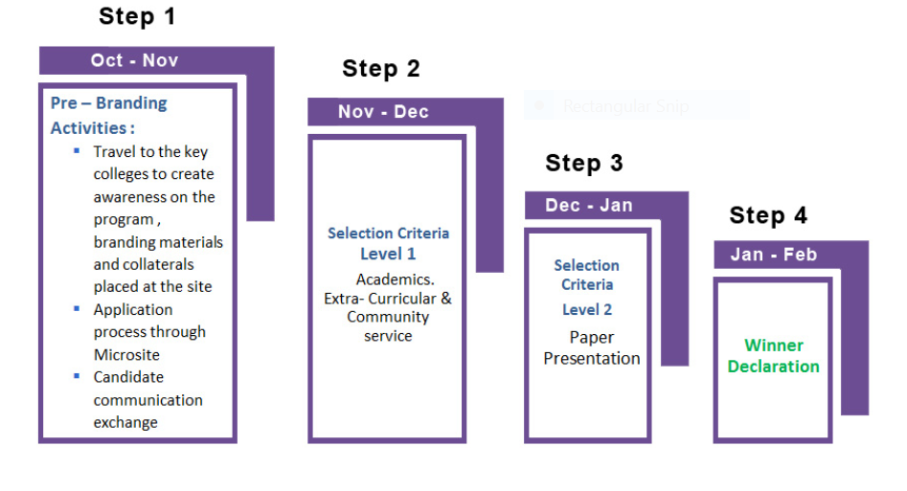

*Benefits of Scholarship:*

1. A one-time scholarship of Rs. 60,000.

2. An opportunity to interact with Eaton leaders & teams to understand and comprehend the true meaning of innovation and diversity in technology.

3. Exposure to the IT culture and work environment.

4. Learning a new technical domain.

Esha then talked about *How to prepare for internship?*

*‘Practice’* is the key to prepare for internship or placement. Research about the company before the interview and always find the common type of questions asked. Prepare the answers to frequently asked questions. Practice for technical as well as non-technical rounds. Esha also shared her experience as an intern at Citi.

Revisit your previous interviews in your mind. Dig deeper into what went wrong or how you could have articulated it. Practice your technical and non-technical skills from various sites. *Learn from your failures. Work for accomplishing your goals.*

The session concluded with Q&A.

Here’s the link to Esha’s slides:

<https://github.com/aicvs-cummins/aicvs-1.0/tree/master/4.%20About%20the%20Eaton%20Pratibha%20Award>

Link to the full video: https://youtu.be/Mh5PGKJe9rI

Written by Anaya Garde