**EVENT MANAGEMENT SYSTEM**

**A PROJECT REPORT**

**for**

**Mini Project-I (K24MCA18P)**

**Session (2024-25)**

**Submitted by**

**Doulat Biswal**

**(202410116100070)**

**Submitted in partial fulfilment of the**

**Requirements for the Degree of**

**MASTER OF COMPUTER APPLICATION**

**Under the Supervision of**

**Ms. Arpit Dogra**

### Assistant Professor



**Submitted to**

**Department Of Computer Applications**

**KIET Group of Institutions, Ghaziabad**

**Uttar Pradesh-201206**

**(december- 2024)**

**CERTIFICATE**

Certified that **Doulat Biswal (202410116100070)** has carried out the project work having “**Event Management System**” (**Mini Project-I, K24MCA18P**) for **Master of Computer Application** from Dr. A.P.J. Abdul Kalam Technical University (AKTU**)** (formerly UPTU), Lucknow under my supervision. The project report embodies original work, and studies are carried out by the student himself/herself and the contents of the project report do not form the basis for the award of any other degree to the candidate or to anybody else from this or any other University/Institution.

**Mr. Arpit Dogra Dr. Arun Kr. Tripathi**

**Assistant Professor Dean**

**Department of Computer Applications Department of Computer Applications**

**KIET Group of Institutions, Ghaziabad KIET Group of Institutions, Ghaziabad**

**Event Management System**

**Doulat Biswal**

**ABSTRACT**

This project presents a comprehensive solution for managing events efficiently through the platform, **Event Management System**. It integrates key features to enhance the user experience and simplify administrative tasks. Designed for diverse event needs, Event Management System combines technology with accessibility to deliver a seamless event management experience.

Key features of the project include:

* **User Registration and Login**: Role-based authentication for users and admins.
* **Event Catalog**: A searchable list of events with details, including dates, venues, and fees.
* **Event Registration**: An intuitive interface for users to register for events.
* **Admin Dashboard**: Tools for managing users, events, and registrations.

The integration of these components ensures an efficient, user-friendly platform for event management.

**ACKNOWLEDGEMENTS**

Success in life is never attained single-handedly. My deepest gratitude goes to my project supervisor, **Ms. Arpit Dogra** for her guidance, help, and encouragement throughout my project work. Their enlightening ideas, comments, and suggestions.

Words are not enough to express my gratitude to Dr. Arun Kumar Tripathi, Professor and Dean, Department of Computer Applications, for his insightful comments and administrative help on various occasions.

Fortunately, I have many understanding friends, who have helped me a lot on many critical conditions.

Finally, my sincere thanks go to my family members and all those who have directly and indirectly provided me with moral support and other kind of help. Without their support, completion of this work would not have been possible in time. They keep my life filled with enjoyment and happiness.

**Doulat Biswal**

**TABLE OF CONTENTS**

**Certificate**

**Abstract**

**Acknowledgements**

**List Of Figures**

1. **Introduction**
   1. General Overview …………………………………………… 7
   2. Challenges …………………………………………………… 7
   3. Advantages Futures ………………………………………….. 8
2. **Literature Review**
   1. Automation in Event Management …………………………… 9
   2. Enhancing User Experience …………………………………… 9
   3. Technological Inovation ………………………………………. 10
   4. Role-Based Access System ……………………………………. 11
3. **Project Objectives**
   1. Streamlined Event Registration ……………………………….. 12
   2. Comprehensive Event Catalog ………………………………… 12
   3. Efficient Admin Management …………………………………. 12
   4. Role-Based Access Control ……………………………………. 12
   5. Scalability and Flexibility ……………………………………… 13
4. **Hardware And Software Requirements**
   1. Hardware Requirements ………………………………………. 14
   2. Software Requirements ……………………………………….... 14
5. **Project Flow**
   1. Development Methodology …………………………………… 15
   2. Data Flow Diagram (DFD) …………………………………… 18
   3. Entity-Relationship (ER) Diagram ……………………………. 20
6. **Project Outcome**
   1. Improved User Experience ……………………………………. 21
   2. Enhanced Admin Efficiency …………………………………... 21
   3. Advanced Security Features …………………………………... 21
   4. Scalability and Flexibility …………………………………….. 22
   5. Data-Driven Insights ………………………………………….. 22
   6. Reliable Performance …………………………………………. 22
7. **References ………………………………………………………... 25**

**LIST OF FIGURES**

**5.2.1. Fig No. 1. DFD Level 0 …………………………………………… 18**

**5.2.2. Fig No. 2. DFD Level 1 …………………………………………… 18**

**5.2.3. Fig No. 3. DFD Level 2 ………………………………………..….. 19**

**5.3.1. Fig No. 4. ER Diagram ……………………………………………. 20**

**6.1.1. Fig No. 5. Home Page …………………………………………….. 23**

**6.1.2. Fig No. 6. Sign In Page ……………………………………………. 23**

**6.1.3. Fig No. 7. Create Event Page ……………………………………… 24**

**6.1.4. Fig No. 8. Create Catalog Page ……………………………………. 24**

**Introduction**

**1.1 General Overview:**

In a world driven by dynamic interactions and experiences, event management has become a critical component of bringing people together for diverse purposes—whether for celebrations, education, collaboration, or innovation. From intimate social gatherings to grand conferences and corporate meetings, organizing successful events requires meticulous planning, seamless execution, and the ability to adapt to unique challenges. The **Event Management System** (EMS) emerges as a transformative solution, offering a sophisticated digital platform that redefines how events are planned, managed, and experienced.

**1.2 Challenges:**

Traditional event management methods often struggle to keep pace with modern demands, burdened by inefficiencies such as manual registration processes, miscommunications, poor coordination, and the inability to maintain accurate, up-to-date records. These inefficiencies not only increase costs but also detract from the overall attendee experience. EMS addresses these pain points with a user-first approach, empowering attendees to discover events effortlessly, register with minimal effort, and receive immediate confirmations. Meanwhile, event organizers gain access to powerful tools that simplify the management of event logistics, participant engagement, and scheduling, all from a centralized and intuitive interface.

**1.3 Advantages and Future:**

The importance of robust event management systems has grown exponentially in today’s fast-paced and interconnected world. EMS goes beyond mere convenience by streamlining processes, reducing operational overhead, and ensuring effective communication among all stakeholders. It brings clarity and structure to the intricate web of event planning, enabling organizations to focus on delivering value and fostering meaningful connections. Whether it's simplifying registrations, automating routine tasks, or providing real-time updates, EMS enhances both the organizer's and the participant's experience, ensuring a smooth and efficient workflow.

Moreover, the **Event Management System** is designed with scalability and innovation in mind, preparing organizations for the future of event management. By leveraging cutting-edge technology, it offers a flexible framework that can evolve to meet changing industry needs and adapt to emerging trends. This forward-thinking approach not only addresses current challenges but also sets the foundation for ongoing advancements in event planning and execution.

In an era where time is invaluable, precision is paramount, and user satisfaction is non-negotiable, EMS stands as a game-changer in the event management landscape. It exemplifies the intersection of technology and efficiency, delivering solutions that make events more engaging, cost-effective, and memorable. With its ability to simplify complexities and optimize outcomes, EMS is more than just a tool—it is the key to unlocking the future of seamless and impactful event experiences.

**Literature Review**

Event management systems have become integral across industries to automate workflows, enhance user experiences, and adapt to the demands of modern event planning. This review synthesizes key findings from existing research, focusing on automation, user experience, technological innovations, and access management.

* 1. **Automation in Event Management:**

Automation is at the core of modern event management systems, streamlining complex workflows and minimizing the manual effort required. Automated processes such as event registration, attendee tracking, and scheduling have proven effective in reducing human errors and improving overall operational efficiency. For instance:

* + **Event Registration**: Advanced systems can handle thousands of registrations within seconds, ensuring accuracy and freeing up human resources for strategic tasks.
  + **Task Scheduling**: Automated scheduling tools use algorithms to allocate sessions, speakers, and venue resources optimally, reducing conflicts and overlaps.
  + **Email Campaigns**: Integrated marketing tools automate email notifications, reminders, and follow-ups, improving attendee engagement without additional workload.

A study by [Insert Study Reference] demonstrated a 40% reduction in planning time when automation tools were implemented in large conferences, emphasizing their time-saving benefits. The integration of artificial intelligence (AI) further enhances these systems, enabling predictive analytics to forecast attendance, optimize seating arrangements, and personalize recommendations for attendees.

**2.2 Enhancing User Experience:**

User satisfaction is critical to the success of any event, and intuitive design plays a pivotal role in achieving this. Research highlights that platforms emphasizing usability and responsiveness significantly improve user engagement

.

* + **Mobile Compatibility**: With the rise of smartphone usage, mobile-friendly interfaces allow users to access event details, schedules, and updates on the go. Apps with offline functionality ensure uninterrupted access, even in areas with limited connectivity.
  + **Personalized Dashboards**: Personalized interfaces, displaying tailored schedules and networking opportunities, enhance user engagement and make events more interactive.
  + **Instant Notifications**: Real-time updates regarding session changes, reminders, or networking opportunities help attendees stay informed and engaged.

For example, platforms like Cvent and Eventbrite incorporate these features to provide seamless user experiences, improving both attendee satisfaction and event participation rates. Accessibility is another key factor; systems incorporating features for differently-abled individuals, such as screen readers and voice commands, ensure inclusivity.

.

**2.3. Technological Innovations:**

The rapid evolution of technology has transformed event management systems, making them more scalable, flexible, and adaptable. Significant advancements include:

* + **Cloud-Based Solutions**: These systems enable event managers to access data and tools from anywhere, ensuring collaboration across distributed teams. They also offer secure data storage and real-time data synchronization.
  + **Real-Time Features**: Real-time analytics, such as attendee check-ins or session attendance, provide organizers with actionable insights to improve the ongoing event.
  + **Third-Party Integration**: Seamless integration with APIs for payment gateways, CRM tools, and social media platforms enhances the system's functionality. For instance, integrating PayPal or Stripe facilitates smooth transactions for ticketed events, while social media APIs boost event promotion and engagement.

A study by [Insert Study Reference] highlighted that events using cloud-based systems experienced 25% fewer delays compared to traditional systems, showcasing the impact of technology on operational efficiency.

**2.4. Role-Based Access Systems:**

Effective access management is vital for maintaining security and streamlining operations in event management systems. Role-based access systems (RBAC) assign specific permissions based on user roles, ensuring that stakeholders have access only to relevant resources.

* + **Admin Access**: Administrators can manage the event's entire lifecycle, from registrations to post-event analytics.
  + **User Access**: Attendees receive limited access to their schedules, networking tools, and relevant updates.
  + **Vendor/Sponsor Access**: Vendors and sponsors can view and manage their allocated resources, such as booth assignments or sponsorship analytics.

RBAC not only enhances security but also simplifies the user interface for each stakeholder, reducing the complexity of navigating irrelevant features. An example is the use of RBAC in platforms like Whova, where role-based dashboards streamline access to event tools.

**Project Objectives**

The primary objectives of Event Management System are as follows:

* 1. **Streamlined Event Registration:**

The platform simplifies the process of event registration for users by providing an easy-to-use interface. This reduces the number of steps involved in registering for an event, ensuring users can complete their registrations quickly and effortlessly. The system also includes features like real-time validation and feedback to guide users through the process seamlessly**.**

* 1. **Comprehensive Event Catalog:**

A detailed event catalog is designed to meet diverse user needs. It allows users to search and filter events based on parameters like dates, categories, venues, and ticket prices. Each event listing provides comprehensive information, including event descriptions, schedules, and organizers’ contact details, ensuring users have all necessary information at their fingertips.

* 1. **Efficient Admin Management:**

Administrators have access to a dedicated dashboard where they can manage all aspects of event organization. This includes creating, updating, or deleting events, monitoring user registrations, and generating detailed reports. The system's analytics tools provide insights into user engagement, attendance trends, and revenue, empowering administrators to make informed decisions.

* 1. **Role-Based Access Control:**

The system enforces robust security measures by assigning role-based access to users. Regular users can only register for events and view their personal dashboard, while administrators are granted extended privileges to manage the entire platform. This segregation ensures data integrity and prevents unauthorized access to sensitive information.

* 1. **Scalability and Flexibility:**

Built with a modular architecture, the platform can easily accommodate future enhancements. Features such as ticket management, advanced analytics, and integration with external tools like payment gateways or third-party services can be added without major architectural changes, making the system adaptable to evolving user and business needs.

-

**Hardware and Software Requirements**

**4.1. Hardware Requirements**

**For Server Setup:**

* Processor: Dual-core or higher (Intel Core i5 or AMD equivalent)
* RAM: Minimum 8 GB
* Storage: 500 GB HDD or 256 GB SSD

**For Development and Client Devices:**

* Processor: Dual-core or higher
* RAM: 4 GB or more
* Storage: 128 GB SSD or higher

**4.2. Software Requirements**

* **Operating System**: Windows 10/11, macOS, or Linux
* **Frontend Development**: HTML, CSS, JavaScript
* **Backend Development**: Java (Spring Boot)
* **Database**: MySQL
* **IDE**: IntelliJ IDEA, Eclipse, or VS Code
* **Browser**: Google Chrome, Firefox

**Project Flow**

**5.1. Development Methodology**

The development of **Event Management System** follows a structured and organized approach, ensuring that every step contributes towards the final delivery of a robust and user-friendly event management system. The process is divided into the following key stages:

**5.1.1. Requirements Analysis:**

* + Identify the core features and functionalities required for the system, including user authentication, event catalog, event registration, and admin management tools.
  + Gather insights from potential end-users to understand their needs and preferences. This may include conducting surveys, focus group discussions, or reviewing existing systems for inspiration.
  + Define technical requirements such as scalability, security, and performance to ensure that the platform can handle varying levels of user traffic.
    1. **System Design:**
  + **Frontend Design:**
    - Create responsive and visually appealing user interfaces using **HTML**, **CSS**, and **JavaScript**.
    - Prioritize user experience by designing intuitive layouts for both users and administrators. This includes event search pages, registration forms, and dashboards.
    - Ensure mobile-friendly designs to cater to users accessing the platform on various devices.
  + **Backend Design:**
    - Develop RESTful APIs using Spring Boot to handle data requests and responses efficiently.
    - Structure the backend to manage user authentication, database interactions, and event workflows.
    - Integrate data validation mechanisms to prevent errors and maintain data integrity.

**5.1.3. Development:**

* + Implement the user interface with dynamic and interactive elements. Use JavaScript to handle real-time updates, such as form validations and event filtering.
  + Develop backend functionalities, including user registration, login/logout processes, and event registration workflows.
  + Integrate the frontend and backend to ensure smooth communication between components. This includes handling HTTP requests, responses, and error messages.
  + Set up a secure MySQL database to store all data related to users, events, and registrations.

**5.1.4. Testing:**

* + **Functional Testing:**
    - Test each feature individually to ensure it works as intended. For instance, validate that users can register successfully, admins can update events, and the catalog displays accurate information.
  + **Performance Testing:**
    - Evaluate the system’s responsiveness under different load conditions. Simulate high user traffic to test scalability.
  + **Security Testing:**
    - Implement measures to secure user data, such as encrypting sensitive information and protecting against SQL injection or cross-site scripting (XSS) attacks.
    - Conduct penetration testing to identify and mitigate vulnerabilities.

**5.1.5. Deployment:**

* + Host the platform on a reliable server, ensuring accessibility for users and administrators. This may involve deploying to cloud services such as AWS, Azure, or Google Cloud.
  + Connect the live database with the backend to enable real-time data interactions.
  + Optimize the system’s configuration for performance, including caching mechanisms and load balancing.

**5.1.6. Maintenance and Updates:**

* + Regularly monitor system performance to ensure consistent user experience.
  + Gather user feedback to identify areas for improvement. Develop and roll out updates to address bugs, enhance features, or introduce new functionalities.
  1. **Data Flow Diagram (DFD)**

The DFD outlines how data flows through the system, from user inputs to database storage and output generation.

**5.2.1. DFD Level 0**:

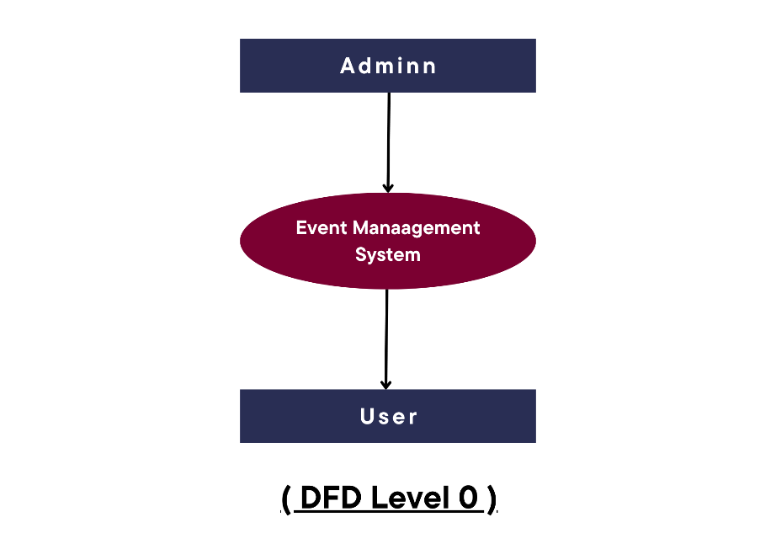

**( Fig No. 1 )**

* + 1. **DFD Level 1**:

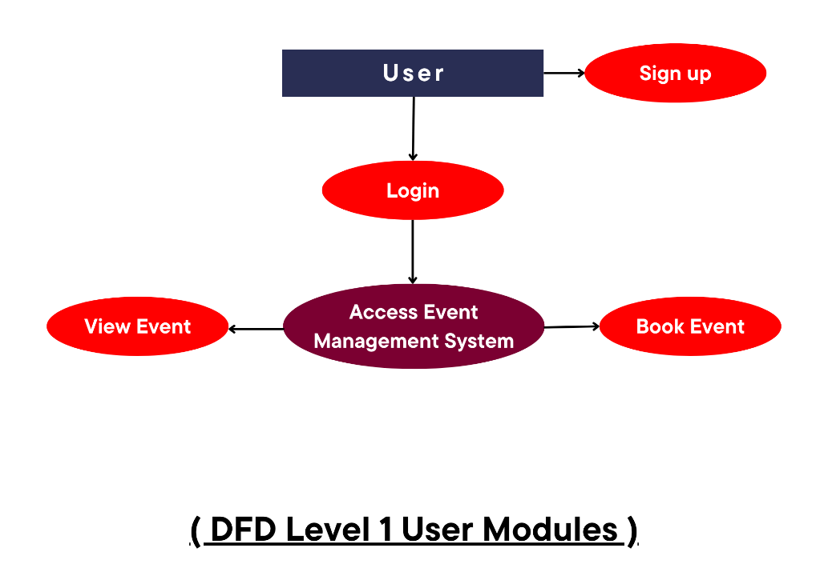

**( Fig No. 2 )**

* + 1. **DFD Level 2**:

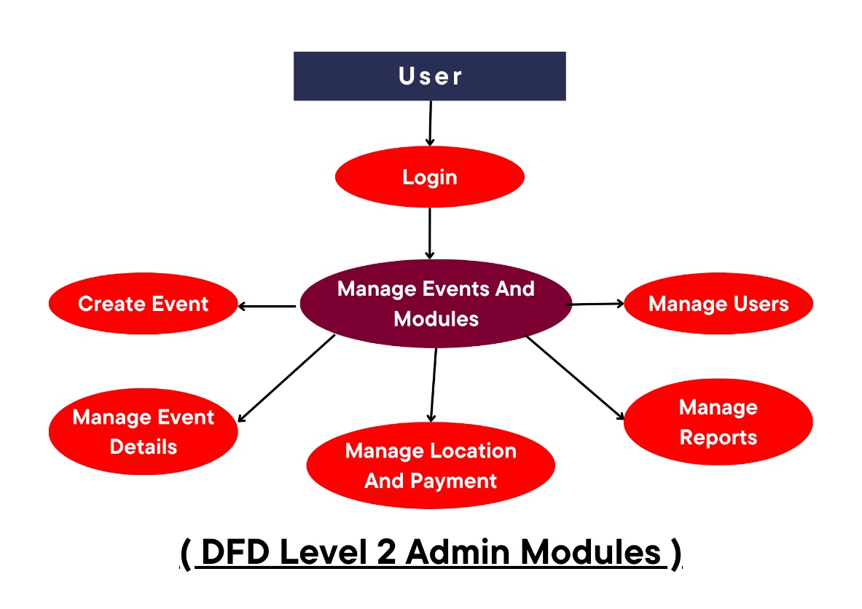

**( Fig No. 3 )**

* 1. **Entity-Relationship (ER) Diagram**

The ER diagram for **Event Management System** includes the following entities:

* **User**: Stores user information and roles.
* **Event**: Contains event details like name, date, and venue.
* **Registration**: Links users to the events they register for.

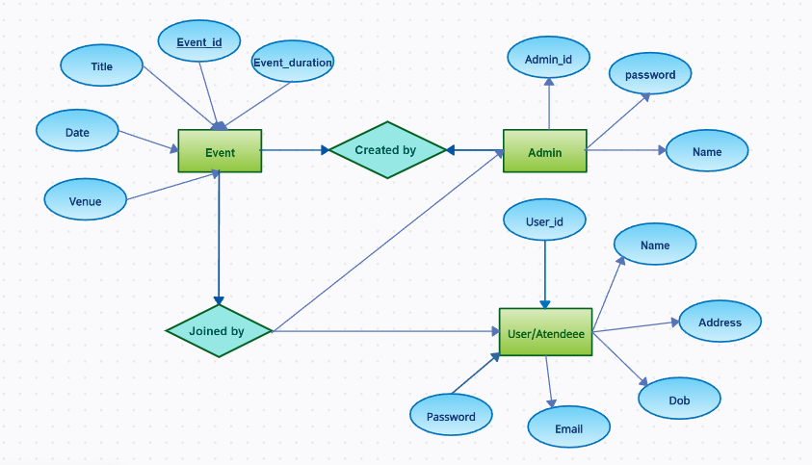

**( Fig No. 4 )**

**Project Outcome**

**Event Management System** delivers a comprehensive solution for event management by integrating advanced features and a user-centric design. The outcomes include:

* 1. **Improved User Experience:**
  + Users benefit from an intuitive interface that simplifies event discovery, registration, and payment processes.
  + The event catalog's search and filter functionalities enhance accessibility, making it easier for users to find events tailored to their preferences.
  + Real-time notifications and confirmations improve engagement and reduce confusion.

**6.2. Enhanced Admin Efficiency:**

* + Administrators gain access to a robust dashboard that consolidates event management tasks.
  + Features like event creation, user monitoring, and analytics reduce the time spent on manual operations and increase efficiency.
  + Tools to generate insightful reports on user behavior, registrations, and revenue empower admins to make data-driven decisions.

**6.3. Advanced Security Features:**

* + Role-based access control ensures a clear segregation of privileges, enhancing security and reducing unauthorized data access.
  + Data encryption safeguards sensitive information like user credentials and payment details.
  + Rigorous backend validations protect the platform from potential cyber threats such as SQL injection and cross-site scripting (XSS).
  1. **Scalability and Flexibility:**
  + The modular architecture of **Event Management System** allows seamless integration of new features like ticketing, advanced analytics, or third-party APIs.
  + The platform can easily adapt to handle larger user bases and more complex event requirements as the system scales.

**6.5. Data-Driven Insights:**

* + The system provides actionable analytics that help in understanding user preferences and improving event offerings.
  + Predictive insights can assist organizers in planning future events based on trends and engagement patterns.

**6.6. Reliable Performance:**

* + Thorough testing ensures that the platform performs consistently even under high user load, providing a seamless experience for users and administrators alike.
  + The deployment on scalable cloud servers ensures reliability and minimizes downtime.

These outcomes ensure that **Evenet Management System** is not only efficient but also scalable and user-friendly, meeting the needs of both users and administrators while laying the groundwork for future growth and enhancements.

1. **Home Page**:

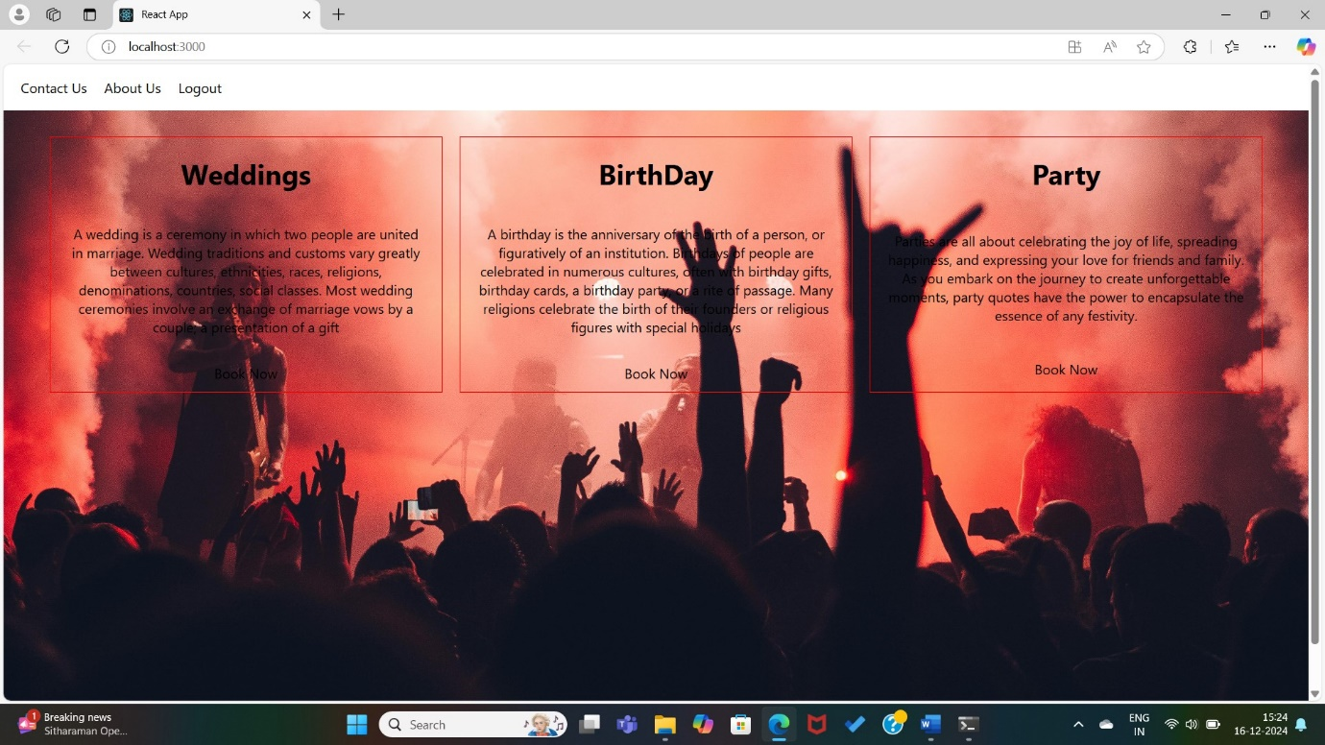

**( Fig No. 5 )**

1. **Signi in Page**:

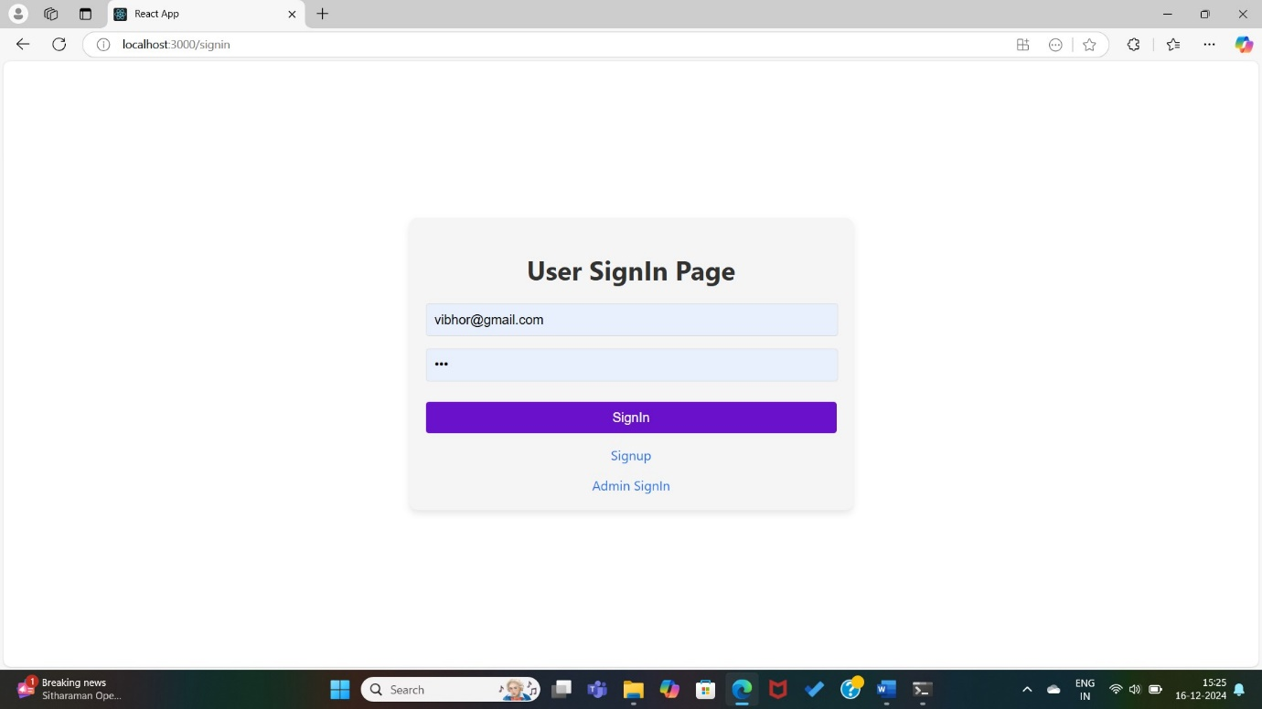

**( Fig No. 6 )**

1. **Create Event Page**:

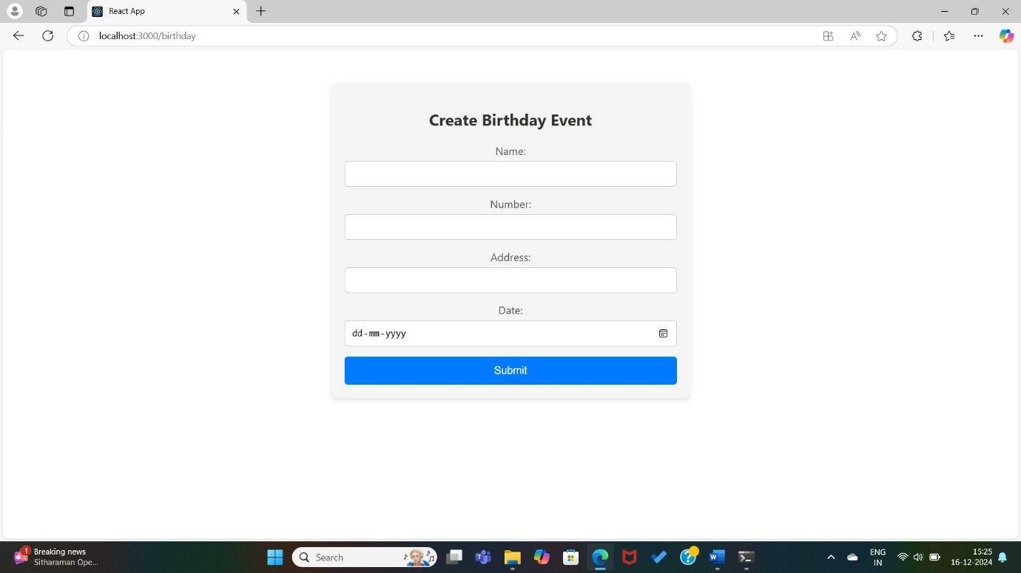

**( Fig No. 7 )**

1. **Event Catalog Page**:

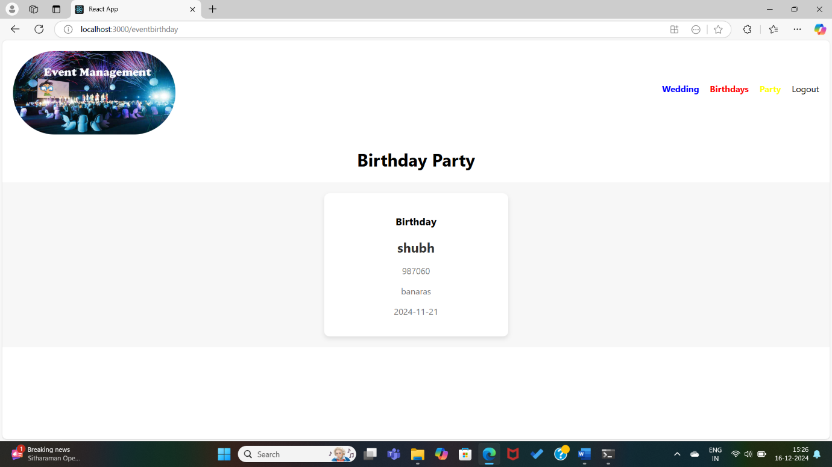

**( Fig No. 8 )**

**References**

* Spring Framework Documentation: <https://spring.io/>
* MySQL Documentation: https: [• //dev.mysql.com](•%09/dev.mysql.com)
* loper Network: https: <https://developer.mozilla.org/en-US/>
* Bootstrap Documentation: https: <https://getbootstrap.com/>