**HospitEX**

**A PROJECT REPORT**

**for**

**Mini Project (K24MCA18P)**

**Session (2024-25)**

**Submitted by**

**Pragya Tiwari**

**University Roll No. 202410116100144**

**Preksha Ruhela**

**University Roll No. 202410116100148**

**Submitted in partial fulfilment of the**

**Requirements for the Degree of**

**MASTER OF COMPUTER APPLICATION**

**Under the Supervision of**

**Ms. Divya Singhal**

**Assistant Professor**



**Submitted to**

**Department Of Computer Applications**

**KIET Group of Institutions, Ghaziabad**

**Uttar Pradesh-201206**

**(December 2024)**

**CERTIFICATE**

Certified that **Pragya Tiwari Roll No. 202410116100144, Preksha Ruhela Roll No. 202410116100148,** has / have carried out the project work having “**HospitEX**” (**Mini Project-1, K24MCA18P**) for **Master of Computer Application** from Dr. A.P.J. Abdul Kalam Technical University (AKTU**)** (formerly UPTU), Lucknow under my supervision. The project report embodies original work, and studies are carried out by the student himself/herself and the contents of the project report do not form the basis for the award of any other degree to the candidate or to anybody else from this or any other University/Institution.

**Pragya Tiwari**

**(University Roll No- 202410116100144)**

**Preksha Ruhela**

**(University Roll No- 202410116100148)**

This is to certify that the above statement made by the candidate is correct to the best of my knowledge.

**Date: 23/12/24**

**Ms. Divya Singhal Dr. Arun Kr. Tripathi**

**Assistant Professor Head**

**Department of Computer Applications Department of Computer Applications**

**KIET Group of Institutions, Ghaziabad KIET Group of Institutions, Ghaziabad**

# I

# ABSTRACT

HospitEX is an innovative healthcare management system designed to streamline hospital operations, improve patient care, and enhance administrative efficiency. The system focuses primarily on the patient module, enabling seamless management of patient data, appointment scheduling, medical records, and treatment plans. By digitizing key processes, HospitEX aims to reduce paperwork, minimize human errors, and enhance communication between patients and healthcare providers.

At its core, HospitEX allows patients to easily register, schedule appointments, access their medical records, view prescriptions, and receive lab results through a user-friendly platform. The system offers a modern approach to healthcare management, making it convenient for patients to track their health status and engage with healthcare providers digitally. Healthcare providers, on the other hand, can streamline their workflow, improving efficiency and enabling them to deliver better care.

HospitEX integrates multiple functionalities, such as automated appointment reminders, online prescriptions, patient history tracking, and lab test results, into a single platform. It ensures better coordination between healthcare providers, reducing the risk of medical errors and improving overall treatment outcomes. The system also enhances patient experience by providing timely notifications and personalized care plans, making healthcare more accessible and transparent.

The project focuses on creating a scalable, secure, and user-friendly platform that complies with healthcare data protection regulations like HIPAA and GDPR. By providing an intuitive interface and mobile compatibility, HospitEX ensures that both patients and healthcare providers can easily adopt and integrate the system into their daily routines.

In conclusion, HospitEX addresses key challenges in healthcare management, offering a comprehensive solution that improves both operational efficiency and patient care. With the potential for increased patient satisfaction, reduced operational costs, and enhanced healthcare delivery, HospitEX is poised to revolutionize the healthcare industry by fostering digital transformation in medical services.

II

**ACKNOWLEDGEMENT**

Success in life is never attained single-handedly. My deepest gratitude goes to my project supervisor, **Ms. Divya Singhal** for her guidance, help, and encouragement throughout my project work. Their enlightening ideas, comments, and suggestions.

Words are not enough to express my gratitude to Dr. Arun Kumar Tripathi, Professor and Dean, Department of Computer Applications, for his insightful comments and administrative help on various occasions.

Fortunately, I have many understanding friends, who have helped me a lot on many critical conditions.

Finally, my sincere thanks go to my family members and all those who have directly and indirectly provided me with moral support and other kind of help. Without their support, completion of this work would not have been possible in time. They keep my life filled with enjoyment and happiness.

**Pragya Tiwari**

**Preksha Ruhela**

III

# TABLE OF CONTENTS

|  |  |  |  |
| --- | --- | --- | --- |
| 1 | Introduction | | 1- 3 |
|  | 1.1 | Background | 1 |
|  | 1.2 | Objectives | 1 |
|  | 1.3 | Purpose, Scope and Applicability | 2 - 3 |
|  | 1.4 | Functional Requirements | 3 |
|  | 1.5 | Non - Functional Requirements | 3 - 4 |
| 2 | Feasibility Study | | 5 - 7 |
|  | 2.2 | Market Analysis | 5 |
|  | 2.2 | Technical Feasibility | 6 |

|  |  |  |
| --- | --- | --- |
| 3 | Requirement Analysis | 16 – 17 |
|  | 3.1 Problem Definition | 16 |
|  | 3.2 Requirement Specification | 16 -17 |
|  | 3.3 Planning and Scheduling | 17 |
|  | 3.4 Conceptual Methods | 18 |
| 4 | System Design | 40 - 45 |
|  | 4.1 Basic Modules | 43 |
|  | 4.2 User Interface Design | 44 |
| 5 | References | 46-47 |

**Chapter 1 Introduction**

## Background

HospitEX is an advanced healthcare management system designed to streamline operations, improve patient care, and enhance overall healthcare delivery. As the healthcare industry faces challenges such as fragmented patient records, inefficient administrative processes, and communication gaps, HospitEX offers a comprehensive solution to address these issues. The platform focuses primarily on the patient module, enabling seamless management of patient data, appointments, prescriptions, and medical records.

HospitEX aims to simplify healthcare services by offering patients the ability to register, schedule appointments, access their medical history, and receive prescriptions and lab results digitally. With a user-friendly interface and mobile compatibility, the platform ensures that patients can easily manage their healthcare needs from any location. This digital shift not only increases convenience for patients but also enhances patient engagement by providing timely updates and reminders.

For healthcare providers, HospitEX offers a solution that integrates key administrative functions such as appointment scheduling, patient data management, and prescription handling into a single platform. This reduces paperwork, minimizes the risk of errors, and improves operational efficiency. Medical professionals can access critical information in real-time, enabling them to make better-informed decisions and provide timely care.

By centralizing and automating processes, HospitEX reduces operational costs and improves the quality of care delivered. The system also adheres to strict security protocols to ensure compliance with healthcare regulations like HIPAA and GDPR. In essence, HospitEX is transforming healthcare management by offering a secure, efficient, and patient-centric solution that benefits both patients and healthcare providers.



Figure 1.1: The work of HospitEX

## Objectives

1. **Streamline Healthcare Management**:  
   To develop a comprehensive digital platform that simplifies and automates various healthcare management tasks such as appointment scheduling, patient data management, and prescription handling. This will reduce administrative workloads and improve operational efficiency in healthcare settings.
2. **Enhance Patient Engagement**:  
   To provide patients with easy access to their medical records, appointment schedules, prescriptions, and lab results, empowering them to take an active role in managing their healthcare. The system aims to improve patient satisfaction by offering a user-friendly interface and mobile compatibility.
3. **Improve Communication Between Healthcare Providers and Patients**:  
   To create a seamless communication channel between healthcare providers and patients, enabling faster and more efficient exchanges of information. This includes notifications for appointments, medication reminders, and updates on medical test results.
4. **Reduce Medical Errors**:  
   To minimize the risk of errors by providing healthcare providers with real-time access to accurate patient information, including medical history, prescriptions, and test results. This helps doctors make better-informed decisions, leading to improved patient outcomes.
5. **Ensure Compliance with Healthcare Regulations**:  
   To design the platform in adherence to healthcare data privacy and security regulations like HIPAA and GDPR, ensuring that patient data is protected and the system complies with relevant industry standards.
6. **Boost Healthcare Efficiency and Productivity**:  
   To optimize the use of resources in healthcare facilities by automating routine administrative tasks, reducing paperwork, and improving workflow management, thus allowing medical staff to focus more on patient care.
7. **Foster Digital Transformation in Healthcare**:  
   To drive the adoption of digital tools and technologies in healthcare, modernizing traditional healthcare systems and promoting the use of electronic health records (EHR) for better service delivery.

## Purpose, Scope and Applicability

### Purpose

The primary purpose of **HospitEX** is to streamline healthcare management by providing a digital platform that simplifies administrative processes and improves patient care. The system is designed to reduce manual paperwork, enhance communication between patients and healthcare providers, and offer seamless access to critical health information. By automating tasks such as appointment scheduling, medical record management, and prescription handling, HospitEX ensures that healthcare providers can focus more on patient care while patients gain better control over their health journey. The platform is aimed at enhancing operational efficiency, reducing medical errors, and improving the overall healthcare experience for both patients and medical staff.

### Scope

The scope of **HospitEX** is focused on managing patient-centric healthcare processes. The platform is designed to serve hospitals, clinics, and other healthcare institutions by centralizing essential functions such as patient registration, appointment booking, medical history management, prescriptions, and lab results. The system will also facilitate notifications for upcoming appointments, prescription refills, and test results, providing patients with timely reminders. By integrating these services, Hospitex reduces administrative workload, enhances data accessibility, and helps healthcare professionals make more informed decisions. Additionally, the system adheres to stringent healthcare data protection regulations, ensuring compliance with standards like HIPAA and GDPR to guarantee data privacy and security.

### Applicability

HospitEX is applicable to a wide range of healthcare settings, including hospitals, private clinics, outpatient care centers, and specialized medical practices. Its user-friendly design allows easy adoption by both healthcare providers and patients, making it adaptable to different types of healthcare institutions, regardless of size. The system’s mobile compatibility ensures that patients can access their healthcare data and communicate with their providers from anywhere, at any time. By digitizing healthcare processes, HospitEX fosters greater efficiency, improves patient engagement, and supports the broader goal of digital transformation in the healthcare sector. It is particularly beneficial for institutions looking to enhance operational efficiency, reduce costs, and improve the overall quality of care provided to patients.

**Chapter 2**

**Feasibility Study**

## ****2.1 Market Analysis****

### ****2.1.1 Industry Insights****

The healthcare industry is rapidly adopting digital solutions, with a projected CAGR of over 15% for healthcare IT from 2023 to 2030. Trends such as electronic health records (EHR), telemedicine, and patient-centric care drive demand for streamlined healthcare management systems like HospitEX. The industry prioritizes improving operational efficiency, enhancing patient experiences, and ensuring compliance with data protection regulations.

### ****2.1.2 Target Audience****

* **Hospitals and Clinics** seeking to digitize operations and reduce administrative workloads.
* **Healthcare Providers** who need efficient tools for managing patient data and workflows.
* **Patients** looking for convenient ways to manage appointments, access records, and receive updates.
* **Specialized Practices** requiring tailored solutions for specific medical fields.

### ****Competitive Landscape****

The market features established players like Epic Systems and Cerner, focusing on large-scale institutions, leaving smaller clinics underserved. HospitEX differentiates itself with a patient-centric, user-friendly approach, mobile compatibility, and scalability. By addressing the needs of smaller institutions and emphasizing ease of use, HospitEX offers a competitive edge in a fragmented market. HospitEX positions itself as an accessible and efficient solution, aligning with industry trends and filling gaps in existing offerings.

## ****2.2 Technical Feasibility****

HospitEX is technically feasible, leveraging modern technologies like Node.js for a robust backend, React.js for a responsive interface, and cloud platforms like AWS for secure, scalable hosting. It integrates seamlessly with existing systems like EHR through APIs and ensures data security with encryption and compliance with HIPAA/GDPR. The modular architecture allows for easy updates and future scalability, making HospitEX a reliable and adaptable solution for modern healthcare needs.

**Chapter 3**

**Requirement Analysis**

## Problem Definition

The healthcare industry faces significant challenges in managing patient data, streamlining communication, and ensuring efficient delivery of services. Traditional methods of handling healthcare processes often involve fragmented systems, manual paperwork, and inefficient communication channels, leading to delays, errors, and reduced quality of care. Patients frequently encounter difficulties in accessing their medical records, scheduling appointments, and receiving timely updates on their health, creating frustration and disengagement.

For healthcare providers, the lack of a centralized platform to manage patient information and appointments results in administrative inefficiencies and increased workloads. These inefficiencies often lead to mismanagement of patient data, missed follow-ups, and potential medical errors. Moreover, the absence of digital solutions makes it harder for healthcare institutions to maintain compliance with data protection regulations like HIPAA and GDPR, putting sensitive patient information at risk.

In addition, the growing demand for patient-centric care and real-time access to health information remains unmet in many healthcare settings. Patients today expect seamless digital solutions to manage their health needs, but the lack of a user-friendly, integrated platform limits their ability to take an active role in their healthcare.

HospitEX addresses these problems by providing a centralized, secure, and user-friendly healthcare management system. It simplifies the process for patients to access their records, schedule appointments, and receive updates. For healthcare providers, it offers an efficient way to manage workflows, reduce errors, and enhance the quality of care. By digitizing and integrating healthcare processes, HospitEX aims to solve these critical issues, improving patient outcomes and operational efficiency in healthcare institutions.

## Requirements Specification

### Existing System

In many parts of our country people cannot find mechanics around them because of several reasons. To illustrate, sometimes people may not be in their own registration region and due to this fact, they are not able to find mechanics or are not able to contact them. In the present system there is no such application level system provisions in the country to find mechanics and procedure as a whole. Also, in the present status, there is no such application in use for online mechanics help and getting problems solved very easily and effectively structure existing in the country. All the step by step procedures are carried out by the registered mechanics and also when their details are provided with the correct information and job that they do. The fact is all the procedures are carried out manually, starting from the registration process to result of booking.

If this process is done manually it wastes a lot of time and money. Thus, the present system proves itself to be an inefficient one. The existing system is not web based. The user or person must register themselves and then book the mechanic as per their needs and use.

### Proposed System

The design of any online mechanics helping system, whether electronic or manual, must satisfy several sometimes-competing criteria including a high degree of security and accuracy, eligibility and authentication, integrity, verifiability and auditability, reliability, flexibility, performance and scalability.

As India is moving towards the Digital India and the conventional findings of the mechanics is very difficult for new people to adjust with this if any problems occur. The new implemented website protocol has two main players: The customer and the administrator sections. The customer (which can be found at home, in a working station, or any other device have the function of booking). The administrator performs the function of mechanics registration, validation of customer, database and booking the service.

The main advantages of the new protocol are the following:

1. Customer finds it easy as they need not to find them anywhere else.
2. Inured to manual troubles like mechanics not available or he his on holiday.
3. Possibility of configuration for different bookings of the services at a particular time.

Furthermore, it is assumed that a trustworthy Administrator is available. Apart from that, the accessibility to the customer in booking the procedure plays a special role, which means that the booking result can be monitored and mechanics gets the work to go that to that house and do his work. Accessibility to the customer is necessary for all booking stages.

The system is to cater for the following generic requirements:

1. *Privacy:* After customer login with username and password their login-info should not get revealed or else there are chance of getting their account hacked.
2. *Accuracy:* Customer should book only what kind of service is been needed. They shouldn’t book the services which is not in their use.
3. *Security*: Throughout the booking process, once the slot is booked they cannot book the same service at same particular point of time again.
4. *Democracy*: All customers can book their particular services. One person can book multiple services if needed.
5. *Verifiability*: Customers as well as mechanics both can verify the services. Customer can verify whether service is booked or not and mechanics can verify where he has to go, whose house he has to visit.

The system-specific requirements of the framework allow:

1. *Multi-user:* Several customers can book services simultaneously.
2. *Availability*: Whether the mechanic is available or not.

## Planning and Scheduling

### Functional Requirements

The functional requirements of **HospitEX** are designed to provide a comprehensive, secure, and user-friendly healthcare management system that caters to both patients and healthcare providers. The platform ensures streamlined workflows, better data management, and enhanced communication, addressing the core challenges faced in traditional healthcare settings. Below are the key functional requirements of **HospitEX**:

* **Patient Registration and Authentication**: A secure system for patients to register and log in, ensuring personalized access to their healthcare information.
* **Appointment Management**: Features for booking, rescheduling, and cancelling. appointments, coupled with reminders and notifications to reduce no-shows.
* **Medical Records Management**: Centralized storage for patient histories, prescriptions, and test results, accessible to both patients and doctors.
* **Real-Time Communication**: A secure communication channel for follow-ups and consultations between patients and doctors.
* **Scalability**: Designed to support additional features like telemedicine and insurance claims in the future.

### Non - Functional Requirements

The non-functional requirements of **HospitEX** ensure that the system operates efficiently, securely, and reliably while delivering a seamless user experience. These requirements focus on performance, security, usability, and scalability, making HospitEX a robust and adaptable healthcare management solution. Below are the key non-functional requirements:

* **Performance**: The system should support concurrent access by multiple users without performance degradation, ensuring quick response times for all actions, such as loading medical records or scheduling appointments.
* **Scalability**: HospitEX must be scalable to accommodate growing numbers of users, healthcare providers, and additional features like telemedicine or insurance claim processing.
* **Usability**: The interface should be intuitive and user-friendly, enabling patients and healthcare providers to navigate the system easily without extensive training.
* **Maintainability**: The system should be designed for easy maintenance, allowing for quick updates, bug fixes, and the addition of new features.

### Software and Hardware Requirements

### Hardware Requirements

1. Processor: Intel Pentium IV and above
2. RAM: 1GB or more
3. Hard disk 250 GB and more

### Software Requirements

1. Operating System:
   1. Microsoft Windows
   2. Smart Phone: 2 GB RAM and 8 GB
2. Front End:
   1. JS, CSS, HTML.
3. Back End:
   1. MySQL
   2. PHP
   3. **Conceptual Models**

### Entity-Relationship Diagram

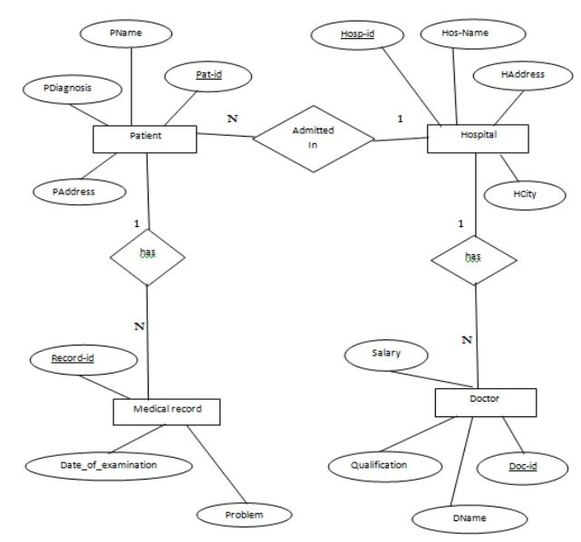

Figure 3.4.1: E-R Model of the project

### ENTITIES:

### Patient:

### Attributes: patientID (Primary Key), name, gender, dateOfBirth, contactDetails

### Doctor:

### Attributes: doctorID (Primary Key), name, specialization, contactDetails

### Appointment:

### Attributes: appointmentID (Primary Key), patientID (Foreign Key), doctorID (Foreign Key), appointmentDate, appointmentTime.

### Medical Record:

### Attributes: recordID (Primary Key), patientID (Foreign Key), doctorID (Foreign Key), diagnosis, medications, treatment

### RELATIONSHIPS:

### Patient ↔ Hospital: A patient is admitted to one hospital (1:N relationship).

### Hospital ↔ Doctor: A hospital employs multiple doctors (1:N relationship).

### Doctor ↔ Patient: A doctor treats multiple patients, and a patient can consult multiple doctors (N:M relationship).

### Patient ↔ Medical Record: A patient can have multiple medical records (1:N relationship).

### Doctor ↔ Medical Record: A medical record is associated with one doctor (1:1 relationship).

### 3.4.2 Data Flow Diagram

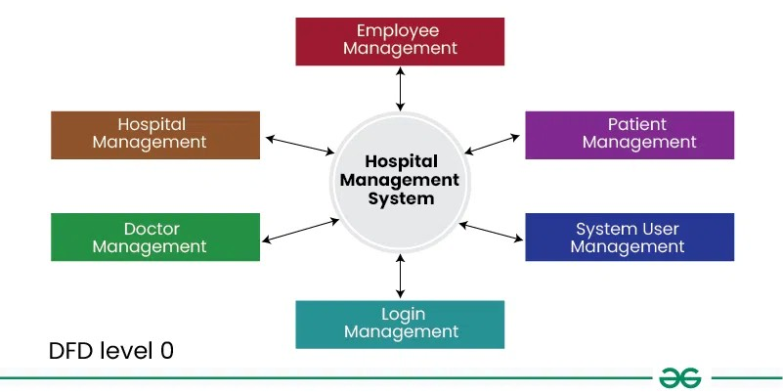

Figure 3.4.2: Data Flow Diagram Level 0

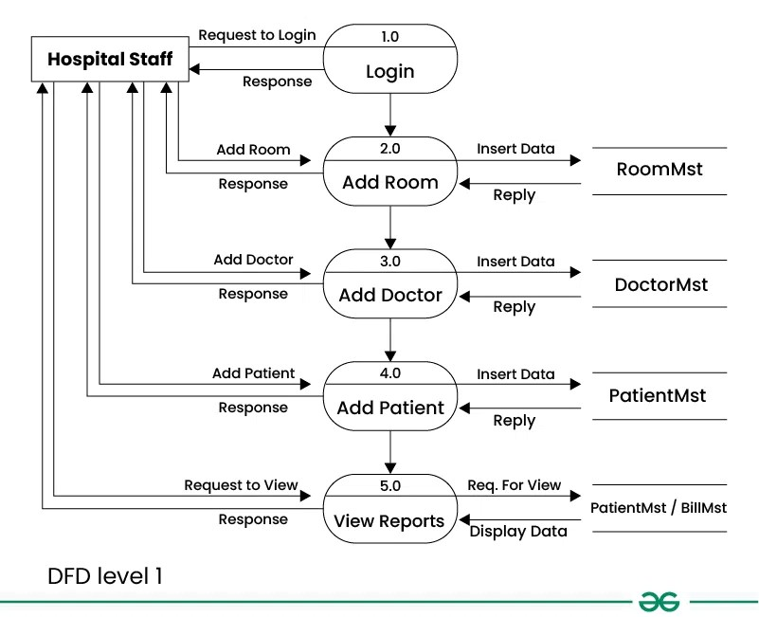

Figure 3.4.3: Data Flow Diagram Level 1

**3.4.3** **Use Case Diagram**

### 

### 

Figure 3.4.4: Use Case Diagram

**Chapter 4**

**System Design**

## Basic Modules

***Patient Module***

The **Patient Module** is responsible for managing the information related to patients, such as their personal details, medical history, treatment plans, and current health status. It is a critical part of the system as it stores and processes all patient-related data.

**Features:**

* + - * 1. **Patient Registration:** Allows new patients to register in the system by providing personal information (e.g., name, age, gender, contact details).
        2. **Patient Profile Management:** Patients can update their personal details, medical history, allergies, and other relevant information.
        3. **Medical Records:** The system can store and manage the patient’s past and current medical records, diagnoses, treatments, and test results.
        4. **Health Tracking:** Allows tracking of vital signs, medication adherence, and other health-related metrics over time.

**Functions:**

* + - * 1. **Add/Update Patient Info:** For healthcare staff to add or modify patient data.
        2. **View Patient History:** For doctors and healthcare professionals to access the patient’s medical history.
        3. **Record Diagnosis & Treatment:** Doctors can record their diagnoses and the corresponding treatments.

***Registration Module***

The **Registration Module** is responsible for managing the registration process for both patients and healthcare staff (like doctors, nurses, etc.). It ensures that all essential information is captured and stored in the system.

**Features:**

* 1. **New Patient Registration:** Patients can register themselves either through the hospital's website or in-person at the registration desk.
  2. **Staff Registration:** Healthcare staff such as doctors, nurses, and admin staff can be registered and assigned roles within the system.
  3. **Assigning Unique IDs:** Once registered, both patients and staff are given unique IDs that are used throughout the system to identify them.
  4. **Verification Process:** The system may require verification of patient or staff information, like age, address, and qualifications.

**Functions:**

1. **Register New Patient/Staff:** Collect essential details and assign a unique identification number.
2. **Edit Registration Details:** Update or modify personal information for patients or staff members.
3. **Delete or Deactivate Registration:** Allow admins to remove or deactivate user accounts if necessary.

***Login Module***

The Login Module is used for authentication and access control. It ensures that only authorized users (patients, doctors, staff) can access the system.

**Features:**

* 1. **Authentication:** Users are required to enter a username and password to log in to the system.
  2. **Role-Based Access Control (RBAC**): Different users (patients, doctors, staff) have different access levels based on their roles. For example, a patient can view their records but not modify them, while a doctor can add notes.
  3. **Password Management:** Users can reset or change their passwords if they forget them or wish to update them for security reasons.

**Functions:**

* 1. **User Login:** Allow patients, doctors, and staff to access the system by entering credentials.
  2. **Password Reset/Change: Enable users to reset their passwords through email or other methods.**
  3. **Access Control:** Restrict access to sensitive data based on user roles (admin, doctor, patient).

## User Interface Design

### Home Page

### 

### 

### Figure 4.4.1: Home Page

### Why Choose US Page

### 

### 

### Figure 4.4.2: Why Choose US of the System

### Our Services Page



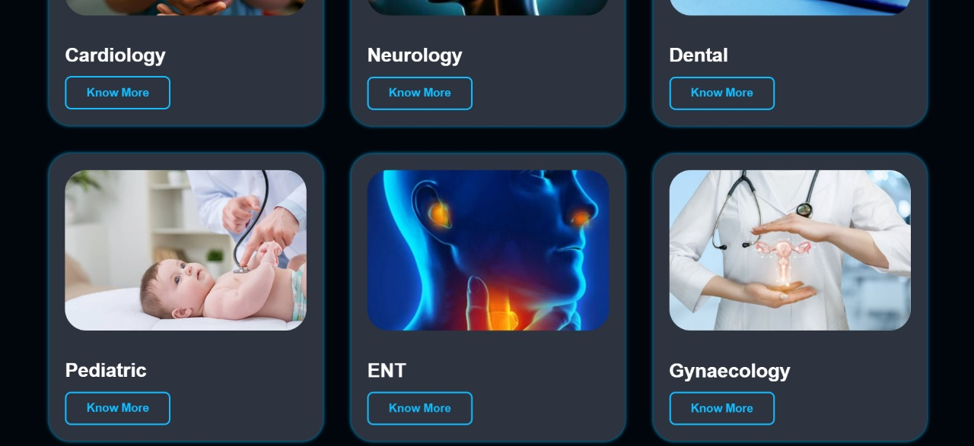

### Figure 4.4.3: Our Services of the System

### Make Appointment Page

### 

### Figure 4.4.4: Make Appointment of the System

### Patient Login Page

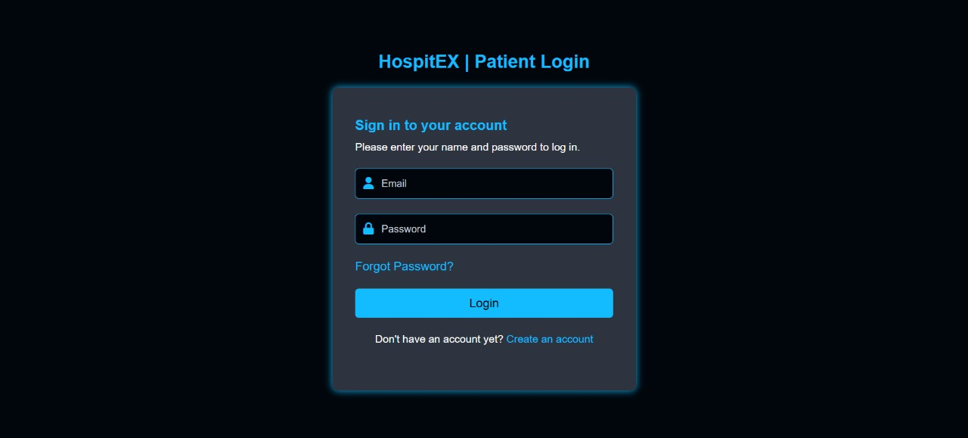

Figure 4.4.3: Patient Login Page

### 4.1.6 Patient Registration Page

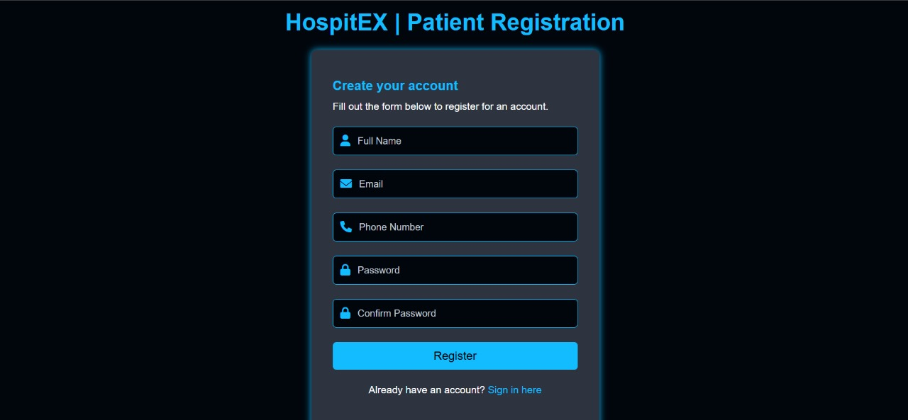

Figure 4.4.3: Patient Registration Page

### Dashboard Page

### 

Figure 4.4.3: Dashboard Page

### 5. References

**Books:**

1. Pressman, R. S., & Maxim, B. R. (2014). *Software Engineering: A Practitioner's Approach* (8th ed.). McGraw-Hill Education.
2. Sommerville, I. (2015). *Software Engineering* (10th ed.). Pearson Education.
3. Laudon, K. C., & Laudon, J. P. (2020). *Management Information Systems: Managing the Digital Firm* (16th ed.). Pearson Education.

**Websites:**

1. GeeksforGeeks. *Introduction to Hospital Management System.* Retrieved from <https://www.geeksforgeeks.org>