1. ***Brief snapshot of the features that will be implementing in this app.***

**Web App** with **.Net 8, Entity Framework and Angular 17 and 18.** This is an example of a Developers Connecting app, a social kind of app which has features common to many different types of apps, such as registration and login, we will use **ASP.Net identity** to do that.

Also got **live presence**, so users will be able to see who else is online, **at the same time.**

We can like other users as well, and there's an area where **users can view the list of members that they like and who like them.** We'll have the ability **to edit a profile** and persist those changes to our **back-end database**, which is going to **be our API and using Entity Framework.**

There is also **a system for uploading a photo**, so users can upload their own photos. They can **switch the photo** **and it updates** everywhere in our app.

Also, a **messaging system** so users can message other users and **this is live**. So, if a user is connected somewhere else in the world, then they'll be able to see this message coming in and **there'll be live chats** between two different users.

Also, implementing **pagination** with **caching**, so, we can instantly go to other user’s profiles and it remembers what we've done and if they go to a different page and reset the filters, then we see all of this in place.

1. ***Technical features***

Using **dotnet** (was dotnet core). That is going to form the **back-end of the application** the **API**. Also adding **angular** **framework** to provide the **client-side,** and build a single page application. Display the user interface to the client. Also going to use **Entity Framework** that provide us with the **ability to query our database**. To build this app, we'll be using **HTML bootstrap to provide the styling framework** and by adding a touch of CSS.

*Hint\** it is useful to have the NVM (node version manager), for choosing between deferent node.js versions and not need to uninstall and reinstall.

1. ***Simple walking skeleton***

We're going to **have some data in a database,** then **create an API project** that's going to **fetch the data out of that database,** also **create an angular project** that's going to **query our API and receive the data from our API that comes from our database**, and then we're going to **display it in the client's browser**. It will be really simple initially and then it will add complexity.

* First, implement the **basic API functionality** and have an introductory understanding of using the **dotnet command line interface (CLI)**. A command line interface that we can use to do various things with dotnet.
* **API controllers and endpoints**, and understand the structure of an API controller.
* **Entity Framework**
* We're going to take a look at **the API project structure**. What involves in a .Net project, how our application starts up.
* The **configuration and environment variables** that it uses inside our application.
* Then **commit the code into source control**, which allows us to take effectively a backup of our code and it also contains a version history of the code as well.

In the cmd id we run *dotnet –info* then we will see all the different SDKs we have installed on our computer. When we create the project from the CLI it automatically creates it by using the latest SDK. But if I want to use an older one I need to create this *global.json* as we see below:

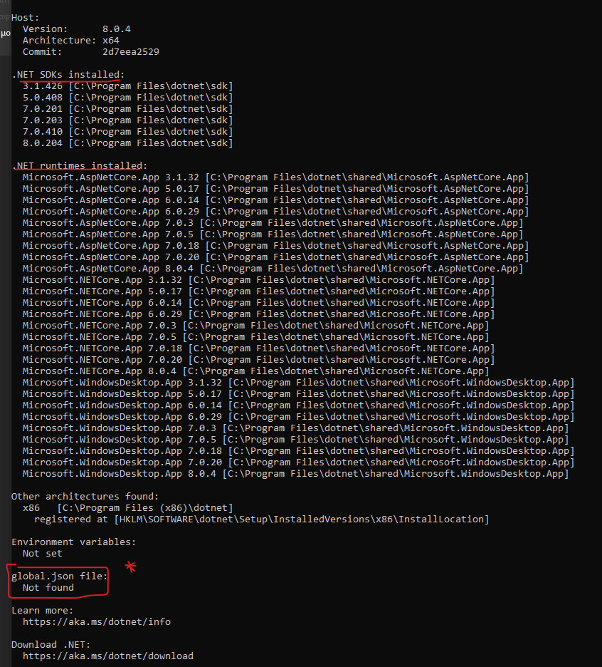

Also, we have the list of all the runtimes installed.

Useful CLI commands:

* dotnet -h: for help, where it lists all available commands
* add, new, sln are the most common commands.

For our case the steps are:

Type *mkdir ProfessionalsConnectApp* -> *cd ProfessionalsConnectApp -> dotnet new sln -> dotnet new webapi -h* (for help to see what it includes) ->

**

We are going to use this option.

*-> dotnet new webapi -controllers -n API*, so this will create a folder with the name API and inside

-> *dotnet sln list,* we see there are no projects found so we need to add it.

*-> dotnet sln add API,* and the result

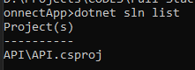

When we open the project and run the server `***dotnet run***`, it says that **listens to a port**, and how the CLI command knows to listen to this port? In the properties folder the ***launchSettings.json***file where we got a number of **different settings and profiles** of what's going to happen when the application starts. The first one in the list is typically the default one.

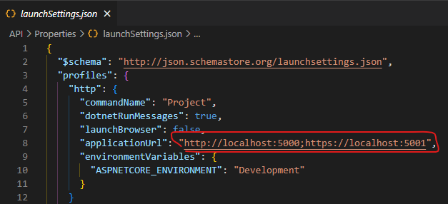

That's the reason my application started on that particular URL. And it started in **development mode** because that's the setting contained in **this environment variables section.**  In this project we will use postman instead of swagger.

When we **installed the .Net SDK is that dot net has added a self-signed certificate** so that it's **trusted by our browser when we use this URL**, and let’s restart the server. We can see it's running on these two URLs that I've specified there.

**An important file is the Program.cs class**. This is our main entry point for our application. When we run the .net run command this is where it looks into and here is **the App.run method. Then this executes and effectively runs our application.** Inside this program class the first area is the **services area,** where we **register any service** that our application needs inside this part of the file, **then the application is getting built**, and then is the section to **configure the HTTP request pipeline**. The stuff that's contained in the **HTTP request pipeline** is considered middleware and we can put things inside here that allow us to do something with the HTTP request on its way into our API service or on its way out of our API service.

So, if we wanted to check if a user is authorized to access an API endpoint, then we've got middleware such as use authorization or if we wanted to redirect them, then we could use the Https redirection middleware contained.

If we click on API (API.csproj), then this our project file contains the target framework that I'm using.

The API.http file is just another way of testing an API endpoint in Visual Studio 2022.

Some configuration files are the appsettings.Development.json for developer mode and Appsettings.json, which is used whatever mode we're running our application in.