ÉSTIAM — 3EADOTN
Modern Enterprise Software Engineering
Project Brief: CloudExpense Deployment Challenge

1. Presentation & Framework
Fictitious company: Nimbus Expensing Ltd., a fast-growing startup that has built a personal expense-tracking application for its staff — "ExpenseTrack". Employees log day-to-day expenses (groceries, entertainment, restaurants, and similar categories) and can optionally attach a photo of the receipt for their records.
Nimbus's development team has already written the full application — both the API and the user interface. What Nimbus does not have yet is production infrastructure to run it on. You have been hired as their cloud engineer: your job is not to write or change a single line of application code, but to design, provision, and secure the Azure infrastructure that this given application will run on, deploy it, and prove — live, to Nimbus's management — that it works and is being monitored.
Goal: stand up a secure, observable, working deployment of the provided ExpenseTrack application on your own Azure subscription, and defend your infrastructure choices in a live presentation.

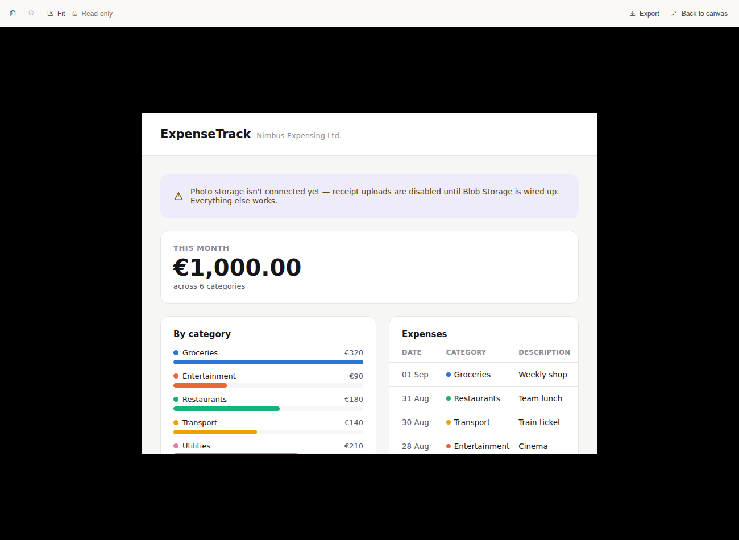

2. What you are given vs. what you must build
- Given to you (no changes required or expected): the complete ExpenseTrack API and UI source code, ready to build and deploy.
- Your deliverable: the infrastructure — resource provisioning, security configuration, monitoring, and a working deployment of the given code onto that infrastructure.
- Receipt photo upload is optional for any single expense record (a student demo does not need every entry to have a photo), but the Blob Storage capability behind it is mandatory infrastructure — it must be provisioned and working.

3. Data Model & Technical Specification
The application code is identical for every student, so every student's infrastructure must match this specification exactly — this is what the given code expects to find. There is no end-user login: the app is single-tenant ("my expenses"), secured at the infrastructure level (Managed Identity, RBAC, Key Vault) rather than with per-user accounts.

3.1 Expense item (Cosmos DB)
Field | Type | Notes
id | string (GUID) | Cosmos DB item id, generated by the API on create.
category | string, fixed list | One of: Groceries, Entertainment, Restaurants, Transport, Utilities, Other. This is also the Cosmos DB partition key value.
description | string | Free-text description of the expense (e.g. "Weekly shop").
amount | decimal | Expense amount.
currency | string | Fixed to "EUR" for every deployment.
date | date | Date the expense was incurred (not the record creation date).
receiptPhotoUrl | string, nullable | Blob Storage URL of the receipt photo. Null/empty when no photo was attached — optional per record.
createdAt | datetime | Record creation timestamp, set by the API.

- Cosmos DB database name: ExpenseTrackerDb
- Container name: Expenses
- Partition key: /category — mirrors the pattern used in the module demos (catalog-api's /genre).

3.2 Receipt photos (Blob Storage)
- Blob container name: receipts
- One photo per expense, named by the expense's id (e.g. <id>.jpg).
- Attaching a photo is optional per expense record; the container and upload path must still exist and work regardless of how many records use it.

3.3 Resource Naming Convention
Use these exact resource names and types — they match what the manuals from Modules 1-5 already walked you through, and the two application components go on the same Azure services as their module counterparts (catalog-ui on App Service, catalog-api on Container Apps), so the same commands apply here.
Component | Azure Resource | Plan / SKU | Naming Pattern
expenses-ui | App Service (Web App) | Linux, B1 App Service Plan | webapp-expenses-<your_suffix> *
expenses-api | Container App | Consumption, in a Container Apps Environment | app-expenses-<your_suffix>
(shared) Registry | Azure Container Registry | Basic SKU | acrexpenses<your_suffix> *
(shared) Resource Group | Resource Group | — | rg-expenses-<your_suffix>
(shared) Env. | Container Apps Environment | — | env-expenses-<your_suffix>
Database | Cosmos DB Account (Core/SQL API) | Manual throughput, 400 RU/s | cosmos-expenses-<your_suffix> *
Receipt storage | Storage Account | Standard_LRS | stexpenses<your_suffix> * (no hyphens, ≤24 chars)
Secrets | Key Vault | RBAC authorization mode | kv-expenses-<your_suffix> *
Monitoring | Application Insights + dedicated Log Analytics workspace | Workspace-based | appi-expenses-<your_suffix> / law-expenses-appi-<your_suffix>
API gateway | API Management | Consumption tier | apim-expenses-<your_suffix> *

- <your_suffix> is fixed by a rule, not freely chosen: the first two letters of your surname, followed by the first letter of your first name — all lowercase, no accents or spaces. Example: Marie Dupont → "dum". Use the exact same suffix in every resource name so it's obvious in the Azure Portal, and during the soutenance, which resources are yours.
- An asterisk (*) marks a globally-unique name (it becomes part of a public DNS name) — if Azure rejects a name built from your suffix as already taken, append a digit (e.g. "dum2") and keep using that adjusted suffix everywhere for that resource.
- Resource Group and Container Apps Environment names only need to be unique within your own subscription, not globally.

4. Deliverables
Each deliverable below is assessed independently as part of the project barème in Section 5.
- D1 — Core resources: Resource Group, Cosmos DB, Blob Storage, and a hosting compute service for the app (e.g. Azure Container Apps or App Service), matching the names in Section 3.
- D2 — API Management: the API is exposed through Azure API Management, not called directly.
- D3 — Security: Managed Identity, RBAC, and Key Vault used throughout — no secrets or connection strings hard-coded or pasted into configuration.
- D4 — Working deployment: the given application actually runs, end to end, on your infrastructure.
- D5 — Monitoring: Application Insights instrumented and showing real telemetry.
- D6 — Architecture documentation: a short diagram and written explanation of what you built and why.
- D7 — Soutenance: a live defense of the above (Section 5).

5. Project Barème — /20
Criterion | Points | What is assessed
Core resources provisioned | 5 | Resource Group, Cosmos DB account/database/container, Blob Storage account/container — created, correctly configured, and reachable by the deployed app.
API exposure via API Management | 2 | An Azure API Management instance fronts the API (import/route configured, subscription key required) rather than the API being called directly.
Security configuration | 4 | Managed Identity used for service-to-service access, RBAC role assignments in place, secrets/connection strings held in Key Vault — nothing sensitive hard-coded or pasted into app configuration.
End-to-end working deployment | 4 | The provided application (API + UI) runs on the student's infrastructure and is fully usable: log an expense, optionally attach a receipt photo (stored in Blob Storage), list past expenses.
Monitoring & observability | 3 | Application Insights is wired into the deployed app and shows real, live telemetry (requests, dependencies) — not just provisioned and empty.
Architecture documentation | 2 | A short written record (diagram + brief explanation) of what was provisioned, why, and how the pieces connect — submitted alongside the rest via Teams.
Total — Project | 20

6. Soutenance (Live Defense) — /20
The soutenance is a live video call (Microsoft Teams) — not a recorded submission. At the start of your call you will be asked to show a valid photo ID on camera for identity verification, per ÉSTIAM's assessment rules.
You will present as if to Nimbus's management: a professional walkthrough of what you built and why, followed by questions. The running order and time slots will be communicated to you in advance of Day 3.
Criterion | Points | What is assessed
Live demo & walkthrough | 6 | Student shares their screen and shows: the provisioned resources in the Azure Portal, the app working end-to-end, and live telemetry in Application Insights.
Technical explanation | 5 | Student explains the choices behind the infrastructure — why these resources, how the security model works, how API Management is configured — in their own words.
Questions & depth of understanding | 4 | Student answers the trainer's follow-up questions convincingly, showing they understand what they built rather than having memorized steps.
Communication & delivery | 3 | Clear, structured, professional delivery — as if presenting to a client or manager, not just a class exercise. Keeps to time.
Visual support | 2 | A short set of slides or a diagram is used to support the walkthrough (not read from, used as backing).
Total — Soutenance | 20

7. Submission & Logistics
- Submissions are individual — this is not a group project.
- Submit via the Microsoft Teams "Assignments" (Devoirs) feature in the class's Général channel. Emailed submissions are not accepted.
- Include your architecture documentation (D6) and any supporting screenshots as part of your Teams submission.
- Provision your infrastructure on your own Azure for Students subscription.
- Remember to delete or pause resources you are not actively demoing, to conserve your Azure credit.
- Grading combines: Contrôle continu (participation + in-course exercises — assessed separately, see Section 8), the Project barème (Section 5), and the Soutenance barème (Section 6).
- Remediation: any student scoring below 10/20 on this module will be offered a second project subject (rattrapage), per ÉSTIAM policy.

8. Timing
Project kickoff: Day 2, afternoon session. Project work time: Day 3, morning session. Soutenance: Day 3, afternoon session (assessment block).
Contrôle continu (participation and in-course exercise grades) is recorded separately across all three days and is not part of the barèmes above.

