**TP 1 :**

L1 = {abb, b, a} L2 = {ba, baa, a}

1. L1 ⋃ L2 = { abb, b, a, ba, baa, a}

L2 ⋂ L2 = {a}

L1.L2 = {abbba, abbbaa, abba, bba, bbaa, ba, aba, abaa, aa}

L2.L1 = {baabb, bab, baa, baaabb, baab, baaa, aabb, ab, aa}

(L1.L2) ⋂ (L2.L1) = {aa}

(L1)0 = {e}

(L2)2 = {baba, babaa, baa, baaba, baabaa, baaa, aba, abaa, aa}

L1 ⋂ L2 = X*\L1 ⋂ L2

= L2 ⋂ X*\L1

= L2\L1

= {ba, baa}

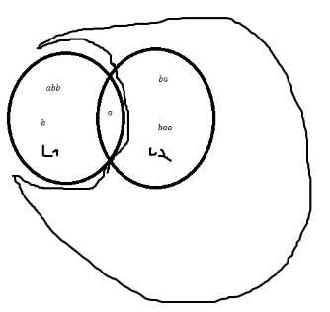

(L1 ⋃ L2)2= { abbabb, abbb, abba, abbba, abbbaa,

babb, bb, ba, bba, bbaa,

aabb, ab, aa, aba, abaa,

baabb, bab, baa, baba; babaa,

baaabb, baab, baaa, baaba, baabaa }

(L1)3 ⋂ L2 = {baa}

L1 ⋂ L2* = {a}

2)

(d+c) = {d, c}

(c*+e) = {eps, c, cc, ccc, …. ,e}

da(a+c+t)f = {daaf, dacf, datf}

(a+b)(c+d) = {ac, ad, bc, bd}

b(e+f)* = {be, bf, bee, bff, bef, bfe, beee, bfff….} : b.(e+f).(e+f) : X={b,e,f} X`={e,f} -> {w € X*| w=b.w`, w`€X`}

(b+c)* = {e, b, c, bb, bc, cb, cc, …}

(ba+abc) = {ba, abc}

(bba+bba*) = {bb, bba, bbaa, ….}

(ab+)* = {e, ab, abb, abbb, abab, abbab, ababb, ababbabbb,…}

(a+b+)+ = {ab,aab,abb,aabb,aba,abab,aababb,…}

(a+b)*a(a+b)*a(a+b)* = {aa, aaa,aba,baa,aab,babaa} -> {w € {a,b}* | |w|a >= 2}

3)

{a, aa, aaa, aaaa...} = a+

{aba, aca, ada, aea} = a(b+c+d+e)a

{abc, cbc, abcbc, cbcbc, abcbcbc...} = (a + c)bc+

{am, cm, an, cn} = (a+c)(m+n)

{bd, bad, baad, baaad, baaaad …} = b(a*)d

4)