# **Scrum Self-Assessment**

***Information*** *: X-CO**is an IT company founded three years ago. They deliver small and medium projects. They have decided to test Scrum for the first time.*

*They are in the middle of four projects right now, and a new project named S-Proj will be started soon. They wish to use Scrum in this project.*

*So lets pretend we are part of this S-Proj project.*

**Q1**. Do we (X-Co) need to discuss the Scrum method with the customer and receive its approval to use Scrum in this project?

A. Yes, because it changes our delivery method

B. Yes, because it increases our return on investment

C. No, because it is our internal way of managing the project

D. No, because it is acceptable nowadays to use Scrum

**Q2**. We are going to assign John (our marketing manager) to take on the role of Product Owner; but we are not sure about this as John has recently joined X-CO and he is not an expert in software development. Should we choose another person instead?

A. Yes, we need an expert who can participate fully with the specialist work and is capable of communicating with the customer

B. Yes, we need an expert who can participate fully with the specialist work and who can be part of the Development Team

C. No, he doesn’t need to be a development expert (specialist work), as he gets expert help when needed

D. No, he doesn’t need to be a development expert (specialist work), he just needs to be business oriented

**Q3**. We are going to choose either of Mary or Mark for the role of Scrum Master. Mary knows Scrum very well, but she’s very young and has no real world experience. Mark doesn’t know Scrum, but has eight years of experience in managing IT projects. Which one is a better choice for the role of Scrum Master?

A. Mary, because she knows Scrum and doesn’t have to manage the project

B. Mary, because she knows Scrum and she will learn project management soon

C. Mark, because he knows project management and doesn’t have to know Scrum

D. Mark, because he knows project management and will learn Scrum soon

**Q4**. We are going to assign a number of our developers to the Team. We have the choice of (1) using 8 part-time developers that also work on other projects of our company, or (2) change the arrangement of teams and assign only 4 of them full-time and hire a new person to complete the Team. Which option is better?

A. First one, beca wuse it is less costly

B. First one, because it creates a more collaborative environment

C. Second one, because it increases the number of developers in the company

D. Second one, because it creates a more focused environment

**Q5**. No one in the current composition of the Team knows how to test a piece of software professionally and we do need to test each piece of software as it’s developed. What should we do ?

A. Add another person to the Development Team, who is a pro software tester

B. Ask the test unit, which provides services to other projects of the company, to handle the tests of this project

C. Outsource the tests to another company

D. It is too soon to decide on a task that is due to the end of the project

***Information****: All roles are assigned now, and we’re going to start the project. The Product Owner starts communicating with the customer to create the Product Backlog, and others are helping him, as they have nothing else to do at the moment.*

**Q6**. Who should estimate the volume of work of each backlog item?

A. Product Owner, because they have the full responsibility for the Product Backlog, and knows the items more than others

B. Scrum Master, because she’s responsible for planning

C. Development Team members, because they are supposed to do the work and they know best how much work is required to complete each item

D. All roles should estimate the work of items together in a democratic way

**Q7**. One week passes by, and less than half of the Product Backlog (requirements) is recorded. The Product Owner believes that it’s best to start the first Sprint with this information, rather than waiting for the whole Product Backlog to be completed. What should we do?

A. Yes, it’s a good time to start the first Sprint

B. No, we should wait for the whole Product Backlog to be completed before starting the Sprints

**Q8**. Who helps the Product Owner decide on the right action for the previous question?

A. Product Owner

B. Scrum Master

C. Development Team

D. There’s no specific role for that, everyone should share the decision

**Q9**. We are going to start the first Sprint. What’s the first step?

A. Finalizing the Product Backlog items estimations

B. Sprint Initiation

C. Sprint Startup

D. Sprint Planning

E. Daily Scrum

**Q10**. We are going to form the Sprint Backlog. The Development Team prefers to choose 100 points of work for the first Sprint, but Product Owner believes that they should select at least 150 points. What should we do?

A. We should discuss it and reach a common ground

B. It should be 100 points

C. It should be 150 points

D. Scrum Master should decide

**Q11**. We are going to decide on the length of Sprints. Some people believe it should be two weeks and some believe that it should be three weeks. What should we do?

A. Start with either of them and change it later if needed

B. Start the first Sprint anyway, and see how long it needs

C. Scrum Master has the final saying on this

D. Product Owner has the final saying on this

***Information****: We’ve started the first Sprint with 8 backlog items worth 100 points of work, and we are half way through the Sprint now.*

**Q12**. Product Owner has detected some new expectations from the customer. When is a good time to implement them into the Product Backlog ?

A. Right after they are detected

B. After the Sprint

C. Before the next Sprint

D. In the next Sprint Planning

**Q13**. Some Team Members are not sure about the meaning of one of the Sprint Backlog items. What should they do?

A. They should try to understand it themselves

B. They should contact the customer and ask for more information

C. They should ask the Scrum Master to give them more information

D. They should ask the Product Owner about this

**Q14**. The Development Team realizes that the volume of work of one of the items in the Sprint Backlog is estimated incorrectly, and the current volume of work of the whole Sprint Backlog is 130 instead of 100. What should we do ?

A. They should return some items back to the Product Backlog to keep the Sprint Backlog volume to about 100 points

B. They should ask Scrum Master for more time for this current Sprint

C. They should ask Product Owner to decide on this

D. They shouldn’t do anything now

***Information****: The Sprint time is going to end. Off the 8 items in the Sprint Backlog, only one is completely finished, three items are almost finished, and others are just 50% complete.*

**Q15**. Team Members realize that if they focus on the three almost finished items and extend the Sprint for only two days, they will be able to complete them too. What should we do?

A. Expand the duration of Sprint and complete the three items

B. Expand the duration of Sprint, if customer accepts

C. Expand the duration of Sprint, if both Scrum Master and Product Owner accept

D. Do not expand the duration of the Sprint

**Q16**. Everyone is disappointed with the small number of completed items in the first Sprint. The CEO asks the Scrum Master for an explanation on who is responsible for this. What should the Scrum Master reply regarding who is responsible?

A. All three roles are responsible

B. The Development Team is responsible

C. Two of the Development Team members that were sick for a number of days during the Sprint are responsible

D. Product Owner has the primary responsibility

**Q17**. It’s time for Sprint Review. Team Members believe that they should only demonstrate the one completed item, but the Product Owner believes that they should also demonstrate the three items that are almost finished. What’s the right choice?

A. The Team Members are right

B. The Product Owner is right as near completed products can also be shown

C. The Product Owner is right, given that they will mention in the Sprint Review that those three items are not completed yet but will be done in the near future

***Information****: The customer’s representative is replaced by a new person. This is the person that communicates with the Product Owner. This new customer representative is a very experienced project manager and used to work in many large and medium projects before.*

**Q18**. The new representative of the customer asks X-CO for an urgent meeting with the project manager of S-Proj. Who’s the project manager?

A. Product Owner

B. Scrum Master

C. Development Team

D. None

**Q19**. Who should attend the meeting with the company representative as mentioned in the previous question?

A. Product Owner

B. Scrum Master

C. Team

D. Product Owner and Scrum Master

E. All three roles

**Q20**. The new representative of the customer asks X-CO to formally introduce their tester, and arrange a meeting with him/her to discuss some important topics. What should we do or who should attend this meeting?

A. Formally introduce the person in the Team whose expertise is in testing and send the tester to the meeting

B. Formally introduce the person in the Team who’s expert in testing and send all the Team Members to the meeting as they work as a team

C. Do not introduce anyone as the tester and send all Team Members to the meeting

D. Do not introduce anyone as the tester, and send Product Owner to the meeting

***Information****: The first Sprint is done and we are almost ready for the next one.*

**Q21**. We believe that it’s a good choice to have a day off after the first Sprint (for education, research, see what other development teams are doing…), but the company does not accept it. Who should discuss it with the company and try to get their approval?

Nb : it's called the SLACK

A. Product Owner

B. Scrum Master

C. Development Team

D. All three roles

**Q22**. Unfinished items of the previous Sprint (7 items out of 8) are returned to the Product Backlog. Development Team members believe that these items should be selected for the next Sprint, so that they can keep focused on them and finish them as soon as possible. However, the Product Owner believes that some other items are more important now. What should we do?

A. Select old items so the team can stay focused and maximize the output

B. Select old items because we shouldn’t start anything new, unless the current tasks are finished

C. Select new items because Product Owner says so

D. Select new items because it’s a good idea to start the new Sprint with new and fresh items

***Information****: We’ve planned the second Sprint, and the Sprint has started with 6 items worth 85 points. We are in the middle of the Sprint, no items are finished yet, and we are worried that we cannot develop enough items in this Sprint either.*

**Q23**. Team Members decided to cancel Daily Scrums for the rest of this Sprint, to save time and get things done faster. What do you think of this decision?

A. Acceptable, because delivery of the products is our first priority

B. Not right, but acceptable since they’ve reached this decision and it’s their own responsibility to manage their own efforts

C. Not acceptable, because the Daily Scrum is required in Scrum

D. Not acceptable, because 15-minutes a day is not really that much

**Q24**. The Scrum Master realizes that Product Owner attends all Daily Scrums and asks Team Members about their tasks and gives them directions for the following day. What should the Scrum Master do?

A. It’s wrong, the Product Owner should not attend Daily Scrum

B. It’s wrong, the Product Owner should not speak in Daily Scrum

C. It’s OK, the Product Owner can do this

D. It’s OK, it’s recommended for the Product Owner to give direction

**Q25**. The Product Owner realizes that the customer has made very significant changes to the items that are in the current Sprint Backlog. These changes have completely altered these items. What should the Product Owner do?

A. Ask Team Members to stop working on those items and focus on the remaining item of the Sprint Backlog

B. Change those five items in the Sprint Backlog as soon as possible

C. Cancel the Sprint

D. Do nothing, allow the Sprint to complete as normal

***Information****: The second Sprint is almost finished, and it’s time for the Sprint Retrospective. We could only finish two Sprint Backlog items in the previous Sprint.*

**Q26**. We couldn’t finish most of the Sprint Backlog items in the past two Sprints. What should we do?

A. Reduce the capacity of Sprints

B. Increase the length of the future Sprints

C. Both of the above as we are still deciding on the correct time for each Sprint

D. None of the above

***Information****: Time passes, and the results of our work is shown in the following burn-down chart:*

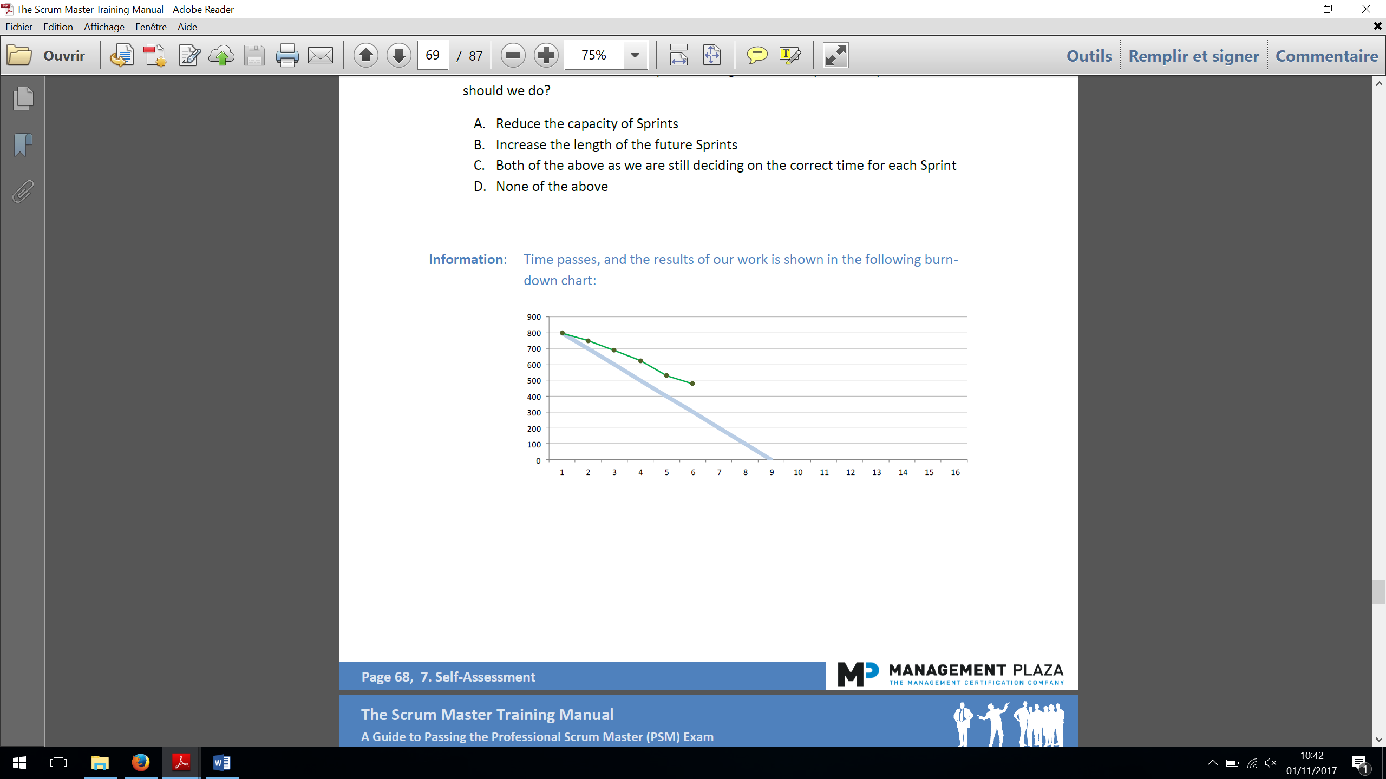

**Q27**. How many Sprints are done so far ?

A. One

B. Six

C. Nine

D. Sixteen

E. It’s not determines by the chart

**Q28**. What was our initial estimate of the number of Sprints needed for this project?

A. One

B. Six

C. Nine

D. Sixteen

E. It’s not determined by the chart

**Q29**. How many Sprints will it probably take us to actually complete the project?

A. About nine sprints

B. About ten sprints

C. About eleven sprints

D. About fourteen sprints

E. About sixteen sprints

**Q30**. Customer wants to add some new features worth 400 points to the project, and expects us to provide them with an estimate on the additional time needed for them. What’s your idea? (Tip: Use the answer from Q29 to help you)

A. About four additional sprints

B. About five additional sprints

C. About seven additional sprints

D. About nine additional sprints