Terminology:

Agent: a concrete implementation of an intelligent agent

Player: human player

What happens if all exit positions are blocked?

If all exit positions are blocked, no matter how close the player is to the exit positions, he or she cannot win the game. Therefore, agent is not encouraged to move towards exit. Only when the exit positions freed up will the agent's pieces start moving towards the exit. While waiting, the agent can focus on other objectives such as eating other player pieces.

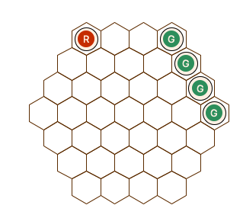

What happens when pieces blocks player’s path?

If other player pieces are blocking the shortest path to exit the path becomes longer. However, the distance to exit position ignores the positions of other player pieces for a faster computation. The red piece will move towards the nearest exit position ignoring the line of green pieces.

The risk associated with the proximity to other players is evaluated by the number of pieces left. The red agent will try moving towards nearest exit position. After Max N search. If Max N place a heavier penalty on losing pieces compared to moving away from exit position, it will result in red piece moving away from Green pieces. On the other hand, if red pieces are blocking itself, Max N will realize that there is no risk and will not apply penalty. Red will intelligently move towards the nearest exit.

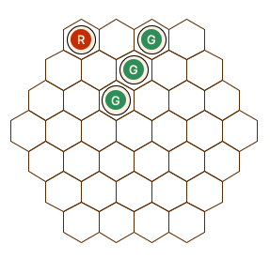 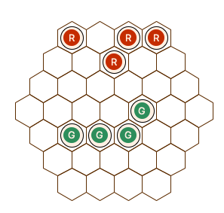

If the cut off of Max N happens very early, then the agent will not discover the risk and walk straight into green’s trap. In the below example, the Max N has a depth of 3. The red piece will move towards the nearest exit and be trapped by green pieces.

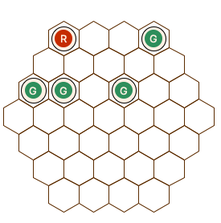 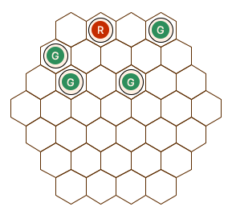

To exit or not to exit, that is the question.

Each piece exited brings the player closer to winning the game. On the other hand, more pieces on the board implies more strageties to implement. You can’t do much if you only have one piece left. In the following example, if red agent choose to exit all its pieces, it will have no more ‘good moves’ since green pieces have it pined to a corner.

However pieces will need to exit.

