

**Survey Taker™**

**Version 2.0.2**

*Productivity Series™*

**Installation and User's Guide**

**Trademarks**

First Choice Software, Inc. (FCS) develops add-on software and customizations to the following

Clarify products:

• ClearSupport

• ClearHelpDesk

• Policies and Customers

• Product Manager

• ClearLogistics

• ClearQuality

• ClearContracts

• ClearSales

• ClearCallCenter

FCS uses the following Clarify tools:

• User Interface Editor

• Data Dictionary Editor

• Data Exchange

• ClearBasic Exchange

• ClearBasic Batch

Clarify, Inc. and all of its product and tool names are trademarks of Amdocs, Inc.

**Publication Notice**

The information in this document does not constitute a warranty of performance. First Choice

Software, Inc. reserves the right to modify the content of this document without obligation to notify any person or party of such revisions or changes. First Choice Software, Inc. assumes no liability

for losses incurred as a result of the use of information contained in this document.

© First Choice Software, Inc. 1997 - 2010. All rights reserved.

Table of Contents

Overview 5

General Overview 5

Before You Upgrade to a New Version… 6

What’s New in Version 2.0.2 7

What’s New in Version 2.0.1 7

What’s New in Version 2.0 7

What’s New in Version 1.1.1 8

What’s New in Version 1.1 8

What’s New in Version 1.03 8

Surveys 9

Respondent Types 9

Survey Question Setup 10

Question Sets 10

Select Survey Question Form 11

Survey Question Form 11

Administering Surveys 13

Question and Answer Form 14

Question Tab 14

Answer Tab 15

Reporting 16

Business Rules 17

Survey Daemon 17

Implementation 18

Requirements 18

Packaging 18

Installation Tree 18

New Objects 19

New Tables/Views 19

New Forms 19

New Lists 20

Existing Objects 20

New Relations Added to Existing Tables 20

Installation 20

Data Dictionary Modifications 20

User Interface Modifications 21

Import Forms 21

Create Forms 22

Resource Configurations 22

Clear Basic Code Compilation 23

Creating the SURV_QUEST_TYPE List 24

Limitations 24

Performance 24

Internationalization 24

Examples 24

Example 1: Surveys in Find Caller 25

Example 2: Survey on Close Case 25

Example 3: Survey on a Button Click 25

Example 4: Business Rule Surveys 26

Survey Daemon 27

Mailboxes/Folders for the Daemon 27

Configuration of the Daemon 28

Import the Daemon Configuration Items 28

Modify the survey_daemon1.bat file 29

Start the Daemon 29

How to Contact Us 29

# Overview

## General Overview

The *Productivity Series* of products from First Choice Software, Inc. is designed to improve the productivity and profitability of your Clarify system. Many businesses would like the ability to administer surveys against their customer base in the Clarify Environment. **Survey Taker** allows them to both set up andadminister surveys using a simple GUI; there is no coding or database knowledge required. In addition, surveys can be set up and administered for contacts, sites, business organizations, or cases. Surveys can be launched from any form in the Clarify system, or from business rules.

## Before You Upgrade to a New Version…

You should be aware of both the version of the product you currently have as well as the version you are upgrading to.

You may upgrade several revision levels at one time. To perform this multiple-upgrade, you must create a list of files to upgrade. Find the section of the manual with instructions for upgrading from your current software revision. Make a list of the required steps. Repeat this process with each update, adding these steps to the list. If a step is required by more than one version, you only have to list it once.

When your list is completed, you should perform all the steps (in the same order you would install the product (schema first, then files and forms, then resource configurations, then code compilation) for a clean install) using the files provided with the most recent version of the product.

For example, suppose you had version 1.1 of a product, and versions 1.1.1, 1.2, and 1.3 have all been released. You now wish to upgrade from version 1.1 directly to version 1.3. Suppose that the versions require the following steps:

* Version 1.1.1 requires that you compile files a.cbs and b.cbs.
* Version 1.2 requires that you add a new field to the case table, and recompile a.cbs.
* Version 1.3 requires that you import a data file d.dat, import a new form file, c.dat (add it to the resource configuration), and compile c.cbs.

To perform the total upgrade in this situation you would perform the following steps:

* Add the new field to the case table (schema changes always come first)
* Import the d.dat file (data imports come next)
* Import the c.dat form, and add it to the proper resource configuration(s).
* Compile the a.cbs, b.cbs, and c.cbs files.

All of these steps would be accomplished with the files provided with the 1.3 version of the product. If you have questions about this process, please contact First Choice Software.

## What’s New in Version 2.0.2

In some versions of Clarify (such as Amdocs 7.5), there is a baseline bug that can cause clarify.exe to hang when showing/hiding radio buttons on tabs. This hanging can manifest itself when using the Q&A form of Survey Taker, which makes radio buttons visible/invisible depending on the number of answer choices in a survey question. This bug has been reported to Amdocs, and requires a change in clarify.exe to resolve.

This version of Survey Taker introduces a workaround that can be used until the core issue is resolved.

To apply this version:

* copy the new st1912.cbs file
* edit the st1912.cbs file, setting the *ClarifyBugExistsWhenShowingHidingRadioButtonsOnTabs* variable to *True*
* recompile st1912.cbs

The minor limitation in this workaround is that the selected question (and state of the Questions tab) is not remembered when going from the Questions tab, to the Answers tab, and then back to the Questions tab.

Should Amdocs release a version of clarify.exe that resolves the core issue, then this variable can easily be set back to False, and Survey Taker will function as originally designed.

## What’s New in Version 2.0.1

Version 2.0.1 fixes a small bug in the survey daemon. If the daemon is validating answers, and not using default answers, then a blank answer would be treated as a valid answer. This has been fixed.

In addition, survbr.cbs (Example 4) has changed. Previously, it was always showing which answer is the default. Now, it only shows which answer is the default if the *SURVEY use defaults* config item is set to True.

If you do not use the survey daemon or the survbr.cbs (Example 4), then you do not need this update.

To apply this patch, replace the old version of survey_daemon.cbs & survbr.cbs with the new files.

## What’s New in Version 2.0

Version 2.0 enhances Example 4 – which is an example of sending a survey via a business rule. It adds the ability to automatically email surveys, and it adds the ability to automatically process replies of the emailed surveys.

If you do not use the existing example for creating a survey via a business rule, or you do not want to automatically process responses to emailed surveys, you do not need this update.

The survbr.cbs file has been modified. This file is a CB batch script that can be called by a business rule in order to generate a survey. Previously, it created a text file that contained the survey. Now, it can also automatically email the survey via Microsoft Outlook.

A new daemon process has also been created. This allows automatic parsing of emailed surveys. For example, you can use survbr.cbs to automatically email a survey to a customer. Then, the daemon process can automatically parse the replies and create the answers in the Clarify database. This daemon only supports the Microsoft Outlook mail client.

Also, a new file – *survey_config.dat* – has been provided. This file contains configuration information for the survey daemon.

The basic steps for using the business rule based survey and the daemon are:

* Setup your Outlook Folders
* Modify *survey_config.dat* and import using dataex
* Configure the constants in the survbr.cbs file
* Configure the survey_daemon1.bat file
* Setup a business rule that calls survbr.cbs and emails a survey
* Start the survey daemon using survey_daemon1.bat

To apply this patch, replace your existing copy of survbr.cbs with the new version. Copy the daemon directory and all files from this directory, and follow the instructions in the Survey Daemon section for configuring the survey daemon.

## What’s New in Version 1.1.1

Version 1.1.1 fixes a small bug when using date-based surveys. The correct surveys would not always show during the correct date period.

To apply this patch, copy the new st1912.cbs file and recompile.

## What’s New in Version 1.1

Version 1.1 of the product improves the performance of the Question and Answer form. It also now has that form only show the answers for the selected object and the selected survey (question set). If you want to see all of the answers for a particular respondent, you can select “All” for the question set.

To apply this patch, copy the new st1912.cbs and st1913.cbs files, and recompile them.

## What’s New in Version 1.03

Version 1.03 adds the capability to perform surveys on both *commitments* and *interactions*. To apply this change, copy the new st1912.cbs and recompile.

# Surveys

Survey Taker allows you to set up and administer *surveys*. A survey is a collection of questions forcustomers to answer. Results from surveys are stored in the Clarify database. After you’ve collected the responses you can report on them, generate demographics, use them to provide information the next time that the customer calls back, or use them in a variety of other uses.

Each survey consists of a set of questions, or a *question* *set*. You may have as many question sets as desired, orjust one. For example, you may have a *personal* survey you wish to administer to contacts, and a corporate survey that you ask of *corporate* sites. Each question set may contain as many questions as you would like.

Each survey question can have a variety of different answer types:

* Text answer
* Yes/no
* True/False
* Multiple Choice (2-5 answers)

Text answers allow you to provide a text default. For multiple -choice questions, you can enter the answers that are valid for the question, and you may specify which multiple-choice answer is the default answer. For Yes/No and True/False questions you may also specify the default answer.

Questions can be marked as active or inactive. Inactive questions are not asked on current surveys, but can be made active again. This is commonly used in situations where questions are asked on a periodic basis, and then “retired” for a period of time.

Survey questions may have a date range assigned to them. If you assign a date range, the question will be asked only on the dates specified. If you specify no date range, the question is always asked on surveys.

Finally, each survey question can be marked as *ask* *once*. A question that is marked as “ask once” will beasked only once for each contact, site, business organization, or case (whatever you are taking the survey on). After it is answered for that entity, it won’t be asked again. Questions, which are not marked as "ask once", will be asked each time a survey is taken.

## Respondent Types

Survey Taker is designed for you to be able to administer surveys and relate them to different types of objects:

* Contacts
* Sites
* Business Organizations
* Cases
* Commitments
* Interactions

You may administer surveys against as many different respondent types as you would like. For example, you may wish to ask certain questions of contacts you speak with, but you may wish to ask different questions (from another question set) for each site that you speak with.

First Choice Software has designed Survey Taker to allow multiple respondent types because different Clarify implementations think about their customers differently. For example, some businesses think of their customers in terms of sites. They may only want to ask questions on a site basis, independently of which contact they speak with at the site. Other businesses, however, might like to ask questions of each individual contact. Yet others might choose to ask questions to entire customer business organizations.

With Survey Taker, the choice is yours. Each time you call the question and answer form to administer a survey, you will also pass in the respondent type, and which respondent (contact, site, business organization, case, commitment, or interaction) the survey is for. This is covered in more detail below.

## Survey Question Setup

Survey Taker comes with two forms that allow you to enter and modify survey questions. They are *the Select* *Survey Question* form and *the Survey Question* form.

Installing Survey Taker adds two new menu items to the Policies and Customers menu bar. In the *Select* menu a menu item, *Survey Question*, will call on *the Select* *Survey Question* form. The *New* menu has an itemadded that will post the *Survey Question* form

**Note:** The Survey Question form can also be postedfor new questions by pressing the *New* button on the *Select Survey Question* form.

## Question Sets

Survey Taker allows you to create multiple surveys through the concept of the *Question Set*.

Every survey question will belong to a question set. If you wish to have the same question in multiple surveys, you must create a new question for each survey. If you wish to create a new survey, simply add a new item to the new **SURV_QUEST_TYPE** list that you will create when you install the product.

## Select Survey Question Form

The *Select Survey Question* form allows you to view existing survey questions. It allows the user to filter on key attributes of survey questions: Question set, question text, start date, and end date. In addition, the user can check *the Include inactive questions* checkbox to view both active and inactive questions, or leave it unchecked to view only active questions.

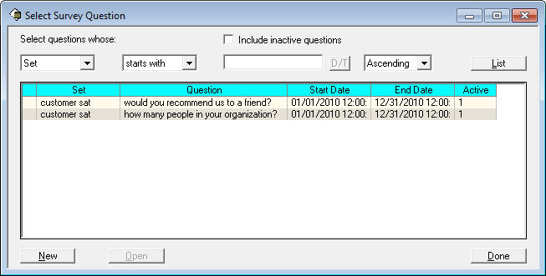

To modify an existing question, enter the proper filtering criteria and press the *List* button. Then select (click) the question of interest and press the *Open* button, or double-click the question. To create a new survey question, press the *New* button at any point. This will display the *Survey Question Form*.

## Survey Question Form

The *Survey Question* form is used to create new survey questions and to modify existing questions.

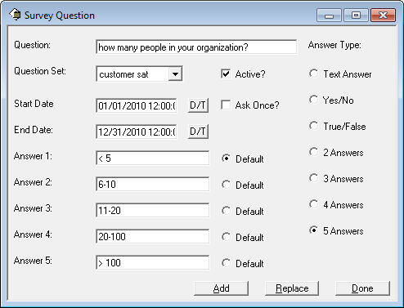

To create a new question with this form:

1. Enter Question text
2. Select the question set
3. Select the answer type
4. If text, enter the default answer
5. If multiple choice, type text for answers
6. If multiple choice, select default answer
7. Select start/end dates, if appropriate
8. Uncheck the *Active* checkbox if this is an inactive question
9. Check the *Ask Once* checkbox if this question should be asked only once for each respondent
10. Press *Add* to create the question

**Note:** Date ranges are completely optional. If you donot specify a date range, the question will always be asked.

To modify an existing question:

1. Modify any of the attributes that are to change
2. Press the *Replace* button

# Administering Surveys

After the survey sets and survey questions are added to your system, you must decide how and when the surveys are to be taken.

For example your workflow might include taking the survey for contacts each time a *Find Caller* operation is performed on the *New Case* form. Or perhaps you wish to take surveys for sites each time the *Close Case* form is posted (Form_Load). The code to call the Q&A form can be placed in any form in the Clarify system.

More examples can be found below in the *Examples* section.

For each place that you wish to take a survey, you will include the following lines of Clear Basic code:

Dim qa_form as New Form

Dim resp_objid as Long

qa_form.Show 1912, cbFrontIfUp

qa_form.Notify cbFirstMessage + 1, "C", _

Trim$(Str$(resp_objid)) + "Personal"

Where the *resp_objid* field is the objid of the respondent (contact, site, business organization, or case). Your code will provide the objid, usually from a contextual object on the form. For examples of this, see the *Examples* section below.

The letter in the qa_form.Notify statement in the code above (“C”) is the code that tells Survey Taker what kind of respondent you wish this survey to be for. The valid codes for this letter are:

* C Contact
* S Site
* B Business Organization
* A Case
* O Commitment
* I Interaction

The *“Personal”* added to the end of the string tells Survey Taker that you would like to initially display the questions associated with the *Personal* question set. You may have different surveys display different question sets using this feature.

For example, the message string that would be sent in the sample code above is:

C268435457Personal

**Note:** The question set string at the end of themessage is optional. If you do not specify a string, then questions from all question sets will be initially displayed.

**Note:** If you want, you may make the question setdropdown list Disabled on the question tab (form #1913). This will restrict the user to the question set that you specify when you call the Q&A form.

Thus, you can display different surveys for different respondents, simply by changing the one line of code. In fact, you could even have multiple buttons on one form that performed surveys on different respondents.

# Question and Answer Form

Executing the code in the previous section will cause the Q*uestion and Answer* form to be displayed. The Q&A form is a tabbed form. On one tab Survey Taker will display all pending questions for the respondent. This tab will allow questions to be selected, and answered. The other tab displays the question/answer history for that respondent.

## Question Tab

The question tab displays a list of the questions that are to be answered by the respondent. The questions may be answered in any order you desire. Any number of questions may be answered in a given session. Questions not answered will be held over for the next time the survey is given.

You may change the question set at any time to display a different subset of questions; when the Q&A form is first posted, the question set is set to the question set specified in your qa_form.Notify statement (or *All* if you do not specify a question set). If you set the question set dropdown listbox to *All* then all questions from all question sets will be displayed.

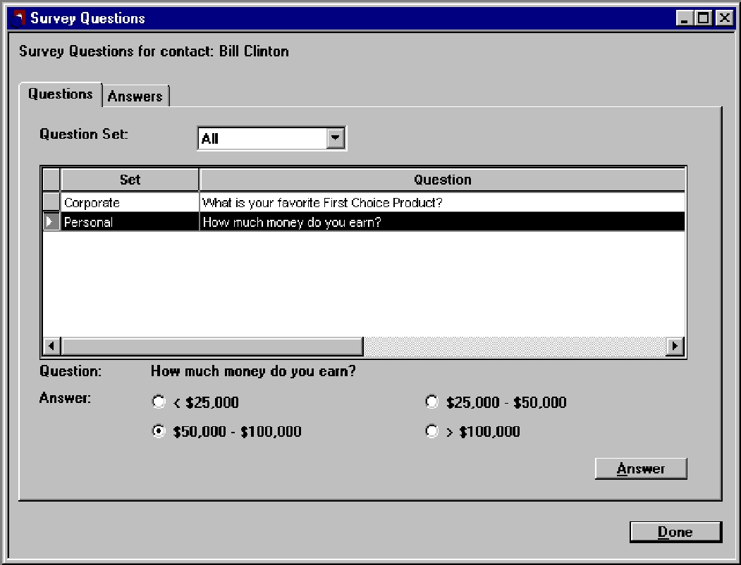

To answer a question, simply select (click on) the question to be answered. The question and the possible answer(s) are displayed below. If it is a text question, a text box with the default answer will be displayed. Select (or type for a text answer) the answer desired, and press the *Answer* button. The question and answer will then be recorded in the database. You may then proceed to the next question.

If the question is set up as *Ask Once*, the question will be removed from the Question tab once it has been answered. If it is not an 'ask once' question, it will remain.

You can view the answers to all questions answered by the respondent at any time by selecting the *Answers* tab.

## Answer Tab

The answer tab displays the question/answer history for the respondent. It displays one row for each question that has ever been answered by the respondent. It displays the question asked, the answer given, when it was asked, and which user asked the question on behalf of your company.

If there is not enough room in the custom list to display either the question or the answer, you may select (click) on the question and the question and answer will both be displayed at the bottom of the tab.

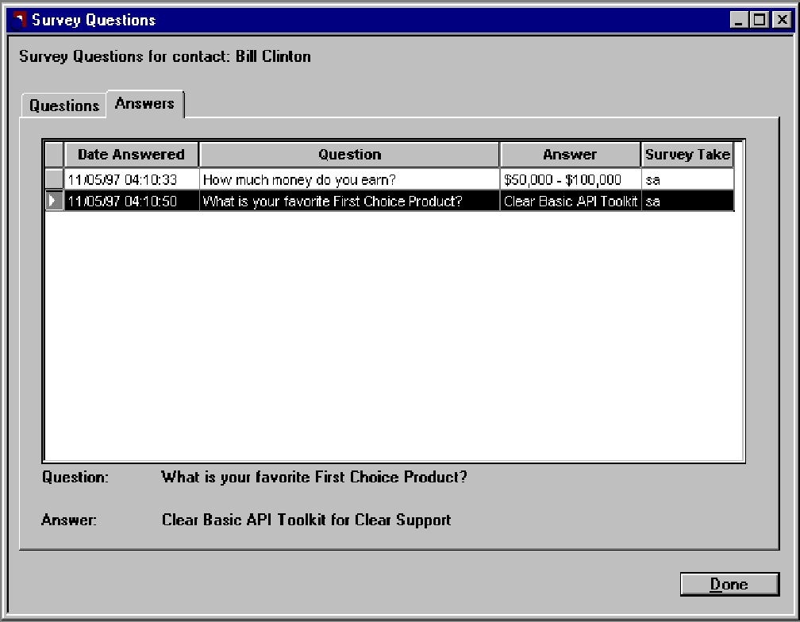

# Reporting

All of the questions and answers for Survey Taker are stored in relational database tables in the Clarify database. This means that you can use your favorite reporting package or mechanism to extract and analyze the data from your Surveys.

What follows is a brief description of the data modeling for Survey Taker. The complete schema can be found in the *survey.sch* file provided with this product.

There is a table provided (*table_surv_quest*) to hold the survey questions. Each question that you create is stored in a row of this table.

Each time an answer is recorded to a survey question, a row is placed in *table_surv_ans*. This table stores both the answer to the question as well as the question. It also stores a relation to the question table row for the question. The question is denormalized in the answer table because you might change the question text after it has been answered for a given respondent, and you may want to know what the exact phrasing of the question was when it was asked.

In addition, there are relations from the answer table to the contact table, the site table, the bus_org table, and the case table. Only one of these is filled in for a given answer. The one that is filled in tells you who responded to this survey

# Business Rules

Many businesses have requested the ability to generate files that contain surveys (for a given contact, site, business organization, or case) generated from a business rule. These survey files can then be emailed, mailed, or faxed to the customer. A common requirement is to generate a survey after a case is closed.

Survey Taker provides a mechanism to generate surveys from business rules. There is a Clear Basic batch file provided, *survbr.cbs* that will create a survey and place it in a file or email it.

The business rule generation routine is called *generate_survey*, and it has the following fourarguments:

1. file_name The file in which to place the survey
2. survey_type "C" for contact  
    "S" for site

"B" for business organization

"A for case"

"O" for commitment"

"I" for interaction

1. objid The objid for the record. This is usually the [Database ID] variable   
    in the business rule.
2. question_set The survey that contains the questions to include in the file.   
    If you want to use all questions for this customer, use "All".

See the Example #4 section below for usage of the business rule.

# Survey Daemon

Many businesses have requested the ability to automatically process survey replies. For example, using the business rule example included with this product, you can email a survey to a customer. The customer can reply to the survey with their answers, and then the survey daemon can process the replies and automatically create the answers in the database.

The Survey Daemon is only supported on Windows platforms. In addition, it currently requires Microsoft Outlook as a mail client.

See the Example #4 section below for usage of the survey daemon.

# Implementation

This section provides detailed requirements, what files are included in this product, installation and other implementation considerations.

## Requirements

This version of **Survey Taker** requires the following:

**Clarify Version:** 4.0 or later

**Clarify Tools:** Data Dictionary Editor (ddeditor)User Interface Editor (uieditor) Clear Basic Compiler (cbex) Data Exchange (dataex)

**Survey Daemon:** Microsoft Outlook Mail Client

## Packaging

Survey Taker is shipped as a zip file.

## Installation Tree

It is recommended that you uncompress the zip file containing Survey Taker into an fchoice subdirectory created at the top of the Clarify install tree. For example on NT, should your Clarify server install tree be “c:\clarify”, then:

1. Switch to “c:\clarify” directory.
2. Create an “fchoice” directory, if necessary.
3. Switch to “fchoice” directory.
4. Unzip into “c:\clarify\fchoice” directory.

After uncompressing, you will have the following installation tree:

c:\clarify\fchoice\survey\<survey_taker_version>

The following files are provided with this product:

|  |  |
| --- | --- |
| File Name | Purpose |
| SurveyTaker.pdf | This document |
| forms.dat | Data exchange file containing new forms for the product. |
| st1910.cbs | Clear Basic code for Survey Question form. |
| st1911.cbs | Clear Basic code for Select Survey Question form. |
| st1912.cbs | Clear Basic code for Q&A form. |
| st1913.cbs | Clear Basic code for Question tab. |
| st1914.cbs | Clear Basic code for Answer tab. |
| survgl.cbs | Global Clear Basic code for adding two new menu options to menu bar. |
| survey.dir | Directives file for compiling Clear Basic code. |
| survey.sch | Schema changes for Survey Taker. |
| example | Directory containing example code |

The example directory contains the following entries:

|  |  |
| --- | --- |
| File Name | Purpose |
| example1 | Find Caller survey example |
| example2 | Close case survey example |
| example3 | Contact form button click example |
| example4 | Business rule generation of surveys |

## New Objects

First Choice Software has defined the following new objects to implement Survey Taker:

### New Tables/Views

|  |  |  |
| --- | --- | --- |
| Table Name | Table Number | Purpose |
| surv_quest | 3520 | Questions |
| xurv_ans | 3521 | Answers |

If you are already using any of the above table numbers, you may modify the surv.sch file and change them to other, unused numbers in the user-defined range (2000-4999).

### New Forms

|  |  |
| --- | --- |
| Form | Form Number |
| Survey Question Form | 1910 |
| Select Survey Question Form | 1911 |
| Q&A Form | 1912 |
| Question Tab | 1913 |
| Answer Tab | 1914 |

If you are already using any of the above form numbers, you may modify the forms.dat file and change them to other, unused numbers in the user-defined range (1005-4999).

### New Lists

You must create a new user-defined list for this product. The name of the list is **SURV_QUEST_TYPE**. Each survey you wish to administer will be entered as an item in this list.

## Existing Objects

The following changes will be made to existing Clarify objects:

### New Relations Added to Existing Tables

The following relations will be added to Clarify objects:

|  |  |  |
| --- | --- | --- |
| Table Name | Relation Name | Cardinality |
| contact | contact2surv_ans | OTM |
| site | site2surv_ans | OTM |
| bus_org | bus_org2surv_ans | OTM |
| case | case2surv_ans | OTM |
| interact | interact2surv_ans | OTM |
| commit_log | cCommit_log2surv_ans | OTM |

# Installation

The **Survey Taker** files may be installed on any machine that can execute the Clarify data exchange tool (dataex) and the Clarify Clear Basic Compiler (cbex). You will also need to run the Clarify Data Dictionary Editor (ddeditor) and the User Interface Editor (uieditor). The Clear Basic source files (*.cbs) should be installed in the same directory as the directives file (survey.dir).

**Note**: It is highly recommended that you first install **Survey Taker** on a test system and get familiar withit before installing it on a production system.

## Data Dictionary Modifications

The **Survey Taker** product requires that two new tables be added to Clarify. In addition, new relations must be added to existing objects.

To make the required schema changes:

1. Start the Data Dictionary Editor.
2. Choose *Save To File* from the *File* menu.
3. Type **survey.new** and press the *OK* button.
4. Edit the *survey.new* file (it will be stored in the DD Editor directory) and make the changes listed in the *sureyv.sch* file.
5. Choose *Apply Changes* from the *Actions* menu.
6. Select the *survey.new* file.
7. When asked, press *Continue*.
8. Review the results presented. If any errors, fix them and repeat steps 5-7.
9. If there are no errors, press the *Apply Changes* button.
10. On the next form press the *Upgrade* button.
11. When the upgrade completes, press *Done*.
12. Exit the Data Dictionary Editor

## User Interface Modifications

### Import Forms

The forms provided with this product will be imported into the database with the data exchange tool.

The forms.dat file must be imported into the database:

The forms file is imported with the following command:

<path>\dataex –user_name <user> -password <pass> -db_server <serv> -db_name <db> -imp forms.dat

Where:

* <path> Is the path to the dataex program
* <user> Is the system administrator user
* <pass> Is the system administrator password
* <serv> Is the database server name
* <db> Is the database name

Note: The slash between <path> and dataex should be a forward slash for UNIX systems.

Note : If the <file> is not in the current directory, it must be preceded by the path to the directory it is in.

Note: Each file should import with 0 errors and 0 warnings. If there are any errors or warnings, the dataex.mes file should be investigated for the reason.

### Create Forms

You will save a new user version (or use a user version you have already created) for each form in your Clarify system from which you wish to administer a survey.

Note: If you already are using a customized version of one of the above forms, you may use your version for Survey Taker. You must, however, merge your customized code with the Survey Taker code for that form.

To create new user versions of the forms:

1. Start the User Interface Editor.
2. Choose *Forms…* from the *Select* menu.
3. Type the name of the form you wish to save*.*
4. Press the *List* button.
5. Select the form from the custom list.
6. Press the *Open* button.
7. Choose *Save As…* from the *File* menu.
8. Type *surv1.0* as the version number.
9. Enter a comment (such as “First Choice Survey Taker”)
10. Press the *Save* button.
11. Select the form and choose *Close* from the *File* menu.

Repeat steps 2-10 for each of the remaining forms.

### Resource Configurations

After the form files have been imported or saved successfully, the new forms must be added to the proper resource configuration(s) in UI Editor. You must decide which user or groups of users should see the new versions of the imported forms.

To add the forms to the resource configuration(s):

1. Start the User Interface Editor.
2. Choose *Resource Configs…* from the *Select* menu.
3. Press the *List* button.
4. Select the resource configuration you want to modify and press the *Open* button.
5. Type **surv** in the text box to the right of the starts with dropdown list and press the *List* button.
6. Select the form(s) you wish to add to the resource configuration from the left grid control, and press the *Copy>>* button.
7. If any confirmation dialogs appear, press the *OK* button to continue.
8. Press the *Replace* button. After the save is completed, press the *Done* button.
9. Repeat steps 4-8 for any other resource configurations you wish to modify.
10. Exit the User Interface Editor.

## Clear Basic Code Compilation

You will now compile the supplied Clear Basic code against the forms you have imported and created.

When Clarify starts up it runs the routine ‘initialize_app’ (if one exists). Only one routine with this name will be run on client start-up. The module *survgl.cbs* contains an ‘initialize_app’ routine for thisapplication. If some other custom application has a version of this routine, only one of these versions will execute. It is REQUIRED that you merge any existing version of ‘initialize_app’ into the version in module *survgl.cbs.* Then, replace the original version of‘initialize_app’ with the merged version and recompile it. This will prevent the original version from overwriting the merged version if you recompile your original code, and it will ensure that all your custom applications will still be executed.

Not doing this as specified may cause this application or previous customizations to function improperly.

To compile the code modules, make sure that the code modules (*.cbs) and the directives file (survey.dir) are located in the same directory.

Note: You must also compile the Clear Basic code for any forms that you use to take surveys. Add a line in the directives file for each of these modules.

Start by editing the surv.dir directives file. Make sure that the user versions (surv1.0 by default) are correct for the user versions of the forms you have created. You should not modify the line that starts with *survgl.cbs*.

Enter the following command to compile the code:

<path>\cbex –dir survey.dir –batch –overwrite

Where: <path> is the path to the cbex program.

Note: The survgl.cbs file contains code to add two new menu items to Clarify. If you already have a globals module that contains an Initialize_App method, you must add the code from survgl.cbs to that method and NOT compile survgl.cbs. This is due to the fact that Clarify may only have one application initialization method.

When the compilation is completed, you should look at the cbex.log file to check on the status of the compilation. There should be two rows that start with the word SUCCESS for each file compiled. If there are any failures, check the above instructions to make sure that your compilation environment is set up correctly.

Note: The slash between <path> and cbex should be a forward slash for UNIX systems.

Note: The Clear Basic compiler requires that the user who performs the compilation be a member of a resource configuration that includes the forms compiled against. Example: If user sa compiles the CB code, he must be a member of a resource configuration that holds the new forms.

## Creating the SURV_QUEST_TYPE List

To create the required user-defined list, perform the following steps:

1. Start Clarify as a user who can access Policies & Customers.
2. In the Apps menu, select the Policies & Customers item.
3. In the Setup menu, select the User Defined Pop-Up List item.
4. Type SURV_QUEST_TYPE in the List Name field.
5. Enter a description of: Survey Question Sets for Survey Taker in the Description field.
6. Press the Add button at the bottom of the form.
7. Enter the name of a survey in the Edit Item text box.
8. Press the Add button on the right-hand side of the form.
9. Repeat steps 7-8 for each survey question set.
10. Press the Done button to exit the form.

# Limitations

There are no known issues with Survey Taker.

# Performance

There are no known performance issues with **Survey** **Taker.**

# Internationalization

Future versions of **Survey Taker** are expected to be localized. All strings presented will be read from string tables, allowing surveys to be taken in different languages for different customers at the same time in the same database. If this is a requirement for your organization, please contact First Choice Software so that this can be scheduled.

# Examples

**Survey Taker** is extremely versatile. Surveys can betaken in many different ways. This section details four common ways to take surveys. In the examples directory you will find source code that implements these examples. You can easily modify this source code to use Survey Taker in any way required by your organization

**Note:** The code examples in the example directoriescome with directive files to compile them. These directives files were created with the 4.5 version of Clarify. If you have a different version of Clarify you may have to modify the directives file to change the Clarify version of the form. You may also wish to change the user version of the form to one that you already have defined in your system.

## Example 1: Surveys in Find Caller

A common requirement is to start taking the survey as soon as you have identified the caller on the other end of the line. In this example we will take a survey for the site that the caller called from, but it can easily be changed to be a survey for contact, bus_org, or case.

The sample code simply adds (to the New Case form - #411) a new message handler. Whenever the Find caller operation is performed, Clarify sends a special message, number 551, to the form.

The New Case form receives that message, finds the site for the case, and then calls on the survey Q&A form.

To use this example, save a new version of the New Case form (#411) with a user version of *stex1*. Then add that user version to the proper resource configurations. Finally, compile the code in the *example1* directory against that form.

## Example 2: Survey on Close Case

Another common time to take surveys is when you are closing the case or subcase. This can be done at any point in the close process. Two common places are when the close case form is posted (which is what is illustrated below), or when the case is actually closed. To understand how to display the survey when the close button is pressed, see example 3.

To implement this example, add the code in the *example2* directory to the *Form_Load* method of theCase Close form (#340), or compile the code provided against a new user version (*stex2*).

The code retrieves the case information and posts a survey for the case. The survey could be on contact, site, or business organization also.

## Example 3: Survey on a Button Click

Perhaps the most common mechanism to post the Q&A form is to add a new button to a form (you can do this to any form in the system). Then add code similar to thecode provided in the *example3* directory to cause the Q&A form to be posted when the button is clicked.

For this example, we used the contact form (#712), and posted the Q&A form for the contact. This technique can be used on most any form, and for any of the respondent types.

To use this example, save a new version of the Contact form (#712) with a user version of *stex3*. Then add that user version to the proper resource configurations. Finally, compile the code in the *example3* directory against that form.

## Example 4: Business Rule Surveys

The file in the *example4* directory contains a sample procedure, *survey_for_contact_from_case*. This routine is passed from a business rule the objid of a case, along with the type of output (email or file). It then locates the contact for that case, and calls on the routine (*generate_survey*), which builds the survey. It names the output file for the survey with the objid number to insure a unique file name. Optionally, you can email this survey directly to a customer using Outlook.

This routine is intended to be illustrative only – feel free to modify it, as you need.

The business rule that would call on this routine is:

Rule Name **Contact Survey**

Rule Set **First Choice**

Rule Status **Active**

Object Type **Case**

Description **Generates a survey for a contact for a given case**

Start Event **Close Task**

Cancel Event **(None)**

Conditions **(None)**

Action Title **Generate Survey**

Notify **(None)**

Start Action **0 minutes from event creation using elapsed time**

Repeat Action **Every 0 minutes for 0 minutes**

Create Actıvıty **Yes**

Type **Command Lıne**

Message **<path>\cbbatch survey_for_contact_from_case**   
 **–f survbr.cbs –r [Database ID] –as “email”**

**Note**: <path> is the path to the rulemanager directoryfor the Clarify server. Also, on UNIX systems, use a forward slash, not a backslash.

**Note**: The survbr.cbs file should be placed in the rulemanager directory.

**Note**: You may wish to change either the output filename that the survey is placed in, or the directory in which the output file is generated by modifying the *survey_for_contact_from_case* method.

You may wish to modify some of the constants defined in the survbr.cbs file. These constants are explained in the following table:

|  |  |
| --- | --- |
| Constant | Descrıptıon |
| CReplyToPerson | When a customer replies to an email survey, who should the email reply be sent to. This should be a valid email address, such as survey_replies@company.com |
| CSurveyTitle | The first part of the email subject for an email survey |
| CSurveyTitle2 | The last part of the email subject for an email survey. |

For example, using the default values of:

CSurveyTitle = "Survey questionnaire for "

CSurveyTitle2 = " from OurCompany"

The actual subject for a case based survey would be:

*Survey questionnaire for Case 12345 from OurCompany.*

The actual subject for a contact based survey would be:

*Survey questionnaire for Contact Joe Customer from OurCompany.*

## Survey Daemon

Many businesses have requested the ability to automatically process survey replies. For example, using the business rule example (Example #4) included with this product, you can email a survey to a customer. The customer can reply to the survey with their answers, and then the survey daemon can process the replies and automatically create the answers in the database.

The Survey Daemon is only supported on Windows platforms. In addition, it currently requires Microsoft Outlook as a mail client.

### Mailboxes/Folders for the Daemon

The Survey Taker Daemon is quite versatile in how it handles your email messages. You may (via configuration items) control the Inbox folder that you want to use to receive your email. It can be a folder as far down the tree as you would like. First Choice recommends that you specify a folder that doesn’t receive any other messages other than those for survey replies.

There are also some other mailbox/folder options. When an email message successfully creates survey answers, you have the choice of either deleting the message, or moving it to another folder (controlled by a config item). Also, if the email message does not parse, you may delete the message, forward the message to someone, or move it to a different folder.

### Configuration of the Daemon

There are a few Clarify configuration items that must be set in order for the daemon to work properly. They are in the file *survey_config.dat*, which can be edited with any text editor and will be imported into the database during product installation. Below is a description of each configuration item and one or more sample values.

|  |  |
| --- | --- |
| Confıg Item | Purpose |
| Survey new mail folder | Which folder to look in for survey replies  Example:  Personal Folders|SURVEY|INBOX |
| Survey location on fail | What to do with the mail message if it was unable to be successfully parsed  To move it to a folder:  Personal Folders|SURVEY|ERRFAIL  To forward to someone:  someone@yourcompany.com  To delete the message, leave blank. |
| Survey location on success | What to do with the mail message if it was able to be successfully parsed  To move it to a folder:  Personal Folders|SURVEY|SUCCESS  To forward to someone:  someone@yourcompany.com  To delete the message, leave blank. |
| Survey validate answers | For multiple-choice answers, tells the daemon whether or not to validate the given answers against the valid choices.  Valid Values: True or False |
| Survey use defaults | Tells the daemon whether or not to use the default answer for a question when the respondent has left the answer blank.  Valid Values: True or False |
| Survey strip comment marks | Tells the daemon whether or not to stripout marked comments that some mail clients can add  For example, a line may look like  ANSWER: [Joe Customer] This is my answer  By stripping out the comment mark, the line would now look like:  ANSWER: This is my answer  Valid Values: True or False |

### Import the Daemon Configuration Items

This step is only necessary if using the survey daemon.

1. Edit the *survey_config.dat* to have the correct configuration items for your system. Make sure the Outlook folders you specify actually exist.
2. Import the *survey_config.dat* file using dataex:

dataex.exe –user_name <user_name> -password <password> -db_server <server> -db_name <db_name> –imp survey_config.dat

### Modify the survey_daemon1.bat file

If you are using the survey daemon, modify the daemon BAT file using a text editor.

Be sure to replace the following parameters:

|  |  |
| --- | --- |
| Parameter | Purpose |
| cbbatch_path | The path to where the cbbatch executable is located. |
| user_name | Database User Name |
| password | Database Password |
| db_name | Database Name |
| db_server | Database Server Name |
| sleep_time | The number of milliseconds to sleep between cycles |
| num_cycles | The number of cycles to process before respawning. This is necessary because of a memory leak in Clarify. The daemon runs for a certain number of iterations then respawns itself and quits. |

### Start the Daemon

If you are using the survey daemon, start the daemon by executing the survey_daemon1.bat file.

# How to Contact Us

For more information about other First Choice Software, Inc. products, or if you have any questions or feedback about this product, please contact us at:

First Choice Software, Inc.

4807 Spicewood Springs Road

Building 4, Suite 200

Austin, TX 78759

(512) 610-5400

[www.fchoice.com](http://www.fchoice.com)