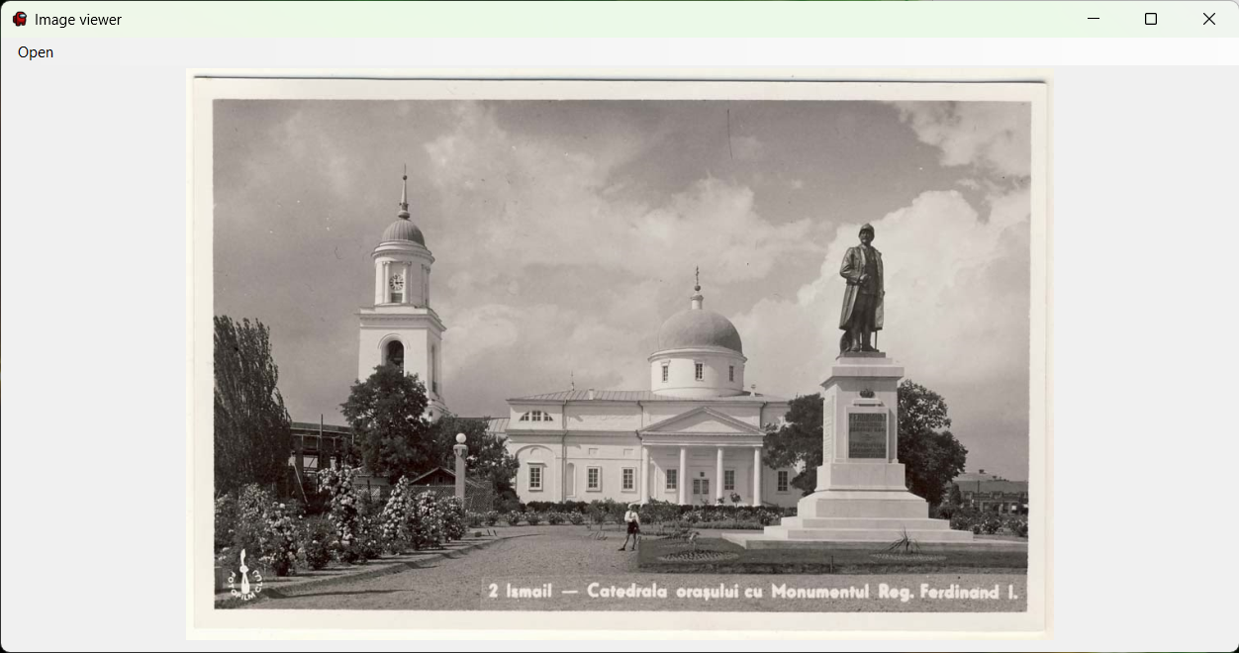

An application to display images defined by a user using a file selection dialog. When a user selects files, the program opens additional form and displays file paths to each selected photo. A user is allowed to open multiple of these selection forms, thus allowing usage of multiple folders.

# Form 1

Imports System.IO

Public Class Form1

Private Sub OpenToolStripMenuItem_Click(sender As Object, e As EventArgs) Handles OpenToolStripMenuItem.Click

Dim opDg As New OpenFileDialog

opDg.Filter = "Images|*.jpg|All files|*.*"

opDg.FilterIndex = 1

opDg.DefaultExt = ".jpg"

opDg.AddExtension = True

opDg.Multiselect = True

If opDg.ShowDialog() = DialogResult.OK Then

Dim selector As New Form2

For Each filename In opDg.FileNames

If File.Exists(filename) Then

selector.ListBox1.Items.Add(filename)

End If

Next

selector.Show()

End If

End Sub

End Class

# Form 2

Public Class Form2

Private Sub ListBox1_SelectedIndexChanged(sender As Object, e As EventArgs) Handles ListBox1.SelectedIndexChanged

Form1.PictureBox1.Image = Image.FromFile(ListBox1.SelectedItem)

End Sub

Private Sub Button2_Click(sender As Object, e As EventArgs) Handles Button2.Click

If ListBox1.SelectedIndex <> -1 Then

If ListBox1.SelectedIndex = 0 Then

ListBox1.SelectedIndex = ListBox1.Items.Count - 1

Else

ListBox1.SelectedIndex = ListBox1.SelectedIndex - 1

End If

Else

MessageBox.Show("You haven't selected anything", "Error", MessageBoxButtons.OK, MessageBoxIcon.Error)

End If

End Sub

Private Sub Button1_Click(sender As Object, e As EventArgs) Handles Button1.Click

If ListBox1.SelectedIndex <> -1 Then

If ListBox1.SelectedIndex = ListBox1.Items.Count - 1 Then

ListBox1.SelectedIndex = 0

Else

ListBox1.SelectedIndex = ListBox1.SelectedIndex + 1

End If

Else

MessageBox.Show("You haven't selected anything", "Error", MessageBoxButtons.OK, MessageBoxIcon.Error)

End If

End Sub

End Class