**Dovlet Amanov**

**99469340666**

**Mobile Programming-2 Final Assignment**

Vision

As we know Social Media shows huge number of users nowadays which leads to making new apps with new features. One of the main parts of Social Media is messaging. I always wanted to try making some apps that allow to chat among clients. It was hard to make that kind of apps with existing tools and performance was not good. As Cloud Platform had too many improvements that now there are some technologies that allows you to develop chat apps such as Firebase by Google. What is Firebase:

“Cloud Storage for Firebase is tightly integrated with [Google Cloud Platform](https://cloud.google.com/). The Firebase SDKs for Cloud Storage store files directly in [Google Cloud Storage buckets](https://cloud.google.com/storage/docs/key-terms#buckets), and as your app grows, you can easily integrate other Cloud services, such as managed compute like App Engine or Cloud Functions, or machine learning APIs like Cloud Vision or Google Translate.

Under the hood, Firebase SDKs for Cloud Storage use the default bucket in the [Google App Engine](https://cloud.google.com/appengine) free tier. This allows you to quickly get up and running with Cloud Storage, without having to put in a credit card or enable a billing account. It also allows you to easily share data between Firebase and a Google Cloud Platform project” – from Firebase’s webpage.

Main Features

-Real time database activities

-Register

-Login

-Chatting between two devices

Some screenshots from app

Screenshots from my mobile device

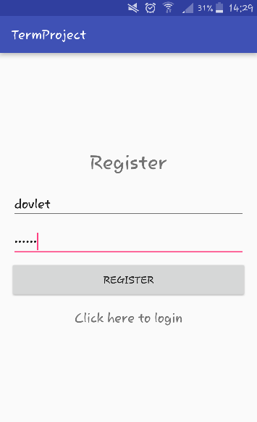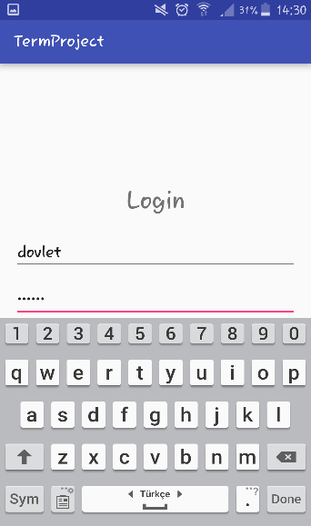

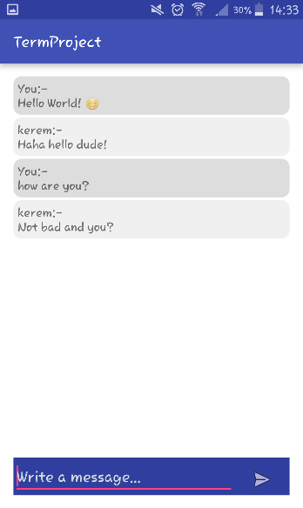

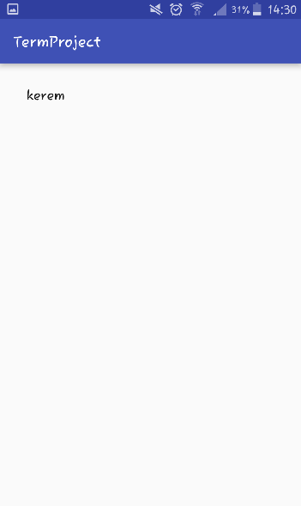

Screenshots from my friend’s mobile device

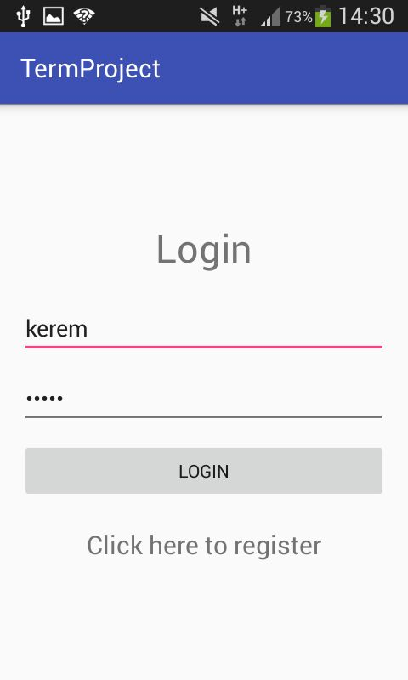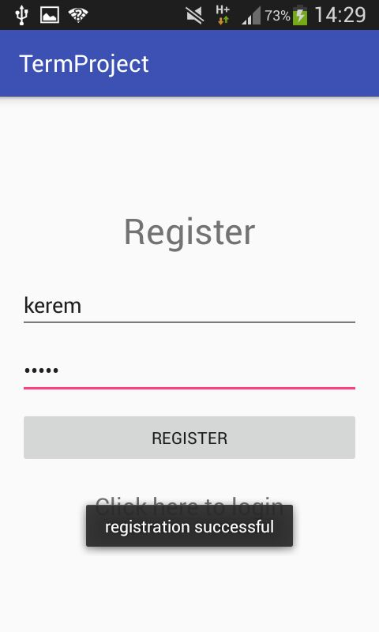

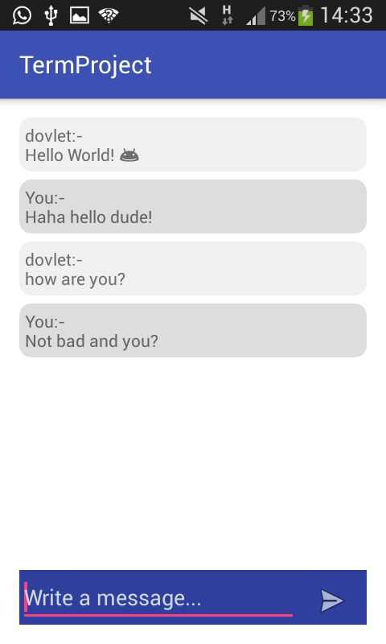



Dependencies

-Firebase

-Android Volley

-Internet Permission

Operating Environment

-minSdkVersion: 15

-targetSdkVersion: 24