Weather_Station

AUTHOR: Dovydas Klisys B00165094, Matas Noreika B00163844

Version 1

Table of Contents
Weather_Station i
AUTHOR: Dovydas Klisys B00165094, Matas Noreika B00163844 i
Version 1 i
Table of Contents ii
Hierarchical Index 2
Class Hierarchy 2
Class Index 3
Class List 3
File Index 4
File List 4
Class Documentation 5
Button Class Reference 5
Public Member Functions 5
Detailed Description 5
Constructor & Destructor Documentation 5
Member Function Documentation 5
Display Class Reference 6
Public Member Functions 6
Detailed Description 6
Member Function Documentation 6
Memory_bank Class Reference 8
Public Member Functions 8
Member Function Documentation 8
Pressure_Sensor Class Reference 9
Public Member Functions 9
Detailed Description 9
Member Function Documentation 9
Sensor Class Reference 10
Public Member Functions 10
Detailed Description 10
Member Function Documentation 10
SensorData Class Reference 11
Public Member Functions 11
Detailed Description 11
Temperature_Sensor Class Reference 12
Public Member Functions 12
Detailed Description 12
Member Function Documentation 12
Weather_information_service Class Reference 13
Public Member Functions 13
Detailed Description 13
Member Function Documentation 13
Weather_station Class Reference 14
Public Member Functions 14
Detailed Description 14
Member Function Documentation 14
Wind_Speed_Sensor Class Reference 16
Public Member Functions 16
Detailed Description 16
Member Function Documentation 16
File Documentation 17
Button.h 17
Display.h 18
Memory_bank.h 19
Pressure_sensor.h 20
Sensor.h 21
SensorData.h 22
Temperature_sensor.h 23
Weather_information_service.h 24
Weather_station.h 25
Wind_Speed_sensor.h 26

Figure 1: StarUML refined class diagram 1
Figure 2: pressure sensor inheritance 9
Figure 3: full sensor inheritance 10
Figure 4: temperature sensor inheritance 12
Figure 5: wind speed sensor inheritance 16

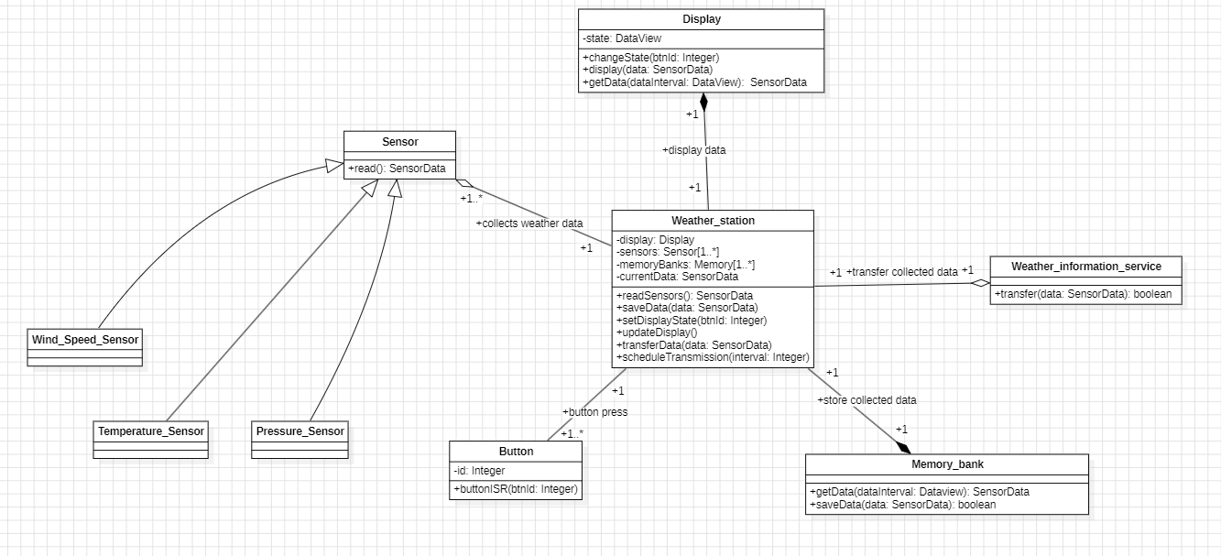
Figure 1: StarUML refined class diagram

Hierarchical Index

Class Hierarchy
This inheritance list is sorted roughly, but not completely, alphabetically:
Button 5
Display 6
Memory_bank 8
Sensor 10
Pressure_Sensor 9
Temperature_Sensor 12
Wind_Speed_Sensor 16

SensorData 11
Weather_information_service 13
Weather_station 14

Class Index

Class List
Here are the classes, structs, unions and interfaces with brief descriptions:
Button (Changes data displayed on the Display (real-time, hourly or historical data) ) 5
Display (Handles display output for different viewing modes ) 6
Memory_bank 8
Pressure_Sensor (Concrete sensor class for measuring atmospheric pressure ) 9
Sensor (Abstract base class for all sensor types ) 10
SensorData (Data structure to hold sensor readings ) 11
Temperature_Sensor (Represents a temperature sensor ) 12
Weather_information_service (Manages satellite communication for data transmission ) 13
Weather_station (Main controller for the weather monitoring system ) 14
Wind_Speed_Sensor (A sensor class that measures wind speed ) 16

File Index

File List
Here is a list of all documented files with brief descriptions:
Button.h 17
Display.h 18
Memory_bank.h 19
Pressure_sensor.h 20
Sensor.h 21
SensorData.h 22
Temperature_sensor.h 23
Weather_information_service.h 24
Weather_station.h 25
Wind_Speed_sensor.h 26

Class Documentation

Button Class Reference

Changes data displayed on the Display (real-time, hourly or historical data)
#include <Button.h>

Public Member Functions
Button (int btnId)
Constructor with button ID.

void buttonISR (int btnId)
Interrupt service routine for button press.

Detailed Description
Changes data displayed on the Display (real-time, hourly or historical data)

Constructor & Destructor Documentation

Button::Button (int btnId)[inline]

Constructor with button ID.

Parameters
btnId | is the unique identifier for button object

Member Function Documentation

void Button::buttonISR (int btnId)[inline]

Interrupt service routine for button press.

Parameters
btnId | Button identifier that was pressed

The documentation for this class was generated from the following files:
Button.h
Button.cpp

Display Class Reference

Handles display output for different viewing modes.
#include <Display.h>

Public Member Functions
Display ()
Constructor sets up the display to real-time mode.

void changState (int btnId)
Changes display mode based on the button input.

void display_data (SensorData data)
Displays the sensor data on the screen.

SensorData getData (DataView dataInterval)
Retrieves data for a specific display mode.

DataView getState () const
Gets current display state.

Detailed Description
Handles display output for different viewing modes.
Manages the display state and renders sensor data according to the current display mode (real-time, hourly, or daily).

Member Function Documentation

void Display::changState (int btnId)[inline]

Changes display mode based on the button input.

Parameters
btnId | button identifier is used for changing display modes

void Display::display_data (SensorData data)[inline]

Displays the sensor data on the screen.

Parameters
data | SensorData to be displayed

SensorData Display::getData (DataView dataInterval)[inline]

Retrieves data for a specific display mode.

Parameters
dataInterval | is the chosen display mode (real-time, hourly historical or daily historical)

Returns
SensorData for the chosen display mode

DataView Display::getState () const[inline]

Gets current display state.

Returns
Returns the current DataView state

The documentation for this class was generated from the following files:
Display.h
Display.cpp

Memory_bank Class Reference

Public Member Functions
SensorData getData (DataView dataInterval)
Retrieves data from the chosen display mode (real-time, daily historical or hourly historical)

bool saveData (SensorData data)
saves sensor data to memory

Member Function Documentation

SensorData Memory_bank::getData (DataView dataInterval)[inline]

Retrieves data from the chosen display mode (real-time, daily historical or hourly historical)

Parameters
dataInterval | is the type of data being collected

Returns
SensorData for the requested interval

bool Memory_bank::saveData (SensorData data)[inline]

saves sensor data to memory

Parameters
data | SensorData to store in memory

Returns
true if save was successful, false if failed

The documentation for this class was generated from the following files:
Memory_bank.h
Memory_bank.cpp

Pressure_Sensor Class Reference

Concrete sensor class for measuring atmospheric pressure.
#include <Pressure_sensor.h>
Inheritance diagram for Pressure_Sensor:

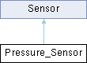
Figure 2: pressure sensor inheritance

Public Member Functions
Pressure_Sensor ()
constructor

SensorData read () override
Reads pressure data from sensor.

Detailed Description
Concrete sensor class for measuring atmospheric pressure.
Implements the Sensor interface to provide barometric pressure readings from the connected pressure sensor hardware.

Member Function Documentation

SensorData Pressure_Sensor::read ()[override], [virtual]

Reads pressure data from sensor.

Returns
SensorData containing pressure reading
Implements Sensor (p.10).

The documentation for this class was generated from the following files:
Pressure_sensor.h
Pressure_sensor.cpp

Sensor Class Reference

Abstract base class for all sensor types.
#include <Sensor.h>
Inheritance diagram for Sensor:

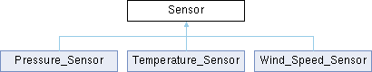
Figure 3: full sensor inheritance

Public Member Functions
virtual SensorData read ()=0
Pure virtual function to read sensor data.

Detailed Description
Abstract base class for all sensor types.
Provides interface for reading sensor data. Derived classes must implement the read() method for specific sensor types.

Member Function Documentation

virtual SensorData Sensor::read ()[pure virtual]

Pure virtual function to read sensor data.

Returns
SensorData object containing the reading
Implemented in Pressure_Sensor (p.9), Temperature_Sensor (p.12), and Wind_Speed_Sensor (p.16).

The documentation for this class was generated from the following file:
Sensor.h

SensorData Class Reference

Data structure to hold sensor readings.
#include <SensorData.h>

Public Member Functions
SensorData ()
default constructor

SensorData (float temp, float wind, float press)
constructor

Detailed Description
Data structure to hold sensor readings.

The documentation for this class was generated from the following files:
SensorData.h
SensorData.cpp

Temperature_Sensor Class Reference

Represents a temperature sensor.
#include <Temperature_sensor.h>
Inheritance diagram for Temperature_Sensor:

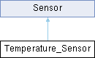
Figure 4: temperature sensor inheritance

Public Member Functions
Temperature_Sensor ()
constructor

SensorData read () override
Temperature sensor read function imlementation.

Detailed Description
Represents a temperature sensor.

Member Function Documentation

SensorData Temperature_Sensor::read ()[override], [virtual]

Temperature sensor read function imlementation.
Implements Sensor (p.10).

The documentation for this class was generated from the following files:
Temperature_sensor.h
Temperature_sensor.cpp

Weather_information_service Class Reference

Manages satellite communication for data transmission.
#include <Weather_information_service.h>

Public Member Functions
bool transfer (SensorData data)
Transfers sensor data via satellite.

Detailed Description
Manages satellite communication for data transmission.
Handles transmission of weather data to external systems via satellite link.

Member Function Documentation

bool Weather_information_service::transfer (SensorData data)[inline]

Transfers sensor data via satellite.

Parameters
data | SensorData to transmit

Returns
true if transmission was successful, else return false

The documentation for this class was generated from the following files:
Weather_information_service.h
Weather_information_service.cpp

Weather_station Class Reference

Main controller for the weather monitoring system.
#include <Memory_bank.h>

Public Member Functions
Weather_station ()
Constructor initializes all components in the Weather system.

SensorData readSensors ()
Reads data from all connected sensors.

void saveData (SensorData data)
Saves sensor data to memory.

void setDisplayState (int btnId)
Updates the display with current state.

void updateDisplay ()
Refreshes the display output.

void transferData (SensorData data)
Transfers data to external service.

void scheduleTransmission (int interval)
Schedules automatic data transmission.

Detailed Description
Main controller for the weather monitoring system.
Coordinates sensors, display, memory storage and data transmission

Member Function Documentation

SensorData Weather_station::readSensors ()

Reads data from all connected sensors.

Returns
SensorData containing current readings

void Weather_station::saveData (SensorData data)

Saves sensor data to memory.

Parameters
data | The SensorData to store

void Weather_station::scheduleTransmission (int interval)

Schedules automatic data transmission.

Parameters
interval | Time interval in seconds

void Weather_station::setDisplayState (int btnId)

Updates the display with current state.

Parameters
btnId | Button identifier for state changes

void Weather_station::transferData (SensorData data)

Transfers data to external service.

Parameters
data | SensorData to transmit

The documentation for this class was generated from the following files:
Weather_station.h
Weather_station.cpp

Wind_Speed_Sensor Class Reference

A sensor class that measures wind speed.
#include <Wind_Speed_sensor.h>
Inheritance diagram for Wind_Speed_Sensor:

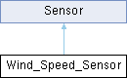
Figure 5: wind speed sensor inheritance

Public Member Functions
Wind_Speed_Sensor ()
constructor

SensorData read () override
Reads wind speed data from sensor.

Detailed Description
A sensor class that measures wind speed.
Implements the Sensor interface to provide wind speed

Member Function Documentation

SensorData Wind_Speed_Sensor::read ()[override], [virtual]

Reads wind speed data from sensor.

Returns
SensorData containing wind speed reading
Implements Sensor (p.10).

The documentation for this class was generated from the following files:
Wind_Speed_sensor.h
Wind_Speed_sensor.cpp

File Documentation

Button.h

1 #ifndef BUTTON_H
2 #define BUTTON_H
3
10 class Button {
11 private:
12 int id;
13 public:
18 Button(int btnId) : id(btnId) {}
19
24 void buttonISR(int btnId) {}
25 };
26
27 #endif

Display.h

1 #ifndef DISPLAY_H
2 #define DISPLAY_H
3
4 #include "SensorData.h"
12 class Display {
13 private:
14 DataView state;
15
16 public:
20 Display() : state(real_time) {}
21
26 void changState(int btnId) {}
27
32 void display_data(SensorData data) {}
33
39 SensorData getData(DataView dataInterval) {}
40
45 DataView getState() const{
46 return state;
47 }
48 };
49
50 #endif

Memory_bank.h

1 #ifndef MEMORY_BANK_H
2 #define MEMORY_BANK_H
3
4 #include "SensorData.h"
5
12 class Memory_bank {
13 public:
19 SensorData getData(DataView dataInterval) {}
20
26 bool saveData(SensorData data) { }
27 };
28
29 #endif

Pressure_sensor.h

1 #ifndef PRESSURE_SENSOR_H
2 #define PRESSURE_SENSOR_H
3
4 #include "Sensor.h"
5
13 class Pressure_Sensor : public Sensor {
14 public:
18 Pressure_Sensor();
19
24 SensorData read() override;
25 };
26
27 #endif

Sensor.h

1 #ifndef SENSOR_H
2 #define SENSOR_H
3
4 #include "SensorData.h"
5
13
14 class Sensor {
15 public:
20 virtual SensorData read() = 0;
21
22 };
23
24 #endif

SensorData.h

1 #ifndef SENSORDATA_H
2 #define SENSORDATA_H
3
8 enum DataView {
9 real_time,
10 hourly_historical,
11 daily_historical
12 };
13
18 class SensorData {
19 private:
20 float temperature;
21 float windSpeed;
22 float pressure;
23
24 public:
28 SensorData() : temperature(0.0), windSpeed(0.0), pressure(0.0) {}
29
33 SensorData(float temp, float wind, float press) : temperature(temp), windSpeed(wind), pressure(press) {}
34
35 };
36
37 #endif

Temperature_sensor.h

1 #ifndef TEMPERATURE_SENSOR_H
2 #define TEMPERATURE_SENSOR_H
3
4 #include "Sensor.h"
5
10 class Temperature_Sensor : public Sensor {
11 public:
15 Temperature_Sensor();
16
20 SensorData read() override;
21 };
22
23 #endif // TEMPERATURE_SENSOR_H

Weather_information_service.h

1 #ifndef WEATHER_INFORMATION_SERVICE_H
2 #define WEATHER_INFORMATION_SERVICE_H
3
4 #include "SensorData.h"
12 class Weather_information_service {
13 public:
19 bool transfer(SensorData data) { }
20 };
21
22 #endif

Weather_station.h

1 #ifndef WEATHER_STATION_H
2 #define WEATHER_STATION_H
3
4 #include "Display.h"
5 #include "Sensor.h"
6 #include "Memory_bank.h"
7 #include "Weather_information_service.h"
8
15 class Weather_station {
16 private:
17 Display* display;
18
19 Sensor* Sensors[3];
20
21 Memory_bank* memoryBanks[1];
22
23 SensorData currentData;
24
25 int transmissionInterval;
26 public:
30 Weather_station();
31
36 SensorData readSensors();
37
42 void saveData(SensorData data);
43
48 void setDisplayState(int btnId);
49
53 void updateDisplay();
54
59 void transferData(SensorData data);
60
65 void scheduleTransmission(int interval);
66 };
67
68 #endif

Wind_Speed_sensor.h

1 #ifndef WIND_SPEED_SENSOR_H
2 #define WIND_SPEED_SENSOR_H
3
4 #include "Sensor.h"
5
12 class Wind_Speed_Sensor : public Sensor {
13 public:
17 Wind_Speed_Sensor();
18
23 SensorData read() override;
24 };
25
26 #endif

