Aim 1 Quant Survey - PPW

David Owaga & Yuwei Wang

2024-11-12

## Women Demographics

Altogether, we currently have data for 390 participants.

Table 1: Table 1: Basic Demographic Summary for Women

| **Characteristic** | **N** | **N = 190***1* |
| --- | --- | --- |
| **Age (Years)** | 190 | 26.0 [IQR: 21.0, 30.0] |
| **Immunization for my baby** | 190 | 106 (56%) |
| **Follow-up antenatal care visit** | 190 | 53 (28%) |
| **First Antenatal care visit** | 190 | 21 (11%) |
| **Postnatal care** | 190 | 27 (14%) |
| **Family planning** | 190 | 4 (2.1%) |
| **Pregnancy Status** | 190 |  |
| *Postpartum* |  | 116 (61%) |
| *Pregnant* |  | 74 (39%) |
| **Gestational age (weeks)** | 74 | 25.0 [IQR: 20.0, 32.0] |
| **Weeks since delivery** | 116 | 20.0 [IQR: 10.0, 32.0] |
| **Total number of pregnancies** | 190 | 2.0 [IQR: 1.0, 3.0] |
| **Education level** | 190 |  |
| *Above secondary / tertiary* |  | 38 (20%) |
| *Primary completed* |  | 44 (23%) |
| *Secondary - not completed* |  | 45 (24%) |
| *Secondary - completed* |  | 40 (21%) |
| *Primary - not completed* |  | 23 (12%) |
| **Kind of partner** | 190 |  |
| *Divorced/widowed* |  | 2 (1.1%) |
| *Married, monogamous* |  | 117 (62%) |
| *Married, polygamous* |  | 23 (12%) |
| *No partner, single* |  | 26 (14%) |
| *Separated* |  | 1 (0.5%) |
| *Steady boyfriend* |  | 12 (6.3%) |
| *Unsteady boyfriend (on and off)* |  | 9 (4.7%) |
| **Employment status** | 190 |  |
| *A homemaker* |  | 40 (21%) |
| *On wages (Irregular salary)* |  | 27 (14%) |
| *Out of work and looking for work* |  | 8 (4.2%) |
| *Out of work but not currently looking for work* |  | 4 (2.1%) |
| *Salaried* |  | 23 (12%) |
| *Self-employed* |  | 19 (10%) |
| *Student* |  | 20 (11%) |
| *Unemployed* |  | 48 (25%) |
| *Volunteer* |  | 1 (0.5%) |
| **Residential area** | 190 |  |
| *Rural areas or countryside* |  | 161 (85%) |
| *Peri-urban areas* |  | 19 (10%) |
| *Urban or city center* |  | 10 (5.3%) |
| **Duration to the facility** | 190 |  |
| *< an hour* |  | 179 (94%) |
| *>= an hour* |  | 11 (5.8%) |
| **Duration to the facility (Minutes)** | 179 | 25.0 [IQR: 15.0, 30.0] |
| **Duration to the facility (Hours)** | 11 | 1.0 [IQR: 1.0, 2.0] |
| **HIV status** | 190 |  |
| *Don't know* |  | 1 (0.5%) |
| *HIV negative* |  | 163 (86%) |
| *Living with HIV* |  | 26 (14%) |
| **Duration known LHIV (years)** | 26 | 5.5 [IQR: 2.0, 12.0] |
| **Currently using antiretroviral therapy** | 26 |  |
| *Yes* |  | 26 (100%) |
| **PHQ2 or QAD2 >= 3** | 190 | 69 (36%) |
| *1*Median [IQR: Q1, Q3]; n (%) | | |

# Screening

Table 1: Table 2: Basic Screening Summary for Women

| **Characteristic** | **N** | **N = 390***1* |
| --- | --- | --- |
| **Service access** | 189 | 43 (23%) |
| **Times of access** | 43 |  |
| *3-4 times* |  | 16 (37%) |
| *5-6 times* |  | 8 (19%) |
| *Less than 2 times* |  | 15 (35%) |
| *More than 6 times* |  | 4 (9.3%) |
| *1*n (%) | | |

## Criticality of Screening Barriers

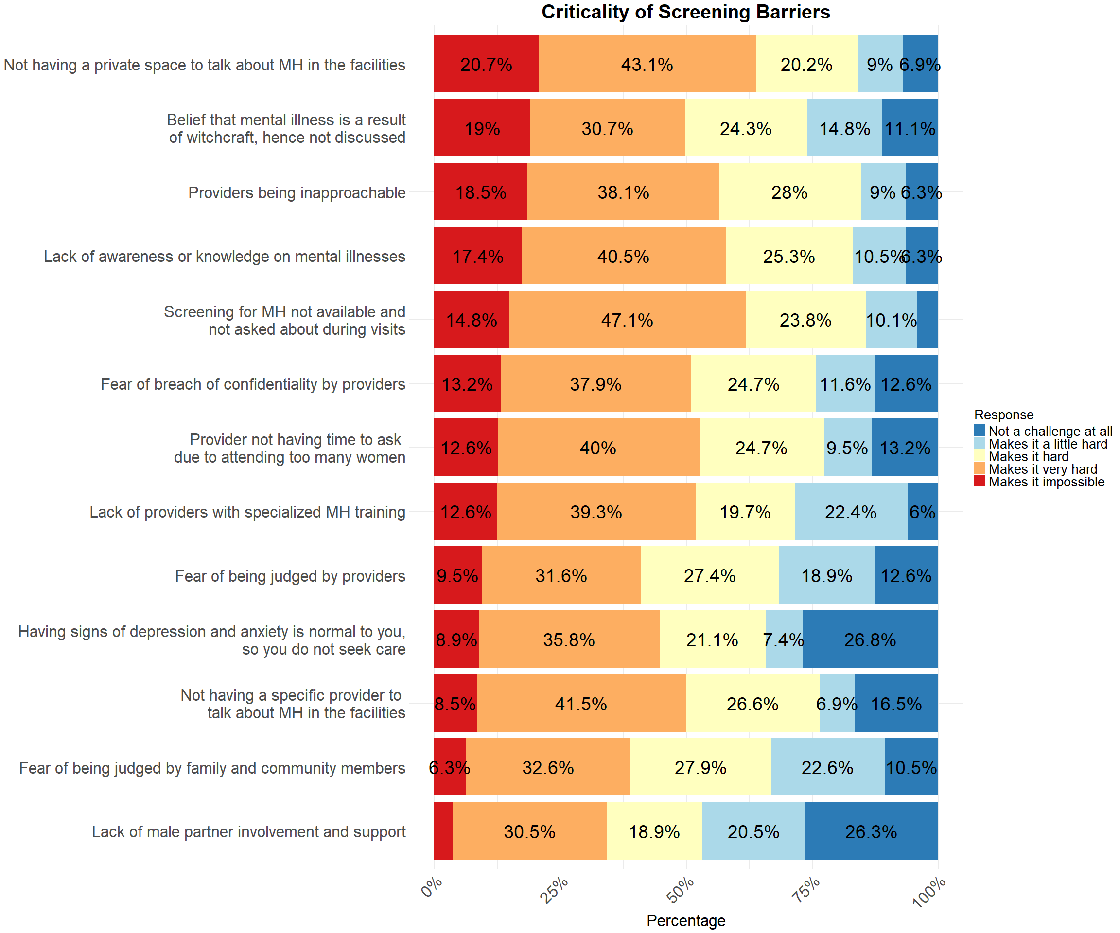

## Impact of Screening Strategies

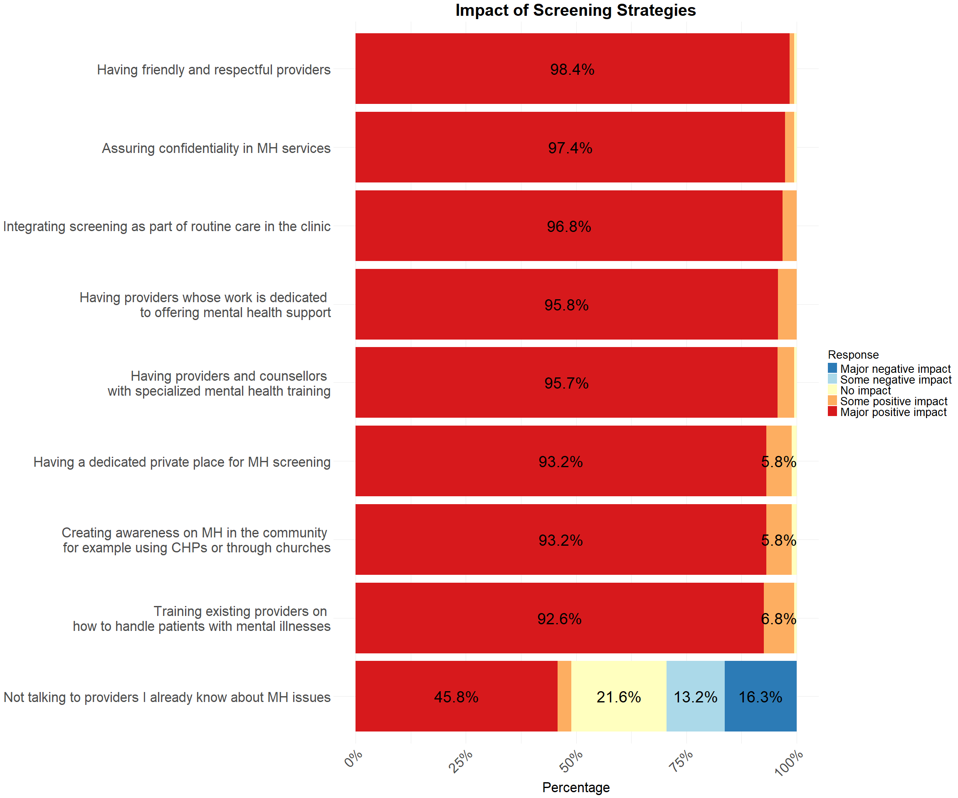

# Diagnosis and Treatment

Table 1: Table 3: Diagnosis and Treatment Summary for PPW

| **Characteristic** | **N** | **N = 390***1* |
| --- | --- | --- |
| **Ever been diagnosed** | 7 |  |
| *Both depression and anxiety* |  | 2 (29%) |
| *Depression* |  | 5 (71%) |
| **Time of depression diagnosis** | 7 |  |
| *After delivery* |  | 2 (29%) |
| *During the pregnancy* |  | 5 (71%) |
| **Gestational age (month) diagnosed with depression** | 5 | 6.0 (3.0, 6.0) |
| **Diagnosed with depression after delivery (month)** | 2 | 3.0 (1.0, 5.0) |
| **Time of anxiety diagnosis** | 2 |  |
| *During the pregnancy* |  | 2 (100%) |
| **Gestational age (month) diagnosed with anxiety** | 2 | 2.5 (2.0, 3.0) |
| **Diagnosed with anxiety after delivery (month)** | 0 | 0 (NA%) |
| **Counselling** | 390 | 7 (1.8%) |
| **Medication** | 390 | 1 (0.3%) |
| **Type of counselling** | 7 |  |
| *General Counselling* |  | 1 (14%) |
| *Interpersonal Counselling* |  | 2 (29%) |
| *Supportive Counselling* |  | 1 (14%) |
| *Unspecified Counselling* |  | 3 (43%) |
| **PMAD treatment in last 2 months** | 7 |  |
| *3-4 times* |  | 2 (29%) |
| *Less than 2 times* |  | 5 (71%) |
| *1*n (%); Median (Q1, Q3) | | |

## Criticality of Diagnosis and Treatment Barriers

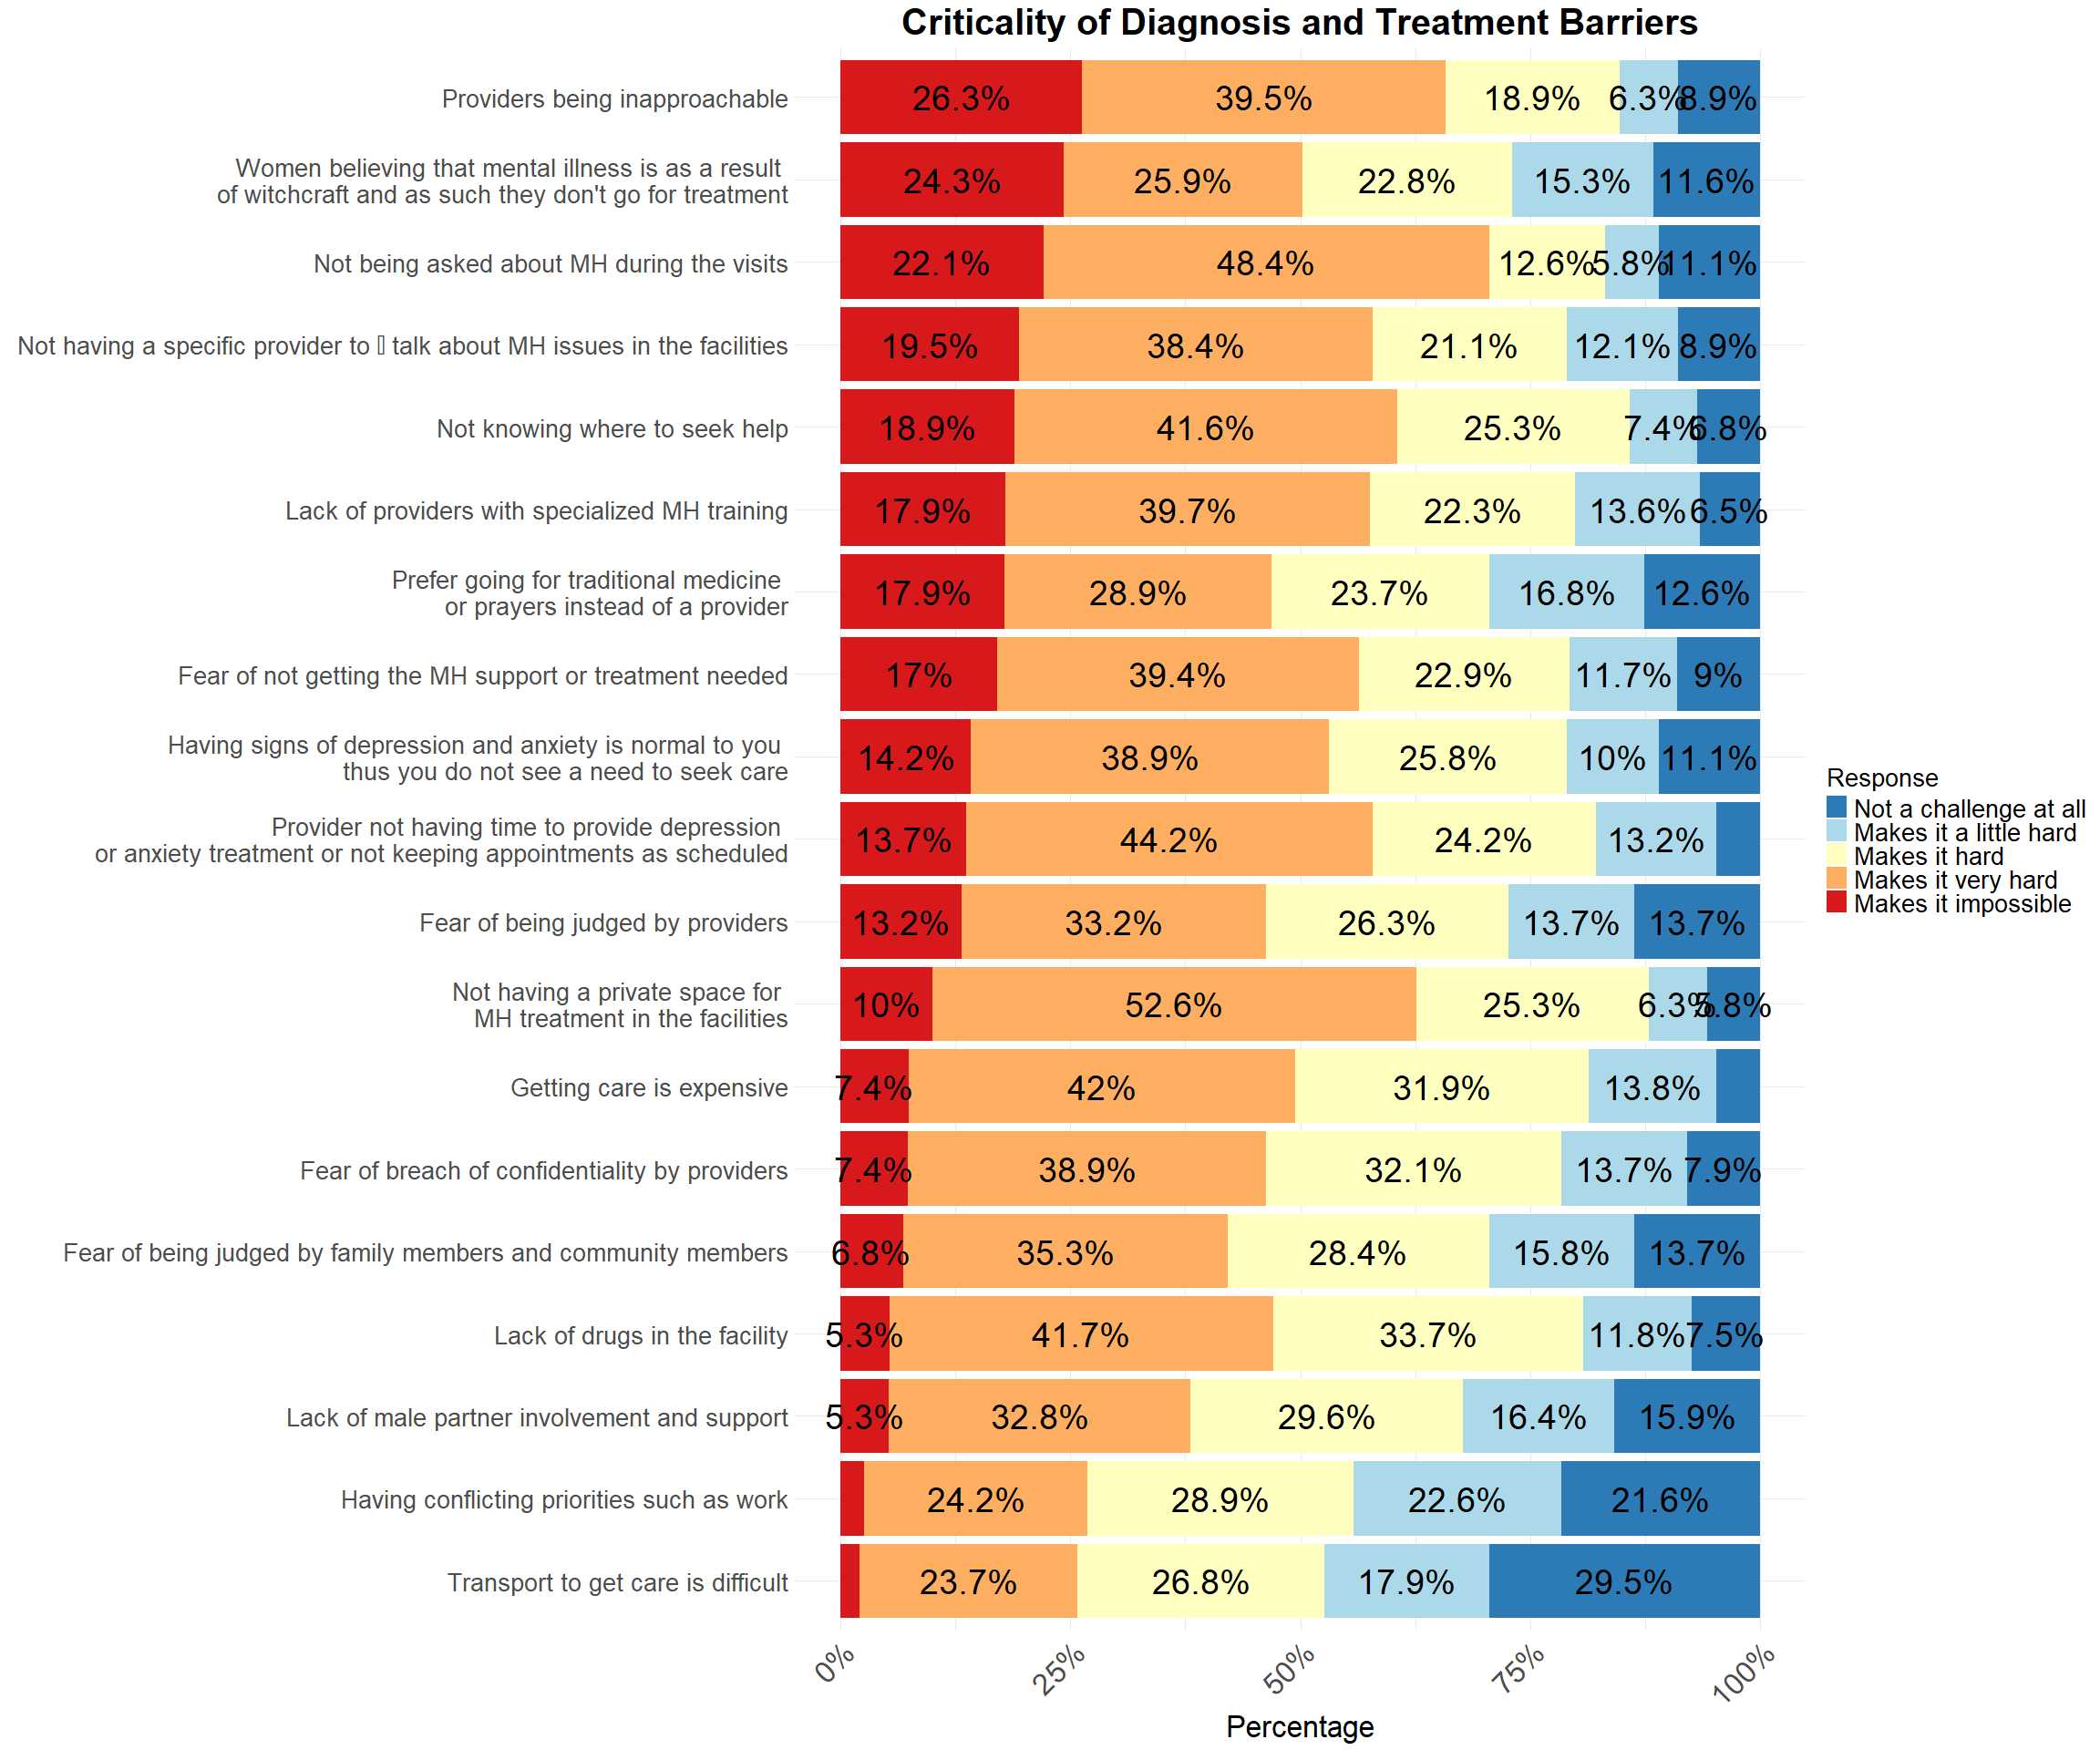

## Impact of Diagnosis and Treatment Strategies

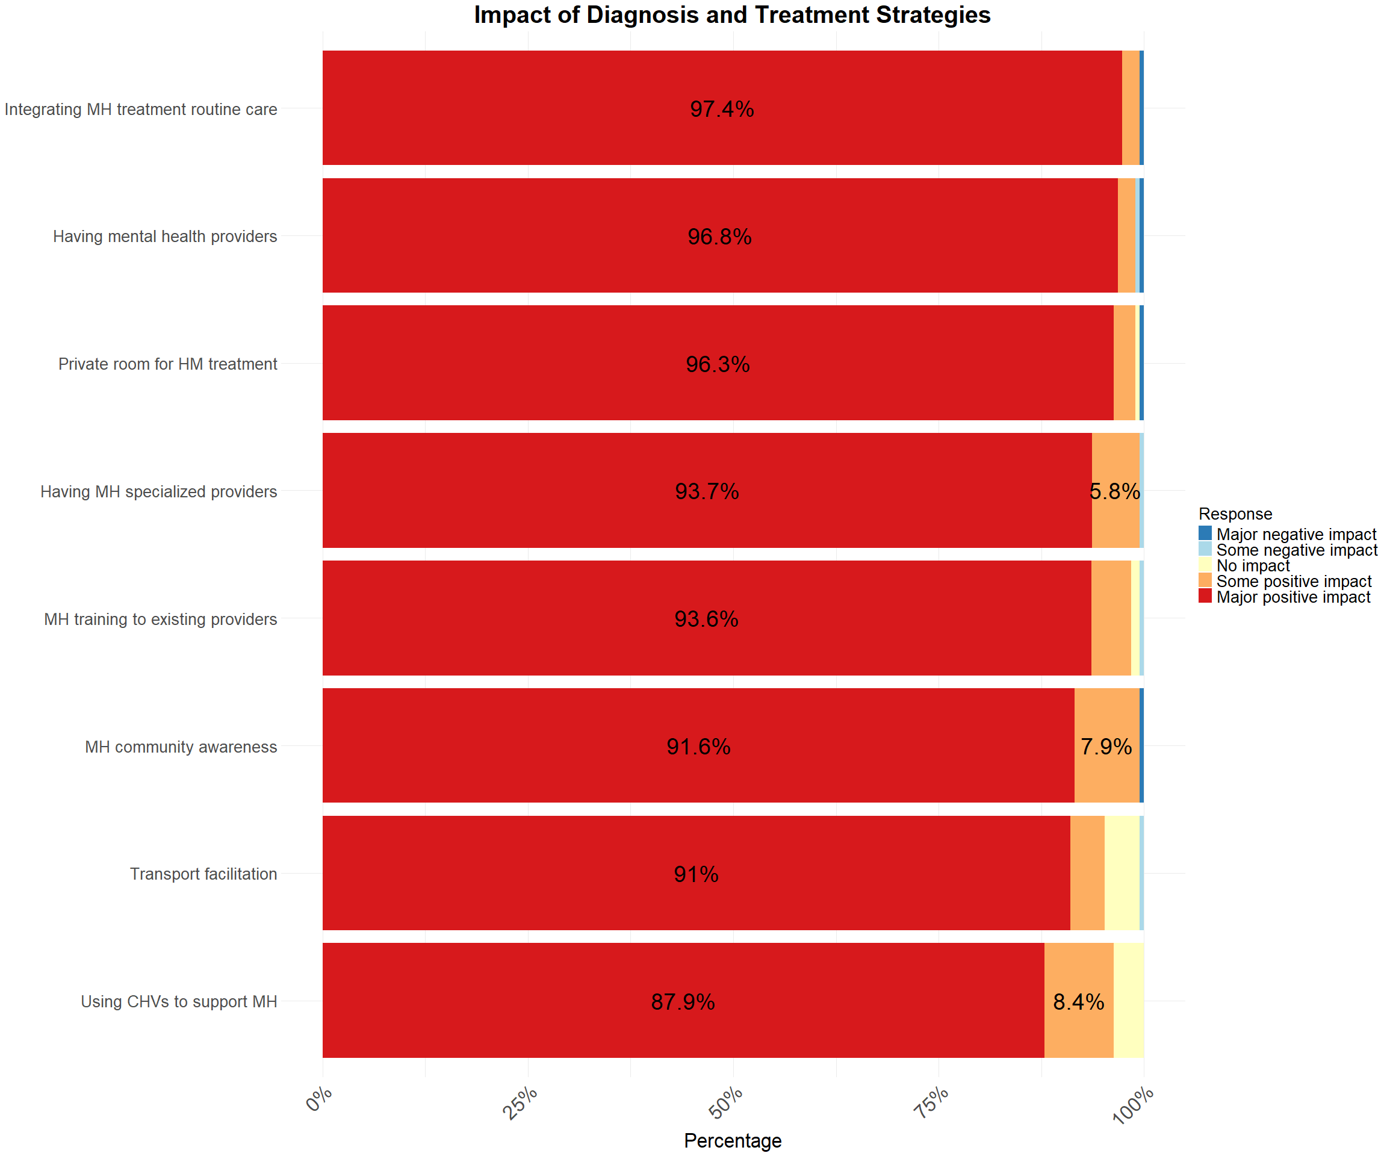

# Referral And Remission

Table 1: Table 4: Referral and Remission Summary for PPW

| **Characteristic** | **N** | **N = 390***1* |
| --- | --- | --- |
| **Refered to receive care for PMAD** | 190 |  |
| *No* |  | 190 (100%) |
| **Received treatment multiple times with the provider monitoring symptoms** | 190 | 1 (0.5%) |
| *1*n (%) | | |

## Criticality of Referral and Remission Barriers

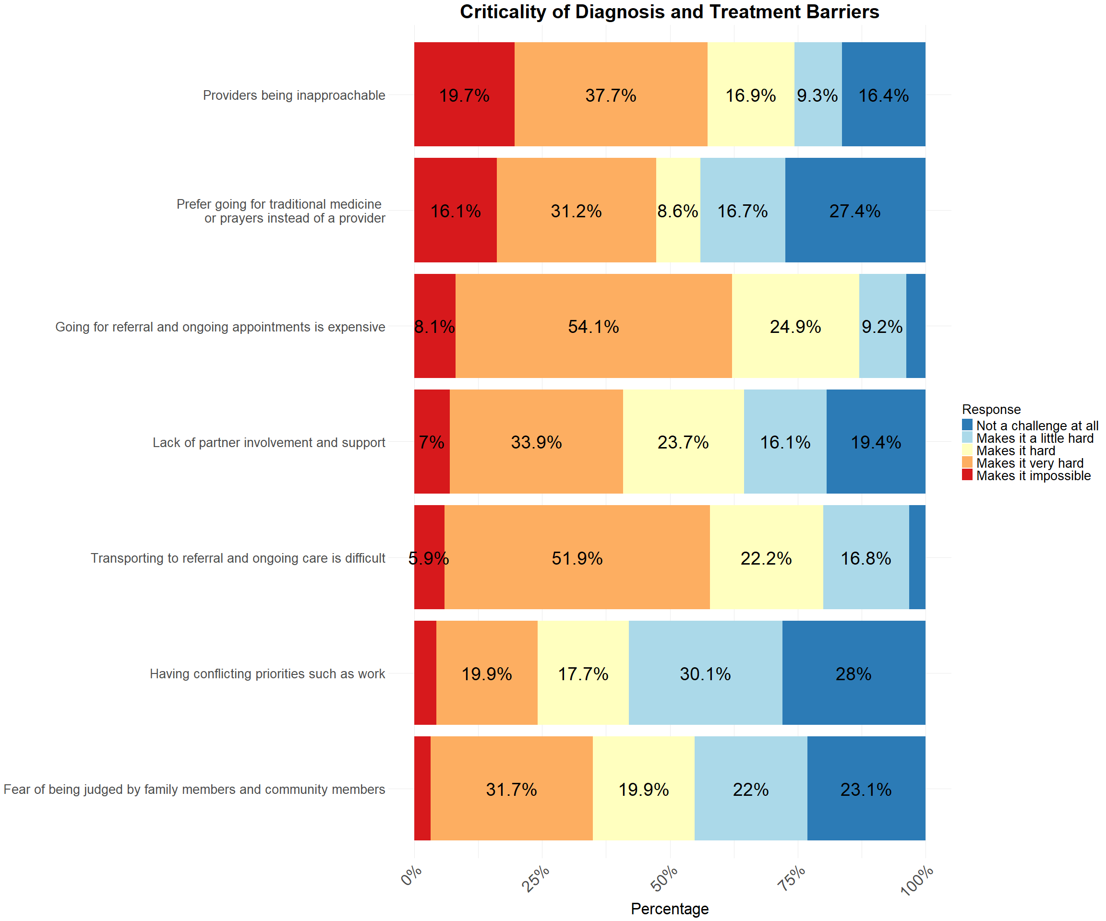

## Impact of Referral and Remission Strategies

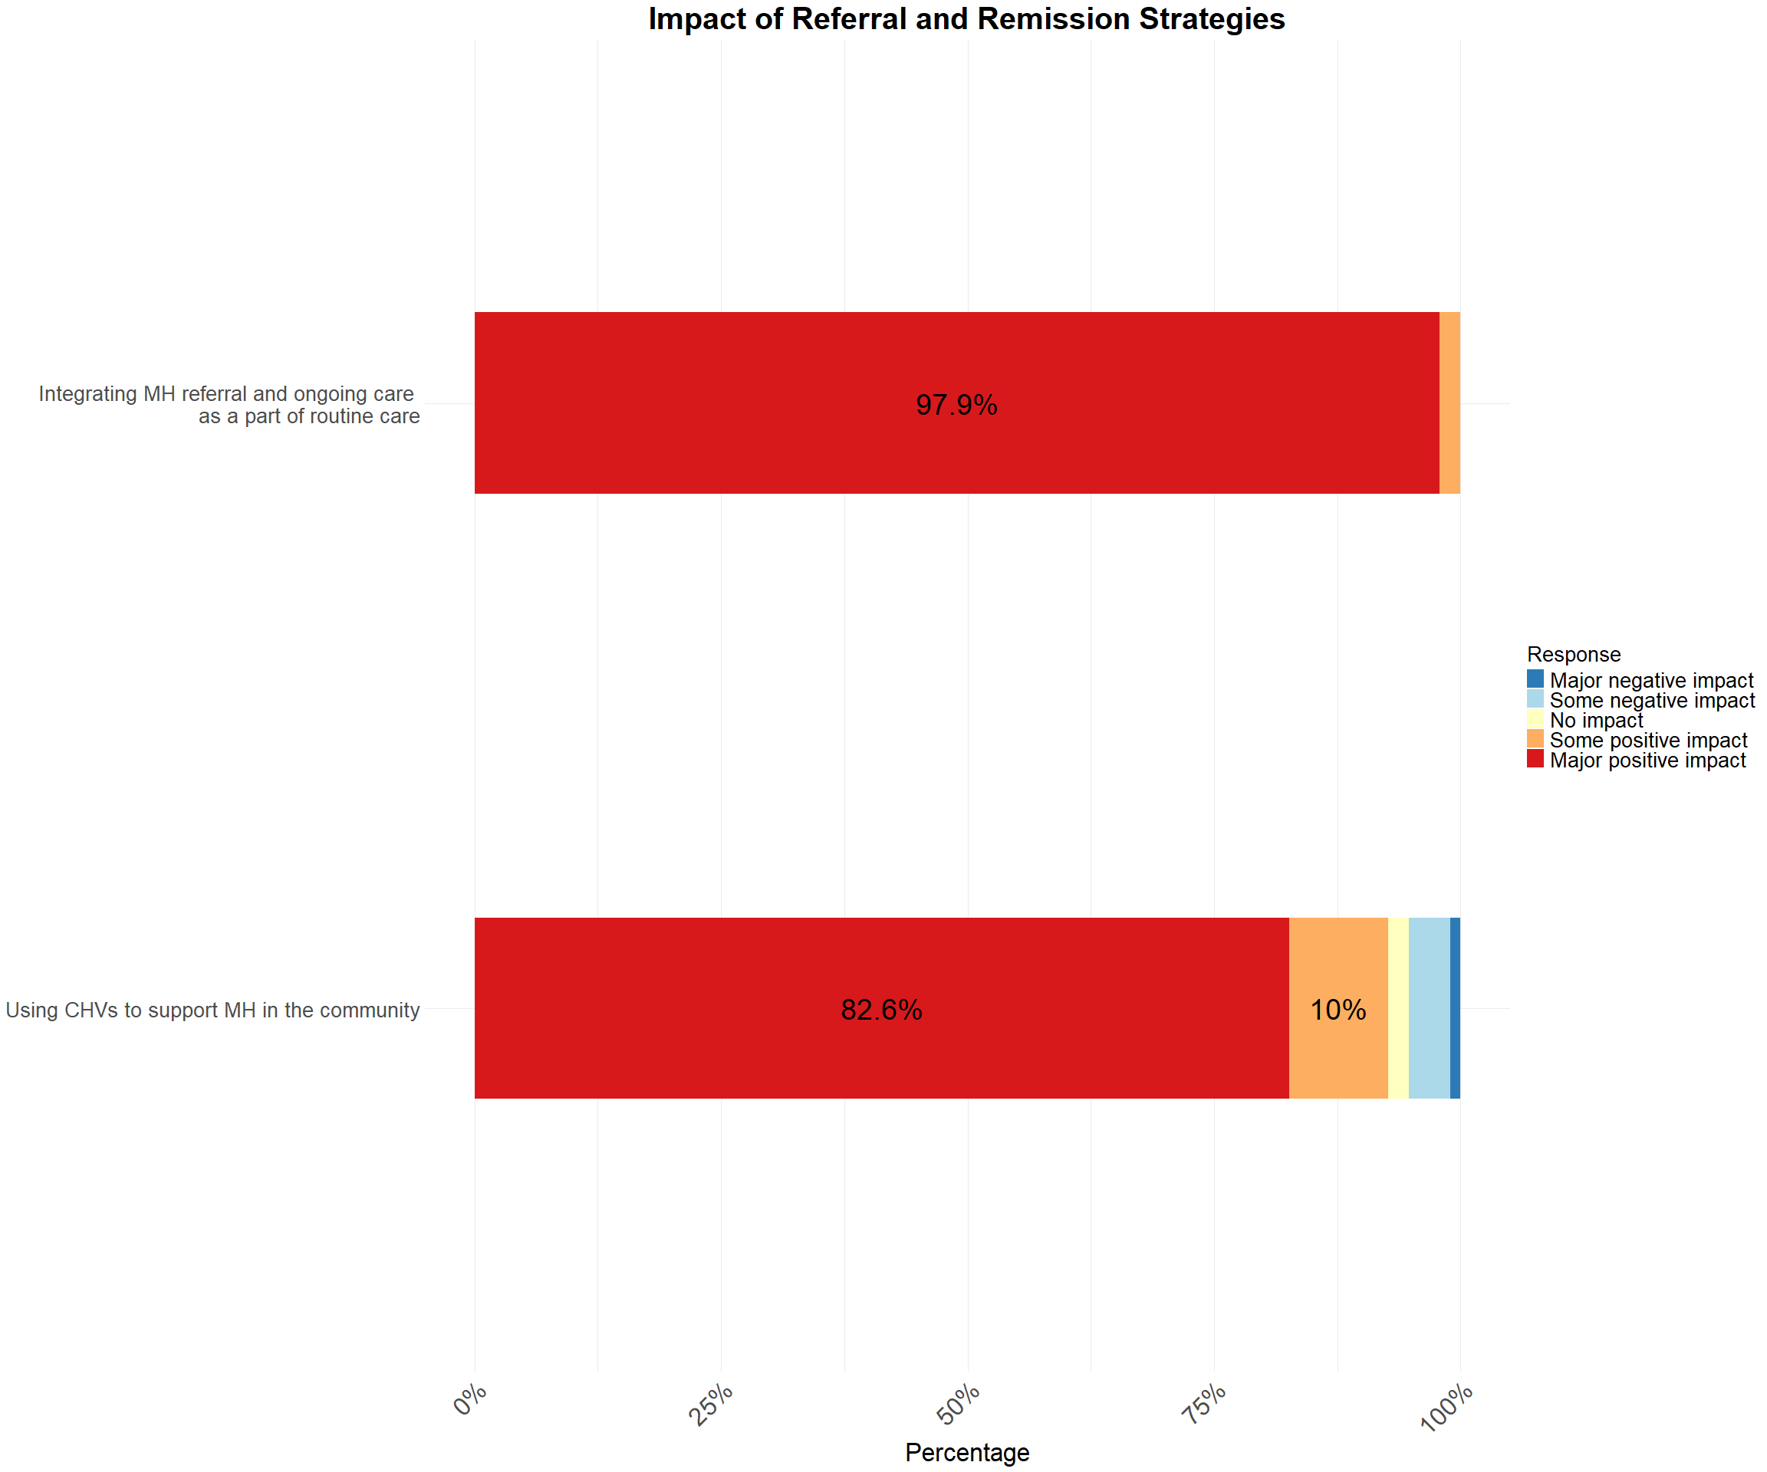

# Frequency of Barriers Across All Steps

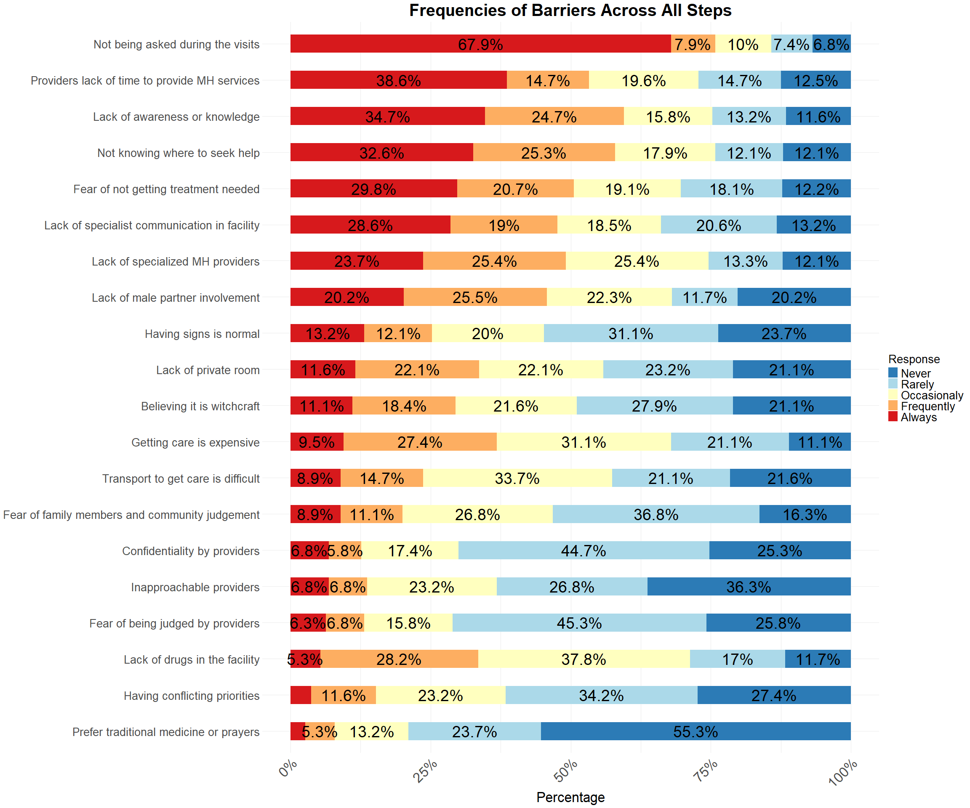

# IPMH

## IPMH screening

### Criticality of IPMH Screening Barriers

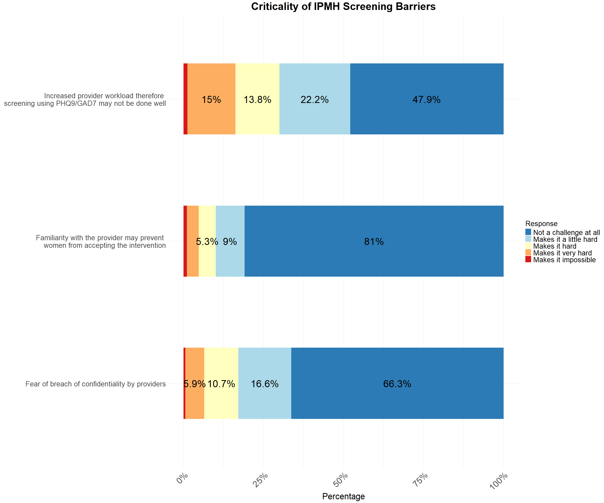

### Frequency of IPMH Screening Barriers

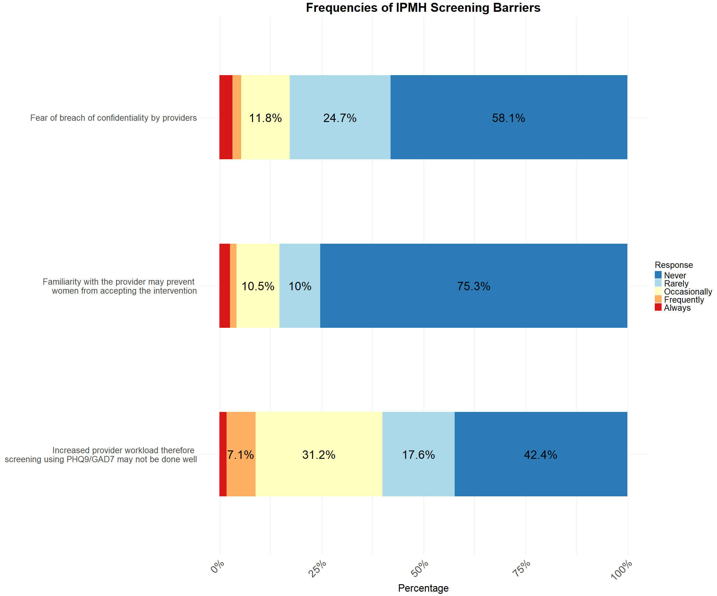

### Impact of IPMH Screening Strategies

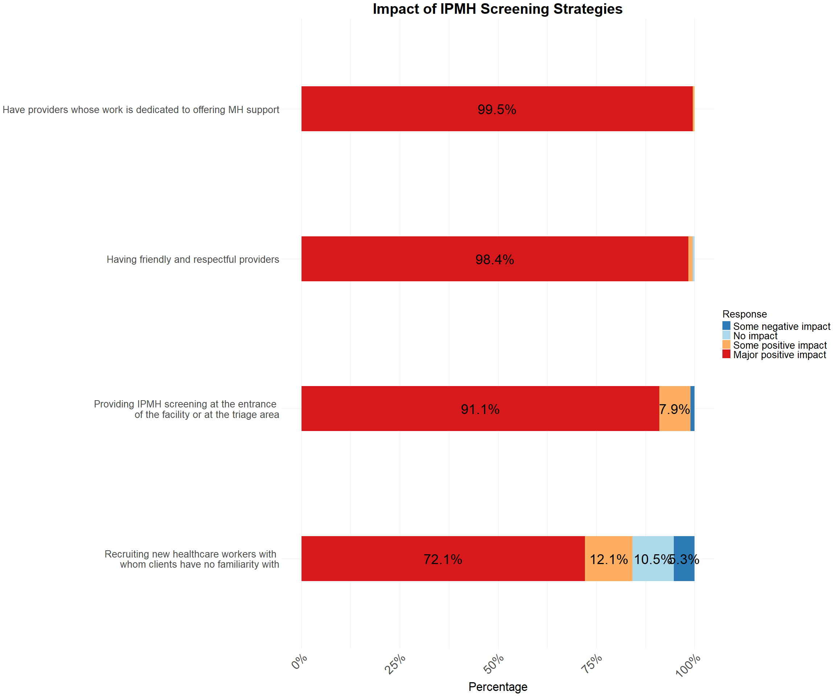

## IPMH PM+

### Criticality of IPMH PM+ Barriers

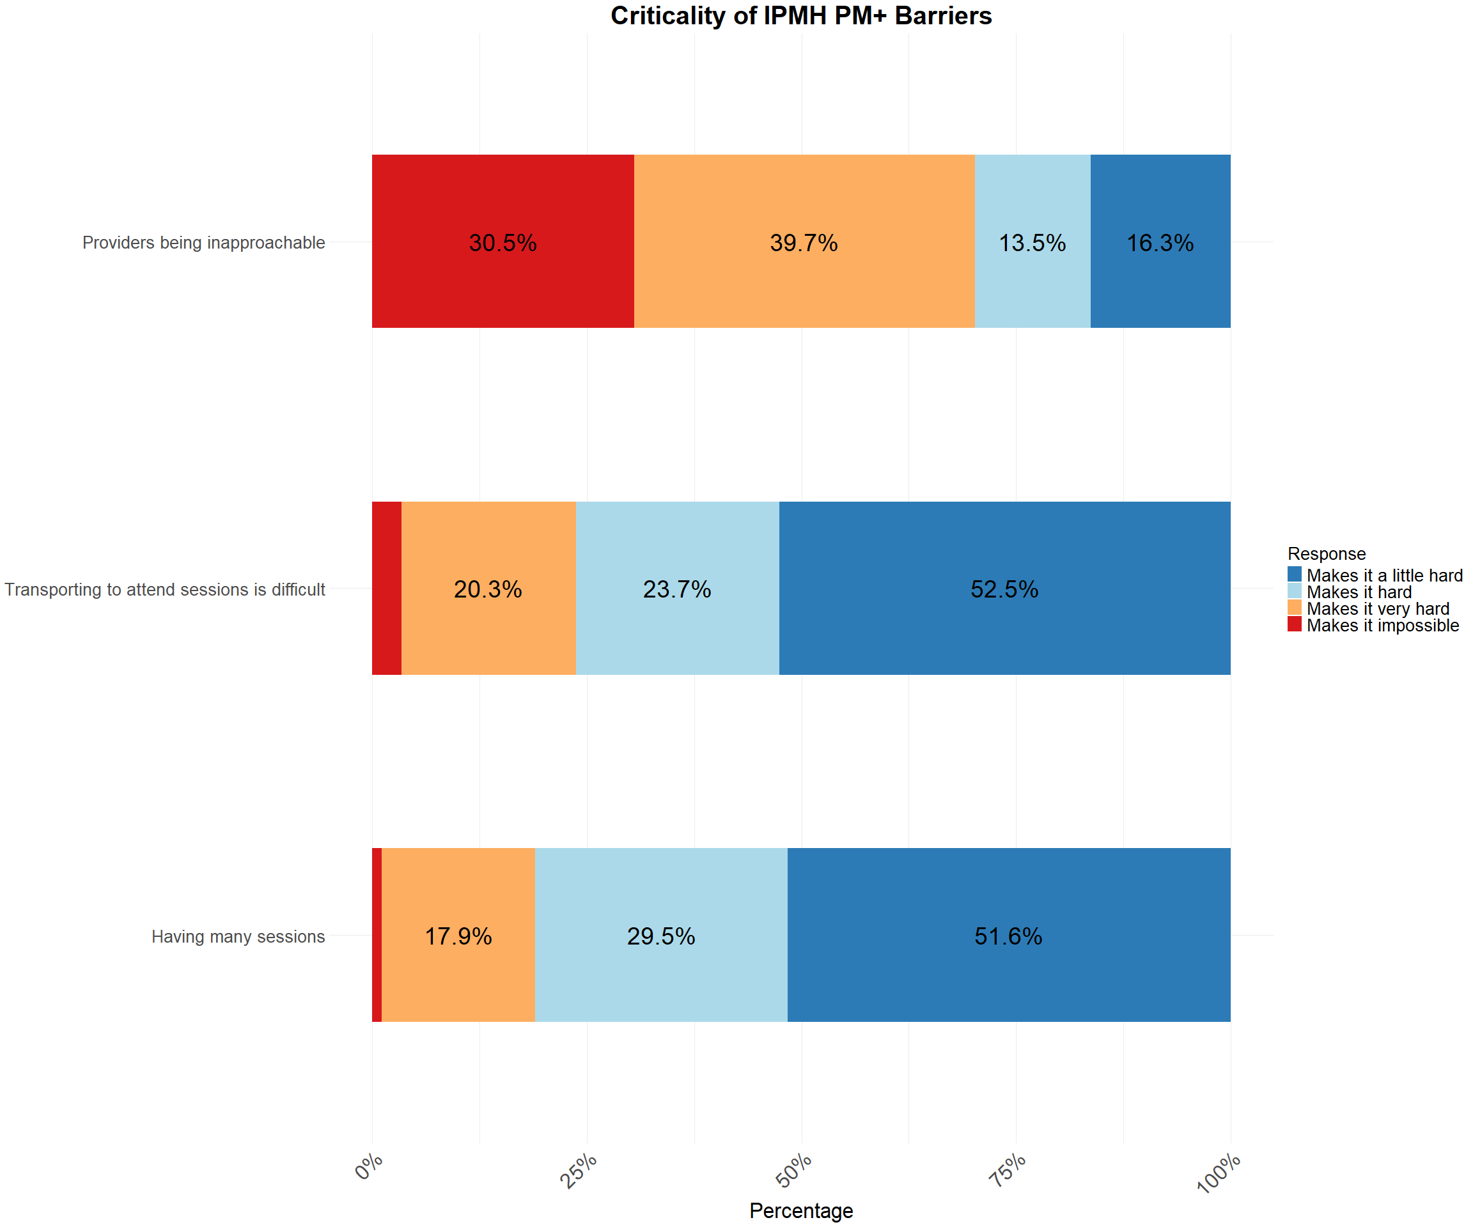

### Frequency of IPMH PM+ Barriers

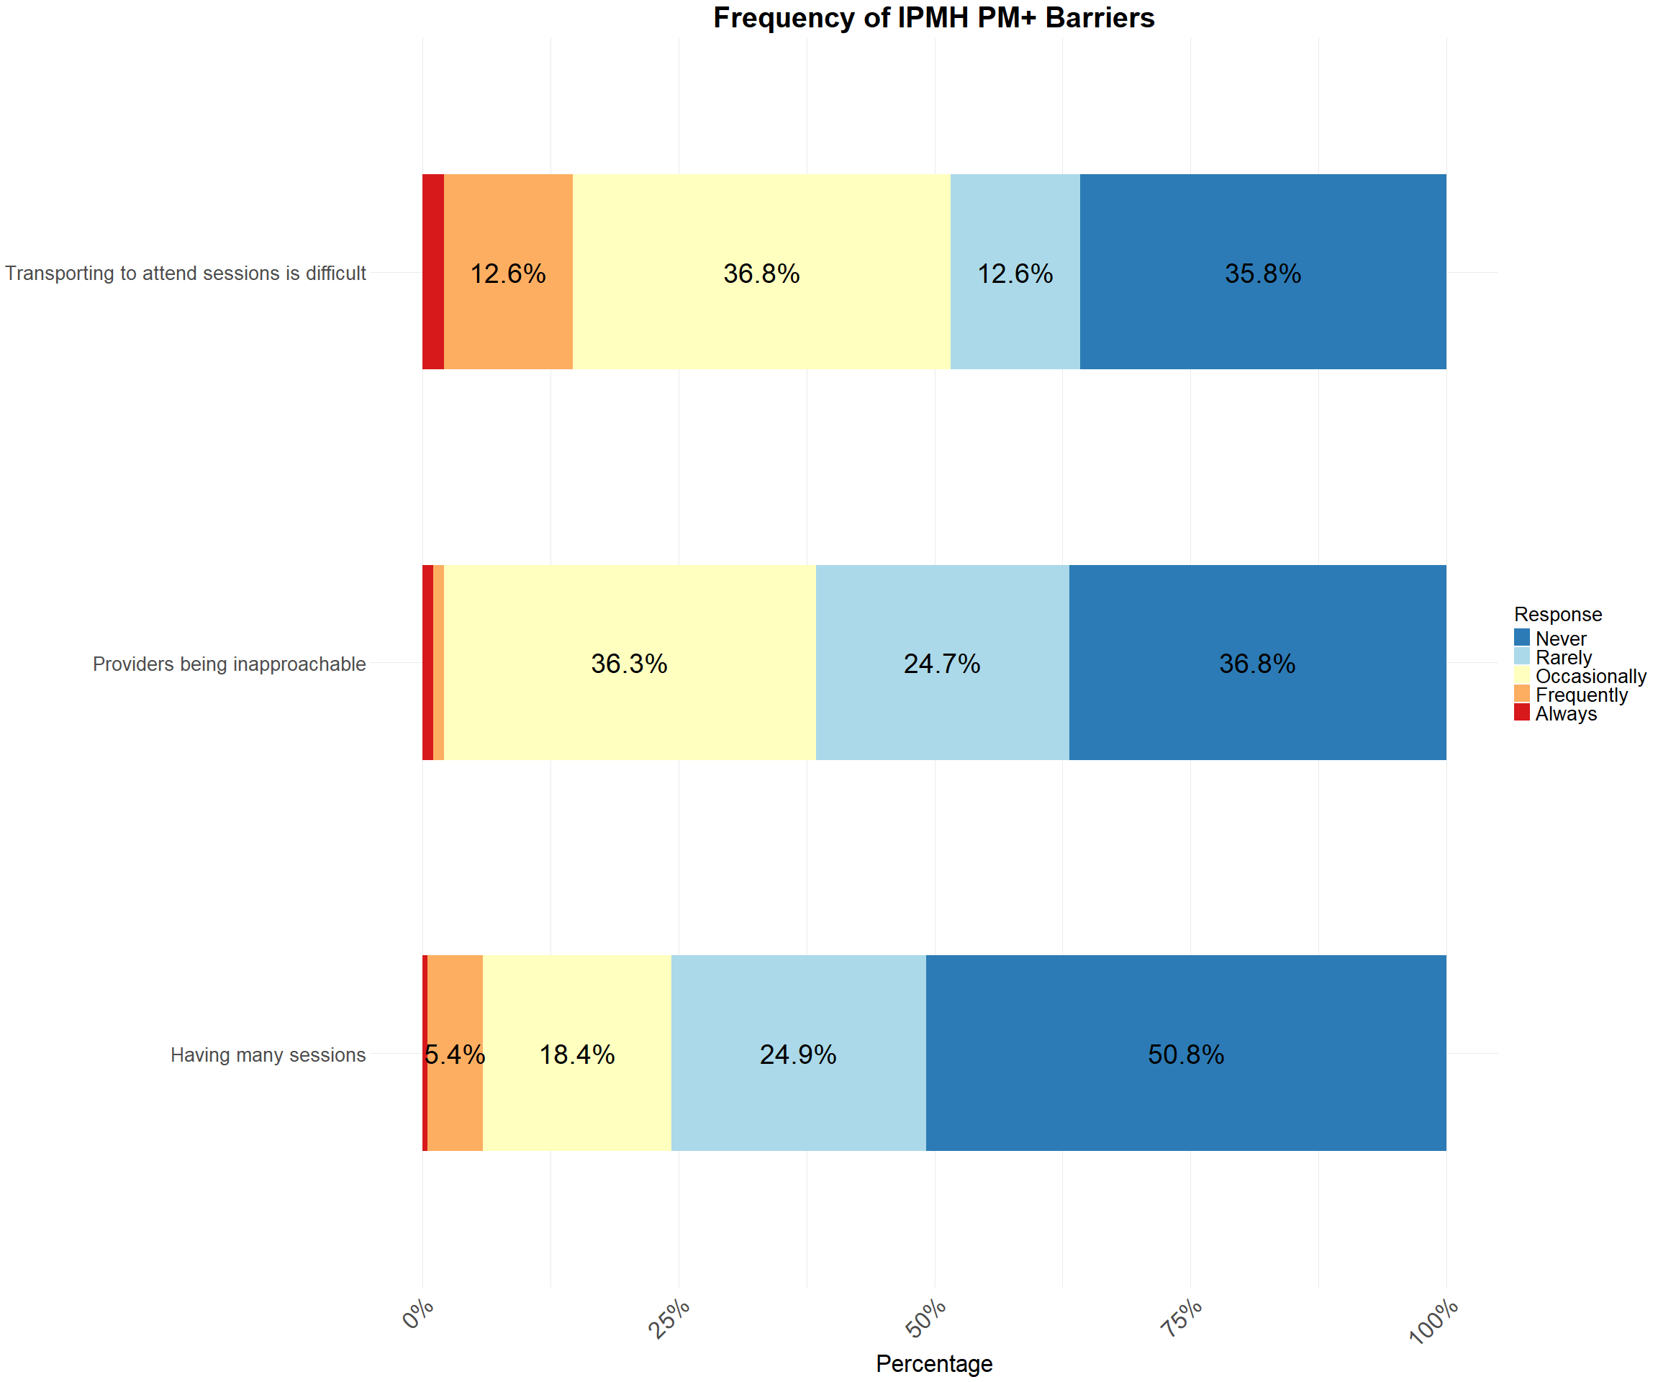

### Impact of IPMH PM+ Strategies

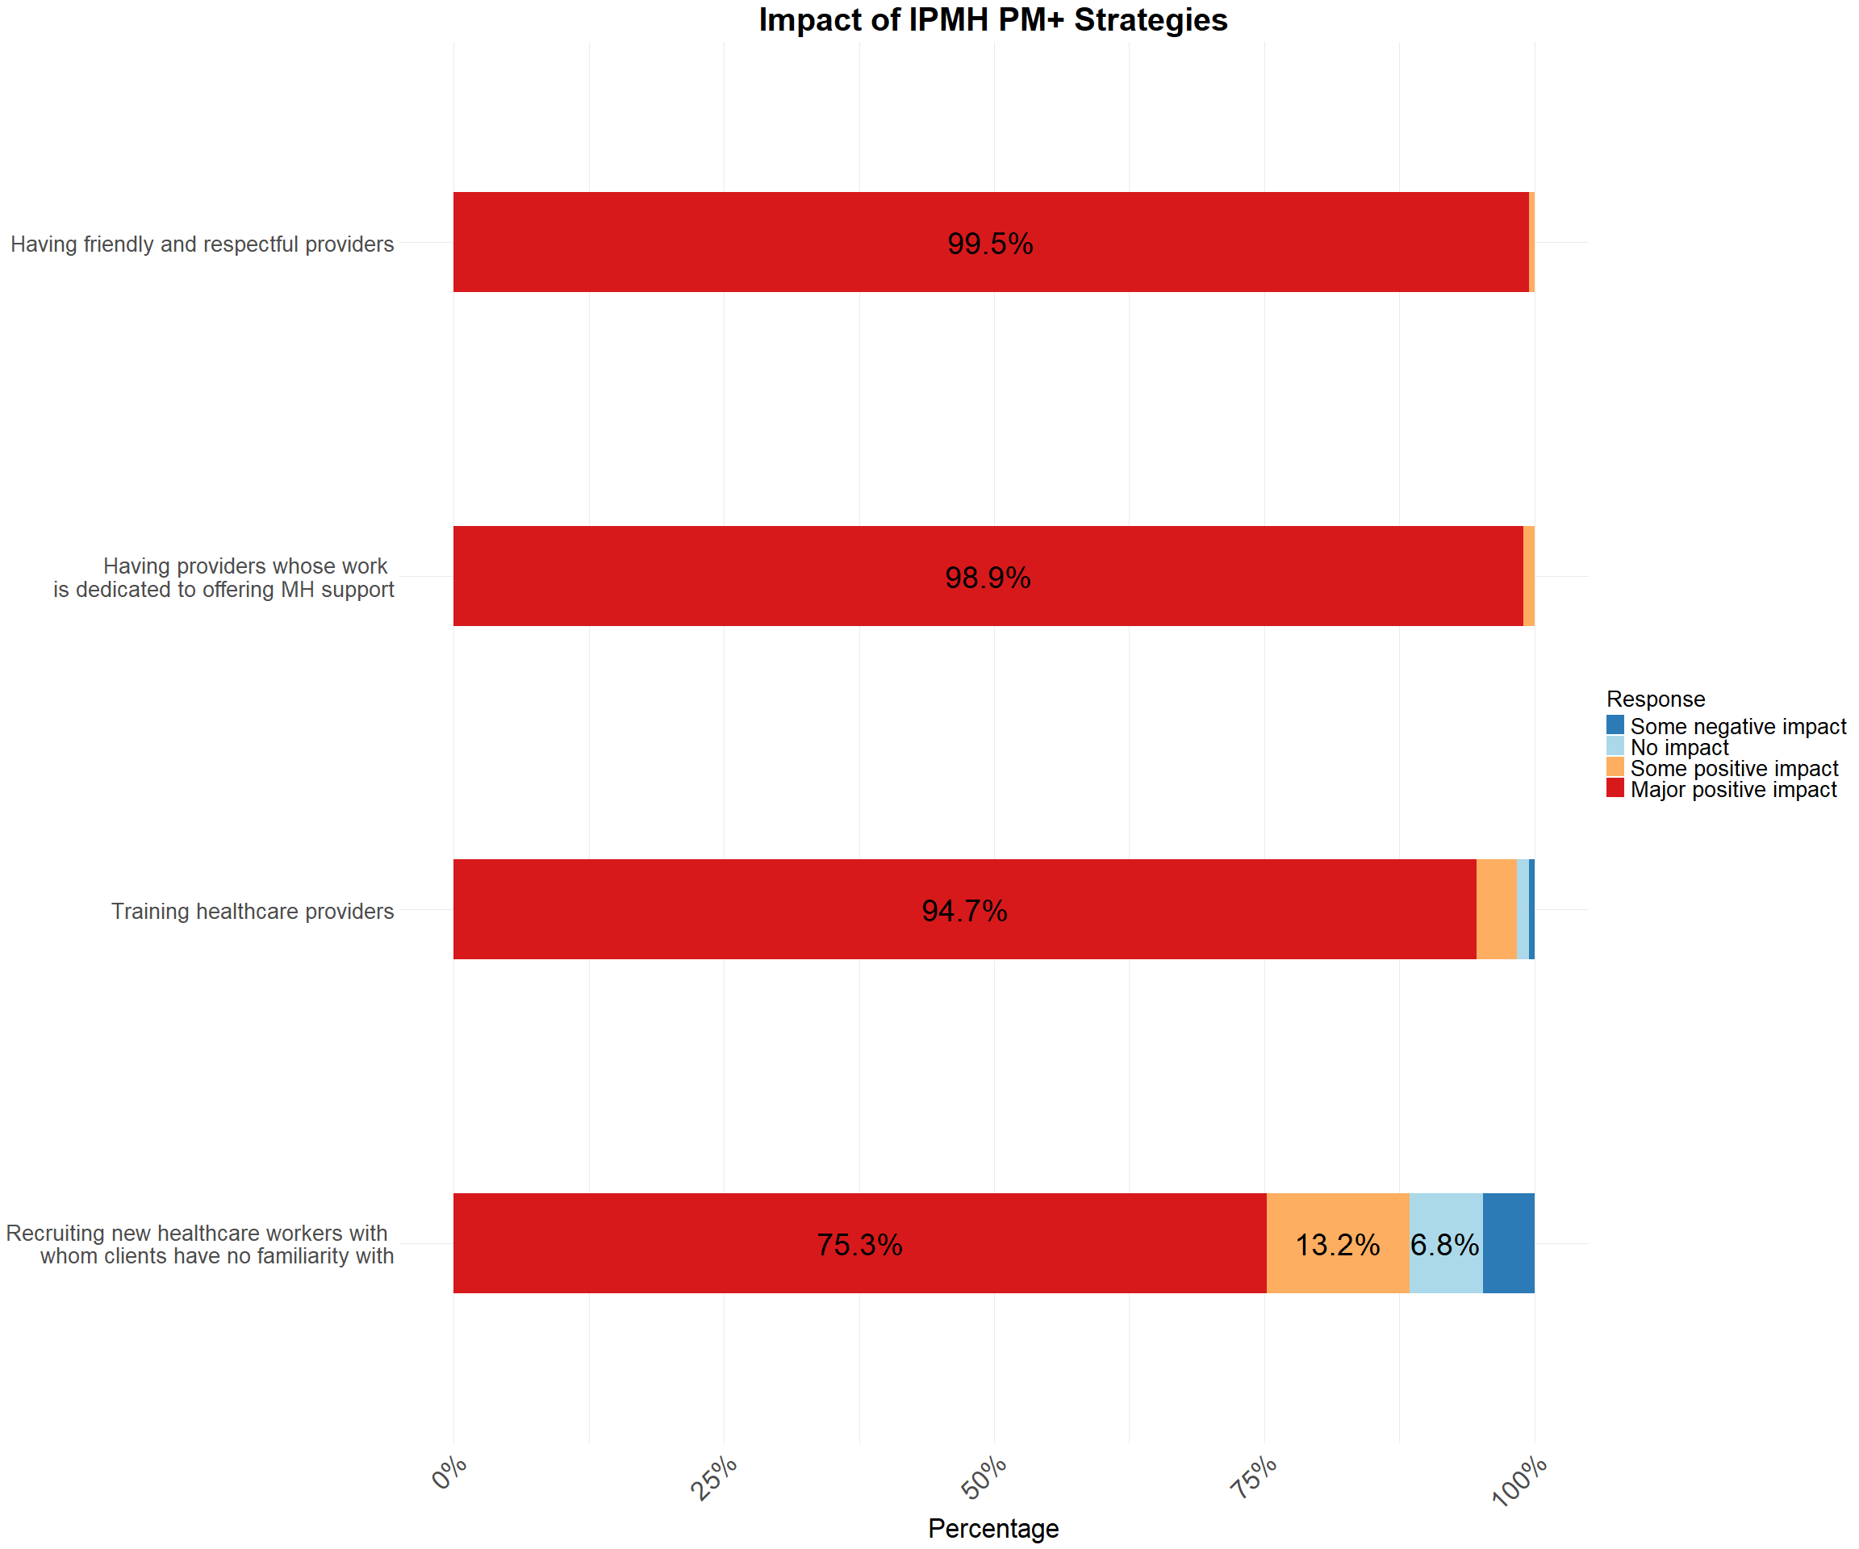

## IPMH Telepsychiatry

### Criticality of IPMH barriers to Telepsychiatry

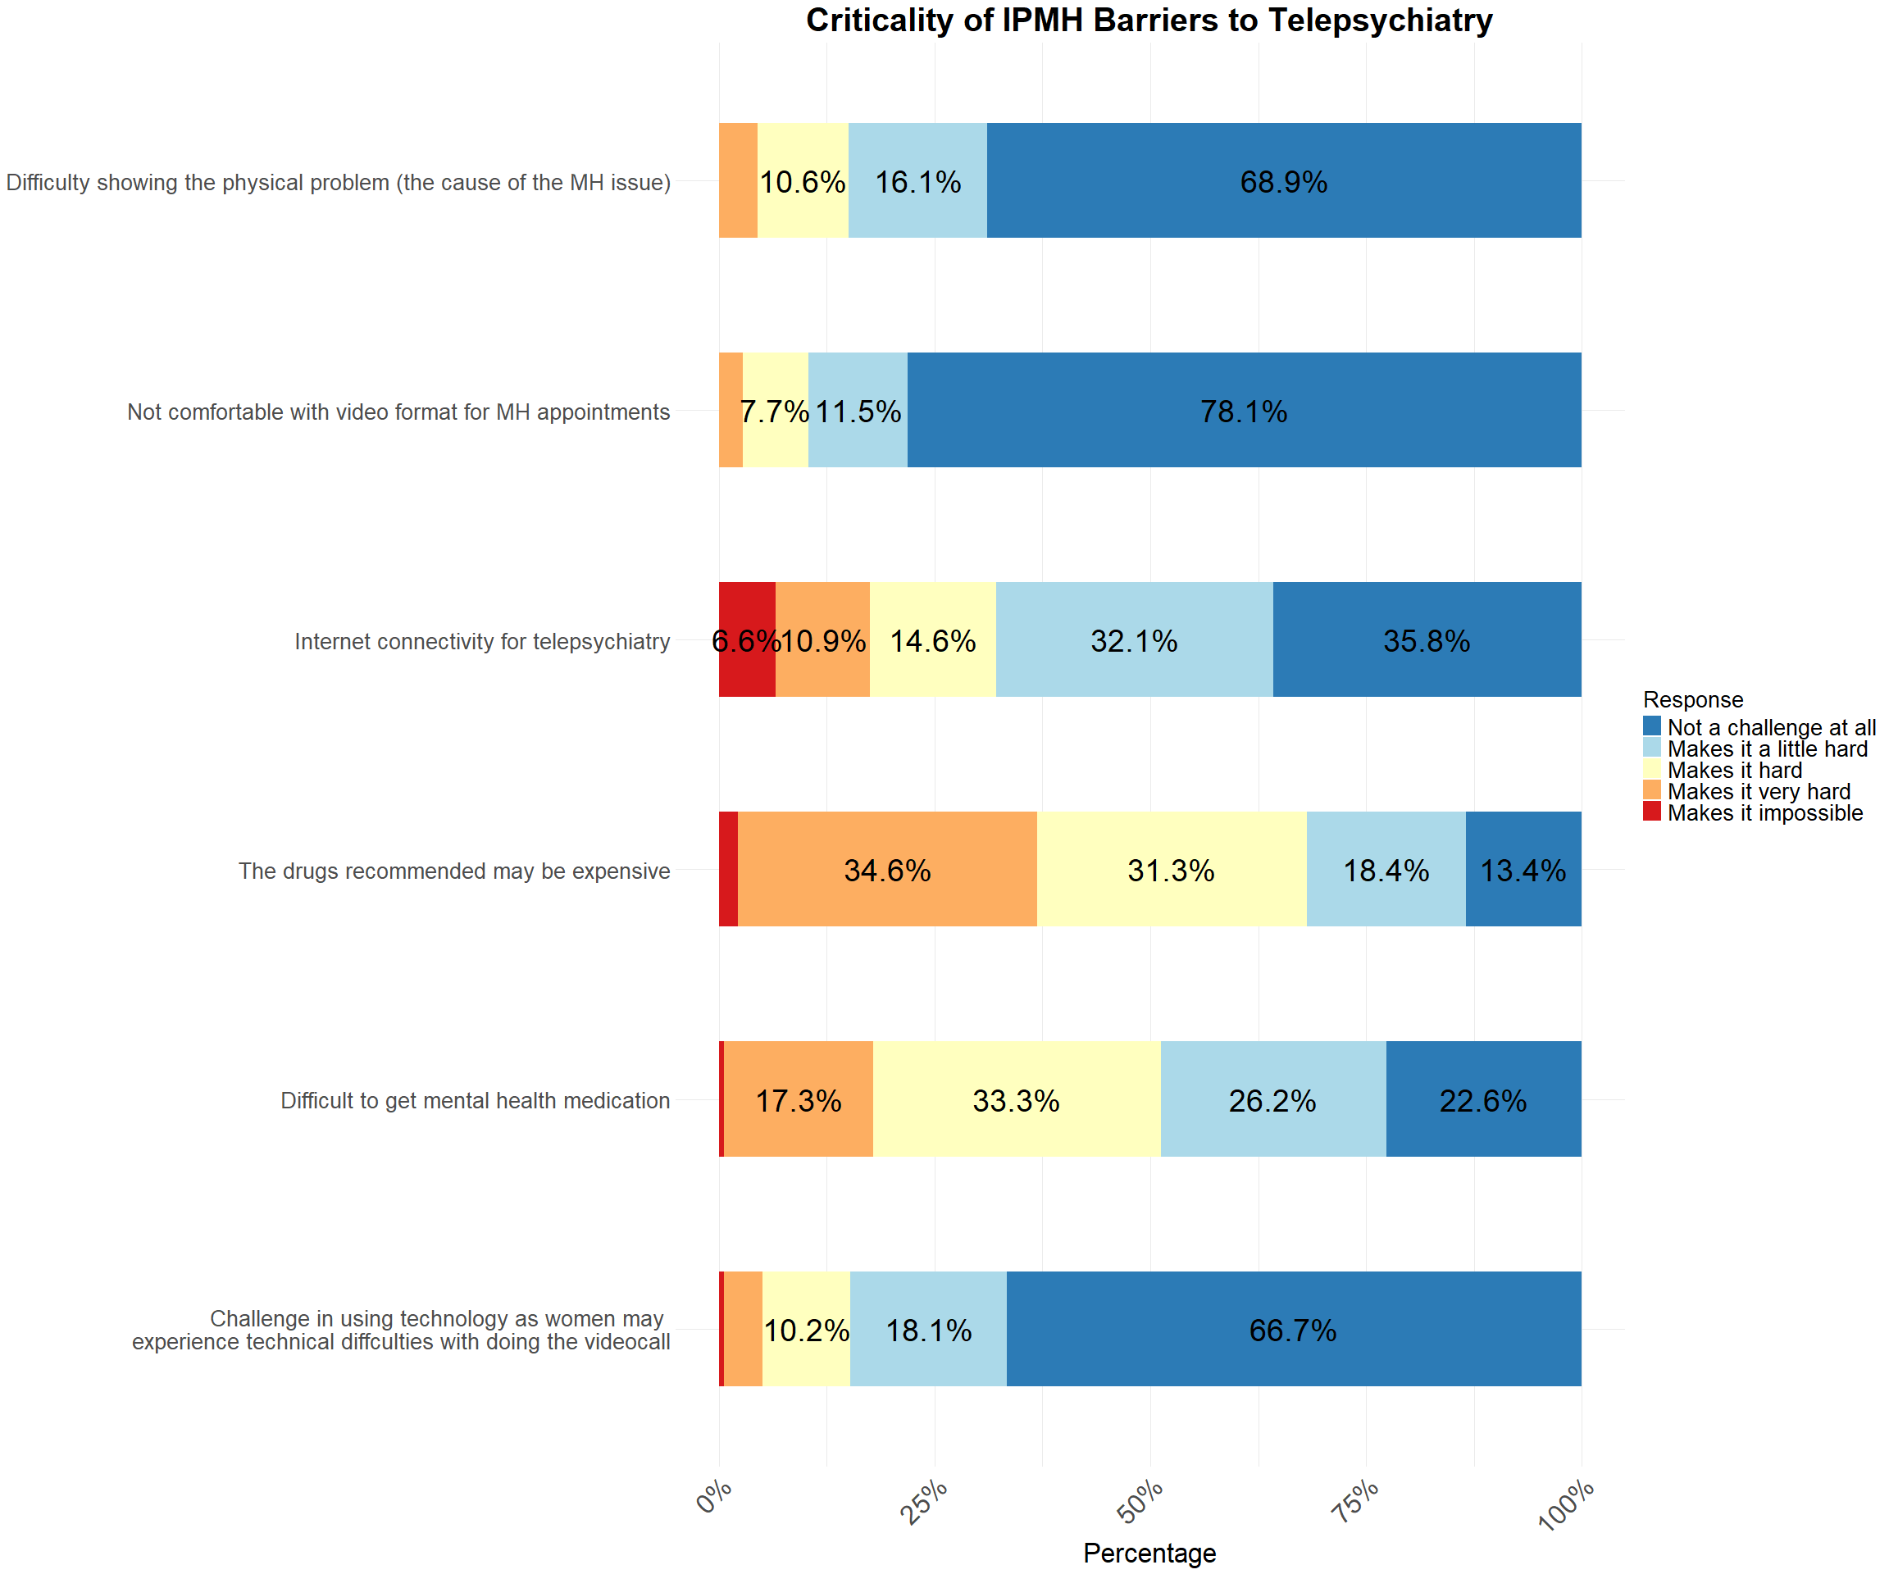

### Frequency of IPHM Barriers to Accessing Telepsychiatry Services

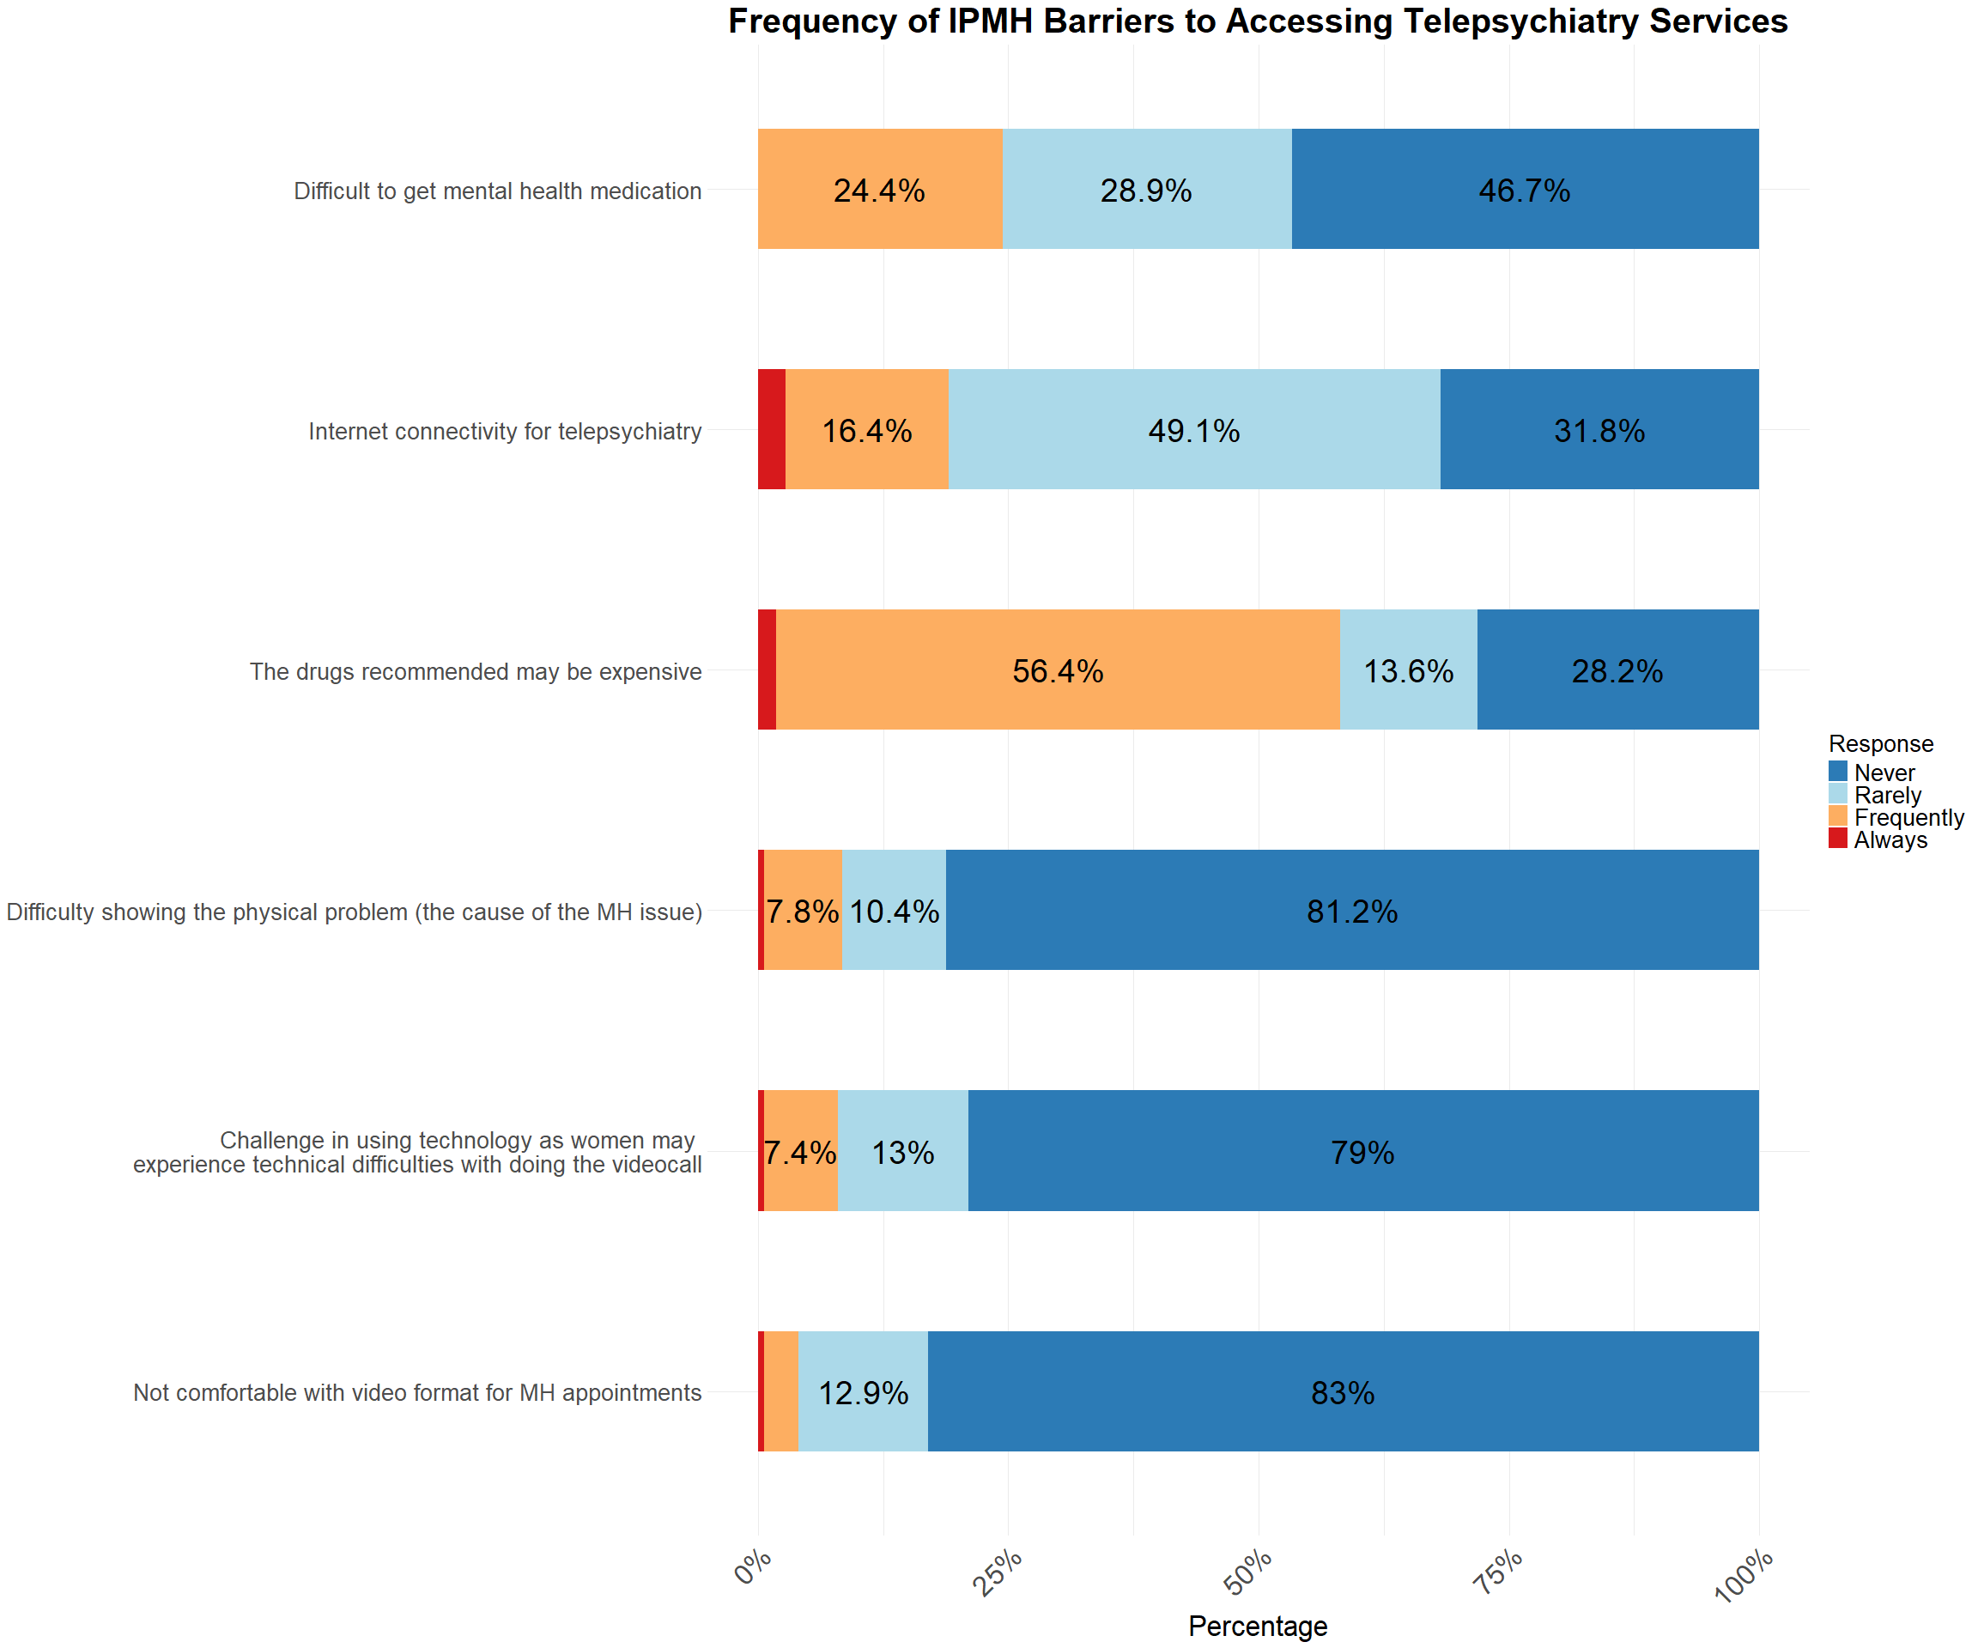

### Impact of IPMH Strategies on Telepsychiatry

