System Design
Project: MediLab, a Multi Tenant Diagnostic Lab Marketplace and Appointment Platform Author: Victoria Dowana (Student ID: 22425077) Version: 1.0 Date: 2026-08-12
Builds on SRS.md (requirements, actors, MoSCoW scope) and Effort_Estimation.md (use case sizing). Diagrams selected are the ones that best communicate a multi tenant system: architecture, tenant data model, use case, class, two sequence flows, and ER. Wireframes are described rather than drawn in full fidelity, which is appropriate for an initial release.

1. Technology Stack
Layer | Choice | Why
Front end | Next.js (React) + Tailwind CSS | Single framework covers three distinct UI surfaces (patient, lab console, platform admin console) without standing up separate apps; fast to scaffold
Back end | Next.js API routes (Node.js/TypeScript) | Keeps one deployable unit for a small team; avoids the coordination overhead of a separate backend service for an MVP
Database | PostgreSQL (managed, e.g. Supabase/Neon) | Relational integrity (foreign keys, unique constraints) is exactly what tenant scoped data and slot clash prevention need
ORM | Prisma | Typed schema/migrations, and its query extension mechanism is the enforcement point for tenant scoping (§2)
Auth | Auth.js (NextAuth) or the managed provider’s built in auth | Password hashing and session handling out of the box, rather than hand rolled, directly supporting NFR1
Hosting | Vercel (app) + managed Postgres | Cost effective/pilot tier per SRS.md §9, minimal ops overhead
This stack is chosen for velocity on a small team, consistent with the effort estimate’s assumption of scaffolding/tooling reuse (Effort_Estimation.md §4).

2. Multi Tenancy Data Model Decision
Decision: shared database, shared schema, with a labId column on every lab scoped table, enforced through a single centralised data access layer.
Alternative considered: schema per tenant (or database per tenant). Rejected for this release because: - The platform’s core value is cross tenant search and comparison (FR3, FR4), which requires querying across labs in one pass; schema/DB per tenant turns that into a fan out query across N schemas, adding real complexity for no benefit at pilot scale. - The initial release onboards a small number of pilot labs (SRS.md §4 assumption); the operational cost of migrating N schemas in lockstep isn’t justified yet. - A shared schema lets tenant scoping be enforced in one place, directly satisfying NFR7 (“tenant scoping logic is centralised, not re implemented per query”), which is the strongest available mitigation against an isolation bug (the single highest severity risk identified in Effort_Estimation.md §3 and §6).
Enforcement mechanism: every Prisma query against a lab scoped model (Lab, LabTestOffering, Appointment when accessed by staff/admin, Sample) is routed through a Prisma Client Extension that automatically injects a where: { labId: session.labId } filter for any session whose role is lab_staff or lab_admin. Application code cannot opt out of this filter, since there is no code path that queries these tables without going through the extension. platform_admin sessions use a separate, explicitly named unscoped client method, so a platform wide query is always a deliberate, visible choice in the code rather than an accidental default.
This decision is the direct architectural response to NFR2 and FR27 in SRS.md, and is the first thing to verify under test (see the tenant isolation checkpoint in Effort_Estimation.md §3 and todo.md Phase 4).
Deliberate exception (FR28, added post delivery): Test is the one platform wide model where the tenant scoped client is allowed a narrow write path, create only, so a lab admin can add a catalog entry the seeded data didn’t anticipate. update/delete on Test stay refused through this client, same as before. This is documented as an explicit, named exception in src/lib/tenant-scope.ts rather than a general loosening of the enforcement mechanism above: only create was opened, only for Test, and a case insensitive duplicate name check in createTest is the (application level, not database level) guard against the catalog fragmentation this design otherwise avoids. See Technical_Debt_Plan.md item 9.

3. System Architecture
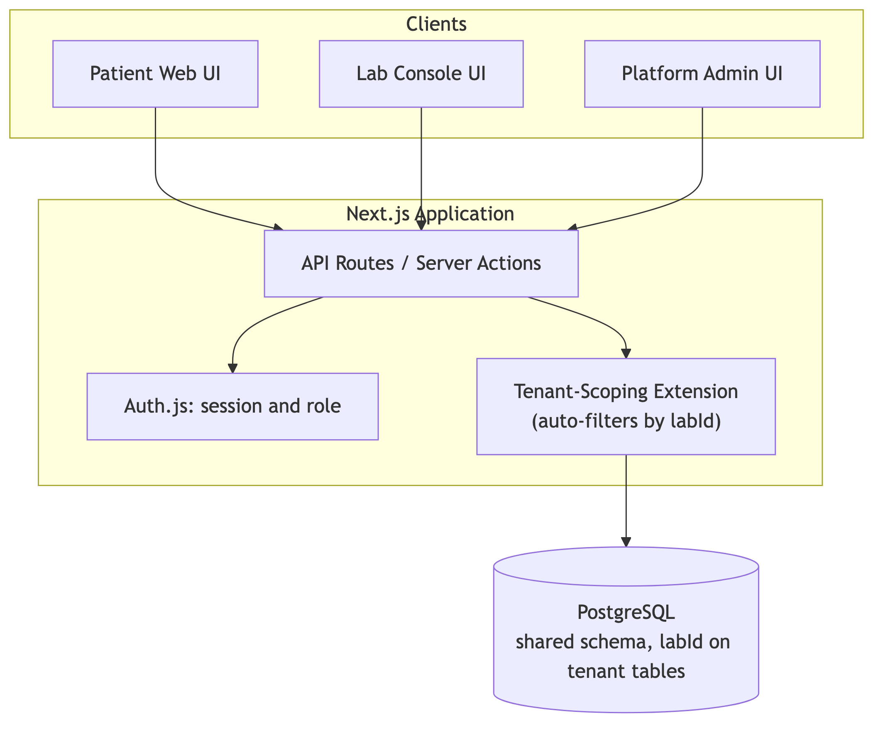
Diagram 1
All three UI surfaces are one application with role based routing/rendering, not three separate apps, which keeps the tenant scoping enforcement point (§2) singular rather than duplicated.

4. Use Case Diagram
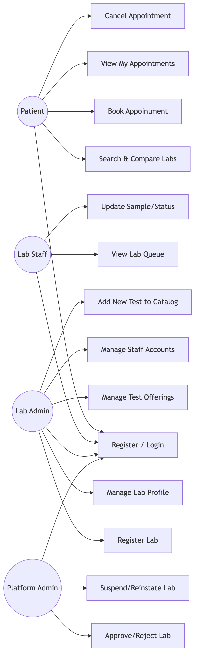
Diagram 2
Maps directly to the FR groupings in SRS.md §5; every Must have FR has a corresponding node above. Test is a platform owned, shared catalog entity (see §5/§8); per SRS.md §5’s FR23 change note the platform admin does not curate it, but per the later FR28 change note (v2.2) a lab admin can add a new entry when the seeded catalog doesn’t cover what they need (UC15), a narrower, lab admin scoped capability, not a return of platform admin catalog management.

5. Class Diagram
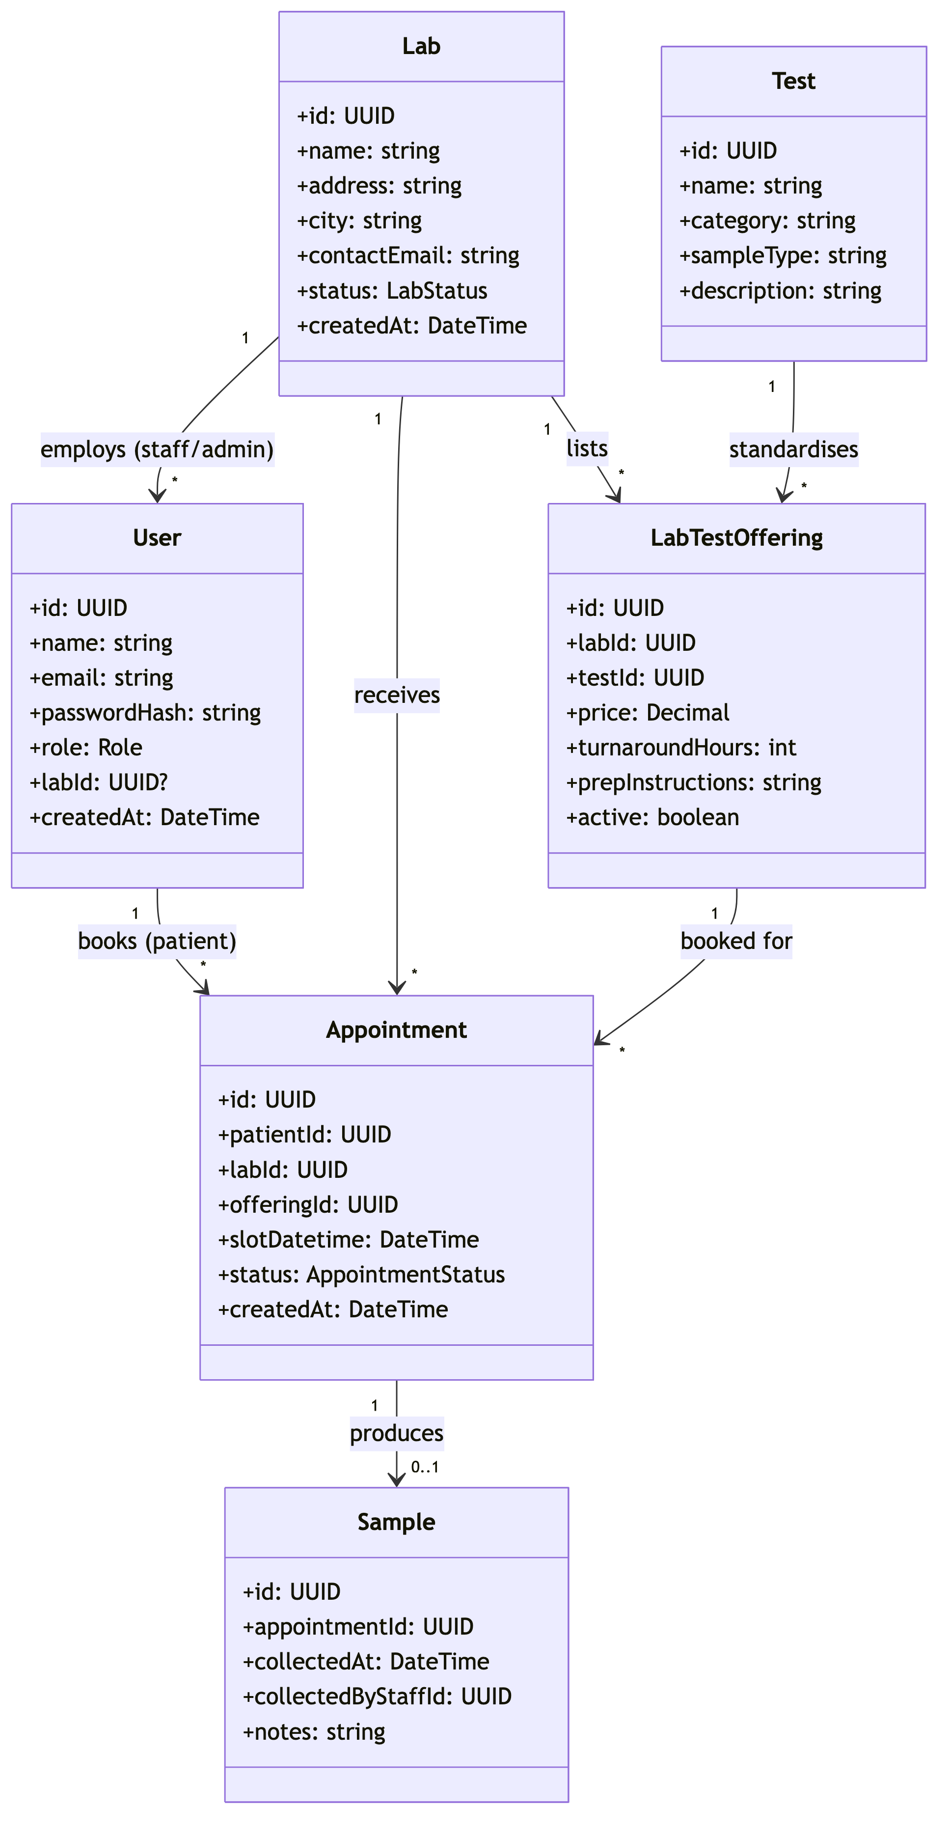
Diagram 3
labId appears on User (nullable, meaning null for patients and platform admins), Lab itself, LabTestOffering, and Appointment. These are exactly the tables the tenant scoping extension (§2) intercepts.

6. Sequence Diagram: Lab Onboarding
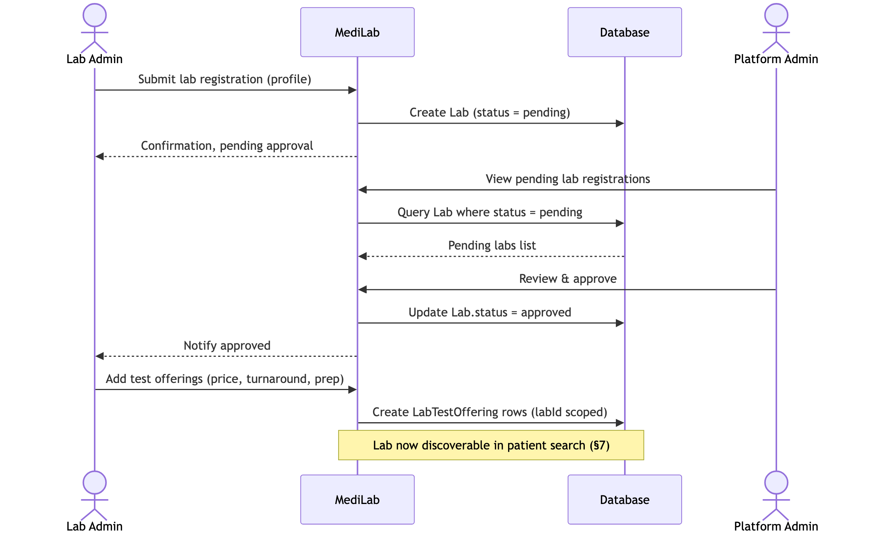
Diagram 4

7. Sequence Diagram: Core Booking Flow
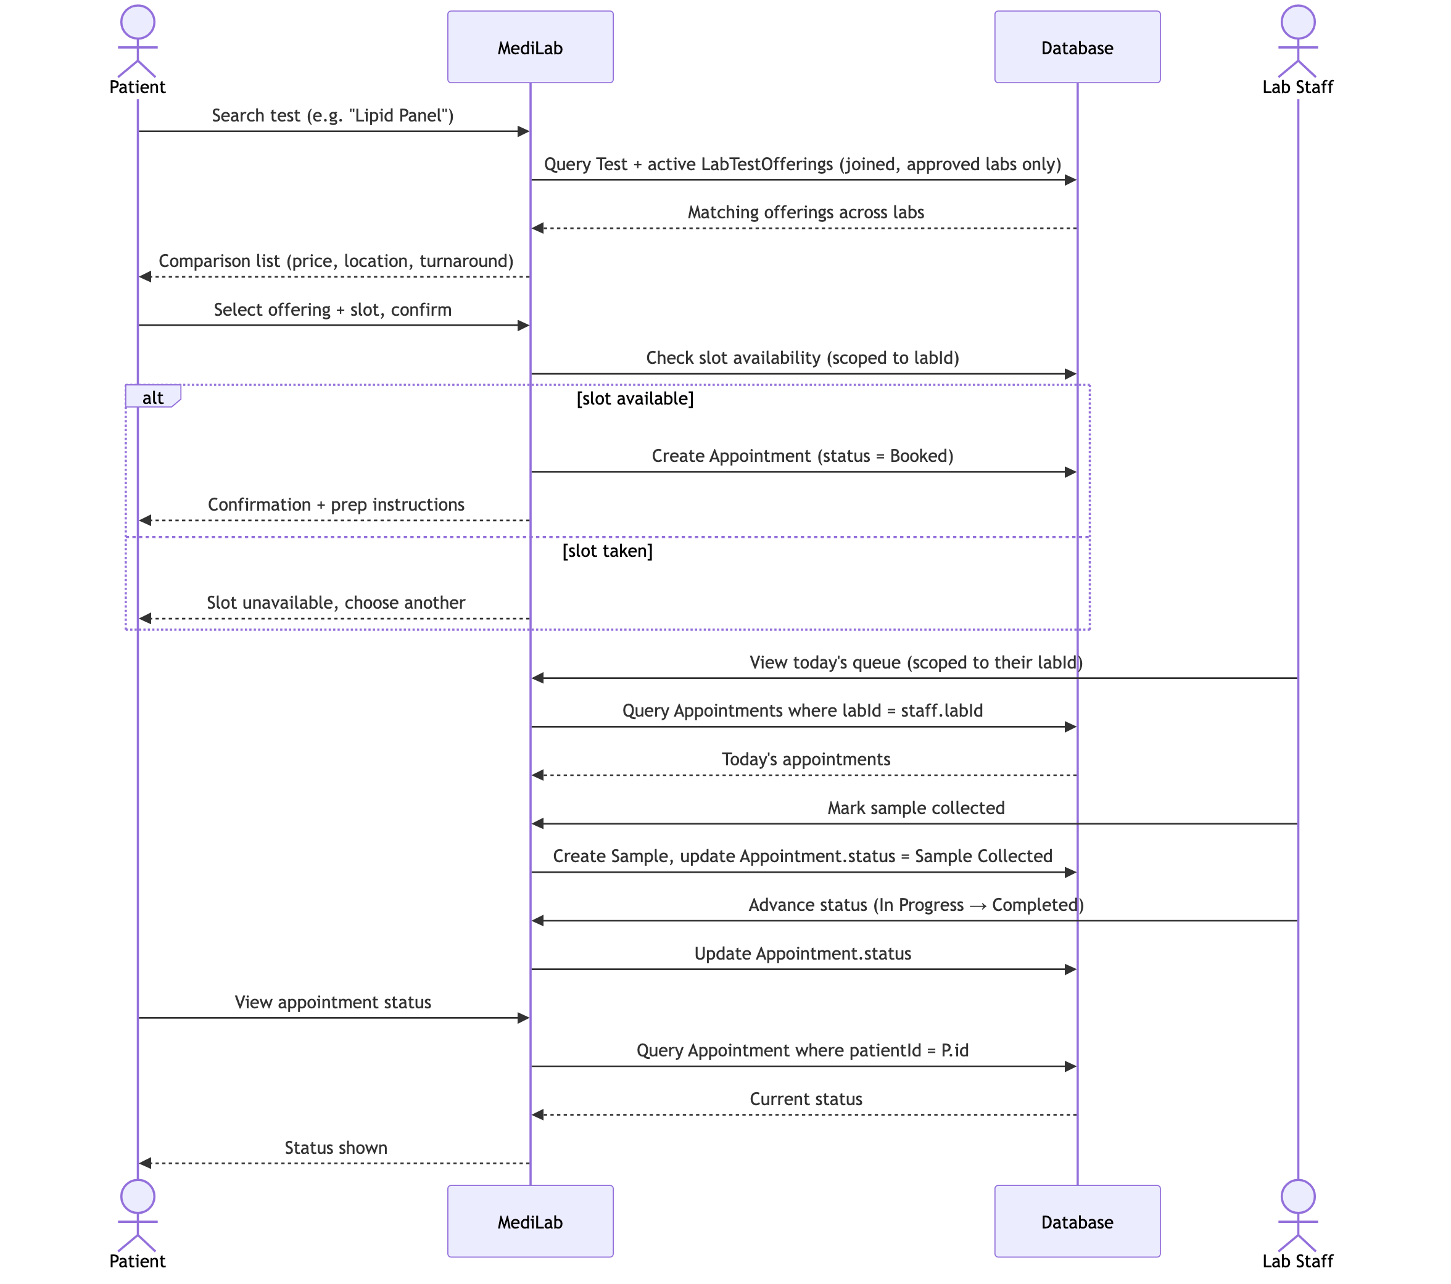
Diagram 5

8. ER Diagram
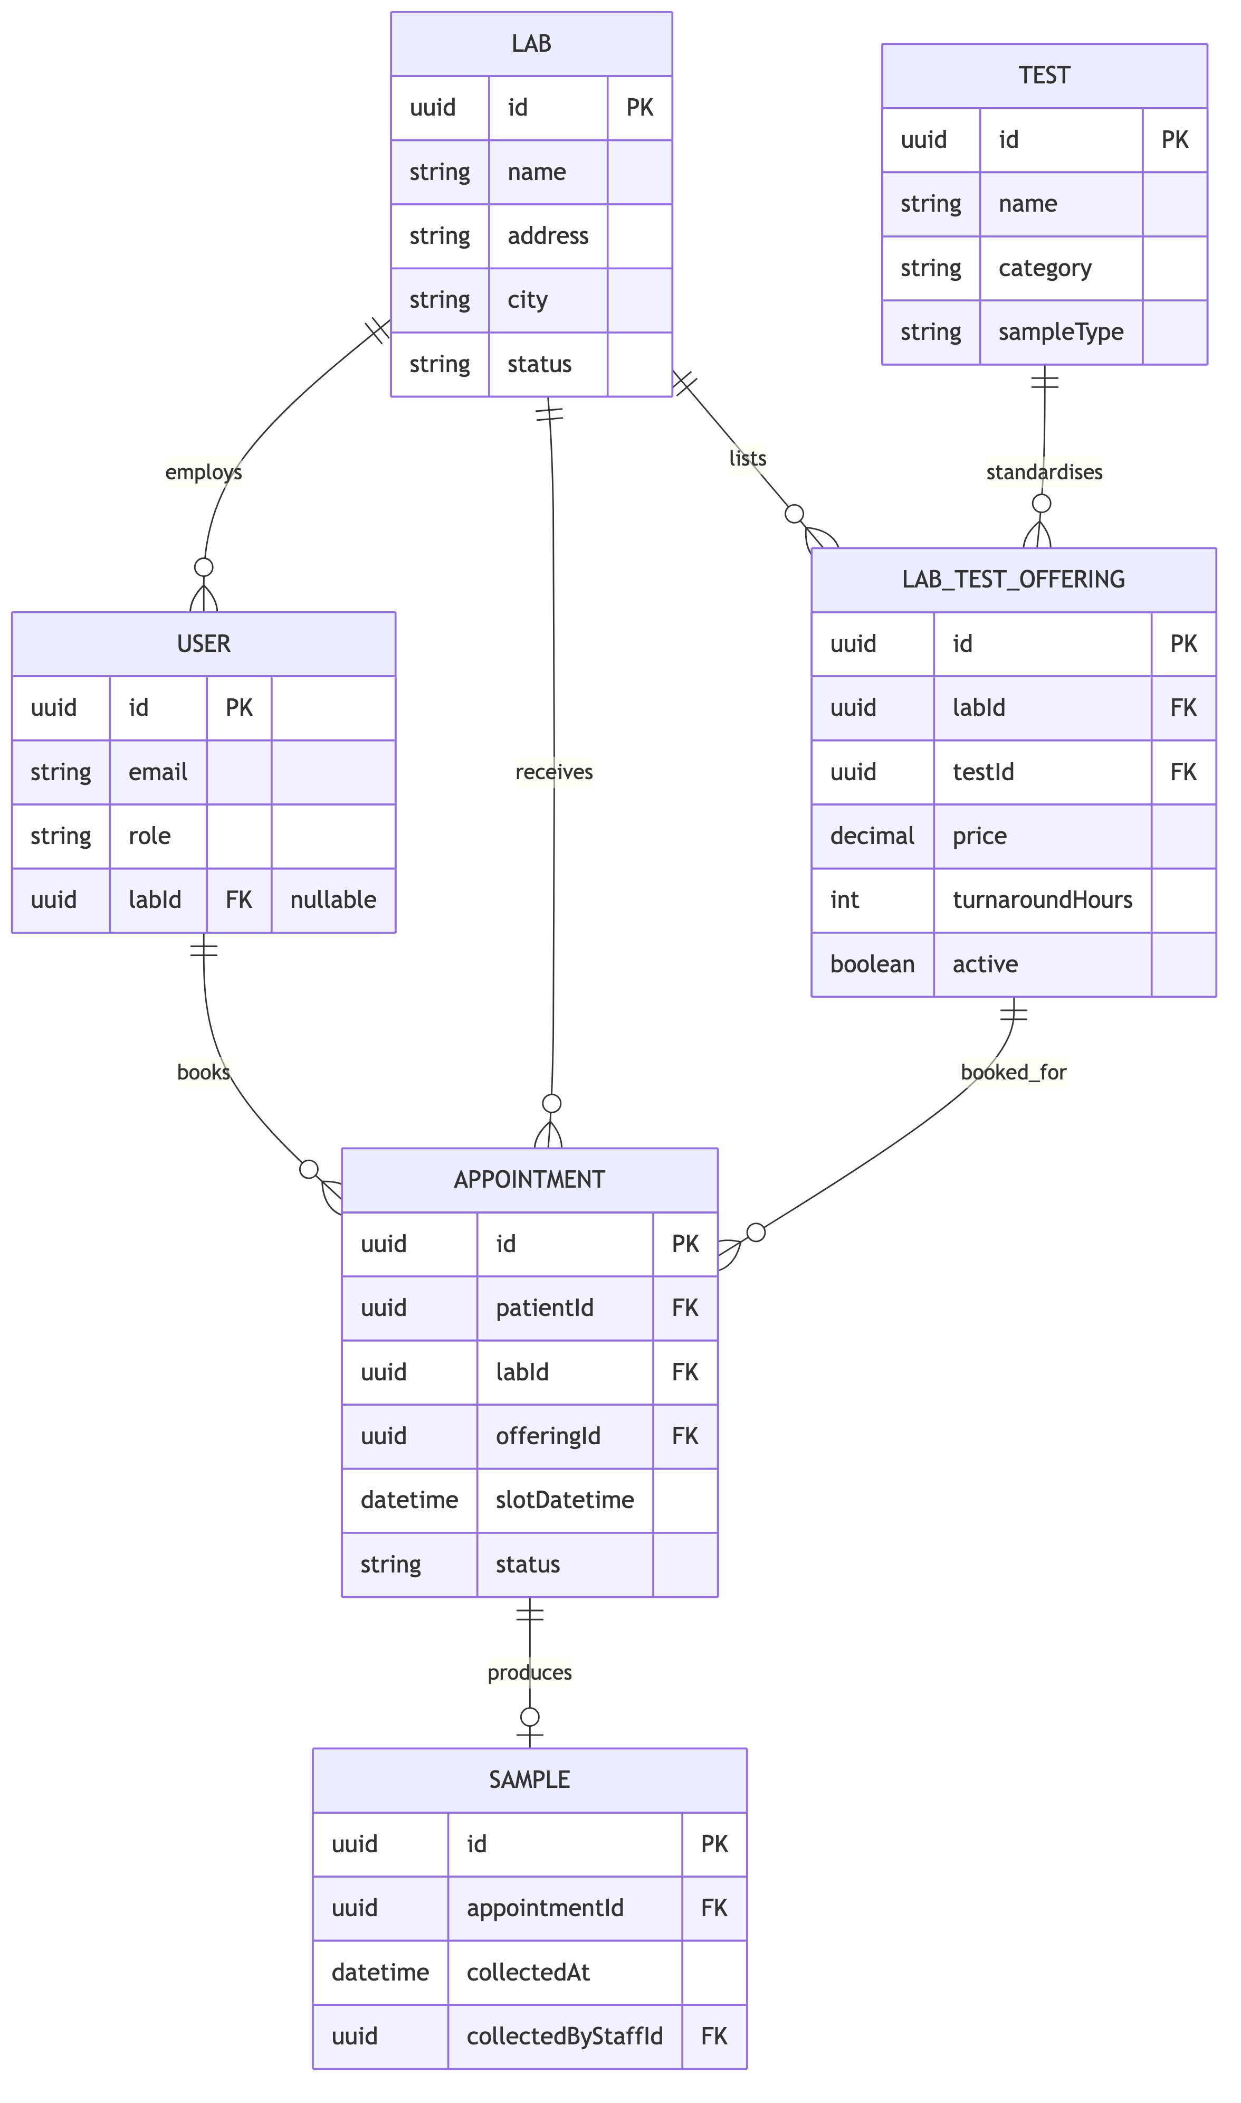
Diagram 6
A unique constraint on (labId, offeringId, slotDatetime) in APPOINTMENT is the database level backstop for FR26 (slot clash prevention). The application check in §7 is the primary defense, but the constraint guarantees correctness even under concurrent requests.

9. UI Wireframes (low fidelity)
Patient: Search and Compare
┌─────────────────────────────────────────────┐
│ Search: [ Lipid Panel ] [Search] │
│ Filter: Price ▾ Location ▾ Turnaround ▾ │
├─────────────────────────────────────────────┤
│ CityLab Diagnostics GHS 80 Osu 24h [Book] │
│ QuickTest Labs GHS 65 Tema 48h [Book] │
│ MedCheck Labs GHS 95 Osu 12h [Book] │
└─────────────────────────────────────────────┘
Patient: Booking Confirmation
┌─────────────────────────────────────────────┐
│ CityLab Diagnostics, Lipid Panel, GHS 80 │
│ Prep: Fast 12 hours before sample collection │
│ Slot: [ Tue 18 Aug, 9:00 AM ▾ ] │
│ [Confirm Booking] │
└─────────────────────────────────────────────┘
Lab Staff: Queue
┌─────────────────────────────────────────────┐
│ Today's Queue: CityLab Diagnostics │
├─────────────────────────────────────────────┤
│ 9:00 J. Owusu Lipid Panel [Mark Collected] │
│ 9:30 A. Mensah CBC Sample Collected │
│ 10:00 K. Boateng Lipid Panel In Progress → [Complete] │
└─────────────────────────────────────────────┘
Lab Admin: Test Offerings
┌─────────────────────────────────────────────┐
│ CityLab Diagnostics: Test Offerings [+ Add] │
├─────────────────────────────────────────────┤
│ Lipid Panel GHS 80 24h Active [Edit] │
│ CBC GHS 45 12h Active [Edit] │
└─────────────────────────────────────────────┘
Platform Admin: Pending Lab Approvals
┌─────────────────────────────────────────────┐
│ Pending Lab Registrations │
├─────────────────────────────────────────────┤
│ MedCheck Labs, Osu [View] [Approve] [Reject] │
└─────────────────────────────────────────────┘

10. Traceability to Requirements
Diagram | Primary FRs covered
Architecture (§3) | NFR2, NFR7, NFR9
Use case (§4) | FR1–FR25, excluding FR23 (removed, see SRS.md §5 change note)
Class (§5) / ER (§8) | Entities underlying every FR
Sequence, onboarding (§6) | FR17, FR22
Sequence, booking (§7) | FR3, FR4, FR7, FR8, FR13–FR15, FR26
Wireframes (§9) | FR3–FR9, FR13, FR20, FR22

