**SSH Keys and the AWS super computer**

Author: Lynn Sanford, 2023

**What is a super computer?**

Super computers have much more memory and processing power than your local computer, which is required for most bioinformatics analysis. For your actual analysis, you’ll either use a super computer run by your campus or a cloud-based computing system like Amazon Web Services (AWS). For this class, our computing is set up through AWS.

This worksheet will take you through the security process of logging onto our class AWS instance.

**Key-based security**

We have set up the AWS to allow access through GitHub usernames. A secure way of connecting your computer to the AWS is through an SSH private/public key pair.

To generate one, first open a terminal application on your computer. On Mac or Linux this is just called Terminal. On Windows, you should have installed Bash for Windows, accessed through the Ubuntu application.

Once you have a terminal window open, follow the below instructions according to your operating system:

**Mac:**

In your terminal, paste the following command, using the email address associated with your github account (keep the double quotes):

ssh-keygen -t ed25519 -C "your_email@example.com"

**Note**: If you get an error that ed25519 is not supported, use:

ssh-keygen -t rsa -b 4096 -C "your_email@example.com"

You will be asked where to generate the files that contain the key, then for a password if you want to password-protect the files. Unless you have done this before, use the default location and no passwords by just hitting Enter in response to each question (three times total).

If everything works, there will be a random image generated.

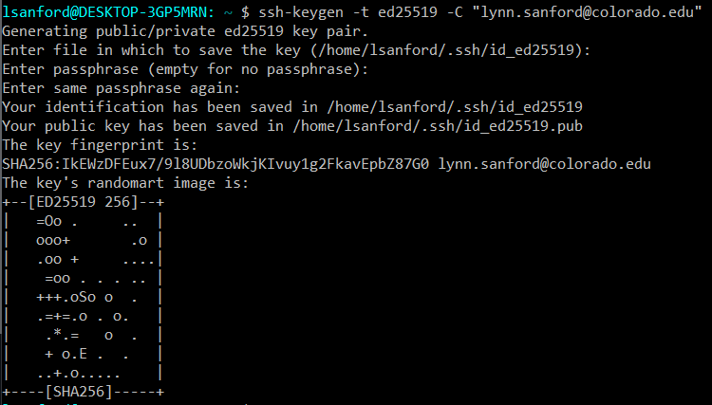

After you get this key generated, you need to add it to the ssh agent that connects your computer to others. Run the following command:

eval "$(ssh-agent -s)"

This will give you a pid. The number isn’t important for us.

Now you need to make a config file. By the end of today, you’ll know how to edit a file, but for now follow these commands:

vim ~/.ssh/config

This will open a file. Hit the i key to begin editing and type or copy/paste the following:

Host github.com

AddKeysToAgent yes

IdentityFile ~/.ssh/id_ed25519

When you’re done typing, hit Esc, then type :wq (starting with the colon)

Now you’re back on the command line. Run the following:

ssh-add --apple-use-keychain ~/.ssh/id_ed25519

Unless you created an rsa key, in which case it’ll be the following:

ssh-add --apple-use-keychain ~/.ssh/id_rsa

Finally, follow these instructions:

<https://docs.github.com/en/authentication/connecting-to-github-with-ssh/adding-a-new-ssh-key-to-your-github-account?platform=mac>

You may need to wait ~5 minutes for the AWS to sync credentials information before logging on. Then login to the AWS by navigating back to your terminal and typing the following:

ssh <github_username>@<aws_ip>

Where <github_username> is replaced by YOUR username and <aws_ip> is replaced by the IP address written on the board.

The first time you log on, it’ll ask if you want to authenticate. Type yes, hit enter, and you’re good to go!

If you get a credentials error AND you’ve waited at least five minutes, more troubleshooting might be required.

**Windows:**

Copying in the WSL Ubuntu app is done as normal with Ctrl-C, but you **cannot** paste with Ctrl-V. Pasting is done with a right-click instead.

In your terminal, paste the following command, using the email address associated with your github account (keep the double quotes):

ssh-keygen -t ed25519 -C "your_email@example.com"

**Note**: If you get an error that ed25519 is not supported, use:

ssh-keygen -t rsa -b 4096 -C "your_email@example.com"

You will be asked where to generate the files that contain the key, then for a password if you want to password-protect the files. Unless you have done this before, use the default location and no passwords by just hitting Enter in response to each question (three times total).

If everything works, there will be a random image generated.

After you get this key generated, you need to add it to the ssh agent that connects your computer to others. Run the following commands:

eval "$(ssh-agent -s)"

ssh-add ~/.ssh/id_ed25519

Unless you created an rsa key, in which case it’ll be the following:

ssh-add ~/.ssh/id_rsa

Finally, follow these instructions:

<https://docs.github.com/en/authentication/connecting-to-github-with-ssh/adding-a-new-ssh-key-to-your-github-account?platform=windows>

You may need to wait ~5 minutes for the AWS to sync credentials information before logging on. Then login to the AWS by navigating back to your terminal and typing the following:

ssh <github_username>@<aws_ip>

Where <github_username> is replaced by YOUR username and <aws_ip> is replaced by the IP address written on the board.

**Note:** If you get an error that says permissions are too open, type the following:

chmod 700 ~/.ssh/id_*

The first time you log on, it’ll ask if you want to authenticate. Type yes, hit enter, and you’re good to go!

If you get a credentials error AND you’ve waited at least five minutes, more troubleshooting might be required.